Water for Life Award Nomination Form
- Eligibility criteria: The person named as the nominee is not required to be a member of RSC or WSF, however the nominator must be a member of WSF.
- Please tick this box to confirm that your nominee has agreed to be put forward for nomination

Your Details
Name | RSC Membership Number | WSF Member Y/N

Nominees Details
Name | RSC Membership Number | WSF Member Y/N

Please describe why this person fits criteria for the award (500 words max.)

Other relevant information (i.e. significant or innovative contributions, awards, publications, charitable works etc.)

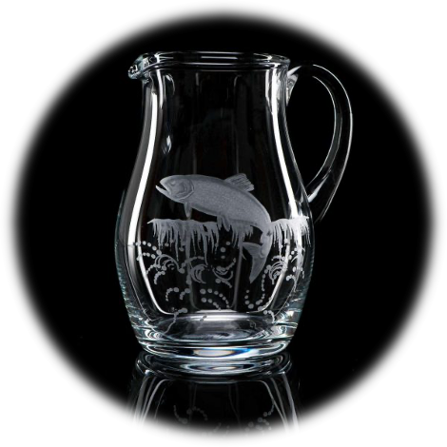
Please include a CV for the candidate (max. 2 pages) Signature…………………………………………………………… Date………………………….

