Supplementary data
Through-space ¹³C–¹⁹F coupling can reveal conformations of modified BODIPY dyes
Jiong Chen, Joe Reibenspies, Agnes Derecskei-Kovacs and Kevin Burgess*
Department of Chemistry, Texas A & M University, PO Box 30012, College Station, TX 77842-3012, USA. E-mail: burgess@chemvx.tamu.edu

NMR data for 1a:

¹H (300 MHz, CDCl₃): δ 8.75 (d, J = 8.7 Hz, 2H), 7.83 (d, J = 8.4 Hz, 2H), 7.27 (d, J = 8.4 Hz, 2H), 6.98 (d of d, J = 8.7 Hz, 2.7 Hz, 2H), 6.81 (d, J = 2.7 Hz, 2H), 6.47, (s, 2H), 3.88 (s, 6H), 2.88 (bs, 4H), 2.67 (bs, 4H).

¹³C (75 MHz, CDCl₃): δ 160.7, 151.9, 142.8, 137.3, 136.0, 135.4, 134.9, 132.2, 132.1, 130.1 (t, J = 11 Hz), 124.4, 121.5, 114.7, 112.4, 95.5, 55.3, 30.9, 22.3.

¹⁹F (282 MHz, CDCl₃, CFCl₃ as external reference, δ = 0): δ -137.5 (q, J = 34 Hz).

¹¹B (64 MHz, CDCl₃, BF₃ etherate as external reference, δ = 0): δ 9.29 (t, J = 34 Hz).

NMR data for 1b:

¹H (300 MHz, CDCl₃): δ 8.80 (d, J = 7.8 Hz, 2H), 7.85 (d, J = 8.7 Hz, 2H), 7.45 (d of t, J = 7.8 Hz, 1.7 Hz, 2H), 7.35 – 7.25 (m, 6H), 6.53 (s, 2H), 2.90 (t, J = 6 Hz, 4H), 2.68 (t, J = 6 Hz, 4H).

¹³C (75 MHz, CDCl₃): δ 152.6, 140.5, 137.9, 137.3, 135.8, 134.5, 133.2, 132.1, 129.8, 128.4 (t, J = 11 Hz), 128.3, 128.2, 127.5, 125.0, 95.8, 30.5, 22.3.

¹⁹F (282 MHz, CDCl₃, CFCl₃ as external reference, δ = 0): δ -137.3 (q, J = 34 Hz).

¹¹B (64 MHz, CDCl₃, BF₃ etherate as external reference, δ = 0): δ 3.98 (t, J = 34 Hz).

NMR data for 2a:

¹H (300 MHz, CDCl₃): δ 8.75 (d, J = 6.9 Hz, 2H), 7.89 (d, J = 8.4 Hz, 2H), 7.66 (d of d, J = 6.9 Hz, 2.0 Hz, 2H), 7.45 – 7.52 (m, 4H), 7.35 (d, J = 8.4 Hz, 2H), 6.84 (s, 2H).

¹³C (75 MHz, CDCl₃): δ 148.3, 140.4, 137.7, 137.5, 133.4, 132.3, 129.6, 126.7 (t, J = 5.2 Hz), 125.7, 125.6, 124.1, 119.8, 96.9.

¹⁹F (282 MHz, CDCl₃, CFCl₃ as external reference, δ = 0): δ -147.0 (q, J = 30 Hz).

NMR data for 2b:

¹H (300 MHz, CDCl₃): δ 8.21 (d, J = 7.5 Hz, 2H), 7.91 (d, J = 8.4 Hz, 2H), 7.51 – 7.35 (m, 6H), 7.36 (d, J = 8.4 Hz, 2H), 6.36 (s, 2H).

¹³C (75 MHz, CDCl₃): δ 164.8, 154.6, 146.1, 143.8, 138.7, 137.8, 133.4, 132.1, 130.5, 124.2, 123.9, 117.0, 112.8, 104.3, 96.8.

¹⁹F (282 MHz, CDCl₃, CFCl₃ as external reference, δ = 0): δ -150.6 (q, J = 28 Hz).

¹¹B (64 MHz, CDCl₃, BF₃ etherate as external reference, δ = 0): δ 0.41 (t, J = 28 Hz).
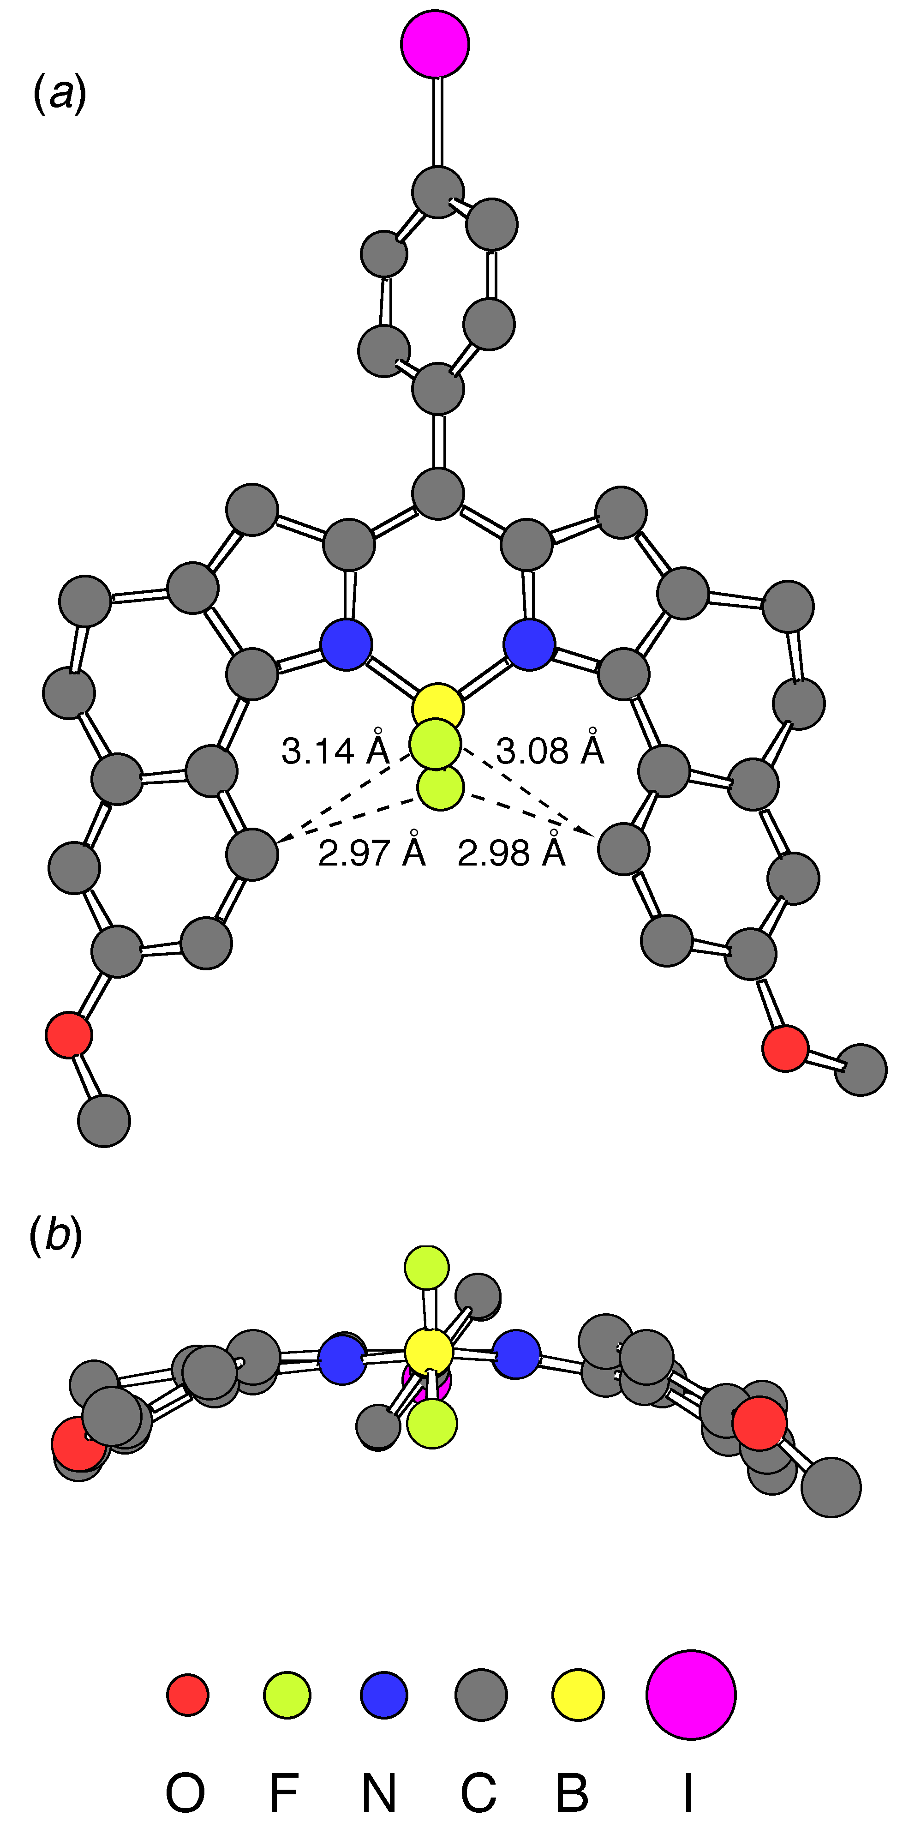

Fig. 1 Chem3D representations of compound 1a from X-ray crystallographic data: (a) top view showing C^{α}-F distances, and (b) side-view illustrating curvature of the molecule.

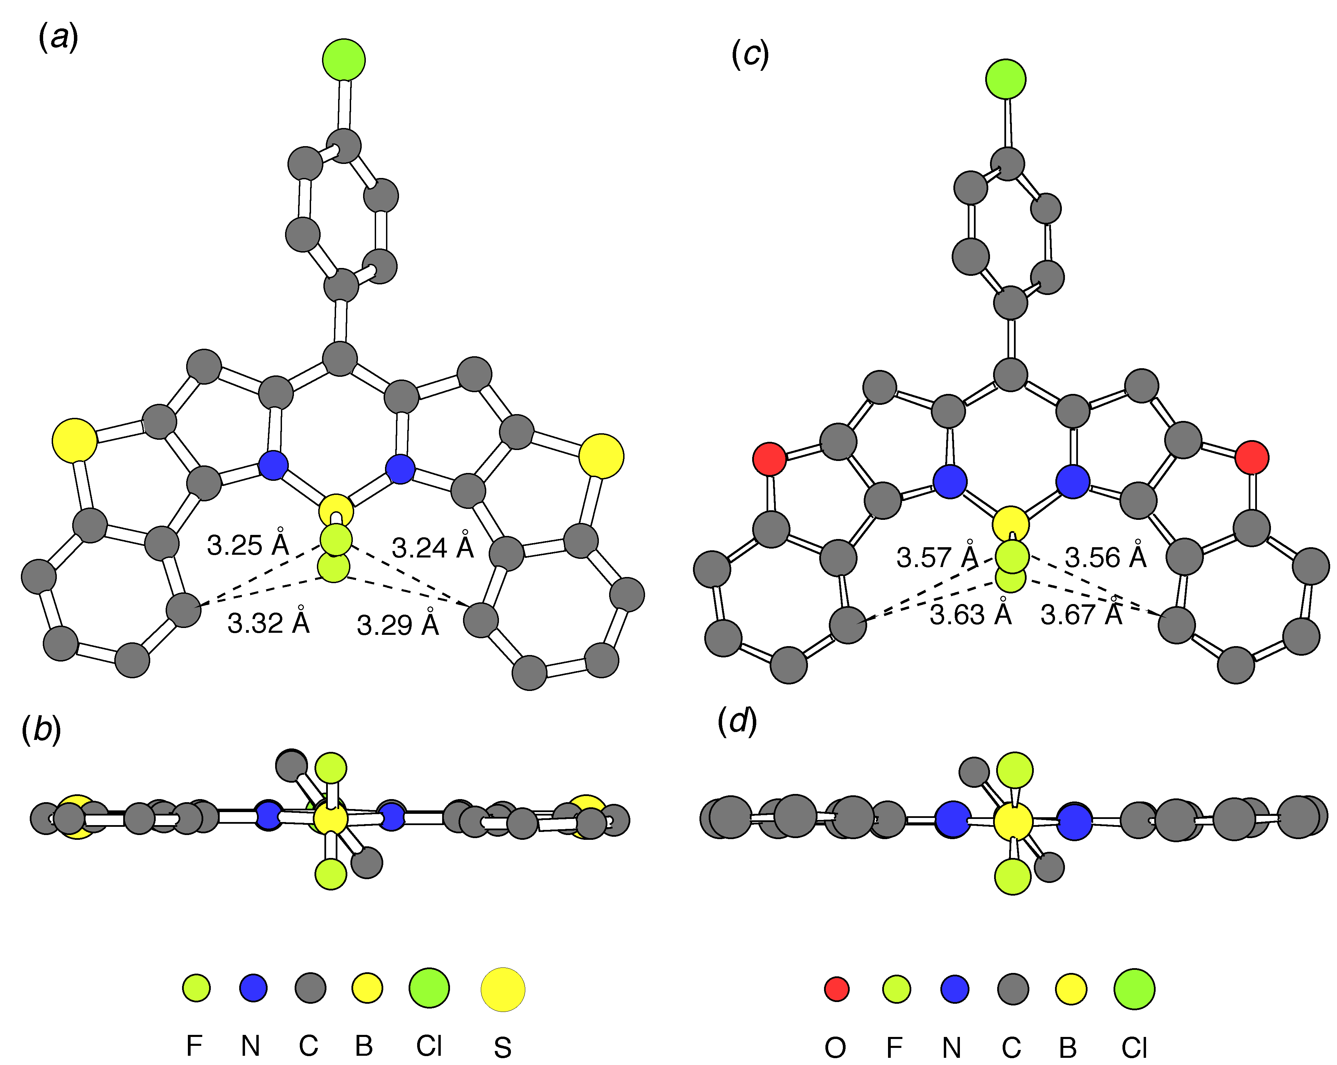

Fig. 2 Chem3D representations of the Cl-for-I analogs from AM1 calculations: (a) top view of compound 2a showing C^{α}-F distances, (b) side-view of 2a, (c) top view of compound 2b showing C^{α}-F distances, and (d) side-view of compound 2b.

