Fig. 1a Rietveld refinement fit to the Cu Kα₁ X-ray diffraction
pattern of Ru_{0.9}Nb_{0.1}Sr₂GdCu₂O₈

Fig. 1b Rietveld refinement fit to the Cu Kα₁ X-ray diffraction
pattern of Ru_{0.8}Nb_{0.2}Sr₂GdCu₂O₈
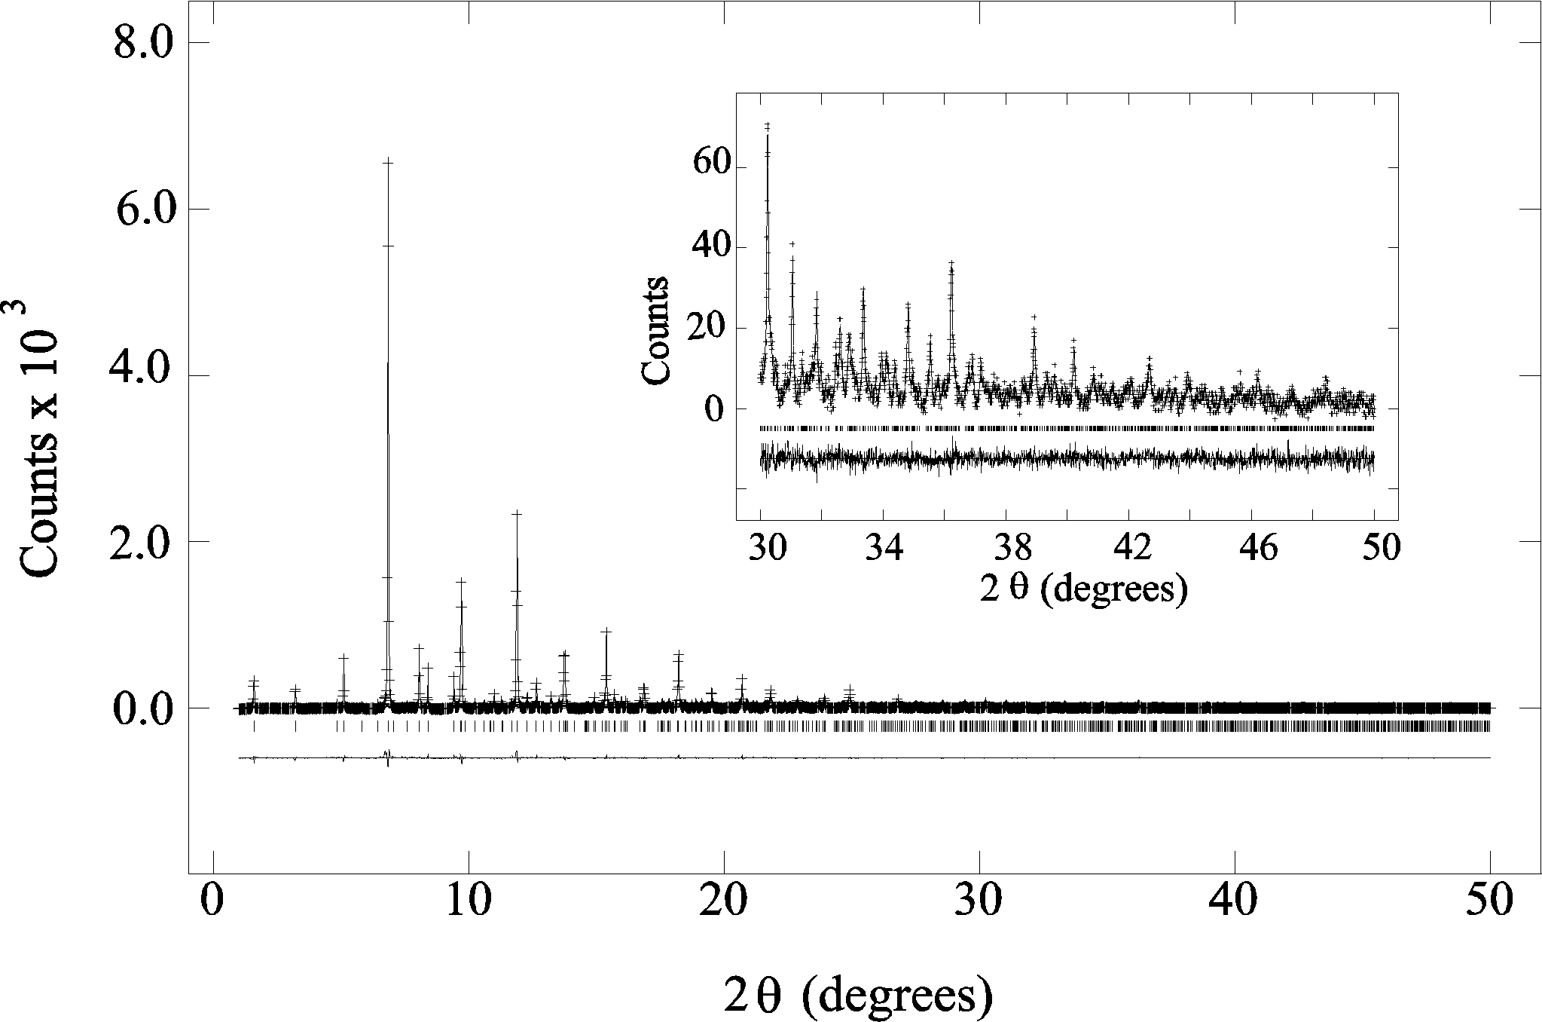

Fig. 1c Rietveld refinement fit to the synchrotron diffraction pattern of Ru_{0.95}Sn_{0.05}Sr₂GdCu₂O₈

