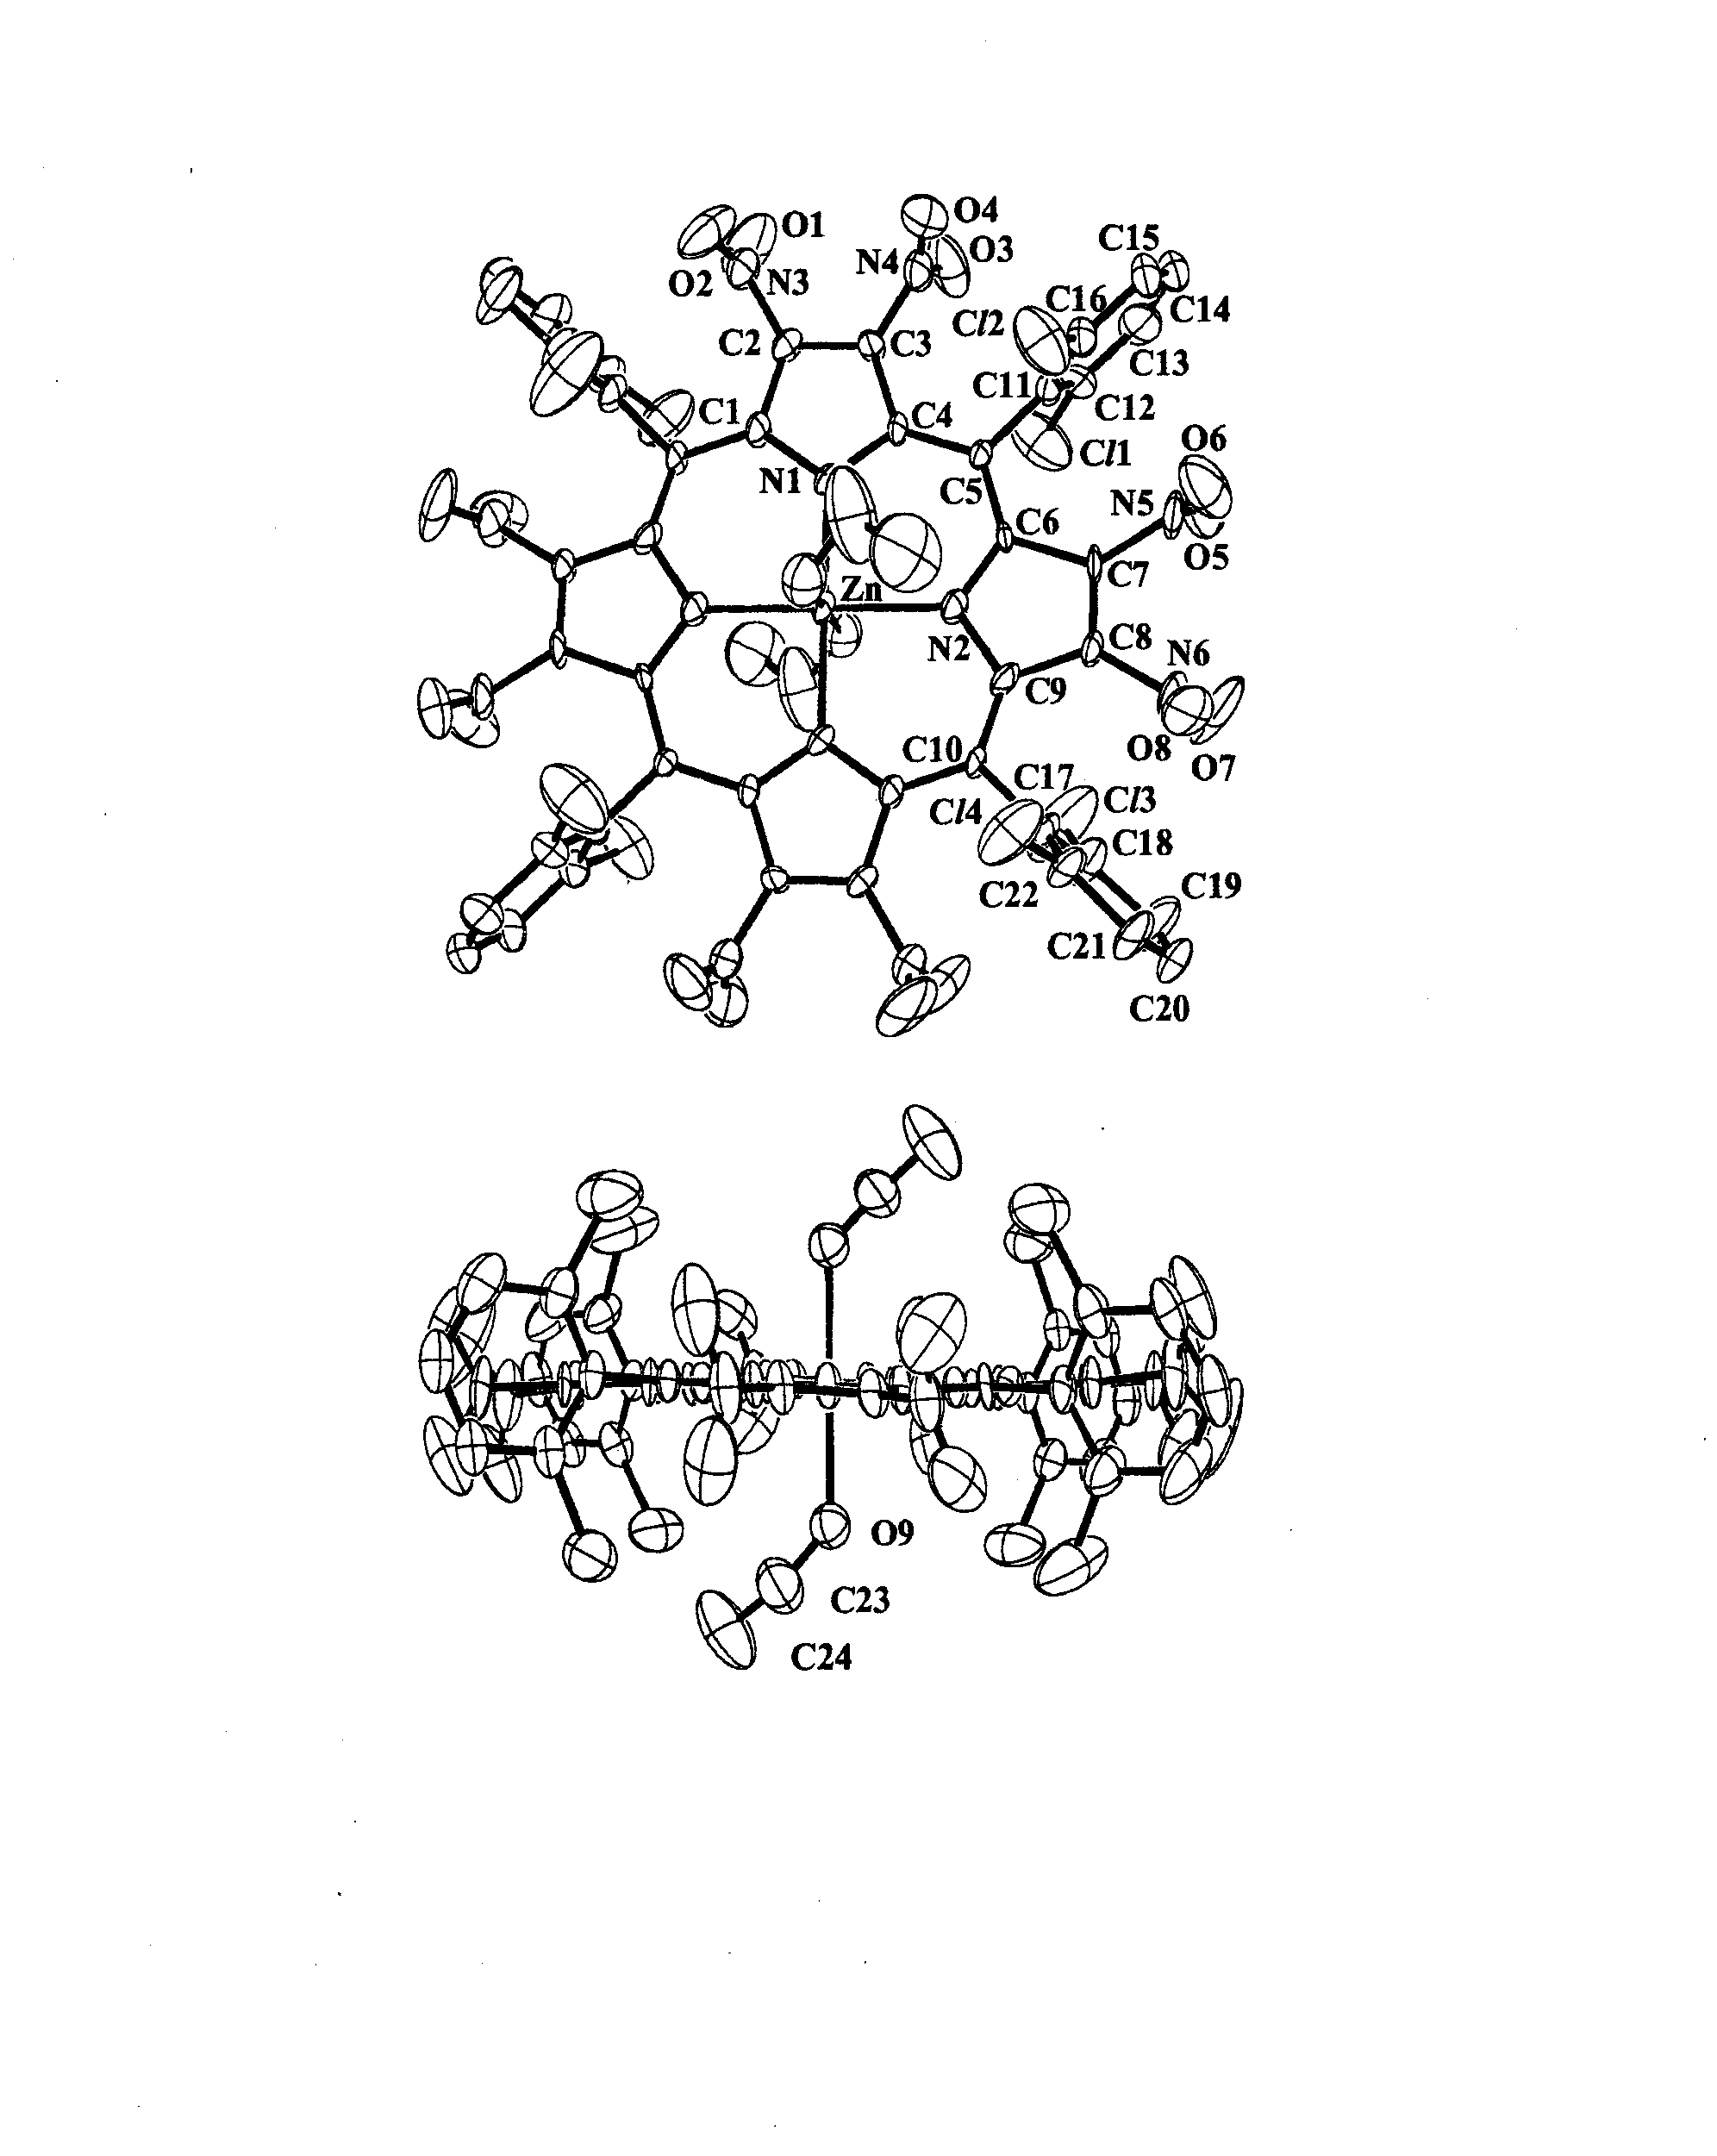
Fig. S1 Molecular structure and atomic labelling for Zn(TDCPN₈P)(EtOH)₂
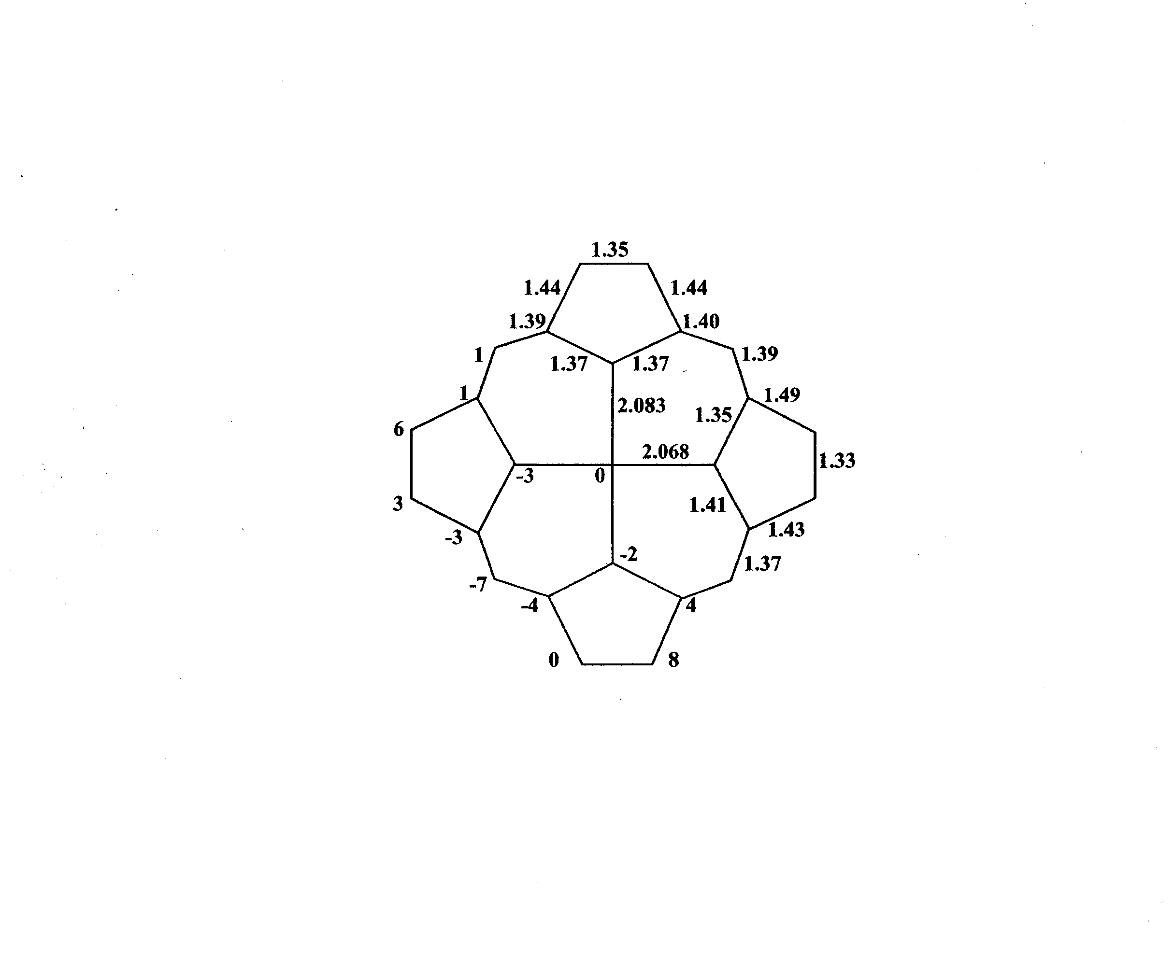

Fig. S2 Bond distances in angstroms, and displacements from the plane of the 24-atom porphyrin core, in units of 0.01 angstroms

