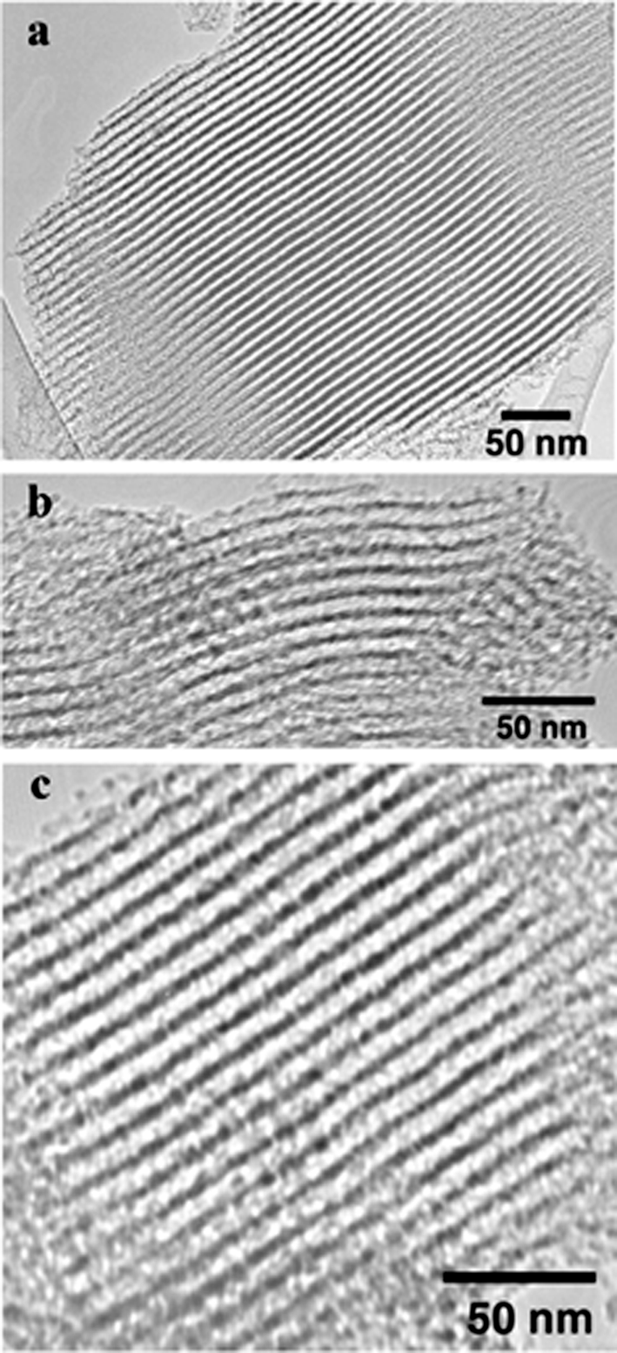

TEM images for calcined mesoporous silica prepared using P123 surfactant species and TMOS in the presence of fluoride at pH (a) 2.0, (b) 5.7 and (c) 9.0. The images were acquired with a 2000 FX JEOL instrument operating at 200 kV.

