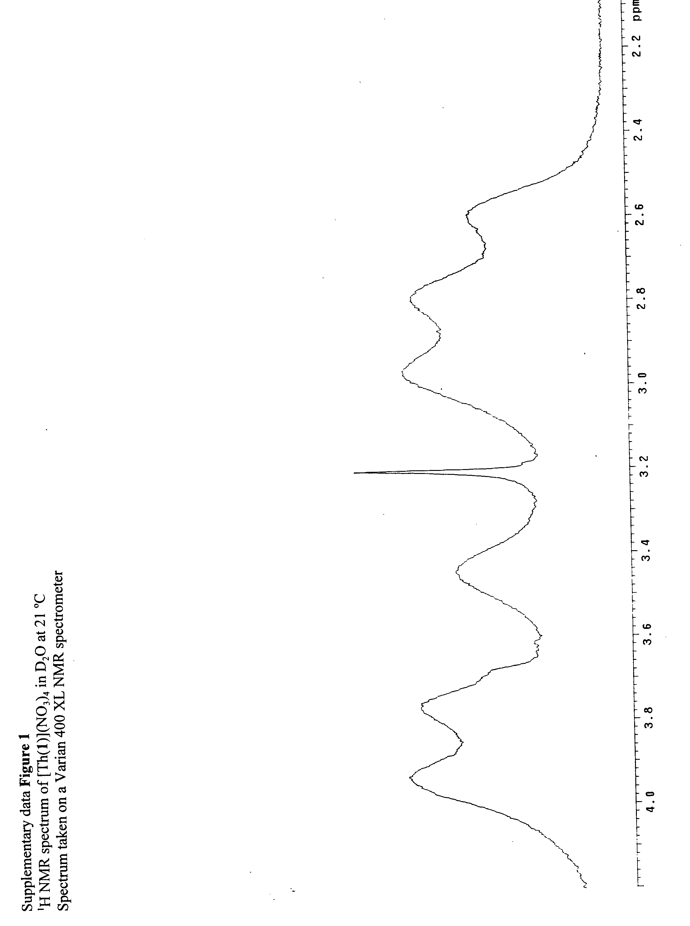Supplementary data for: Harnessing Thorium(IV) as a catalyst: RNA and phosphate diester cleavage by a thorium(IV) macrocyclic complex. C. Wang, S. Choudhary, C.B. Vink, E. Scord and J.R. Morrow



