ESI-MS spectrum of 1 in methanol/dichloromethane and elemental analysis results.

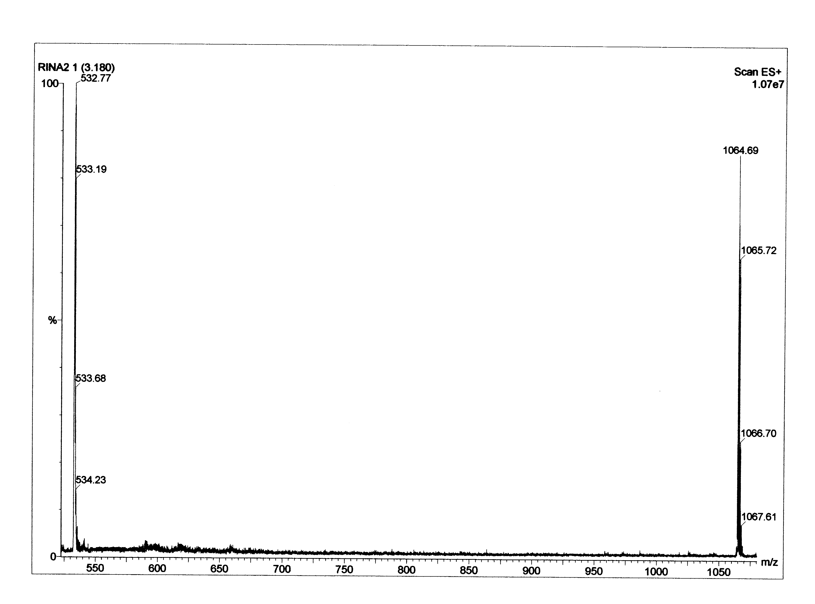
Found: C, 72.45, H, 5.54, N, 12.09. C₆₄H₅₇N₉O₇ requires C, 72.23; H, 5.40; N, 11.85%.

