¹H NMR spectrum (400 MHz) of 2 mM [1]₈-Kpic in CDCl₃ at –10°C
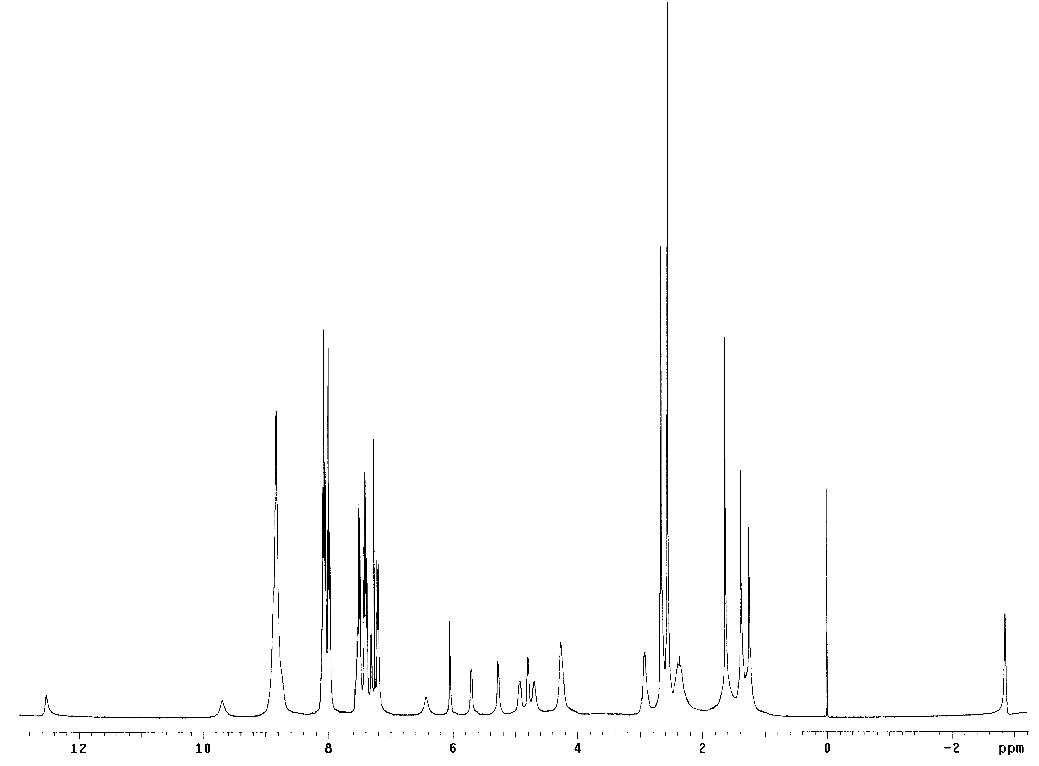

N(1)-H

N(2)-H bonded
H8

N(2)-H free
H1’

