1. 1,5-Diazidonaphthalene (1)

There are three isomers for 1. The computational results of three isomers obtained at the B3LYP/6-31G* level were shown below. The calculated and observed FT-IR spectra indicated that the most stable isomer(1) would be a dominant species in the matrix.

Optimized geometries and energies of three isomers of 1 calculated at the B3LYP/6-31G* level. Bond lengths in angstroms. Energies in hartrees.

Table. Energiesª of three isomers of 1 estimated at the B3LYP/6-31G* level.

HF ZPEª ΔE / kcal·mol⁻¹
Isomer(1) -713.070543 0.150960 0.0
Isomer(2) -713.064323 0.150853 +3.8
Isomer(3) -713.057615 0.150662 +7.9

ªZero-point energies estimated at the UB3LYP/6-31G* level (scaled by 0.9806).

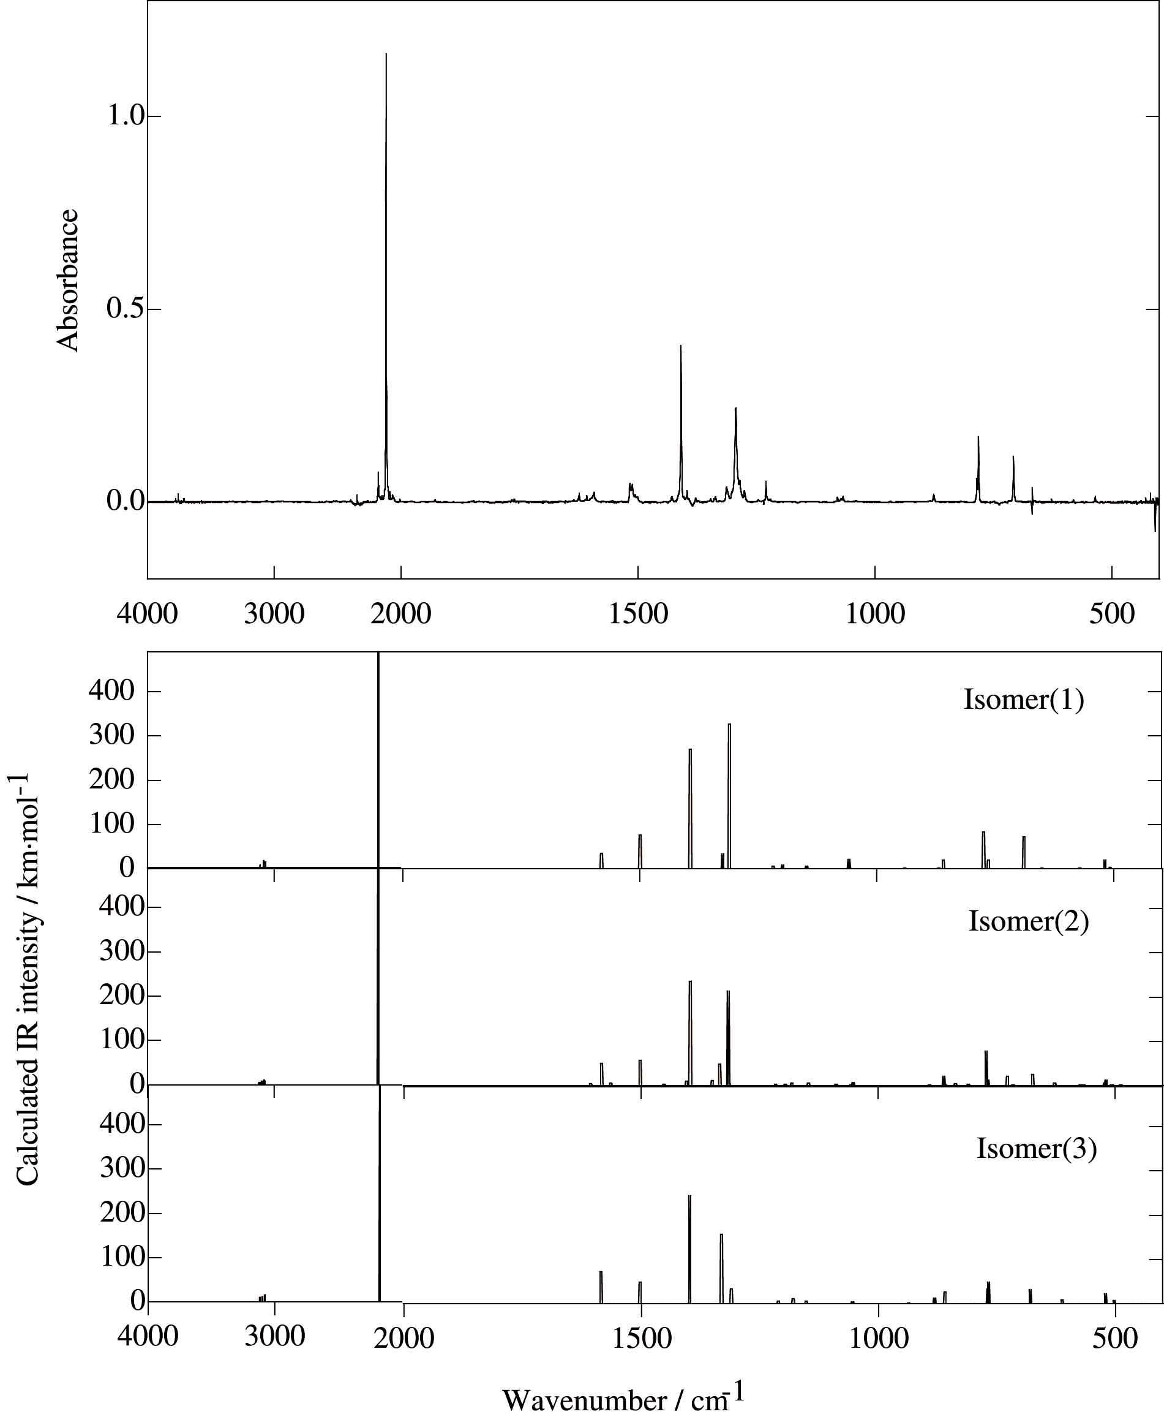

Figure. Observed FT-IR spectra of 1 in an argon matirx at 11 K and the theoretical IR spectra of three isomers of 1 calculated at the B3LYP/6-31G* level.
Table. Observed and calculated IR data of 1.
Isomer(1) Isomer(2) Isomer(3) Obs.
ν / cm⁻¹ I / km·mol⁻¹ ν / cm⁻¹ I / km·mol⁻¹ ν / cm⁻¹ I / km·mol⁻¹ ν / cm⁻¹
502.3 7.5
518.4 19.3 519.4 13.4 520.4 23.3 535
521.7 5.9
627.7 5.6 611.9 8.7
690.0 72.4 673.7 26.0 679.2 32.2 707
727.6 20.6
765.0 20.0 767.8 13.4 767.0 49.5
774.5 83.4 771.9 78.2 769.2 34.0 781
859.7 19.2 861.5 20.9 859.9 27.1 876
881.3 13.3
1059.2 20.5 1052.6 6.9 1054.2 5.4 1067, 1079
1148.4 5.1 1146.7 5.5 1152.2 6.1
1198.9 8.7 1182.3 5.4 1179.4 11.4
1218.7 5.7 1211.1 6.1
1314.7 6.7 1309.9 33.9
1311.2 326.9 1316.3 213.7 1330.7 157.4 1294
1325.4 33.1 1333.8 48.5 1313
1350.0 11.6
1393.6 270.4 1396.4 235.7 1398.2 244.3 1409
1404.5 9.5
1499.4 76.9 1501.7 57.5 1503.1 48.4 1516, 1512
1563.7 5.3
1580.6 34.3 1583.1 50.9 1584.7 71.9 1593
2176.3 1928.9 2173.1 881.0 2174.1 1273.5 2116, 2177
2180.7 678.5
3069.5 16.0 3071.4 7.1
3078.3 10.6 3080.5 15.2
3083.7 18.0 3085.6 8.2
3097.7 7.6 3100.5 12.0
3109.2 7.9 3119.3 5.2 3118.8 9.8
The IR bands with intensity > 5 km·mol⁻¹ are listed.
2. 1-Azido-5-nitrenonaphthalene (2)

There are two isomers for 2. The computational results of two isomers obtained at the UB3LYP/6-31G* level were shown below. The calculated and observed FT-IR spectra indicated that the most stable isomer(1) would be a dominant species in the matrix.

Optimized geometries and energies of three isomers of 1 calculated at the B3LYP/6-31G* level. Bond lengths in angstroms. Energies in hartrees.

Figure. Observed FT-IR spectra of 1 in an argon matirx at 11 K and the theoretical IR spectra of three isomers of 1 calculated at the B3LYP/6-31G* level.
Table. Observed and calculated IR data of 1.
Isomer(1) Isomer(2) Obs.
ν / cm⁻¹ I / km·mol⁻¹ ν / cm⁻¹ I / km·mol⁻¹ ν / cm⁻¹
517.6 10.6 517.2 11.8
588.2 10.1
677.5 8.8
725.8 15.0 698.0 10.2
762.5 78.6 760.8 26.9 769
763.4 9.9 761.6 43.1 783
800.2 7.4
892.8 14.3 893.2 8.5 911
898.0 9.3
1044.4 9.0
1127.5 8.3 1132.5 9.8 1158
1187.3 11.4 1171.7 12.9 1135, 1140
1204.1 7.2
1248.4 14.6 1247.1 16.0 1259
1283.5 20.2 1271
1317.7 179.8 1324.7 34.3 1292
1338.8 60.1 1348.0 92.2 1300, 1310
1354.1 8.7 1354
1393.4 12.0
1428.0 53.7 1424.9 48.8 1438, 1446
1472.7 12.5 1467
1543.1 69.1 1540.2 46.3 1558
1580.9 11.6 1580.7 35.0
2180.6 923.0 2173.4 642.2 2122
3071.0 6.6
3074.2 7.9 3079.4 7.2
3084.5 7.0 3101.6 8.0
3099.7 8.1
The IR bands with intensity > 6 km·mol⁻¹
3. 1,5-Dinitrenonaphthalene (3)

As described in the main text, the state order in the dinitrene is difficult to reproduce. The results obtained at several computational levels were listed below. The computation at the CAS(6,6)/6-31G* // UB3LYP/6-31G* level gave the wrong state order. The geometry optimized using CAS method gave the enhanced bond alternation.

Table. Relative energiesª of dinitrene 3 with different spin multiplicities estimated by several computational methods.

UB3LYP/6-31G* CCSD(T)/6-31G*
// UB3LYP/6-31G*
Energyª <S²> Energyª <S²>
(Singlet)^{b} +41.4 kcal·mol⁻¹ 0.00
Quintet +8.0 kcal·mol⁻¹ 6.06 +22.0 kcal·mol⁻¹ 6.66
Triplet +6.3 kcal·mol⁻¹ 2.03 +16.3 kcal·mol⁻¹ 3.07
Singlet -494.025716^{c} 1.78 -492.506586 0.00

CAS(6,6)/6-31G* CAS(6,6)/6-31G* CASMP2(6,6)/6-31G*
// UB3LYP/6-31G* // CAS(6,6)/6-31G* // CAS(6,6)/6-31G*
Quintet +10.4 kcal·mol⁻¹ +12.2 kcal·mol⁻¹ +4.6 kcal·mol⁻¹
Triplet -7.6 kcal·mol⁻¹ +0.3 kcal·mol⁻¹ +0.4 kcal·mol⁻¹
Singlet -490.985133 -491.002923 -490.985133

ªEnergies were corrected by zero-point energies estimated at the UB3LYP/6-31G* level (scaled by 0.9806).
^{c} Estimated by the spin-restricted method.
^{c} Estimated by the symmetry-broken spin-unrestricted method without sum correction.
Optimized geometries and energies of three isomers of 1 calculated at the B3LYP/6-31G* level. And at the CAS(6,6)/6-31G* level. Bond lengths in angstroms. Energies in hartrees.

Figure. Observed IR spectra of 3 in an argon matrix at 11K and theoretical IR spectra of 1,5-dinitrenonaphthalene with different spin multiplicities.

Table. Observed and calculated IR data of 3.
UB3LYP/6-31G* CASSCF(6,6)/6-31G*ª Obs.
ν / cm⁻¹ I / km·mol⁻¹ ν / cm⁻¹ ν / cm⁻¹ ν / cm⁻¹ I / km·mol⁻¹ ν / cm⁻¹ UB3LYP/6-31G* CAS(6,6)/6-31G* Obs
Au 451.3 5.0 441.3
Bu 483.4 54.7 540.9 507
Bu 503.1 14.8 551.9
Au 742.0 82.9 781.0 750
Bu 751.8 19.3 827.0
Bu 908.3 20.5 983.7 1033
Bu 1036.6 19.3 1092.2 1161
Bu 1148.2 26.1 1275.5 1212
Bu 1246.9 33.0 1435.5 1279
Bu 1376.4 12.4 1548.6 1393
Bu 1436.6 32.9 1737.8
Bu 1479.7 24.4 1810.8 1466
Bu 1529.4 5.2 1889.6 1506
Bu 3076.7 15.6 3376.5
Bu 3106.9 12.3 3404.4
The IR bands with intensity > 5 km·mol⁻¹ are listed. ª IR intensities could not obtained by CASSCF calculation using Gaussian98.
4. ESR measutment

ESR spectra were measured on a JEOL JES-RE3X spectrometer equipped with an optical transmission cavity equipped with Air Products LTD-3 liquid helium transfer system. All measurements were carried out at 78 K.
Diazido precursor was dissolved in purified 1-methyltetrahydrofuran. The solution (4.6 mM) was placed within a quartz 4mm o.d. ESR sample tube and degassed by freeze-pump-thaw cycles. The sample set to the cavity at 78K was irradiated with an USHIO UI-501C xenon lamp through Toshiba UV-D36B band-pass filter (360 < λ < 380 nm).
Observed spectrum is shown below. Signals at 622 and 611 mT were ascribed to triplet mononitrenes. Signals ascribable to a dinitrene with higher spin multiplicity were not observed. The reason for absence can be explained as follows: since the ground state of 1,5-dinitrenonaphthalene was a singlet diradical and it has a large ΔE_{S–T}, the population of the thermally-excited triplet state is too low to detect. To consider this interpretation, we theoretically estimated the relative energies of 2,7-dinitrenophenanthrene 5 whose nitreno groups are connected to rigid aromatic hydrocarbons. This dinitrene showed the highest ΔE_{S–T} value (0.93 kcal·mol⁻¹)³ among the investigated quinonoidal dinitrenes¹: the ΔE_{S–T} value obtained experimentally by the temperature-dependent ESR study. The predicted ΔE_{S–T} value of 5 (5.7 kcal·mol⁻¹) is smaller than that of 3 (6.3 kcal·mol⁻¹) at the same computational level (see ESI). The observed ESR signals due to the thermally excited triplet state were quite weak even for 5.³
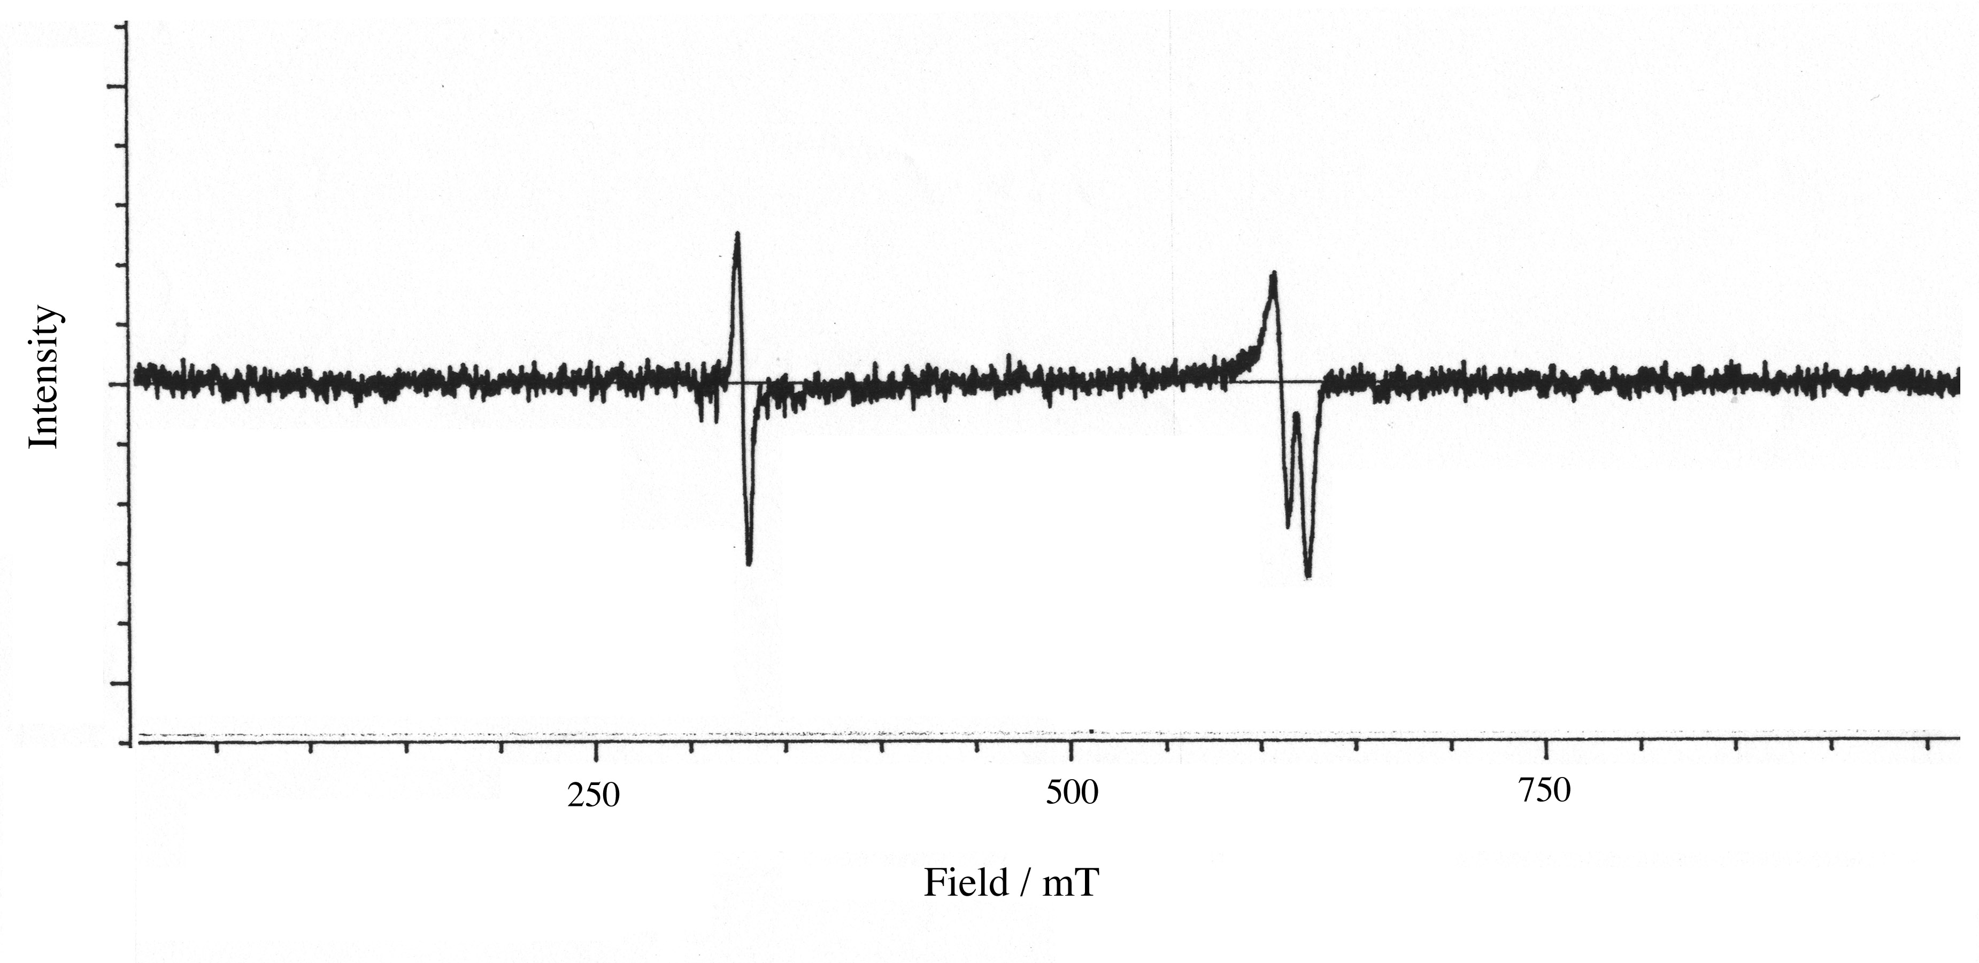

Figure. The ESR spectra of 3 in a glassy MTHF matrix observed upon irradiation with a xenon lamp through a band-pass filter (360 < λ < 380 nm) for 15 min.
5. Computational study of the dinitrenes

In the quinonoidal dinitrenes, the ground state is the singlet diradical state which lies slightly below the triplet state: their energy gaps between singlet and triplet states (ΔE_{S-T}) are rather small (<1 kcal·mol⁻¹). The state order of the dinitrene with different spin multiplicities was often difficult to reproduce in the computational study because of the multireference character of singlet diradicals. However, calculations using the symmetry-broken spin-unrestricted DFT (UDFT) method could give the correct state order as reported by Lahti et al.(J. Phys. Chem. A., 2001, 105, 251.) These results suggest that the UDFT method can describe successfully the electronic state of singlet diradicals. A major drawback of the UDFT method for treating diradicals is that the singlet state can be highly spin-contaminated. Indeed, the UDFT solution for 3 showed the <S²> value of 1.78, indicating the admixure of the triplet and quintet states, and showed relatively large deviations in the wavenumbers in IR bands. However, the spectral features of observed IR spectra were qualitatively reproduced by the UDFT computation. If almost the same amount of spin contamination is shown in two different systems, the estimated ΔE_{S-T} values could be compared qualitatively. In the literature by Lahti et al., dinitrenobiphenyl (bpn) and dinitrenostylbene (stn) showed <S²> values of 1.61 and 1.51, respectively. The experimental ΔE_{S-T} values of bpn and stn were 0.75 and 0.47, respectively (J. Am. Chem. Soc., 1997, 119, 2187.), whereas the predicted ΔE_{S-T} values were 3.2 and 2.7, respectively. Although only one example is available, it seems that the UDFT method may qualitatively predict the relative ΔE_{S-T} values for dinitrenes despite of the overestimation.
To consider the interpretation of ΔE_{S-T} of the dinitrene 3, we compared the theoretically-estimated energies of 3 in different spin multiplicities with those of two other quinonoidal dinitrenes, 1,4-dinitrenobenzene 4 and 2,7-dinitrenophenanthrene 5, whose nitreno groups are connected to rigid aromatic hydrocarbons. The obtained results are summarized in the following table.

Table. Relative energiesª of 3, 4, and 5 with different spin multiplicities estimated at the UB3LYP/6-31G* level.
3 4
Quintet +8.0 kcal·mol⁻¹ <S²>=6.06 +33.1 kcal·mol⁻¹ <S²>=6.02
Triplet +6.3 kcal·mol⁻¹ <S²>=2.03 +1.5 kcal·mol⁻¹ <S²>=2.02
Singlet^{b} -493.768975 <S²>=1.78 -340.317779 <S²>=1.11

5
Quintet +7.5 kcal·mol⁻¹ <S²>=6.07
Triplet +5.7 kcal·mol⁻¹ <S²>=2.03
Singlet ^{b} -647.665910 <S²>=1.79
ªAll energies were corrected by zero-point energies estimated at the UB3LYP/6-31G* level (scaled by 0.9806).
^{b} Estimated by the symmetry-broken spin-unrestricted method without sum correction.

Among the three, 3 and 5 showed the similar spin contamination. Therefore, the experimental results are discussed from these computational results. The dinitrene 5 showed the highest ΔE_{S–T} value (0.93 kcal·mol⁻¹)³ among the investigated quinonoidal dinitrenes.¹ The predicted ΔE_{S–T} value of 5 (5.7 kcal·mol⁻¹) is smaller than that of 3 (6.3 kcal·mol⁻¹). This computational results suggested that 3 would show the high ΔE_{S–T} value as well as 5.
The difference in the ΔE_{S–T} values of 1,5-dinitrenonaphthalene 3, 1,4-dinitrenobenzene 4, and 2,7-dinitrenophenanthrene 5 could be explained on the basis of the spin distributions that were estimated by the unrestricted method (UB3LYP/6-31G* level). Atomic spin density values of 3, 4, and 5 are depicted in Figure. In all compounds, the spin densities on nitrogen atoms are more than 1.00, which reveals the spin alignment due to the one-center interaction between σ and π electrons of a nitrogen atom. The spin densities of nitrogen atoms in 3, 4, and 5 are in order of 5 > 3 > 4, which is different from the order in the ΔE_{S–T} values (3 > 5 > 4). Whereas spin densities on the carbon atom adjacent to nitrogen atoms (underlined) in 3, 4, and 5 are in the same order as that in the ΔE_{S–T} values. This value would reflect two polarization effects: (1) polarization effect from the radical center on the adjacent nitrogen atom. (2) polarization effect from the other radical center through aromatic system. The latter effect would be lager in 3 than in 5, which resulted in the change of the order. Indeed, the larger spin polarization (0.3248) was observed for 3 on the central carbon atoms in the naphthalene framework in comparison with that for 4 (0.1846) and 5 (0.2604) (Figure). These results suggested that the larger spin polarization on the aromatic system, in particular, on the atoms on the pathway connecting two radical centers, enhanced the stability of the singlet state of 3.

Figure. Atomic spin density values of 3, 4, and 5 estimated
at the UB3LYP/6-31G* level.

