Supplementary Information

Repeating unit of schizophyllan

Method
We examined five poly(dA) samples with different base lengths (X_{b}) ; X_{b} = 18, 30, 45, 60 and about 250. The molecular weight of s-SPG was 1.5×10⁵, i.e., 231 repeating units. A mixture of poly(dA) and s-SPG was prepared by adding a DMSO solution of s-SPG to an aqueous solution of poly(dA). Final concentrations of poly(dA) and s-SPG were 2.2 or 5.3×10⁻³ g/dL and 2.2 or 5.0×10⁻² g/dL depending on the thickness of the cell, respectively. The volume fraction of water in the mixture was 0.91 for all samples. Before measurements, all samples were annealed at 5 ºC for 4 days. CD and ultraviolet absorbance spectra at 185-300 nm region were measured in the temperature range of 0-90 ºC on a Jasco J-720WI spectropolarimeter and a Jasco V-570 UV/VIS/NIR spectrophotometer, respectively. When the CD spectra in the 180-240 nm region were measured, DMSO was removed from the mixture by dialysis to improve signal/noise.

Fig.S1 An evidence to show that there is no interaction between dextran and poly(dA), obtained in gel electrophoresis. An excess amount of dextran we added to the poly(dA) solution, as being similar to s-SPG system. Electrophoresis was carried out for 3 h at 3 V cm⁻¹ at 10 ºC in 3.5 wt % NuSieve agarose gel (FMC Bioproducts) and the migrants were stained with Gel Star Nucleic Acid Stainer (FMC Bioproducts).

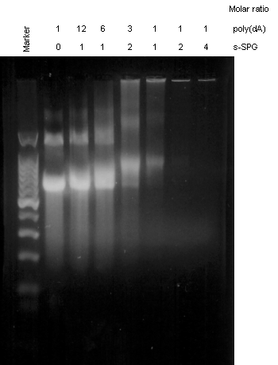

Fig.S2 Stoichiometry is determined from the electrophoresis for the complex of s-SPG and poly(dA). Electrophoresis was carried out for 3 h at 3 V cm⁻¹ at 10 ºC in 3.5 wt % NuSieve agarose gel (FMC Bioproducts) and the migrants were stained with Gel Star Nucleic Acid Stainer (FMC Bioproducts).

