SUPPLEMENTARY MATERIAL

1,1’-Bis(trimethylsilylseleno)ferrocene in Cluster Synthesis: A Redox Active Surface on a Copper-Selenide Core

Andrew I. Wallbank and John F. Corrigan*
Department of Chemistry
The University of Western Ontario
London, Ontario
N6A 5B7 Canada

Parameters for cyclic voltammetry:

Sweep rate: 100 mV/s

Electrolyte: [NBu₄][BF₄]
Solvent: THF

Sample concentration: 1 2.09 mM; 2 1.39 mM

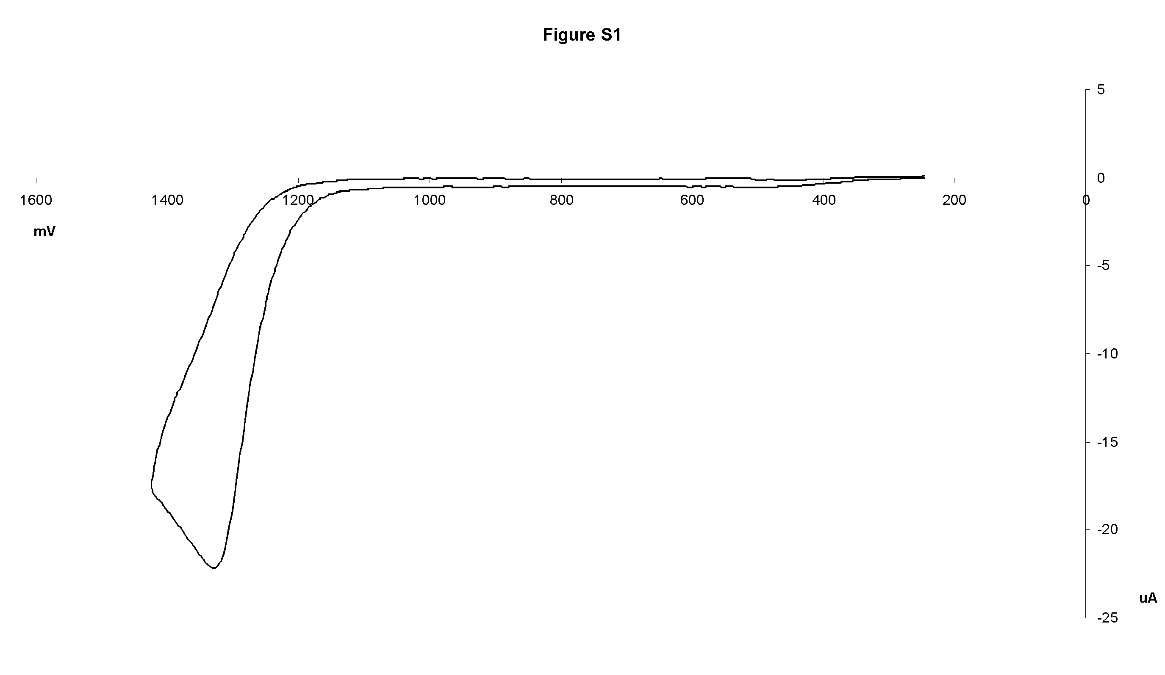

Figure S1: The cyclic voltammogram of 1 (versus CoCp₂/CoCp₂⁺).
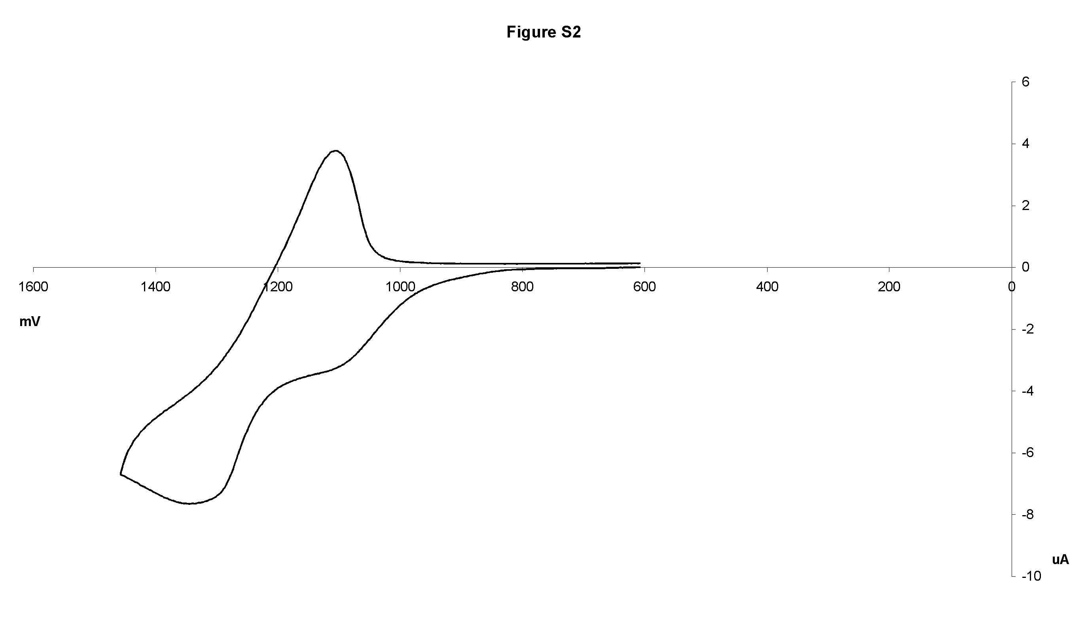

Figure S2: The cyclic voltammogram of 2 (versus CoCp₂/CoCp₂⁺).

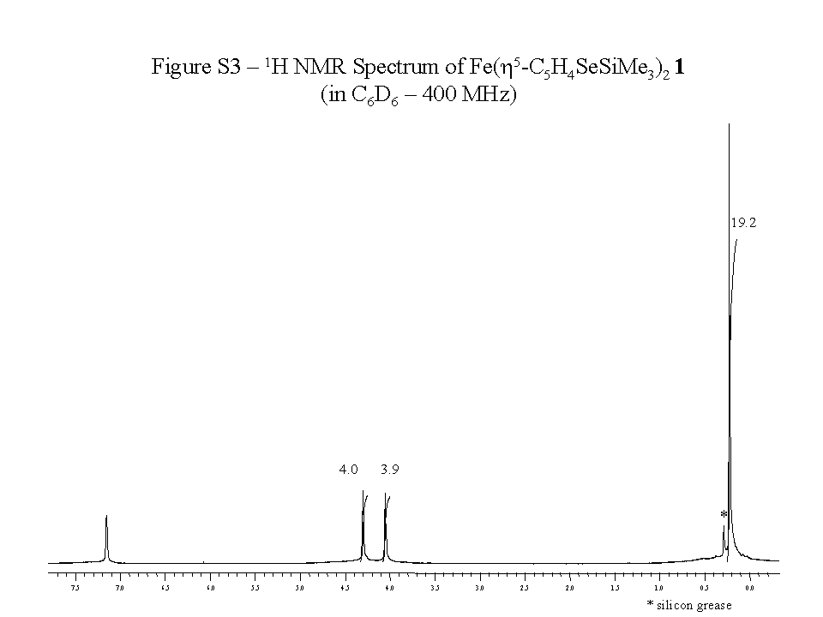

Figure S3: ¹H NMR spectrum of 1 in C₆D₆ at 400 MHz.

