Time decay of the merocyanine absorption. The spectrum is the difference in the IR absorption before and after irradiation of crystals of 1’-(n-propyl)-3’,3’-dimethyl-6-nitrospiro[2H-[1]benzopyran-2,2’-indoline]

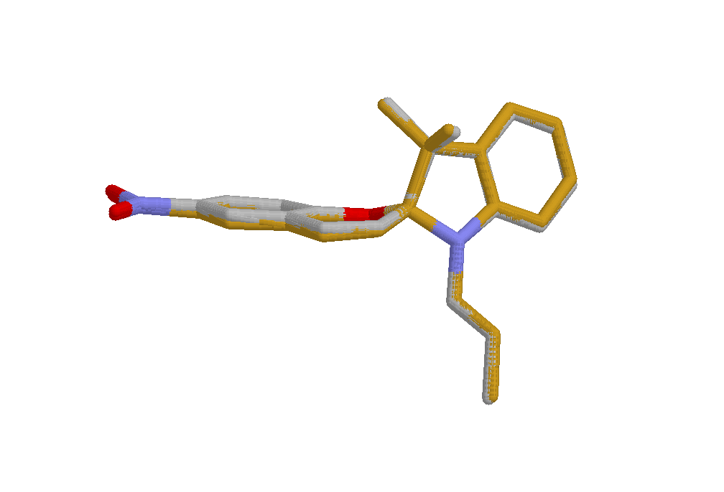

Overlay of the molecules 1_{(A)} and 1_{(B)} in the crystal. The molecules were treated as rigid bodies and the overlap between them was maximized.

The ratio between the effective volume of the two sites as a function of the radius of the rigid sphere in the Monte Carlo calculation.

