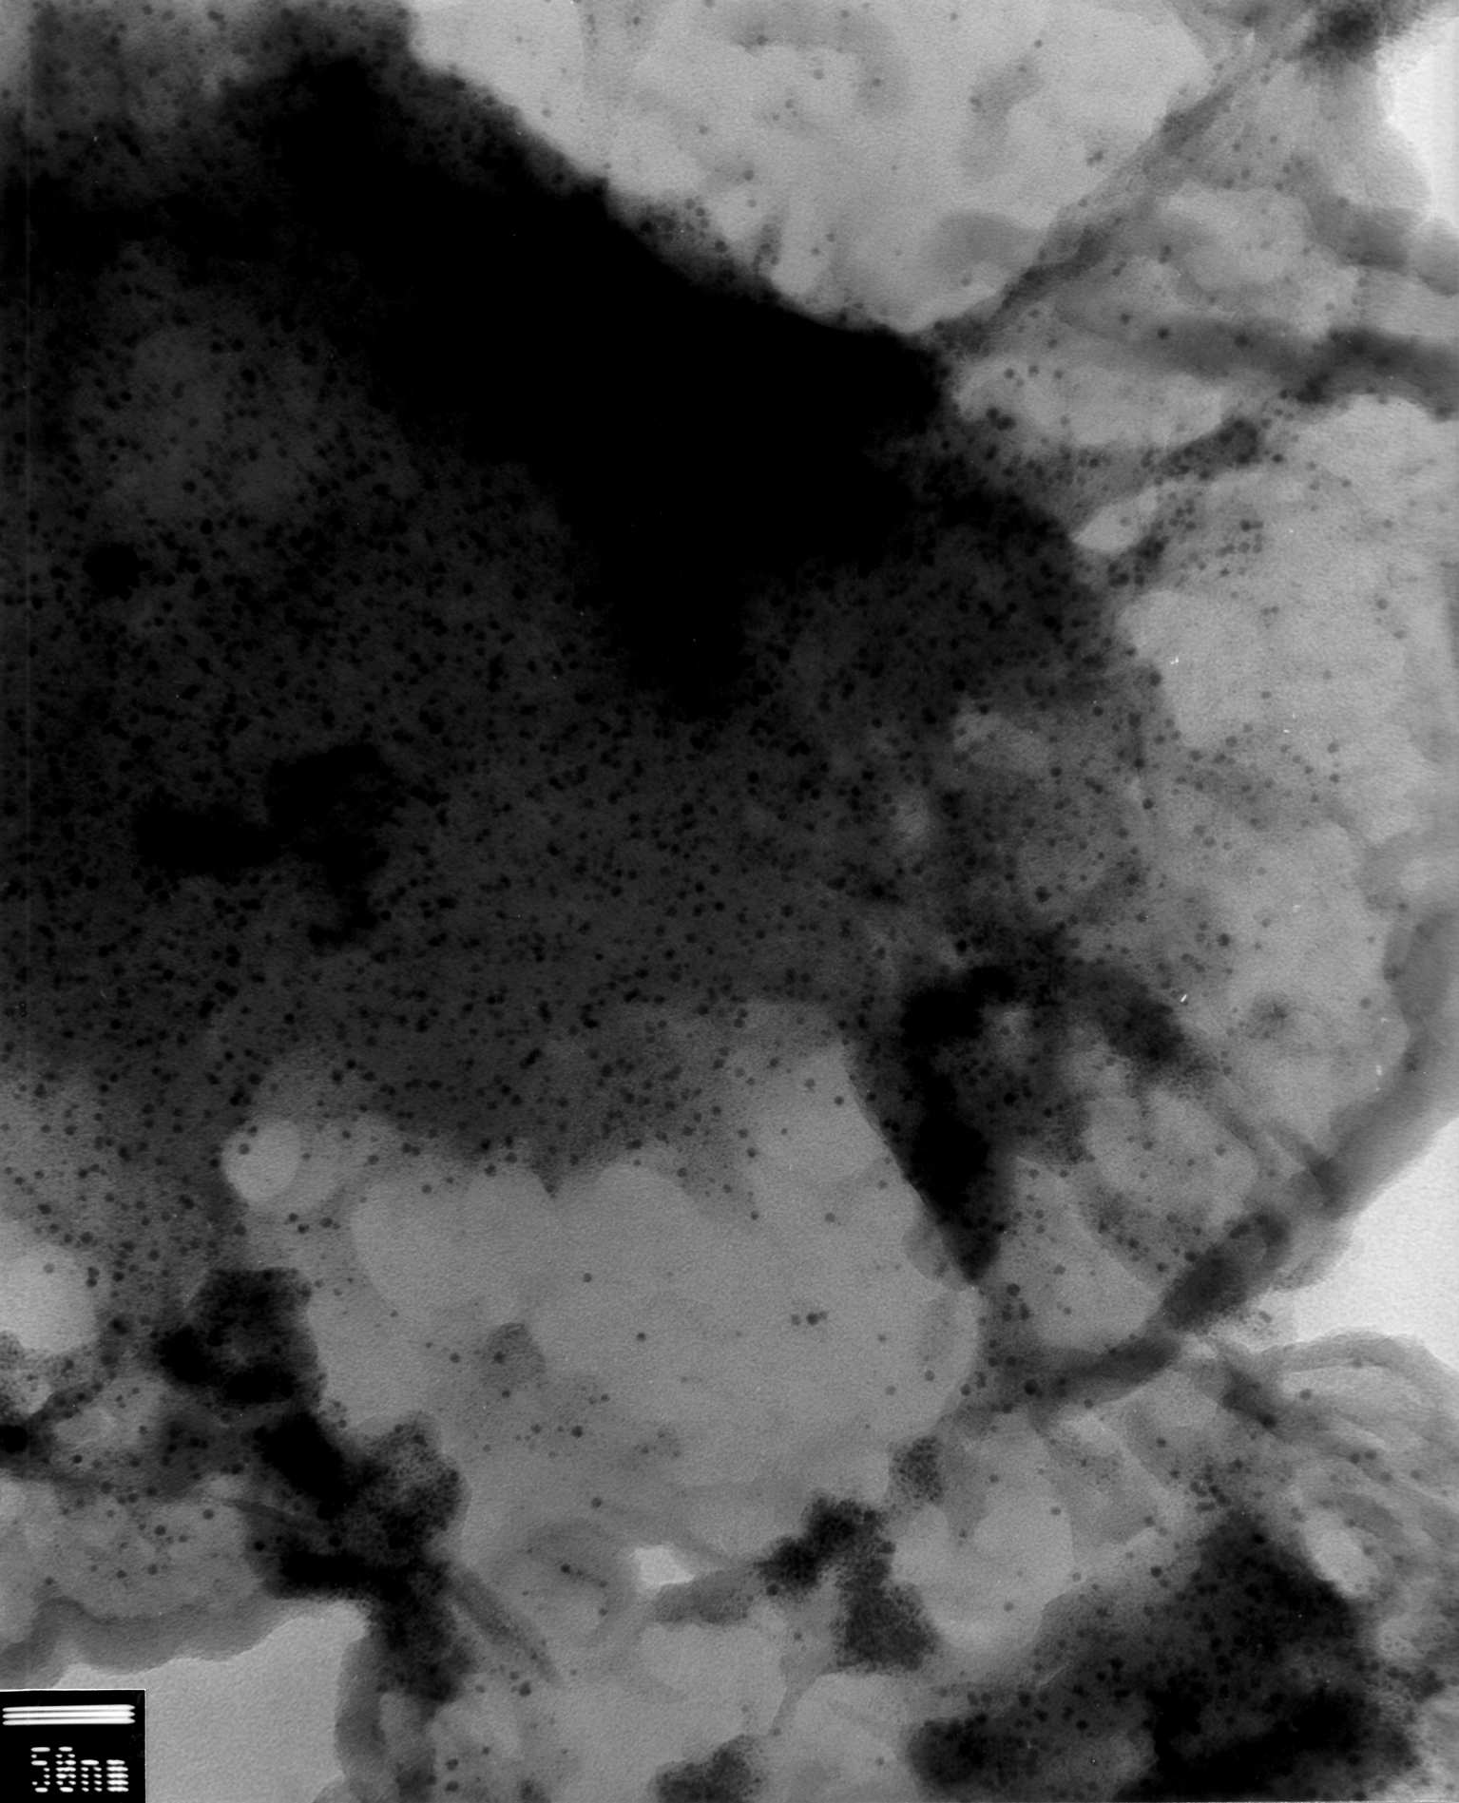

Fig. S5. TEM image of ^{A}3_{a}. Sample was prepared by depositing a suspension of the material in ethanol on a freshly cleaved mica plate followed after evaporation of the solvent by deposition of a carbon film which was extracted using a diluted HF solution and deposited on a grid.

