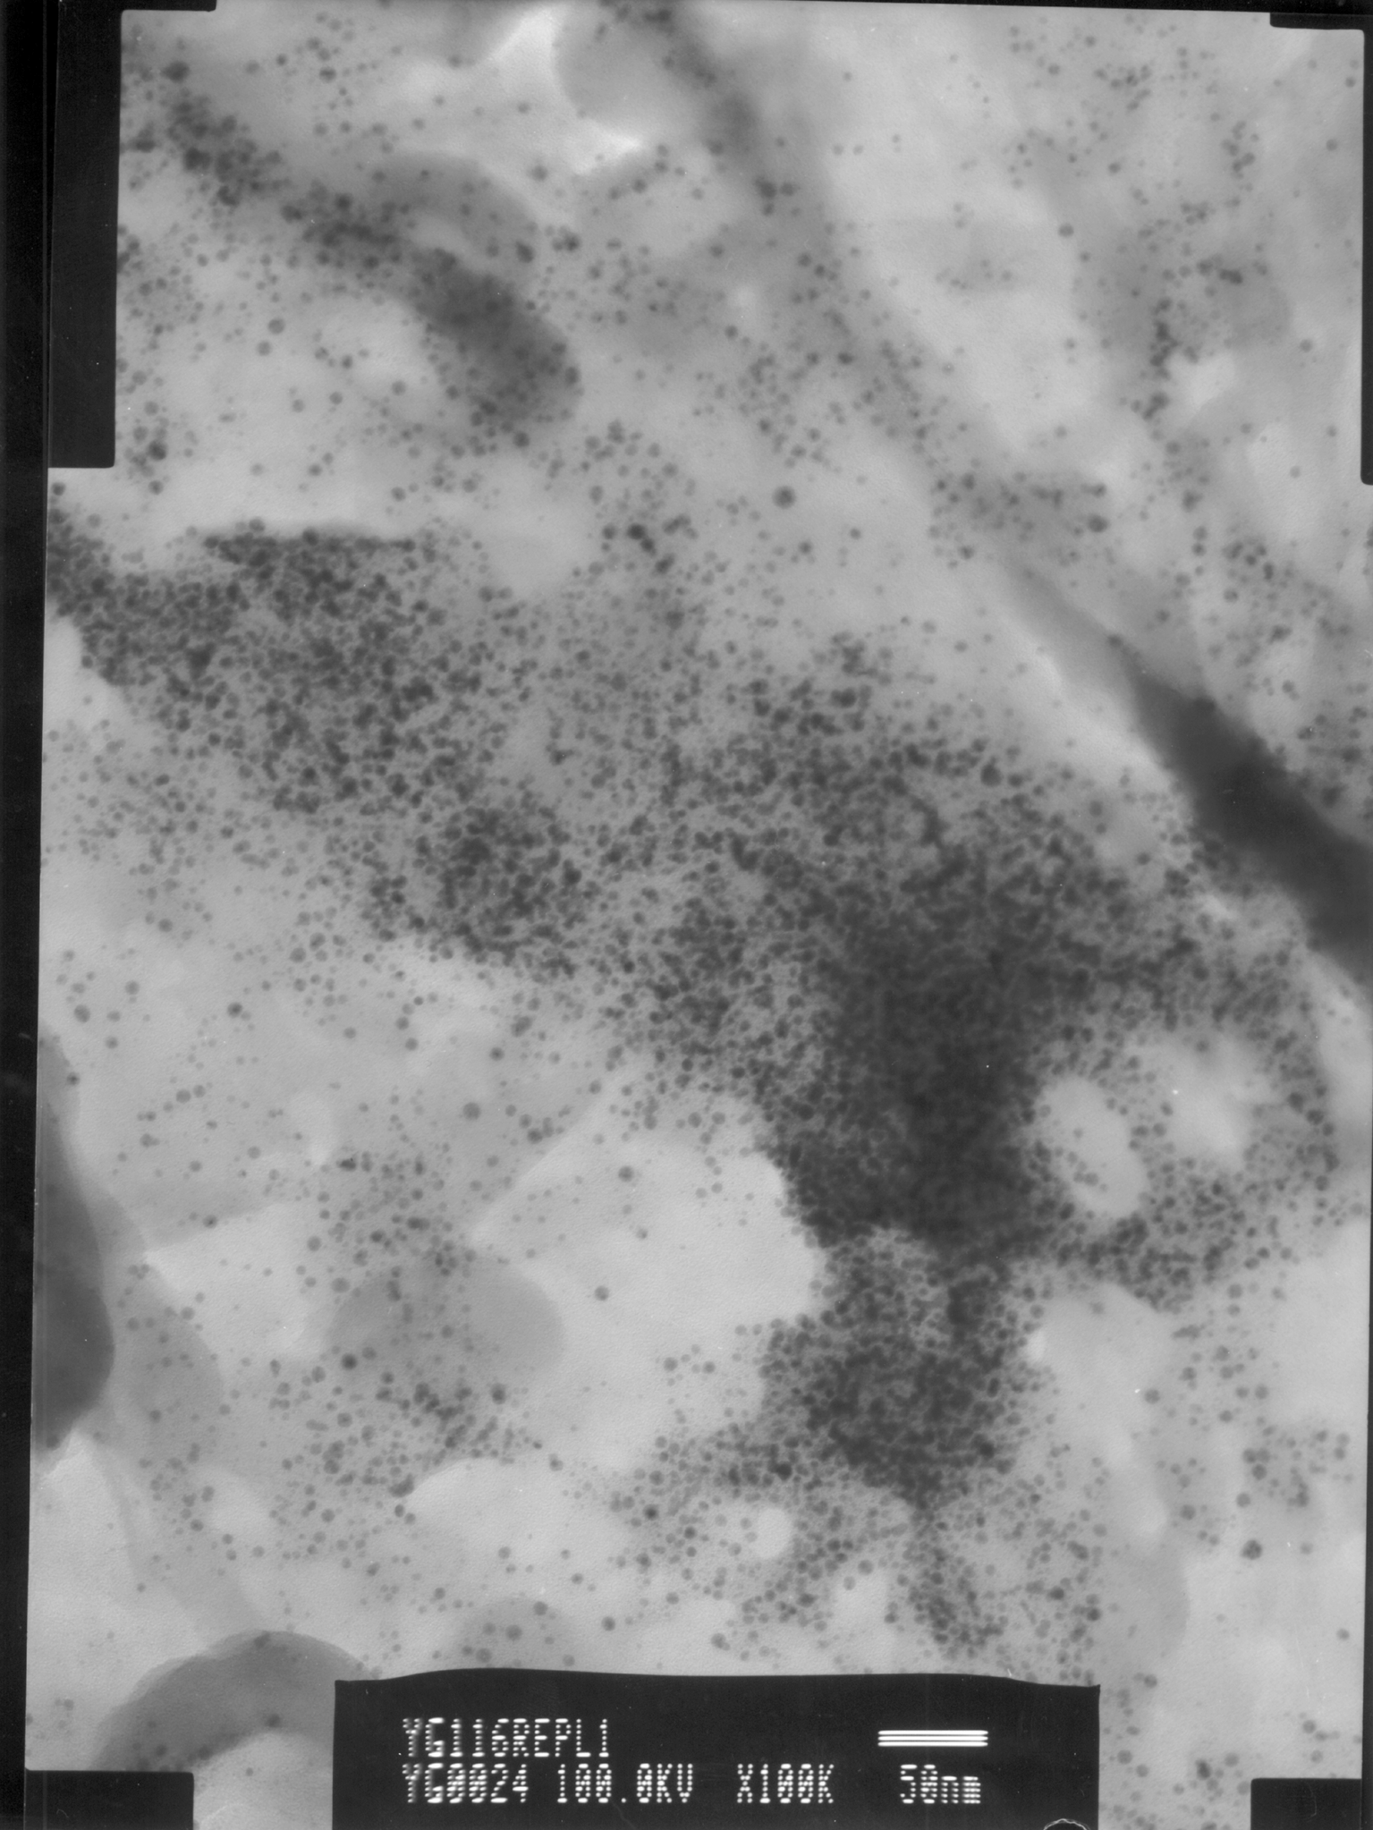

Fig. S6 TEM image of ^{B}3_{b}.

