Supplementary data

- Reagents and conditions for the synthesis of dendritic ligands and their characterisation:
(S,S)-1: ¹H NMR (CDCl₃, 300 MHz), δ: 7.340((d, J=8.7 Hz, 2H, C₆H₄), 7.167-6.786(m, 10H, PhH), 6.436(d, J=8.7 Hz, 2H, C₆H₄), 5.893(s, 1H, NH), 5.301(d, J=7.8 Hz, NH), 4.789(t, J=9.0 Hz, 1H, NCH), 4.496(t, J=8.4 Hz, 1H, NCH), 1.466(s, 9H, CH₃) ppm.
[α]²⁰_{D}= +13.0° (c=0.50, CH₂Cl₂);* [α]²⁰_{D}= -35.4° (c=0.60, C₂H₅OH).
API-ES MS: 506.2[M+K]⁺ (5), 490.3[M+Na]⁺ (60), 368.3[M-99 (Boc)]⁺ (100).

(S,S)-3: ¹H NMR (CDCl₃, 300 MHz), δ: 7.670(d, J=8.7 Hz, 2H, C₆H₄), 7.610(d, J=8.1 Hz, 2H, C₆H₄), 7.474-7.029(m, 22H, PhH and C₆H₃), 6.787(s, 1H, C₆H₃), 5.078(s, 4H, PhCH₂O), 4.613-4.607(m, 1H, NCH), 4.399-4.409(m, 1H, NCH) ppm.
[α]²⁰_{D}= +3.5° (c=0.15, CH₂Cl₂).*
ESI-HRMS: C₄₁H₃₇N₃O₅S (Cacld. 683.2454), Found 684.2429 [M+H]⁺.

(S,S)-4: ¹H NMR (CDCl₃, 300 MHz), δ: 7.592-7.314(m, 24H, C₆H₄, PhH), 7.159-7.119(m, 10H, PhH), 6.752-6.428(m, 9H, C₆H₃), 5.027, 5.012 (s×2, 12H, PhCH₂O ), 4.460-4.455(m, 1H, NCH), 4.228-4.400(m, 1H, NCH) ppm.
[α]²⁰_{D}= -25.2° (c=0.55, CH₂Cl₂); [φ]²⁰_{D}=280.
ESI-HRMS: C₆₉H₆₁N₃O₉S (Cacld. 1107.4129), Found 1108.4179 [M+H]⁺.

(S,S)-5: ¹H NMR (CDCl₃, 300 MHz), δ: 7.617-7.177(m, 54H, C₆H₄, PhH), 7.071-7.535(m, 21H, C₆H₃), 4.999-4.880(m, 28H, PhCH₂O ), 4.079-4.040(m, 2H, NCH) ppm.
[α]²⁰_{D}= -13.1° (c=0.50, CH₂Cl₂); [φ]²⁰_{D}=256.
ESI-HRMS: C₁₂₅H₁₀₉N₃O₁₇S (Cacld. 1955.7478), Found 1956.7929 [M+H]⁺.

(S,S)-6: ¹H NMR (CDCl₃, 400 MHz), δ: 7.417-7.180(m, 94H, C₆H₄, PhH), 7.807-6.483(m, 45H, C₆H₃), 5.072-4.818(m, 60H, PhCH₂O ) ppm, the two NCHs of DPEN are too small to be detected.
[α]²⁰_{D}= -6.6° (c=0.62, CH₂Cl₂); [φ]²⁰_{D}=243.
MS (MALDI-TOF): C₂₃₇H₂₀₅N₃O₃₃S (Cacld. 3652.42), Found 3692.01 [M+K]⁺, 3676.03 [M+Na]⁺.

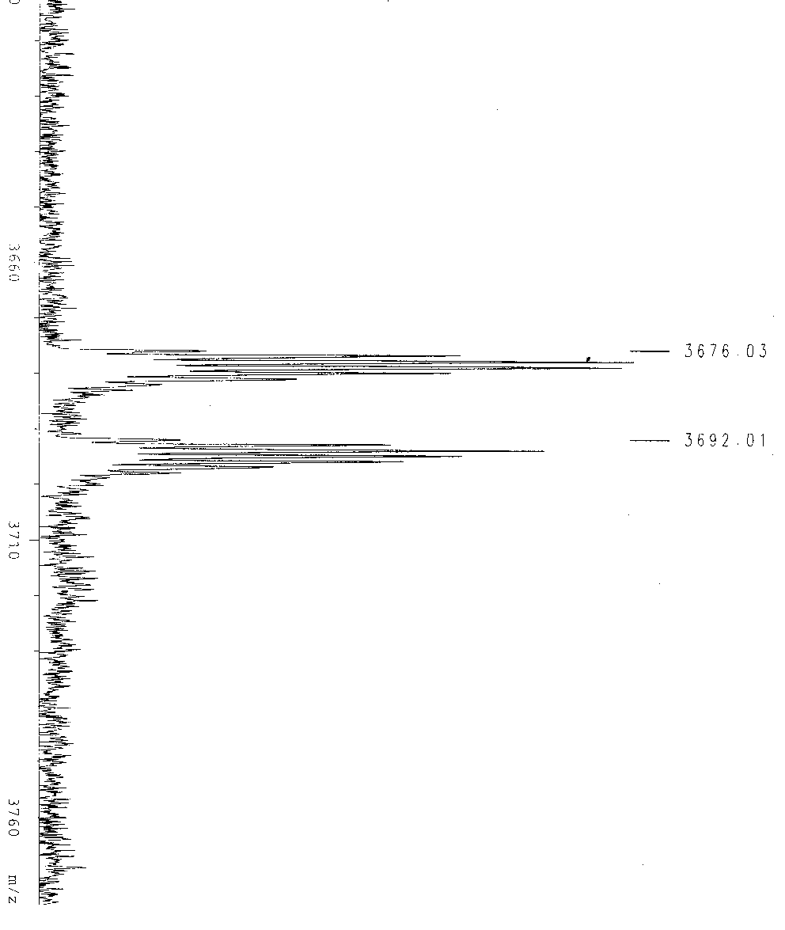
Fig. MALDI-TOF-MS spectrum of (S,S)-6.

* The sign of the specific rotation reverted from the second generation ligand (S,S)-4, also see: Tetrahedron Lett. 1998, 39, 3783, and references therein.
- General procedure for recycling reaction using Ru(S,S)-5 or Ru(S,S)-6 catslyst:
The first use: Dendritic ligand (0.0044 mmol), [RuCl₂(cymene)]₂ (0.002 mmol) and triethylamine (0.008 mmol) was stirred in dry DCM (0.2 mL) for 1 h under argon at 28°C. Then acetophenone (0.4 mmol) and formic acid/triethylamine azeotrope (0.2 mL) was added and the mixture was stirred at 28°C for 20h. (Caution: An outlet for the gases produced was important!). DCM was removed under reduced pressure and dry methanol (1.5 mL) was added. Centrifuged (1000 r/min) for 10 min and the solution was removed with syringe. The precipitated catalyst was washed with methanol (1 mL) and dried under vacuum.
The recycling use: DCM (0.2 mL), acetophenone (0.4 mmol) and formic acid/triethylamine azeotrope (0.2 mL) was added in turn to the recovered catalyst and the mixture was stirred at 28°C for the given time.

- Time-dependent conversion of acetophenone catalysed by dendritic catalysts

