Fig. 4 View of packing of [Pd(7)](BF₄)₂
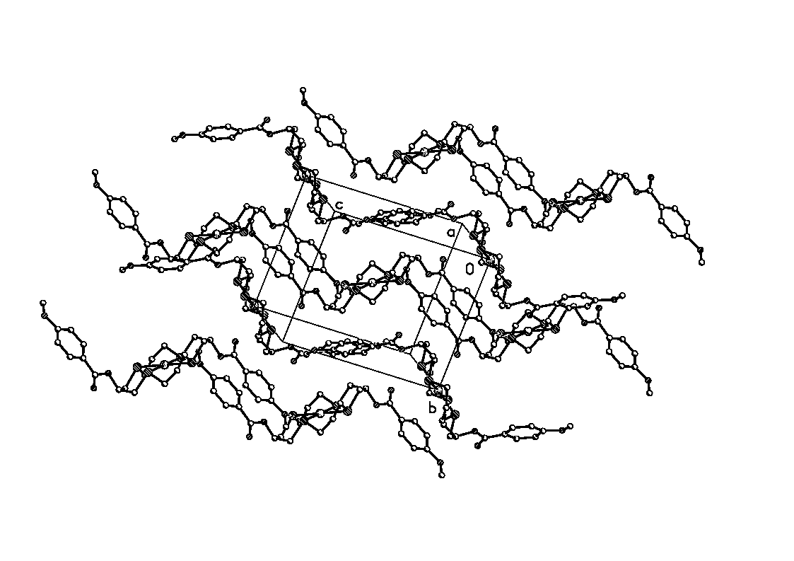
Fig. 5 Schematic representation of undulating layers in [Pd(7)](BF₄)₂

