Supplementary information

Transient spectra at 23.5 °C of ³Bp* and KR in [omim][Tf₂N] obtained 0.2 μs (squares, solid line) and 16.0 μs (triangles, dotted line) after excitation. The inset shows a trace recorded at λ = 530 nm and 23.5 °C. Note that lines connecting data points are for guidance only.

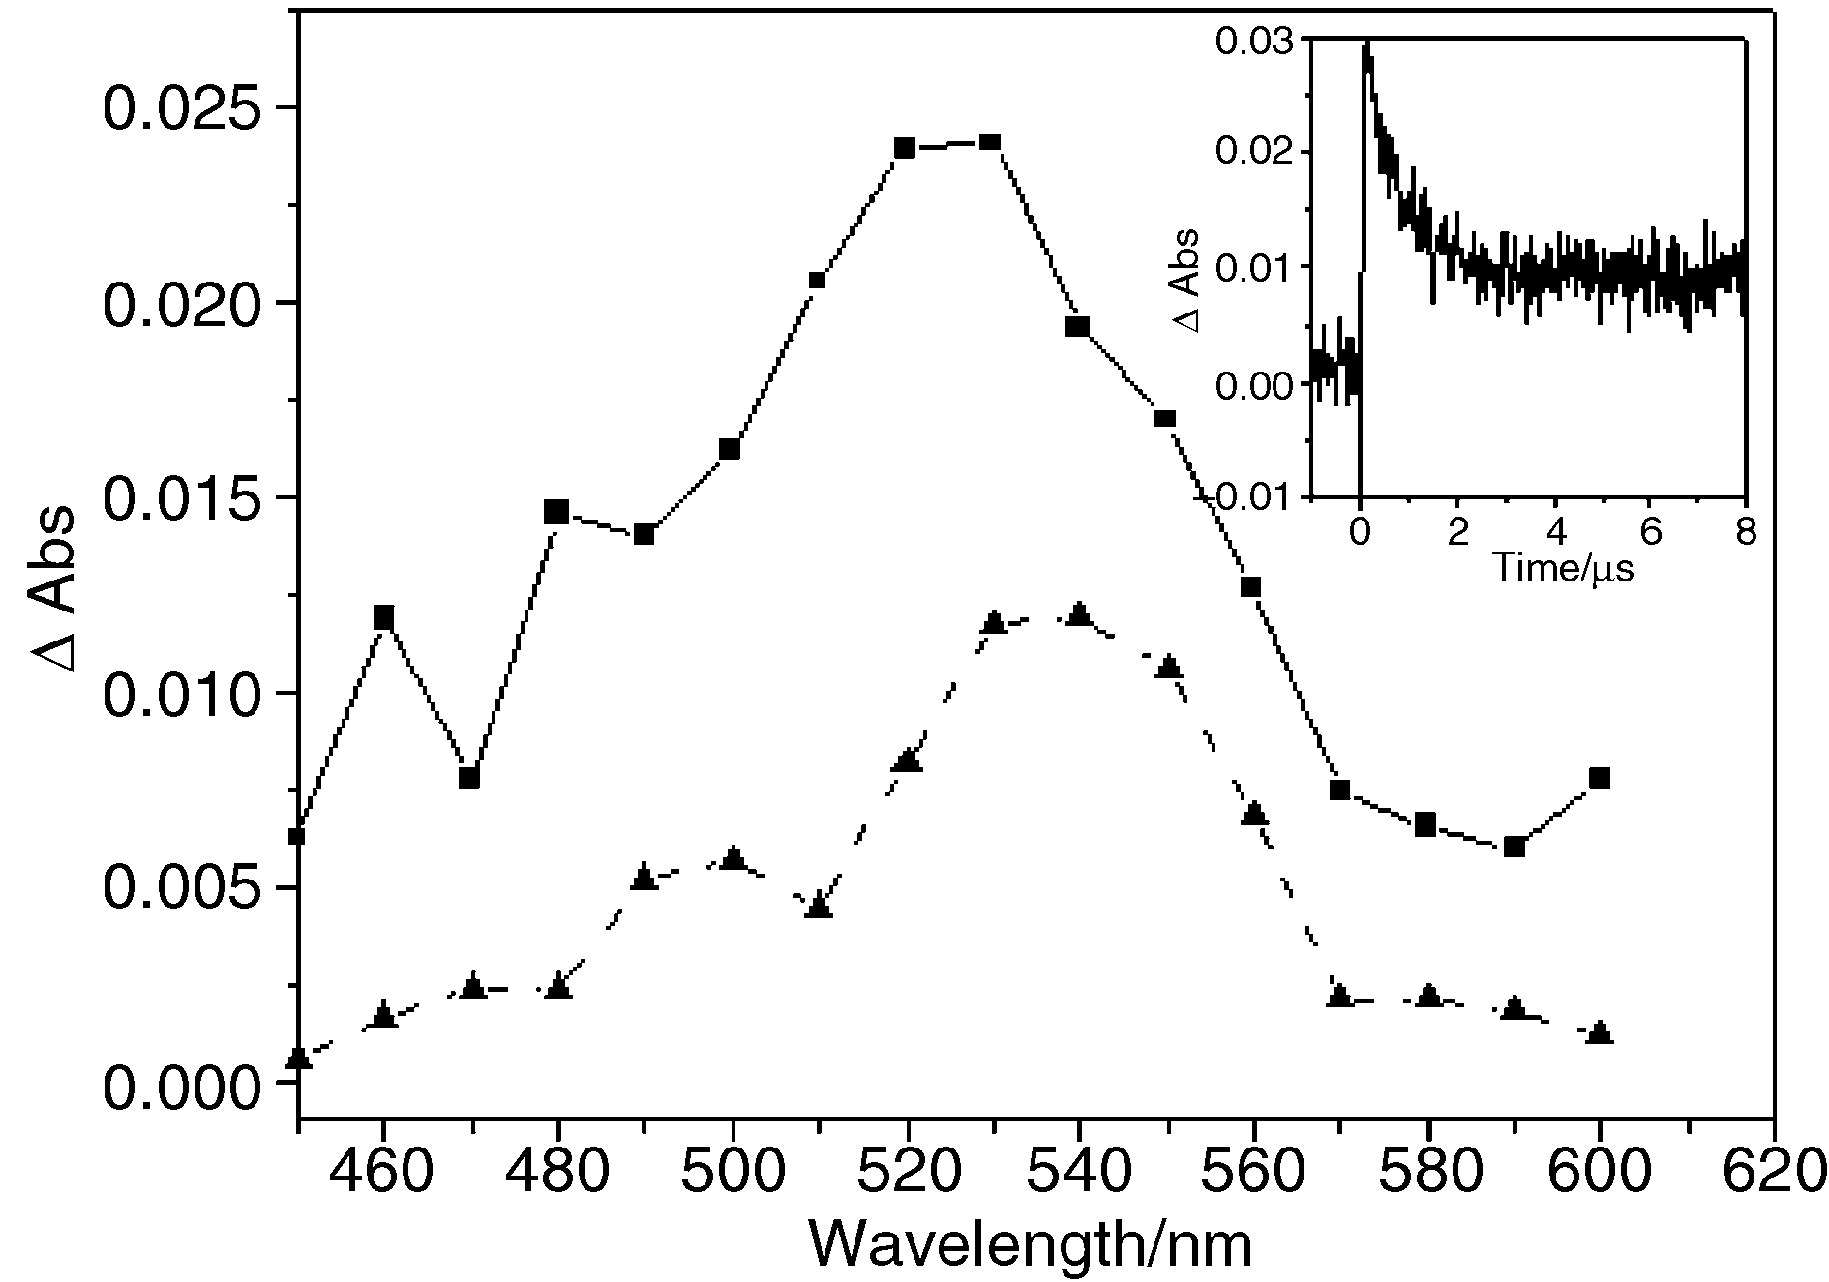

Purification of starting materials for ionic liquids

In order to prepare liquids that were reliably colourless, displaying effectively no absorbance in the region λ > 300 nm, it was necessary to pre-purify the starting materials. The 1-bromobutane and 1-bromooctane were first washed with concentrated sulfuric acid until the washings were colourless, and then with sodium bicarbonate solution and deionised water. They were then distilled from P₂O₅ directly prior to use. 1-Methylimidazole and 1,2-dimethylimidazole were both vacuum distilled from sodium hydroxide and stored in a refrigerator under nitrogen before use.

Arrhenius plots obtained for H-abstraction by ³Bp* ionic liquids

UV-visible spectra of Bp in ionic liquids

