Supplementary data
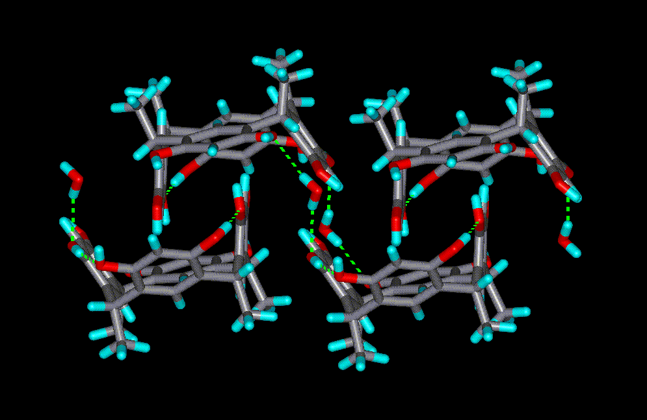
Fig. S1 The inter-locked CMCR molecules between adjacent sheets.

