Silica-based powders and monoliths with bimodal pore systems

Jamal El Haskouri,ª David Ortíz de Zárate,ª Carmen Guillem,ª Julio Latorre,ª Maite Caldés,^{b} Aurelio Beltrán,ª Daniel Beltrán,ª Ana B. Descalzo,^{c} Gertrudis Rodríguez-López,^{c} Ramón Martínez-Máñez,^{c} M. Dolores Marcos*^{c} and Pedro Amorós*ª

ª Institut de Ciència dels Materials (ICMUV), Universitat de València, P. O. Box 2085, 46071-València, Spain. Fax: 34 96 3983633; Tel: 34 96 3983617; E-mail: pedro.amoros@uv.es
^{b} Institut des Materiaux Jean Rouxel, Laboratoire de Chimie des Solides, UMR CNRS 110, Université de Nantes, P. O. Box 32229, 44322-Nantes Cedex, France.
^{c} GDDS, Departamento de Química, Universidad Politécnica de Valencia, Camino de Vera s/n, 46071-Valencia, Spain. Fax: 34 96 3877349; Tel: 34 963877343; E-mail: mmarcos@qim.upv.es

As an illustrative example, isomorphous substitution of Ti for Si in the framework leading to a regular heteroelement distribution in Ti-UVM-7 has been confirmed by UV-Vis spectroscopy. UV-Vis diffuse reflectance spectrum has been recorded at room temperature with a UV-250 1 PC Shimadzu instrument. The UV-Vis spectrum (Fig. 1) corresponding to sample 3 (Ti-UVM-7) shows an absorption band at ca. 210 nm, and no band at ca. 300 nm is detected. Inasmuch as the presence of a definite peak at ca. 300 nm is considered as characteristic of anatase-like phases, this result indicates that nearly all Ti occupies tetrahedral and well distributed sites in the skeletal net.

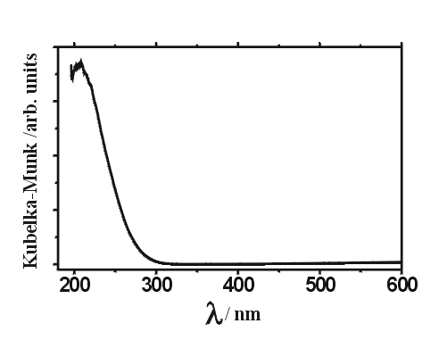
Figure 1. UV-Vis spectrum of Ti-UVM-7 (sample 3)

