Supplementary Material (ESI) for Chemical Communications
This journal is © The Royal Society of Chemistry 2002

Tungsten and Phosphorus analysis in reaction mixture (test for leaching)

After reaction, filtrate (separated from catalyst) is checked for the presence of tungsten (W) and phosphorus (P) by Inductively coupled plasma-optical emission spectroscopy (ICP-OES, Perkin Elmer-Emission Spectrometer Plasma-1000) carried out at Center for Materials for Electronic Technology, C-MET, Pune.
10 ml of aliquot (filtrate) is digested with 1 ml conc. HNO₃ for 1h. To this 1 ml of conc. H₂SO₄ is added and heated at 80°C for 30 min. It is then diluted with 10 ml deionized water and heated to boiling and filtered through Whatman 42 filter paper and washed 2-3 times with deionized water to get total volume 10 ml for the analysis. Measurements were made for P, with NH₄H₂PO₄ as standard (213.618 nm) and for W, with Na₂WO₄ as standard (207.911 nm).

Fig.1 | ³¹P MAS NMR spectra of a) 10; b) 15; c) 20 wt. % TPA/ZrO₂ catalysts prepared in methanol and calcined at 1023K.
Fig.2 | FT-IR pyridine adsorption spectra of a) 5; b) 10; c)15; d) 20; e) 30 wt. % TPA/ZrO₂ catalysts prepared in methanol and calcined at 1023K and evacuated at 573 K.
Fig.3 | Conversion and Acidity versus TPA loading (catalyst prepared in methanol). Reaction conditions: benzylation :- phenol = 4.2g, PhCH₂OH = 0.8g, catalyst = 0.08g, temp. = 363K and time = 1h; acylation :- 2-MN = 2g, Ac₂O = 3.86g, catalyst = 0.2g, temp. = 393K and time = 12h.

Fig.1

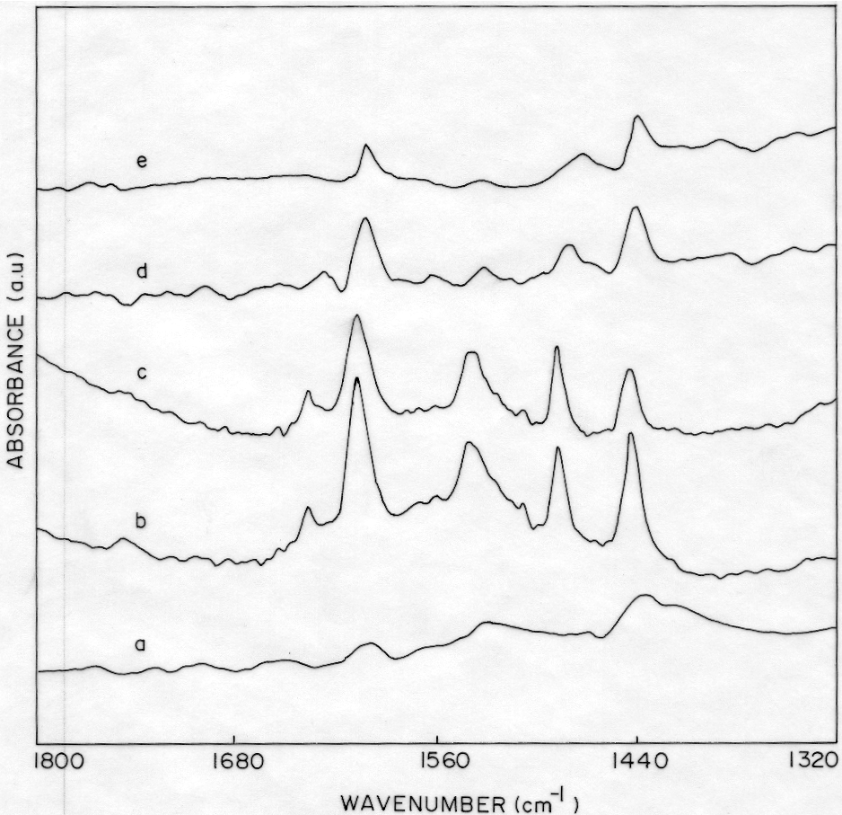

Fig.2

Fig.3

