Supplementary Material (ESI) for Chemical Communications
This journal is © The Royal Society of Chemistry 2002

Nanotectonic approach of the texturation of CeO₂ based nanomaterials

Anne Boucharaª, Galo J. de A. A. Soler-Illiaª , Jean-Yves Chane-Ching^{b} and Clément Sanchez*ª
ª Chimie de la Matière Condensée, UMR CNRS 7574, Université Pierre et Marie Curie 4, place Jussieu, 75252 Paris, France E-mail: clems@ccr.jussieu.fr
^{b} Rhodia Recherche, 52, rue de la Haie Coq, 93308 Aubervilliers, France

antisymmetric vibration
of carboxylate group
The functionalisation of the nanoparticles is followed by FTIR spectroscopy. The FTIR bands at 1302 cm⁻¹ and 1467 cm⁻¹, correspond to antisymmetric and symmetric vibrations of the carboxylate groups. Their position and their 165 cm⁻¹ splitting are characteristic of metal centres bridged by carboxylate groups.[see S. Doeuff et al., Inorg Chem, 1989, 28, 4439, and references therein]

The increasing of PBLG ratio is linked with an increasing of the pores size. For lower values, the film exhibits homogeneous prorosity with a pore size of 0,5μm. For higher values there is a loss of the homogeneity and bigger pores of more than 1 μm appear.

symmetric vibration
of carboxylate group

Fig. S1 FTIR spectra of 5-phenyl valeric acid functionnalised ceria nanoparticles

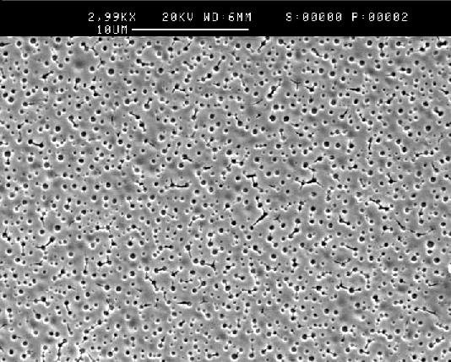
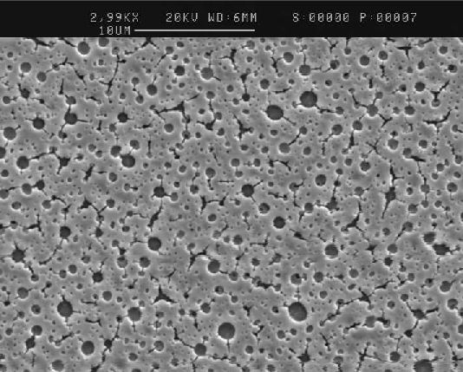

3
5
PBLG/ nanoparticles ratio × 10^{–5}

Fig.S2 SEM pictures of thin films with increasing PBLG/nanoparticles ratio

Heat flow
(W/g)
Temperature (°C)
Mass (%)
TGA measurement of a macroporous sample shows a four step degradation of organic entities in the material. The two first steps correspond to water and THF elimination, a third step at 200°C is linked with the degradation of PBLG and the last step at 300°C corresponds to the complete elimination of organics. The corresponding DSC is represented by the red curve .

The calcined samples are characterized by EDS. They all reveal the presence of O and Ce and the absence of C and N, confirming the elimination of the polymer.

Fig.S3 TGA measurement of a macroporous sample

Fig.S4 EDS analysis of a macroporous sample calcined at 300°C

P/P_{o}
Adsorbed Volume /cm³g^{–1}
At 300°C, the calcined samples exhibit a type I isotherm, which is characteristic of microporous materials. The measured microporosity is due to the voids created upon aggregation of the nanoparticles. This process yields hierarchical porous materials presenting both micro and macro porosity with inorganic walls constituted of nano-crystalline cerium oxide particles as demonstrated by XRD. For higher temperatures, the samples exhibit type III isotherms which are characteristic of macroporous materials. The loss of microporosity is due to the sintering of the ceria nanoparticles.

Fig.S5 Adorption-desorption of N₂ isotherms for300°C and 500°C calcined macroporous samples

