Supplementary Material (ESI) for Chemical Communications
This journal is © The Royal Society of Chemistry 2002
Experimental
The pSV-SPORT1 plasmid DNA (Life Technologies) was linearised at position 864 by the BsmI restriction endonuclease according to the manufacturer's instructions. The messenger RNA synthesised on this template had an expected size of 550 bp, starting immediately downstream of the Sp6 promoter recognized by the bacteriophage Sp6 RNA polymerase and elongated up to this BsmI restriction site.
The in vitro transcription assay was performed as follows: to the complex solutions containing 0.5 pmol of plasmid DNA, illuminated or not, were added 15 units of bacteriophage Sp6 RNA polymerase (Life Technologies), 32 units of ribonuclease inhibitor (Life Technologies), 0.5 mM of ATP, CTP, GTP, 21 mM UTP (Life Technologies), 10 μCi alpha-(32P)-labelled UTP (3000 Ci/mmol, ICN Biomedicals), 1 mM dithiothreitol (Life Technologies), 6 mM MgCl2 and 2 mM spermidine-(HCl)3 in Tris-HCl pH 7.9. This mixture of a final volume of 20 μL was incubated at 37 °C during 1 hour and the reaction stopped by killing the RNA polymerase at 80 °C during 10 min.
An open 1.5 mL Eppendorff tube containing the reaction mixture overlayed with 10 μL of mineral oil to avoid evaporation, was irradiated in the vertical direction during a given time (generally 30 min.) by a high pressure mercury lamp (HQI Powerstar daylight, power: 400W, 10 000 LUX, Osram) equipped with a UV cut off filter (Coherent). The light beam was focused (lens Leica) on the bottom of the tube. During irradiation, the tube was thermostated by a stirred water bath at the constant physiological temperature of 37 °C. Periodically, the intensity of the light source and reproducibility of the optical geometry were checked during a calibration procedure using the [Ru (TAP)3]2+ (Cl-)2 complex.^{1,2}
The radiolabelled messenger RNA produced by the in vitro transcription system was directly analysed by denaturing polyacrylamide gel electrophoresis. An aliquot of 3 μL of the reaction mixture, mixed to an equal volume of denaturing dye solution at a final concentration of 50 % (v/v) formamide, was denatured at 80 °C for 10 min. , chilled and loaded on a 0.3 mm thick and 35 cm long vertical 4% (w/v) polyacrylamide gel (mono-/bis-acrylamide ratio: 19/1) containing 6M urea. The gel was run at a constant voltage of 40 V/cm in Tris-borate buffer at a pH of 8.3. All standard care procedures to avoid any ribonuclease contamination were taken as described in J.Sambrook, E.F. Fritsch and T.Maniatis, Molecular Cloning : A laboratory manual, 2nd ed., Cold Spring Harbor Laboratory Press, Cold Spring Harbor, NY, 1989. After the run, the gel was fixed in 10% (v/v) acetic acid, dried at 80 °C for 45 min. and exposed to a radiosensitive film (Kodak, ICN Biomed) for autoradiography. The intensity of the bands related to the quantity of produced radiolabelled messenger RNA was evaluated on an Ultrascan densitometer using the Gelscan software provided by the same manufacturer (Pharmacia LKB).
Fig. S1. Inhibition of in vitro gene transcription by polyazaaromatic ruthenium(II) complexes under illumination.
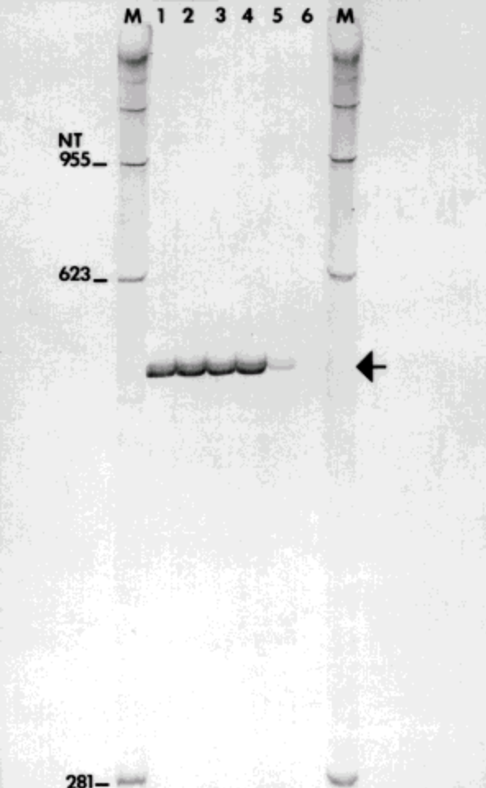
Representative autoradiograph for the transcribed messenger RNA of expected size (550 nucleotides, arrow at the right-handed margin). Lanes M: RNA size marker (left-handed margin: sizes given in nucleotides (NT)); lanes 1-3: controls performed respectively without complex and in the dark (dark control), without complex and after an irradiation of 30 minutes, and with 10-5 M of [Ru (TAP)2 POQ-Nmet]2+ (Cl-)2 in the dark; lanes 4-6: after an irradiation of 30 minutes at 37 °C with respectively 10-6, 10-5 and 10-4 M of [Ru (TAP)2 POQ-Nmet]2+ (Cl-)2.

