Communication Ref.: B206208A
Electronic Supplementary Information

Replication of dendrimer monolayer as nanopores in titania ultrathin film

Jianguo Huang, Izumi Ichinose and Toyoki Kunitake*

Topochemical Design Laboratory, Frontier Research System, The Institute of Physical and Chemical Research (RIKEN), Wako, Saitama 351-0198, Japan. E-mail: kunitake@ruby.ocn.ne.jp

Formation of Gold Nanoparticles within the Prepared Nanoporous Titania Ultrathin Film.
The formation of gold nanoparticles within the obtained titania ultrathin film is an additional supporting evidence of the presence of film nanopores.
0.20 mL ice-cold 0.1 M sodium borohydride in ethanol/water (1:1 v/v) was dropped on activated oxygen gas-treated (TiO₂)₃(PAMAM-OH)(TiO₂)₂ film that deposited on a silicon oxide-coated TEM grid, which was horizontally placed on filter paper. The TEM grid was then rinsed thoroughly with deionized water and dried in a stream of nitrogen. The TEM grid was horizontally placed on filter paper afterward, and 0.2 mL ice-cold 2.5 × 10⁻⁴ M hydrogen tetrachloroaurate in ethanol/water (1:1 v/v) was dropped, followed by thorough rinsing with deionized water and drying with nitrogen gas. The sample was then observed with TEM, and the results are displayed in Fig. 1.
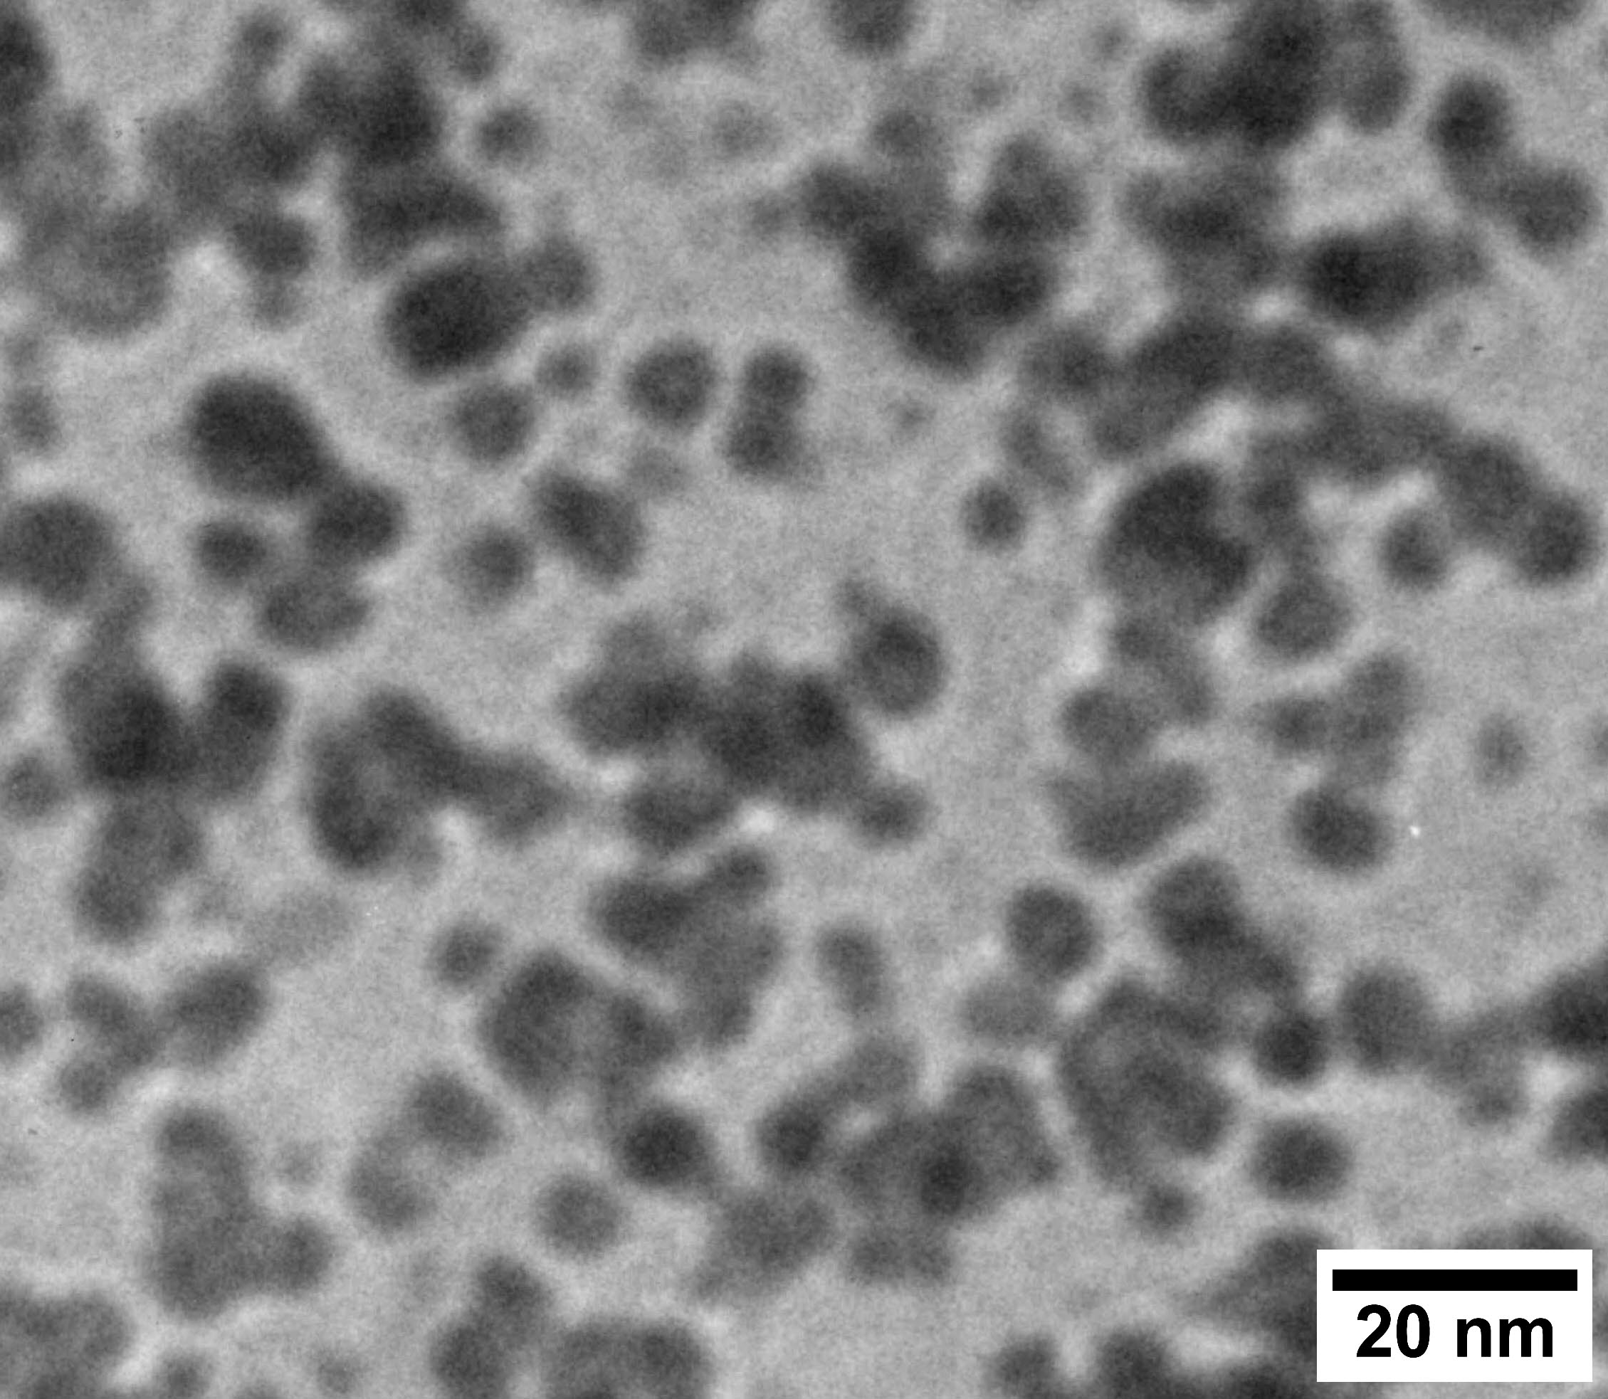
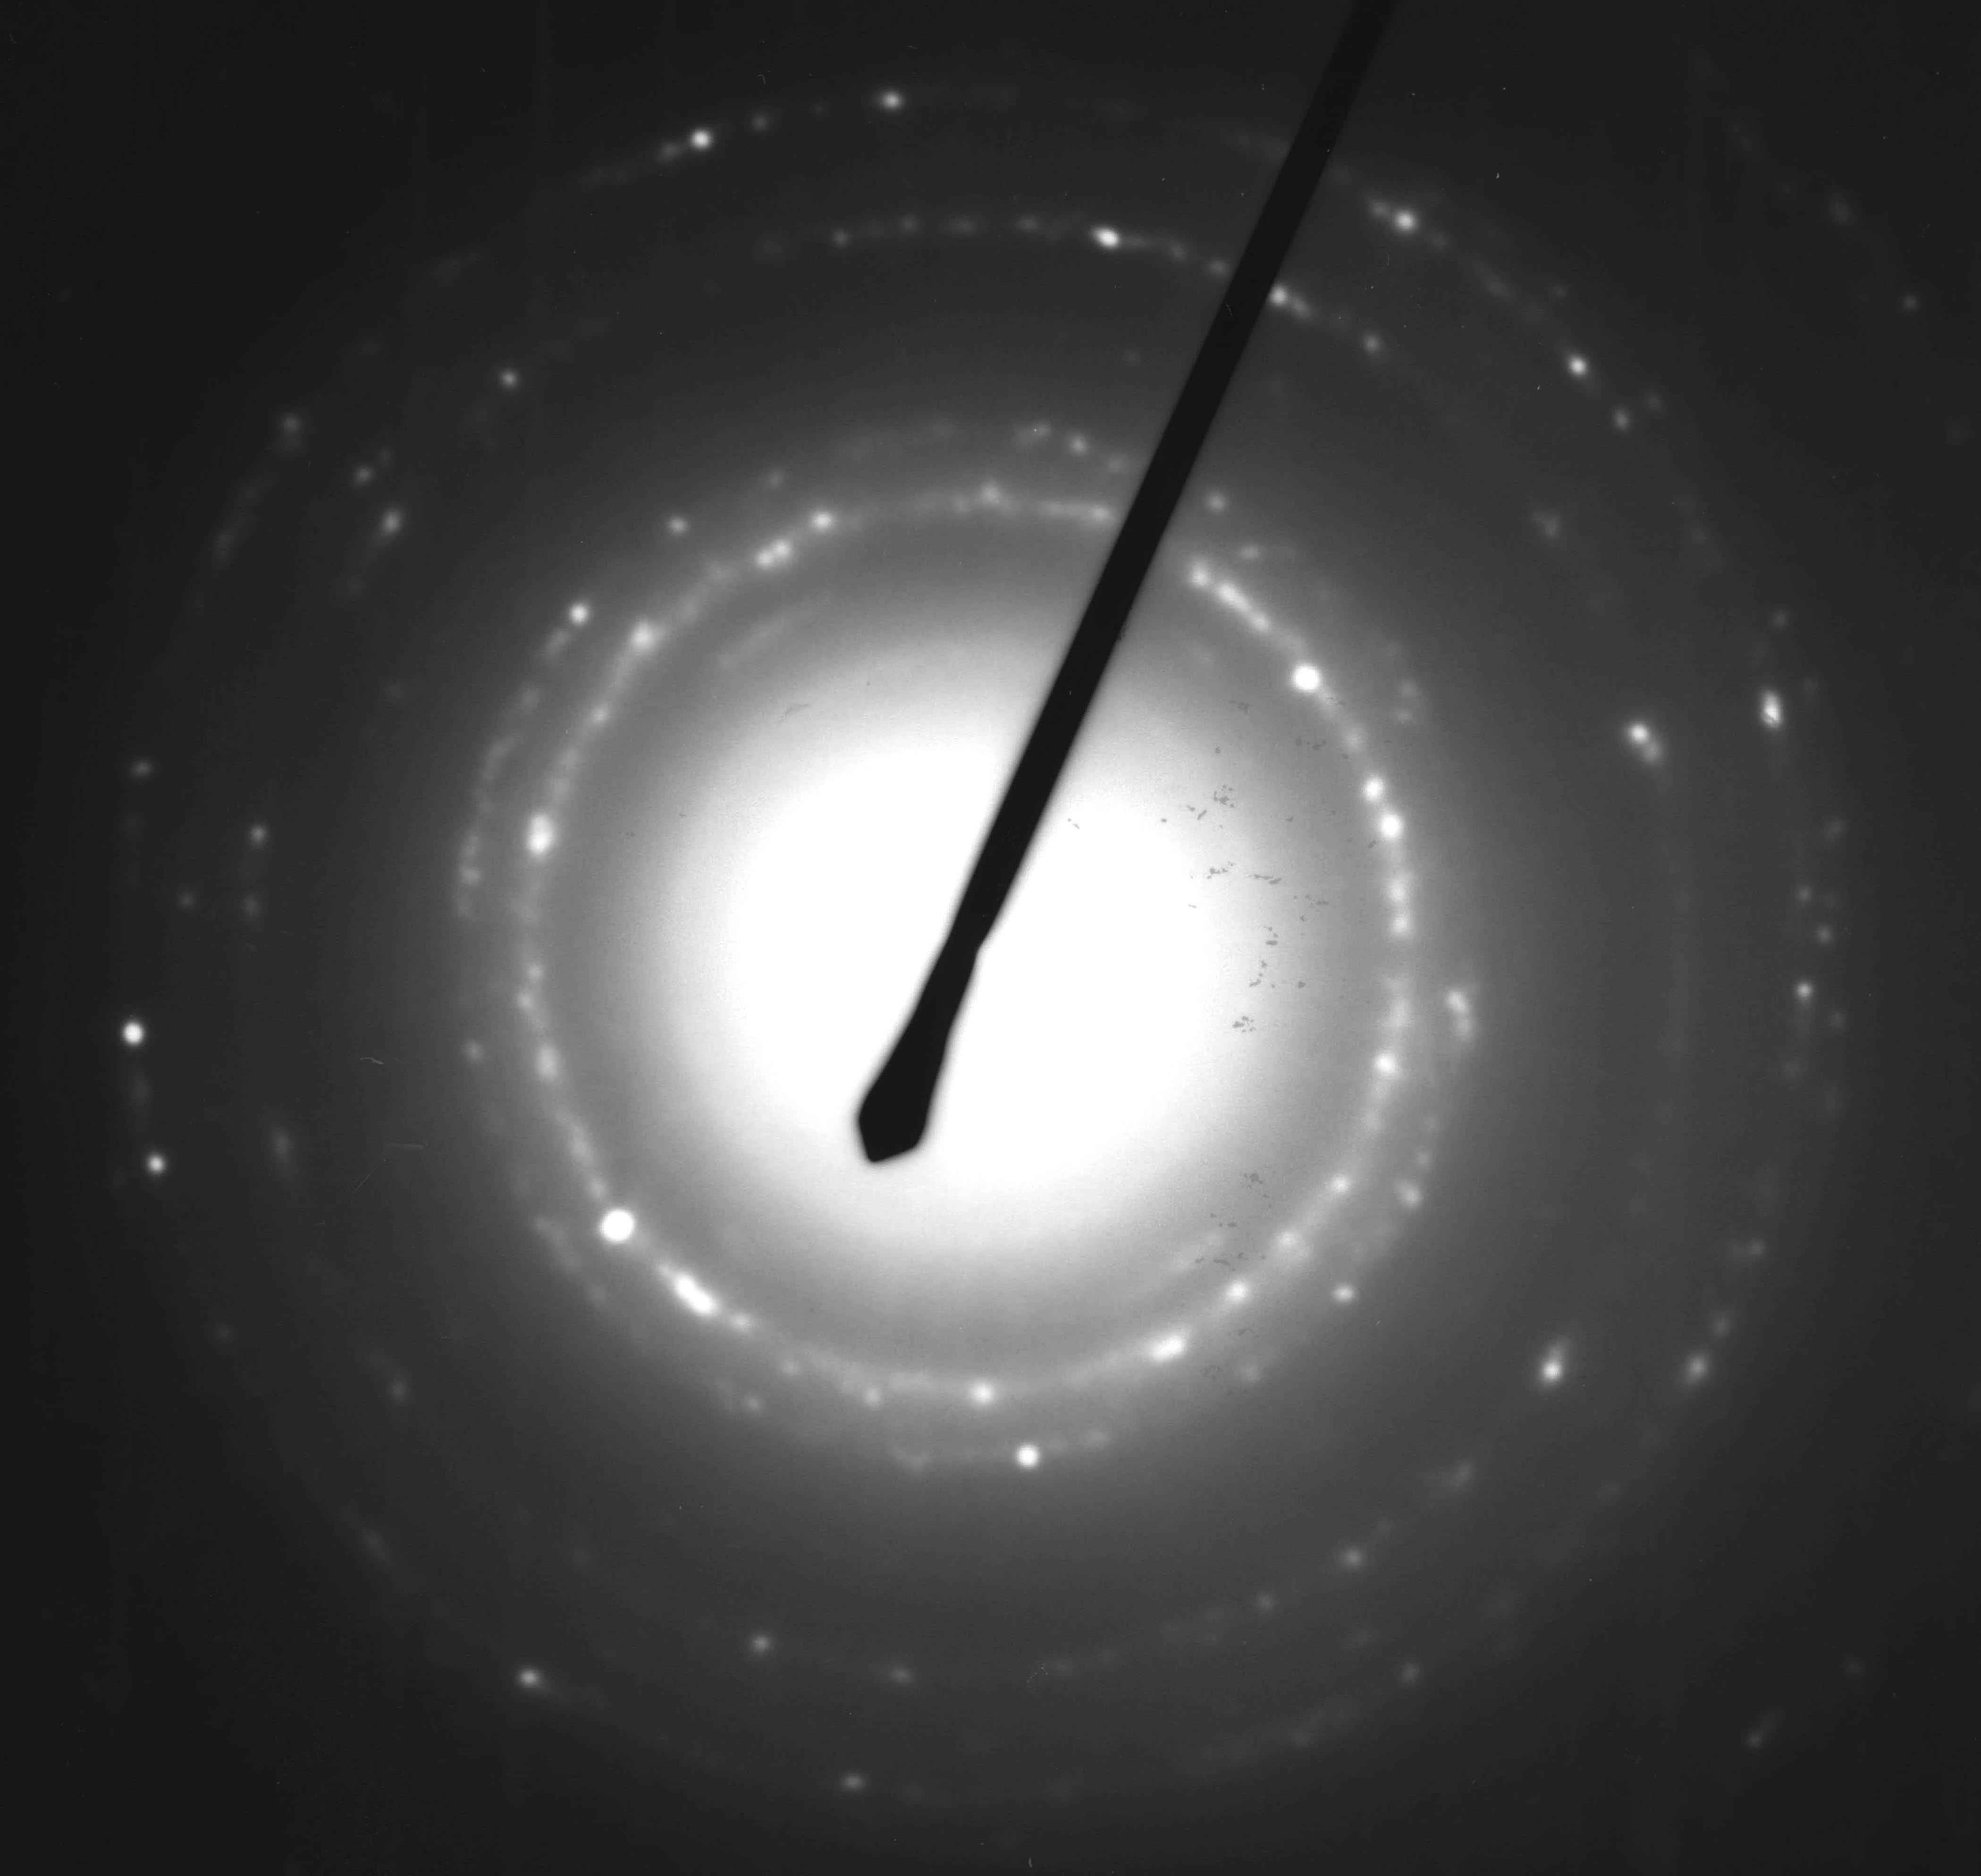
111
200
220
311
222
(A)
(B)
(C)
Fig. 1 Formation of gold nanoparticle in an activated oxygen gas-treated (TiO₂)₃(PAMAM-OH)(TiO₂)₂ film: (A) TEM micrograph of the obtained titania-gold particle nanocomposite film; (B) electron diffraction of the selected area of the film (C) a histogram of the particle size.
Fig. 1A shows the TEM image of the obtained monolayer of spheroidal gold nanoparticles, the selected area electron diffraction (SAED) pattern indicates the presence of gold nanocrystallites (Fig. 1B). A size distribution histogram plotted in Fig. 1C reveals that the size of the individual particle is 5 − 7 nm, which is close to the size of the nanopores that shown in Fig. 3C of the manuscript. Similar experiments were carried out on a 5-layer titania film prepared without dendrimer, no gold particle could be observed in this case. A UV-Vis spectrum of the titania-gold nanoparticle composite film that fabricated on a quartz substrate by the same procedure shows strong surface plasmon resonance absorption band of gold nanoparticle around 530 nm, while no gold particle can be observed on the surface of this film by SEM. The above experimental features indicate that the gold particles are formed inside the titania film.
From the results discussed above, it is clear that the gold nanoparticle formation resulted in nanopores of the titania film that reported in the present work. And it is true that a nanoporous ultrathin titania film was obtained.

The structure of the nanopores in the present titania ultrathin film is different from those of the porous materials that templated by surfactant assemblies (such as MCM-41). The pore formation in the current case was achieved via removal of the embedded dendrimer at room temperature by taking advantage of the activated oxygen gas treatment. The titania framework was stable upon template removal, and the pores were replicated from the template dendrimer. Nanopores are not two-dimensional in that sense, since they are not connected with each other. It is clear that gold nanowires rather than nanoparticles would be formed if there were channels in the film.¹⁻³

References

1 M. H. Huang, A. Choudrey and P. Yang, Chem. Commun., 2000, 1063.
2 S. Bhattacharyya, S. K. Saha and D. Chakravoty, Appl. Phys. Lett., 2000, 77, 3770.
3 Z. Zhang, S. Dai, D. A. Blom and J. Shen, Chem. Mater., 2002, 14, 965.

