Supplementary Material 1: Co-injection of the products of ASY92V with authentic β-(E)-farnesene reveals the identity of 4.
A: GC-trace from an injection of authentic β-(E)-farnesene. *: Impurities in the β-(E)-farnesene sample.
B: Products produced by ASY92V on incubation with farnesyl-pyrophosphate (1).
C: Co-injection of β-(E)-farnesene standard and the ASY92V products. Note the doubling of the intensity of peak 4 while the intensity of the other peaks remains unchanged.
Method: The hexane extractable products of an incubation of 1 with ASY92V and of β-(E)-farnesene were analysed by GC-MS using a Carlo Erba CE8000 gas chromatograph (equipped with a BPX5 30 m column).

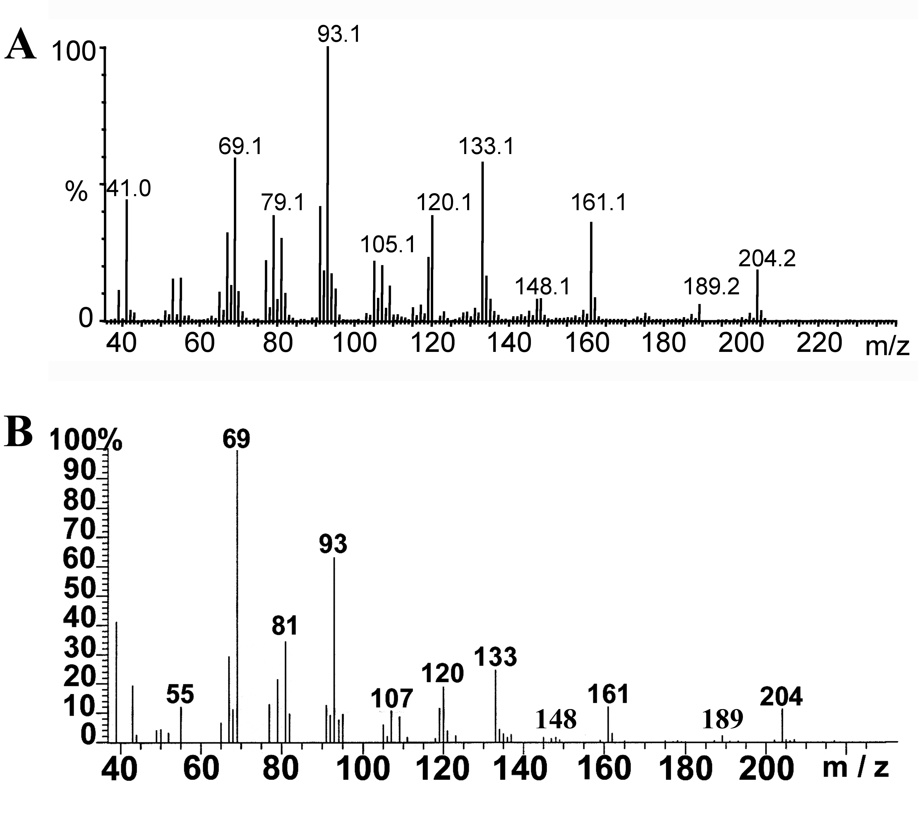

Supplementary Material 2: Product 4 from ASY92V is β-(E)-farnesene.
A: MS of peak 4 of the GC –trace in Figure 1 run on a Micromass GCTTM with an integrated GC (HP6890 equipped with a 30 m DB5 column).
B: MS of the GC-peak of a standard of β-(E)-farnesene a Carlo Erba CE8000 gas chromatograph (equipped with a BPX5 30 m column) and a Prospec Mass spectrometer.

