Electronic Supplementary Information
The role of post-translational modification in the photoregulation of Fe-type nitrile hydratase †
Shannon N. Greene, Christopher H. Chang and Nigel G. J. Richards*
Department of Chemistry, University of Florida, Gainesville, FL 32611
Table S1 Fe-ligand bond lengths and bond angles for the nitrosyl bound NHase active site in the crystal structure and the BLYP-optimised structures for models 1 and 2.

Property | Crystal | Model 1 | Model 2
Fe-S1 | 2.33 Å | 2.32 Å | 2.43 Å
Fe-S2 | 2.26 Å | 2.29 Å | 2.41 Å
Fe-S3 | 2.30 Å | 2.33 Å | 2.40 Å
Fe-N1 | 1.65 Å | 1.63 Å | 1.64 Å
Fe-N2 | 2.05 Å | 1.96 Å | 1.93 Å
Fe-N3 | 2.09 Å | 1.95 Å | 1.97 Å
N1-O1 | 1.33 Å | 1.15 Å | 1.64 Å
S1-O2 | 1.51 Å | 1.69 Å | -
S2-O3 | 1.51 Å | 1.52 Å | -
S2-O4 | 1.41 Å | 1.52 Å | -
O5-O1 | 3.31 Å | 3.34 Å | 3.63 Å
Fe-N1-O1 | 158.1º | 169.4º | 169.4º
S1-Fe-N3 | 171.1º | 165.9º | 172.8º
S2-Fe-N2 | 175.7º | 176.2º | 173.3º
S3-Fe-N1 | 172.3º | 166.8º | 169.4º

Fig. S1 Graphical representations of the electronic transitions calculated for the photoexcitations of the NHase active site model 1. (A) 380 nm, (B) 288 nm. The phases of the initial (left) and final (right) MOs involved in promotion of the electron are shown in blue/green and red/yellow, respectively. Hydrogen atoms have been omitted for clarity.

(A)
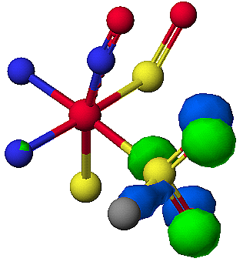
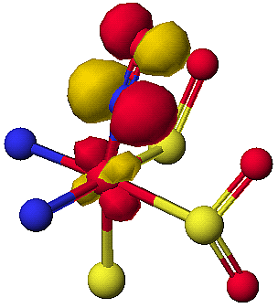
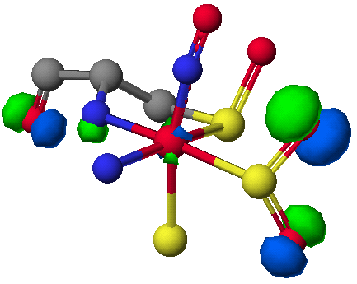

(B)
Fig. S2 Graphical representations of the electronic transitions calculated for the photoexcitations of the NHase active site model 2. (A) 350 nm, (B) 285 nm. The phases of the initial (left) and final (right) MOs involved in promotion of the electron are shown in blue/green and red/yellow, respectively. Hydrogen atoms have been omitted for clarity.

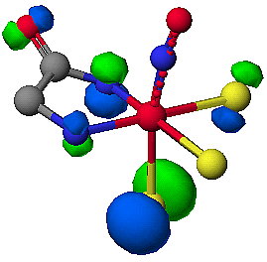
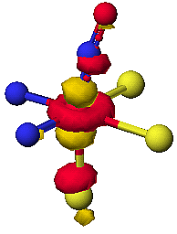
(A)
(B)

† This work was supported by the National Science Foundation (CHE-0079008)

