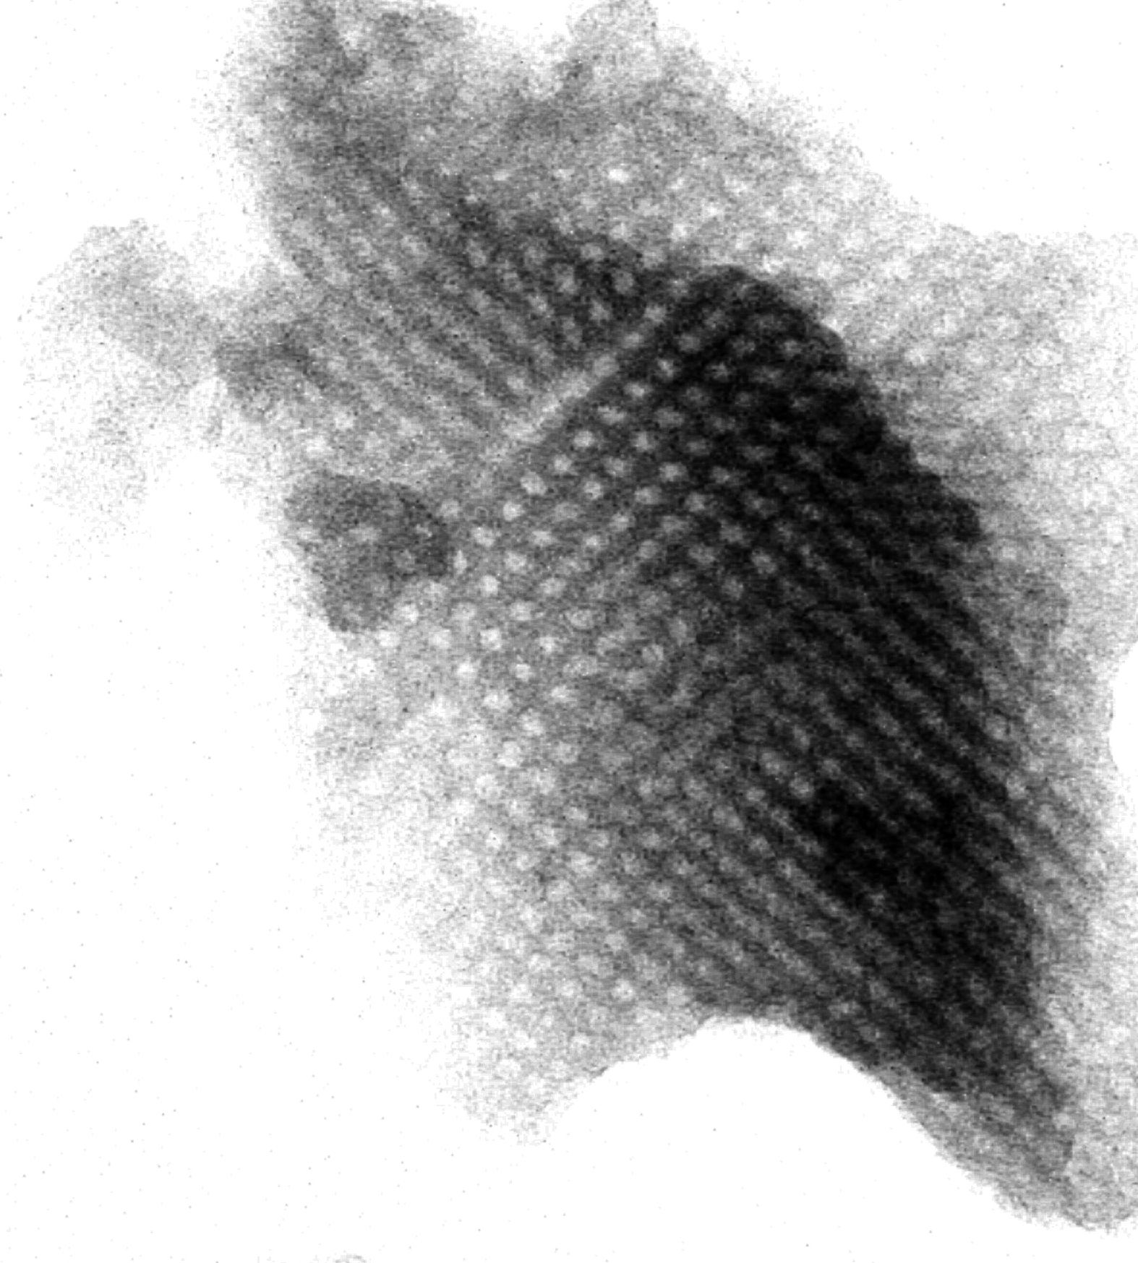
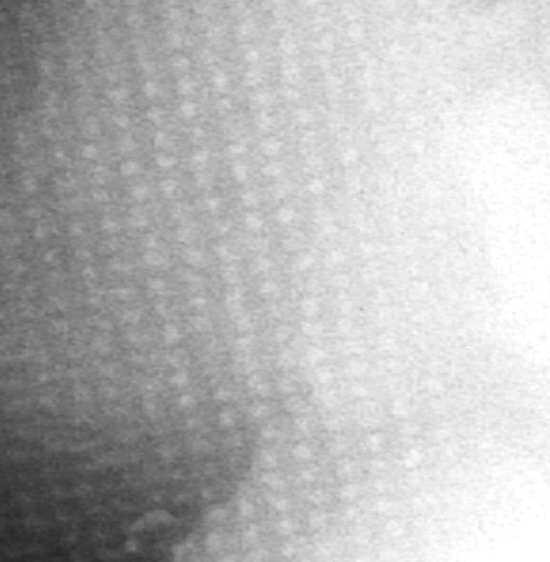
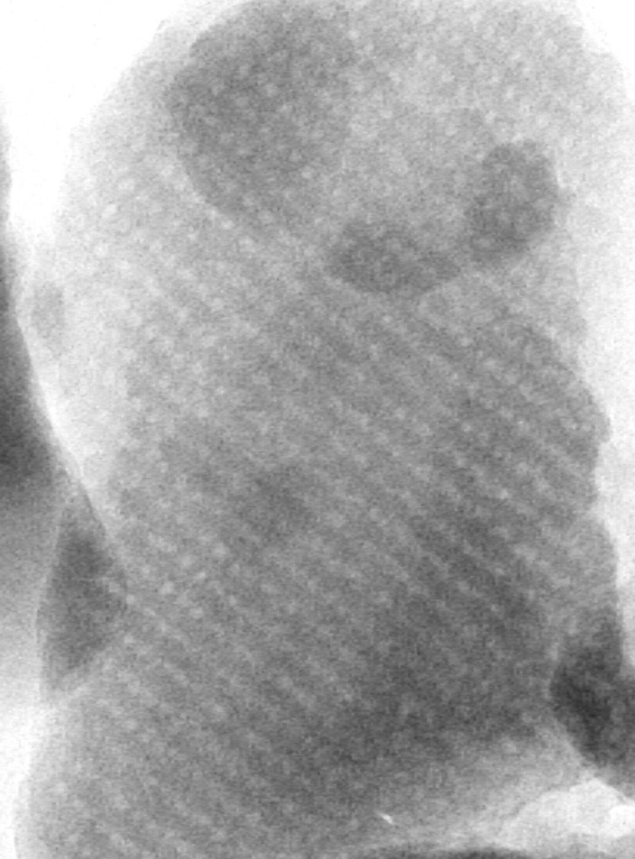
Supplementary Figure 2 – TEM images showing different orientations of the cubic pore system in an F127-silica hybrid, F-50-5. Measurement bars represent 75 nm (left, centre), and 100 nm (right).
Perp to 100
Perp to 110
Perpendicular to 111

