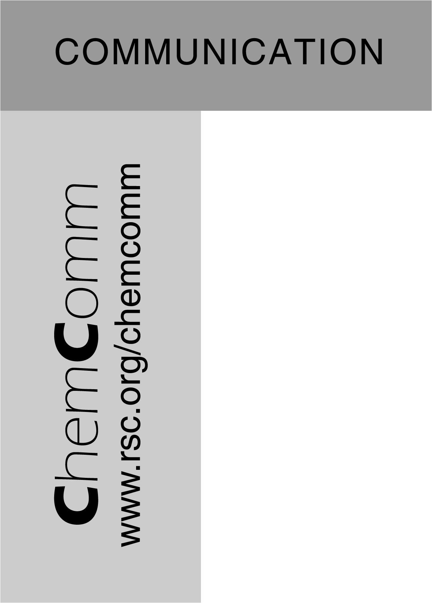
Electronic Supplementary Information for
Formation of Novel Diaza-Metallacycles by Insertion of Tungsten (II) Aryloxides into Aromatic Diazine Rings.
Margaret R. Lentz,ª Phillip E. Fanwickª and Ian P. Rothwell*ª

ª Department of Chemistry 1393 Brown Building, Purdue University, West Lafayette, IN 47907-1393, USA. Fax: 765-494-0239; Tel: 765-494-5473; E-mail: rothwell@purdue.edu.

Preparation of [W(OC₆HPh₃-η⁶-C₆H₅)(OC₆HPh₄-2,3,5,6)(PMe₃)] (1)

A solution of [W(OC₆HPh₄-2,3,5,6)₂Cl₄] (4.00 g, 3.6 mmol) and an excess (2.2-2.5 equiv per W) of PMe3 in toluene (50 mL) was stirred over a sodium amalgam (0.40 g of Na, 17.4 mmol) for 24 h at room temperature. The resulting olive green solution was decanted off the mercury pool, filtered through a pad of celite and evaporated in vacuo to yield a green solid. The crude solid was recrystallized in a minimum amount of benzene layered with hexane giving 1 (1.5 g, 40%) as crystals suitable for an X-ray diffraction study. Anal. calc. for C₆₃H₅₂PO₂W: C, 71.66%; H, 4.96%; P, 2.93%. Found: C, 71.83%; H, 5.02%; P, 2.83%. ¹H NMR (C₆D₆, 30°C): δ 7.00-8.00; 3.45, 2.94, 1.94, 1.52, 1.19 (m, η⁶-C₆H₅); 0.96 (d, PMe₃). ¹³C NMR (C₆D₆, 30°C): δ 169.7, 165.9, 143.1, 141.4, 141.3, 140.2, 139.4, 138.4, 137.2, 132.9, 132.3, 130.5, 130.2, 129.9, 129.3, 129.0, 128.5, 128.1, 127.8, 127.0, 126.3, 125.7, 124.6, 120.0 (aromatic C); 100.6, 96.2, 94.0, 92.0 (br., η⁶-C₆H₅), 16.0 (d, PMe₃). ³¹P NMR (C₆D₆, 30°C): δ 31.6 [¹J(¹⁸³W-³¹P) = 372 Hz].

Preparation of [W(OC₆HPh₄-2,3,5,6)₂{N(C₄H₄)N)(PMe₃}] (2).

A sample of 1 (97.4 mg, 0.092 mmol) was dissolved in 1 mL of d₆-benzene and to this solution was added an equivalent of pyridazine (6.7 μL, 0.092 mmol). Upon addition the solution went from emerald green to red. The sample was analyzed by NMR spectroscopy. Compound 2 was recrystallized from hot benzene yielding red crystals suitable for an X-ray diffraction study (88.0 mg, 73.9 %). Anal. cald. for C₆₇H₅₅N₂O₂W: C, 70.90%; H, 4.88%; N, 2.47%; P, 2.73%. Found: C, 69.89%; H, 4.91%; N, 2.12%; P, 2.38%. ¹H NMR (C₆D₆, 25ºC): δ 7.55 (dd, HC-N), 7.24-6.97 (m, aromatics), 5.83 (dd, NHC=CH-), -0.25 (d, PMe₃, ²J(³¹P-¹H) = 8.39 Hz ). ³¹P NMR (C₆D₆, 25 ºC): δ −11.0 (br. PMe₃).

Preparation of [W(OC₆HPh₄-2,3,5,6)₂(NCH(C₆H₄)CHN)(PMe₃)] (3).

A sample of 1 (150 mg, 0.142 mmol) was dissolved in 4 mL of benzene, and to this solution was added an equivalent of phthalazine (19 mg, 0.146 mmol). The solution was stirred for 20 minutes at room temperature and then layered with hexanes giving dark green crystals of 3 (85.7 mg, 50.9%) suitable for X-ray diffraction study. Anal. cald. for C₇₁H₅₇N₂O₂PW: C, 71.96%; H, 4.85%; N, 2.36%; P, 2.61%. Found: C, 72.41%; H, 5.07%; N, 2.38%; P, 2.50%. ¹H NMR (C₆D₆, 25 ºC): δ 8.52 (s, HC-N), 6.94-7.30 (m, aromatics), 6.5-6.68 (m, aromatics), -0.58 (d, PMe₃, ²J(³¹P-¹H) = 8.09 Hz ). ³¹P NMR (C₇D₈, -30 ºC): δ -17.7 [¹J(¹⁸³W-³¹P) = 296 Hz].

Preparation of [W(OC₆HPh₄-2,3,5,6)₂(N(C₁₂H₈)N)(PMe₃)] (4).

A sample of 1 (100 mg, 0.095 mmol) was dissolved in 4 mL of benzene, and to this solution was added an excess of benzo[c]cinnoline (35 mg, 0.20 mmol). The solution was stirred for 2 hours at room temperature. The solution was layered with hexanes and the yellow precipitate of crude product was dried in vacuo and analyzed by NMR spectroscopy. Yellow-green, X-ray quality crystals were obtained by dissolving the product in a minimum of benzene and layering the solution with hexane (65 mg, 55.6%). Anal. cald. for C₇₅H₅₉N₂O₂PW: C, 72.93%; H, 4.82%; N, 2.27%. Found: C, 73.11%; H, 5.02%; N, 2.38%. ¹H NMR (C₇D₈, -50ºC): δ 8.63 (d, aromatic), 7.72-6.73 (m, aromatics), 6.55 (d, aromatics), -0.58 (d, PMe₃, ²J(³¹P-¹H) = 9.77 Hz ). ³¹P NMR (C₇D₈, -50 ºC): δ -0.5 [¹J(¹⁸³W-³¹P) = 338 Hz].

