Supplementary data

Syntheses and Spectroscopic Studies of Spirobifluorene-bridged Bipolar Systems; Photoinduced Electron Transfer Reactions
Yuh-Yih Chien, Ken-Tsung Wong,* Pi-Tai Chou,* and Yi-Ming Cheng
Department of Chemistry, National Taiwan University, 106 Taipei, Taiwan, ROC.

General Experiments: All reactions were performed under argon and were magnetically stirred. Solvents were distilled from appropriate dying agent prior to use: THF and Et₂O from sodium and benzophenone, benzene and toluene from sodium, CH₂Cl₂ from CaH₂. Commercially available reagents were used without further purification unless otherwise stated. All reactions were monitored by TLC with Macherey-Nagel pre-coated aluminum foil sheets (0.20 mm with fluorescent indicator UV₂₅₄). Compounds were visualized with UV light at 254 nm and 365 nm. Column chromatography was carried out using flash silica gel from Merck (230-400 mesh). Melting points were measured on a Fargo MP-1D and are uncorrected. Infrared (IR) spectra were recorded within KBr on a Nicolet FT-IR spectrometer. ¹H NMR and ¹³C NMR in CDCl₃ were recorded using a Bruker (Avance 4000) or Varian (Unity Plus 400) spectrometer at 400 MHz and 100 MHz respectively. Low and high-resolution mass spectra were recorded using a Jeol SX-102A spectrometer in FAB mode. Microanalyses were carried out on a Perkin-Elmer CHN-2400 or a Heraeus Vario EL-III analyzer. Cyclic voltammetry (CV) was performed in 1.0 mM of substrate on a Princeton Applied Research potentiostat 273A, All oxidation CV measurements were carried out in anhydrous CH₂Cl₂ containing 0.1 M tetrabutylammonium hexafluorophosphate (nBu₄NPF₆) as a supporting electrolyte and all reduction CV measurements were carried out in anhydrous THF containing 0.1 M tetrabutylammonium perchlorate (nBu₄NClO₄) as a supporting electrolyte, purging with argon prior to conduct the experiment. Carbon electrode was used as a working electrode and a platinum wire as a counter electrode, all potentials were recorded versus Ag/AgCl (sat’d) as a reference electrode. Ferrocenium/ferrocene redox couple in CH₂Cl₂/nBu₄NPF₆ occurs at E^{o’}=+0.54 V vs. Ag/AgCl (sat’d), in THF/nBu₄NClO₄ occurs at E^{o’}=+0.63 V vs. Ag/AgCl (sat’d). Differential scanning calorimetry (DSC) analyses were performed on a TA Instrument DSC-2920 Low-Temperature Difference Scanning Calorimeter. For X-ray analysis, the chosen crystals were mounted on a glass fiber. Data collection was carried out on a NONIUS KappaCCD diffractometer with Mo radiation (λ= 0.71073 Å) at 150(1) K. A preliminary orientation matrix and unit cell parameters were determined from 20 frames; each frame corresponds to the 1 degree ω scan in 20 s, followed by spot integration and least-squares refienment. Data were measured using ω scans, 0.50 degree per frame, 25 sec. per degree until five runs of different Phi and Kappa angles had been collected. The detector was put at the position of 4.2 cm. Cell parameters were retrieved and refined using DENZO-SMN software on all reflections. Data reduction was performed on the DENZO-SMN software. An empirical absorption was based on the symmetry-equivalent reflections and absorption corrections were applied with the SORTAV program. Using SHELXTL program on PC computer made the structure analysis. The structure was solved by using SHELXS-97 and refined with SHELXL-97 by full-matrix least squares on F² values. Hydrogen atoms were fixed at calculated positions and refined using a riding mode.
General procedure for the Pd-catalyzed amination of 2,7-dibromo-9,9’-spirobifluorene with diphenylylamine: 9,9’-Spirobifluorene based dibromo derivative (1.0 mmol), diphenylamine (1.0 mmol), and sodium tert-butoxide (115.7 mg, 1.25 mmol) were mixed in a flask. The flask was evacuated, refilled with argon. Pd(OAc)₂ (5.6 mg, 0.025 mmol), P^{t}Bu₃ (2 mL, 0.05 M in toluene, 0.1 mmol) , dry toulene (4 mL) were added into the flask. The flask was heated to 100 ºC with stirring until the dibromo compound has been consumed (4~8 h). The reaction mixture was then cooled to room temperature, diluted with H₂O and extracted with EtOAc, combined organic solution was washed with brine and dried over MgSO₄. Evaporation in vacuum vacuo afforded the crude product which was further purified by column chromatography on SiO₂ (EtOAc/hexane = 1/6). Analytical pure product was obtained by sublimation at 300 ºC (bath temperature) under high vacuum (1.0 x 10⁻⁶ torr).
2,7-dibormospirobifluorene(474 mg, 1 mmole), N,N-diphenylamine (338 mg, 2 mmol), Pd(OAc)₂ (11.2 mg, 0.05mmol), P^{t}Bu₃ (4 mL, 0.055M in toluene, 0.22 mmol), NaO^{t}Bu (230 mg, 2.4mmol), toluene (5 mL), stirred for 4 h stirred to give 2 (624 mg, 96%). mp 246 ºC(DSC); IR (KBr) ν 3067 (w), 3034 (w), 1595 (s), 1494 (s), 1468 (s), 1332 (m), 1273 (s), 807 (m), 761 (m), 734 (m), 696 (m) cm⁻¹; ¹H NMR (DMSO-d₆, 400 MHz) δ 7.81-7.77 (m, 4H), 7.31 (t, J = 7.5 Hz, 2H), 7.18-7.09 (m, 10H), 6.93-6.89 (m, 6H), 6.81 (d, J = 7.5 Hz, 8H), 6.75 (d, J = 7.5 Hz, 2H), 6.16 (d, J = 2 Hz, 2H); ¹³C NMR (DMSO-d₆, 100 MHz) δ 150.1, 148.5, 147.4, 146.8, 141.3, 136.3, 129.8, 128.5, 128.4, 123.9, 123.8, 123.7, 123.4, 121.4, 120.9, 118.7, 65.7; MS (m/z, FAB⁺) 650 (50), 307 (100); HRMS (FAB) Cacld for C₄₉H₃₄N₂ 650.2722, found 650.2728; Anal. Calcd for C₄₉H₃₄N₂ C, 90.43; H, 5.27; N, 4.18, found C, 90.30; H, 5.55; N, 4.18.
2,7-dibormo-2’,7’-dinitrilespirobifluorene (1.56 g, 3.0 mmole), N,N-diphenylamine (1.0 g, 6.0 mmol), Pd(OAc)₂ (33.6 mg, 0.15mmol), P^{t}Bu₃ (8 mL, 0.055M in toluene, 0.44 mmol), NaO^{t}Bu (690 mg, 7.2 mmol), toluene (15 mL), stirred for 4 h stirred to give 5 (624 mg, 96%). mp 327-328°C; IR (KBr) ν 3063 (w), 3038 (w), 2364 (s), 2345 (s), 2230 (s), 1594 (s), 1468 (s), 1272 (s), 821 (m), 754 (m), 696 (s) cm⁻¹; ¹H NMR (CDCl₃, 400 MHz) δ 7.82 (d, J = 8.0 Hz, 2H), 7.66 (dd, J = 8.0, 1.4 Hz, 2H), 7.62 (d, J = 8.3 Hz, 2H), 7.23 (d, J = 0.7 Hz, 2H), 7.18-7.14 (m, 8H), 7.06 (dd, J = 8.3, 2.0 Hz, 2H), 6.97-6.93 (m, 12H), 6.37 (d, J = 2.0 Hz, 2H); ¹³C NMR (CDCl₃, 100 MHz) δ 150.4, 147.4, 147.3, 146.6, 143.8, 136.2, 132.2, 129.1, 127.8, 124.6, 123.9, 122.9, 121.9, 120.6, 118.9, 118.6, 112.4, 65.4; MS (m/z, FAB⁺) 700 (50), 613 (5), 533 (5), 460 (20), 391 (10), 307 (100); HRMS (FAB) Calcd for C₅₁H₃₂N₄ 700.2627, found 700.2624.
2,7-dibromo-9,9’-spirobifluorene (471 mg, 1.0 mmole), , cuprous cyanide (178 mg, 2.0 mmol), and N,N-dimethylformamide (2 mL) were mixed in a flask. The flask was heated to 100 ºC with stirring until the dibromo compound has been consumed (24h). The reaction mixture was then cooled to room temperature, and poured into a solution of hydrated ferric chloride (7.0 g) and hydrochloric acid (4 mL) in cold water (40mL). After the reaction mixture had been maintained at 60-70 ºC for 30 min to decompose the complex. The reaction mixture was then cooled to room temperature and extracted with toluene(15 mL X3), combined organic solution was washed with brine and dried over MgSO₄. Evaporation in vacuum vacuo afforded the crude product which was further purified by recrystallization from CH₂Cl₂ and hexanes to afford 2,7-dinitrilespirobifluorene (329 mg, 90%). Analytical pure product was obtained by sublimation at 220 ºC (bath temperature) under high vacuum (1.0 x 10⁻⁶ torr). mp 271-272 ºC; IR (KBr) ν 3445(br), 2229(m), 1647(s), 741(m), 727(m) cm⁻¹; ¹H NMR (CDCl₃, 400 MHz) δ 8.0 (d, J = 8.0 Hz, 2H), 7.90 (d, J = 7.7 Hz, 2H), 7.73 (dd, J = 8.0, 1.4 Hz, 2H), 7.46 (dt, J = 7.5, 0.9 Hz, 2H), 7.17 (dt, J = 7.5, 0.9 Hz, 2H), 7.07 (s, 2H), 6.67 (d, J = 7.7Hz, 2H); ¹³C NMR (CDCl₃, 100 MHz) δ 150.4, 145.4, 143.9, 141.8, 132.3, 128.9, 128.4, 128.1, 123.7, 121.7, 120.7, 118.4, 112.7, 65.6; Anal. Calcd for C₂₇H₁₄N₂ C, 88.50; H, 3.85; N, 7.65; found C, 88.45; H, 4.00; N, 7.55.
General procedure for the tetrazole formation from 2,7-dinitrile-9,9’-spirobifluorene :
2,7-dibromospirobifluorene (2.0 mmol) was added to dried dimethylformamide solution (10 mL) containing sodium azide (2.2 mmole) and ammonium chloride (2.2 mmole). The mixture was slowly heated to 100 ºC for 24 h under nitrogen. Excess salt remained as a suspension even at high temperature. After the reaction mixture cooled, it was then acidified with 2 N HCl solution until acidic conditions were reached, after which a white powder slowly appeared. The product was isolated by filtration and wash thoroughly with water to eliminate excess salts. The pure product was recrystallized from EtOH.
2,7-Dinitrilespirobifluorene(732 mg, 2.0 mmole), sodium azide (532 mg , 4.4 mmole), ammonium chloride (492 mg, 4.4 mmole) and dry DMF (10 mL)stirred for 24 h stirred to give 8 (723 mg, 80%). mp 156-157°C; IR (KBr) ν 3065 (m), 3022 (w), 2922 (w), 1659 (s), 1618 (m), 1448 (m), 1388 (m), 761 (s), 637 (m)cm⁻¹; ¹H NMR (DMSO-d₆, 400 MHz) δ 8.37 (d, J = 8.0 Hz, 2H), 8.19 (dd, J = 8.0, 1.3 Hz, 2H), 8.12 (d, J = 7.6Hz, 2H), 7.47 (t, J = 7.5 Hz, 2H), 7.34 (d, J = 0.8 Hz, 2H), 7.17 (t, J = 7.2 Hz, 2H), 6.74 (d, J = 7.6 Hz, 2H) ; ¹³C NMR (DMSO-d₆, 100 MHz) δ 162.7, 150.3, 147.3, 143.4, 141.9, 129.0, 128.9, 127.8, 125.0, 124.2, 122.9, 122.3, 121.4, 65.9; MS (m/z, FAB⁺) 453(100), 428(40), 382(20), 355(10); HRMS (FAB) Calcd for C₂₇H₁₆N₈ 452.1498, found 452.1501.

5 (1.40 g, 2.0 mmole), sodium azide (572 mg, 4.4 mmole), ammonium chloride (492 mg, 4.4 mmole) and dry DMF (10 mL) stirred for 24 h stirred to give 6 (1.26 g, 80%) mp 227-228 ºC; IR (KBr) ν 3423 (br), 2370 (w), 2337 (w), 2114 (w), 1652 (m), 1635 (m), 1483 (w), 1273 (w), 1240 (w), 737 (m), 751 (m), 695 (m), 543 (m), 504 (m)cm⁻¹; ¹H NMR (DMSO-d₆, 400 MHz) δ 8.14 (d, J = 7.7 Hz, 2H), 8.12 (d, J = 8.0Hz, 2H), 7.90 (d, J = 8.3Hz, 2H), 7.52 (s, 2H), 7.05 (t, J = 7.5 Hz, 8H), 6.88 (d, J = 7.3Hz, 4H), 6.82 (dd, J = 8.4, 0.8 Hz, 8H), 6.26 (s, 2H); MS (m/z, FAB⁺) 786 (100), 743 (100), 715 (60), 700 (40); HRMS (FAB) Calcd for C₅₁H₃₄N₁₀ 786.2968, found 786.2964.

General procedure for the 1,3,4-oxadiazole formation from 2,7-ditetrazole-9,9’-spirobifluorene : 2,7-ditetrazolespirobifluorene (1.0 mmol) was added to dried pyridine solution (5 mL) containing tert-butylbenzoyl chloride (2.0 mmole). The mixture was heated to 100 ºC for 4-6 h under nitrogen. After the reaction mixture cooled, the solution was subjected to flash column chromatography (silica gel, dichloromethane as eluent). The pure product was recrystallized from iPrOH/hexanes or was obtained by sublimation at 300 ºC (bath temperature) under high vacuum (1.0 x 10⁻⁶ torr).
2,7-Bistetrazole-9,9’-spirobifluorene (452 mg, 1.0 mmole), tert-butylbenzoyl chloride (784 mg, 4.0 mmole) and dry pyridine (5 mL) stirred for 24 h stirred to give 3 (515 mg, 72%). IR (KBr) ν 2967 (s), 2916 (m), 2870 (m), 1616 (m), 1550 (m), 1496 (s), 1463 (m), 1450 (m), 1414 (m), 1273 (m), 1116 (m), 843 (s), 732 (s), 558 (m) cm⁻¹; ¹H NMR (CDCl₃, 400 MHz) δ 8.24 (d, J = 8.0 Hz, 2H), 8.07 (d, J = 8.1 Hz, 2H), 7.99 (d, J = 8.5 Hz, 4H), 7.95 (d, J = 7.6 Hz, 2H), 7.52-7.49 (m, 6H), 7.44 (t, J = 7.4 Hz, 2H), 7.15 (t, J = 8.1 Hz, 2H), 6.77 (, J = 7.6 Hz, 2H), 1.34 (s, 18H); ¹³C NMR (CDCl₃, 100 MHz) δ 164.6, 164.3, 155.4, 150.6, 146.8, 143.7, 142.1, 128.4, 128.2, 127.2, 126.8, 125.9, 124.2, 123.9, 122.7, 121.3, 120.9, 120.6, 65.9, 35.1, 31.1; MS (m/z, FAB⁺) 717 (100), 716 (30), 543 (10), 460 (5), 307 (40), 289 (10); HRMS (FAB) Calcd for C₄₉H₄₀N₄O₂ 716.3151, found 716.3154; Anal. Calcd for C₄₉H₄₀N₄O₂ C, 82.10; H, 5.62; N, 7.82, found C, 81.91; H, 5.65; N, 7.73.

Bistetrazole 6 (1.179 g, 1.5 mmole), tert-butylbenzoyl chloride (784 mg, 4.0 mmole) and dry pyridine (8 mL) stirred for 24 h to give 1 (1.14 g, 73%). IR (KBr) ν 3444 (br), 2696 (w), 2108 (br), 1637 (m), 1495 (m), 1468 (m), 1314 (w), 1271 (w), 751 (m), 728 (m), 697 (m), 504 (m) cm⁻¹; ¹H NMR (CDCl₃, 400 MHz) δ 8.11 (dd, J = 8.0, 1.5 Hz, 2H), 8.08 (dd, J = 6.7, 1.9 Hz, 4H), 7.88 (d, J = 8.0 Hz, 2H), 7.73 (d, J = 1.0 Hz, 2H), 7.68 (d, J = 8.3 Hz, 2H), 7.57 (dd, J = 6.7, 1.9 Hz, 4H), 7.09-7.05 (m, 10H), 6.95 (d, J = 7.6 Hz, 8H), 6.87 (t, J = 7.2 Hz, 4H), 6.51 (d, J = 1.9 Hz, 2H), 1.39 (s, 18H); ¹³C NMR (Acetone-d₆, 100 MHz) δ 164.7, 164.4, 155.5, 150.6, 148.1, 147.5, 147.2, 143.6, 136.6, 129.1, 126.9, 126.1, 124.4, 123.9, 122.6, 122.5, 121.4, 121.0, 120.5, 119.4, 77.2, 35.1, 31.1; MS (m/z, FAB⁺) 1051 (100), 1050 (95), 875 (20), 849 (10), 716 (10); HRMS (FAB) Calcd for C₇₃H₅₈N₆O₂ 1050.4621, found 1050.4657, 1051.4692; Anal. Calcd for C₇₃H₅₈N₆O₂ C, 83.40; H, 5.56; N, 7.99, found C, 83.11; H, 5.80; N, 8.0.

1a was isolated as pale yellow solid in 68% yield with a similar synthectic pathway of 1.
mp 277 ºC (DSC); IR (KBr) ν 2975 (w), 1616 (m), 1595 (m), 1495 (s), 1452 (s), 1293 (m), 1272 (m), 1024 (m), 833 (m), 752 (m), 732 (m), 698 (m)cm⁻¹; ¹H NMR (DMSO-d₆, 400 MHz) δ 8.19 (d, J = 7.8 Hz, 1H), 8.15 (d, J = 8.0 Hz, 1H), 8.05 (d, J = 7.6 Hz, 1H), 7.97 (t, J = 8.9 Hz, 4H), 7.60 (d, J = 8.3 Hz, 2H), 7.45-7.40 (m, 2H), 7.33 (s, 1H), 7.14-7.07 (m, 5H), 6.99 (d, J = 8.4 Hz, 1H), 6.92 (t, J = 7.3Hz, 1H), 6.84 (d, J = 8.0 Hz, 4H), 6.75 (d, J = 7.5Hz, 1H), 6.61 (d, J = 7.5Hz, 1H), 6.25 (s, 1H), 1.30 (s, 9H); MS (m/z, FAB⁺) 684 (100), 683 (100), 508 (5), 460 (10), 307 (75), 289 (35); HRMS (FAB) Calcd for C₄₉H₃₇ON₃ 683.2937, found 683.2934.

1b was isolated as pale yellow solid in 43% yield with a similar synthectic pathway of 1.
IR (KBr) ν 3047(w), 2962 (w), 2909 (w), 2856 (w), 1621 (m), 1614 (s), 1569 (s), 1493 (s), 1451 (s), 1391 (m), 1271 (m), 774 (m), 772 (m), 730 (m) cm⁻¹; ¹H NMR (Acetone-d₆, 400 MHz) δ 8.07 (dd, J = 7.2, 1.5 Hz, 1H), 7.96-7.91 (m, 3H), 7.86 (t, J = 6.9 Hz, 2H), 7.81 (d, J = 8.4 Hz, 1H), 7.76 (d, J = 8.0 Hz, 1H), 7.69 (d, J = 8.2 Hz, 1H), 7.66 (d, J = 8.3 Hz, 1H), 7.56-7.50 (m, 2H), 7.48 (d, J = 1.0 Hz, 1H), 7.34-7.27 (m, 3H), 7.17-7.11 (m , 4H), 7.03-6.95 (m, 4H), 6.85-6.79 (m, 3H), 6.73 (d, J = 7.6 Hz, 1H), 6.40 (d, J = 2.0 Hz, 1H), 1.37 (s, 9H); ¹³C NMR (Acetone-d₆, 100 MHz) δ 164.2, 164.1, 155.1, 149.7, 149.2, 148.9, 148.0, 144.9, 140.3, 129.1, 129.0, 128.4, 126.6, 126.4, 126.2, 126.2, 126.1, 125.9, 123.8, 123.8, 123.5, 122.4, 122.3, 121.3, 120.9,116.5, 65.9, 34.7, 30.5; MS (m/z, FAB⁺) 733(100), 573(5), 558(5), 532(5), 452(5), 402(5); HRMS (FAB) Calcd for C₅₃H₃₉N₃O 733.3093, found 733.3105.

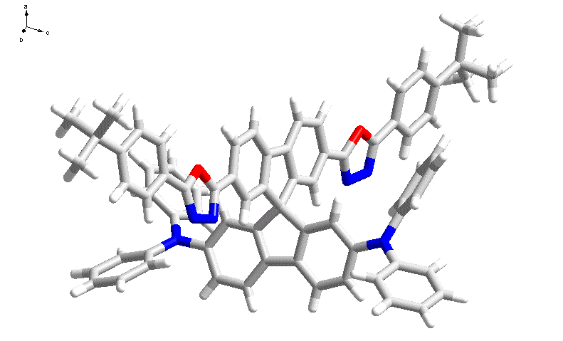
S-Figure 1. The X-ray molecular structure of 9,9’-spirobifluorene-bridged bipolar molecule 1.

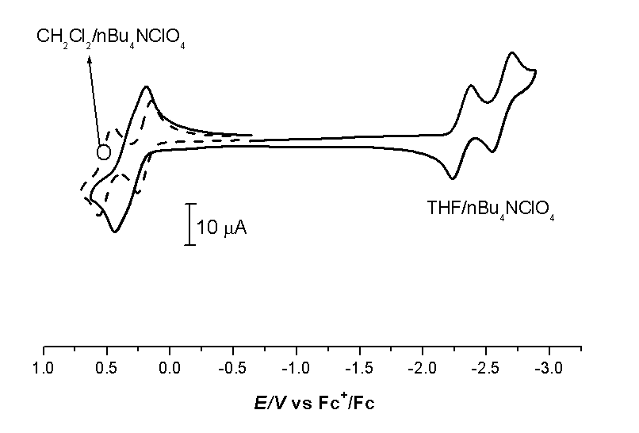

S-Figure 2. The cyclic voltammogram of 1.

