Weight loss data: These were carried out for some representative samples. Due to adherence of bacterial cells onto the polymer, the weight losses are lesser than expected. It is reported that in many such cases, weight loss data are inconclusive due to cell wall accumulation (Ref. Byungate Lee et al., Applied and Environmental Microbiology, pg. 678-685, Mar. 1991).
Sample | Initial weight (mg) | Final weight  (mg) | % weight loss
PSMAH graft lactose degraded by Serratia sp. | 250 | 222 | 11.2
PSMAH graft lactose degraded by Bacillus sp. | 250 | 231 | 7.6
PSMAH graft sucrose degraded by Bacillus sp. | 250 | 220 | 12
PSMAH degraded by Serratia sp. | 250 | 250 | 0
PSMAH degraded by Bacillus sp. | 250 | 244 | 2.4

PSMAH= poly(styrene-co-maleic anhydride)

Figure 2a: Poly(styrene-co-maleic anhydride) contg. 14 wt% maleic anhydride (Aldrich) (Film)

Figur2b: Poly(styrene-co-maleic anhydride) degraded by Bacillus sp. (Film)

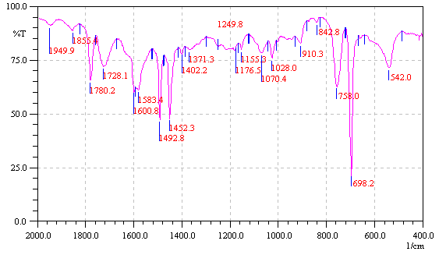
Figure 3a: Poly(styrene-co-maleic anhydride) graft Sucrose (MAH: Sucrose 1:3) (KBr)

Figure 3b: Poly(styrene-co-maleic anhydride) graft sucrose degraded by Serratia marscecens (KBr)

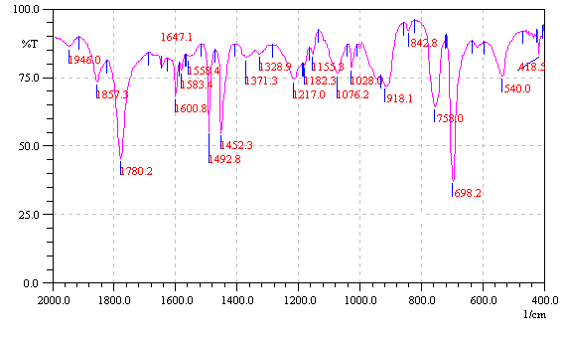
Figure 4: Blank Reaction of poly(styrene-co-maleic anhydride) (KBr)

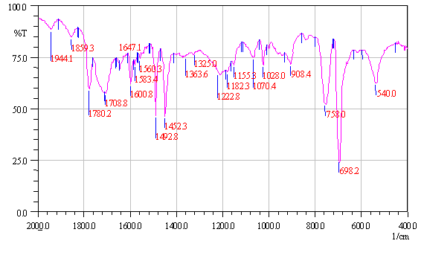
Figure 5: Hydrolyzed poly(styrene-co-maleic anhydride) (KBr)

Use of colorimetry for determination of the sugar content in the poly(styrene maleic anhydride) linked with glucose: The phenol- sulfuric acid reaction method. (Ref: Dubois M., Gilles K.A., Hamilton J.K., Rebers P.A.,Smith F., Anal. Chem., 28(3), (1956).

Glucose and glucose-linked poly(styrene maleic anhydride) polymers were dried overnight in an vacuum oven at ~60°C. A standard plot for glucose was plotted using different concentrations (0.0175mg/ml to 0.07mg/ml) of glucose in water. To 2ml of each glucose solution was added 1ml phenol and 5ml concentrated sulfuric acid was added at a fast rate. In a similar way a blank was prepared using distilled water instead of sugar solution. The absorbances were recorded at 490λ and a standard plot was plotted. Each of the accurately weighed samples (glucose-linked poly(styrene maleic anhydride)) in the range of 25mg was taken in a 50ml beaker to which were added 4ml water, 2ml 5% phenol solution in water and 10ml concentrated sulfuric acid was poured at a fast rate into the above solution. The solutions were placed in a water-bath at 25-30°C for 10 minutes. The solutions were filtered through a sintered disc to remove the undissolved polymeric backbone. The absorbances were recorded at 490λ and the unknown concentrations of the sugars were calculated from the standard plot. Using these concentrations the mole percentages and the weight percentages of the sugars in the polymers. The range of sugar content in the polymer was found to be between 0.1 – 3.7 weight %.

Quantification of carbohydrate groups linked to poly(styrene-maleic anhydride) by silylation of the carbohydrate hydroxyl’s and NMR anlysis of the spectrum :

As an illustration we report here a silylation reaction on poly(styrene-co-maleic anhydride) chemically linked with glucose and its NMR. Glucose linked poly(styrene-co-maleic anhydride) was dissolved in dry pyridine, flushed with argon and reacted with trimethylsilyl chloride in presence of argon. The reaction was stirred at room temperature for 1hour and 30minutes. The reaction mixture was filtered, precipitated in n-hexane, washed with hexane and dried in a vacuum dessicator. The NMR of the product was recorded in d6-acetone solvent on a 200 MHz Bruker instrument. The NMR showed peaks at 0δ (0.26 H) and at 6.3-7.4δ (5 aromatic H). Integration of the peaks show that the weight percentage of the carbohydrate in the polymer is 1.11.

Molecular weight decrease after biodegradation by GPC :

The reduction in the molecular weight of the degraded sample was also confirmed by GPC. The samples were dissolved in tetrahydrofuran, and passed through a ultrastyragel column of 500A°-10⁵A°. The instrument was equipped with a Waters 590 HPLC Pump, RI Waters dectector 410, Waters injecting system U6k. The biodegraded lactose linked-poly(styrene-co-maleic anhydride) sample was not fully soluble in tetrahydrofuran.
Only the soluble fraction was used for injection. This was a general difficulty for all the degraded samples, and reflects changes in the material after subjecting to biodegradation.

The figure below shows GPC Curves of starting Poly(styrene-maleic anhydride) (Curve A) , Poly(styrene-maleic anhydride) degraded by Bacillus sp. (Curve B), and Poly(styrene-maleic anhydride-linked lactose) degraded by Serratia marscecens (Curve C). Notice the shift in the peak maximum to the right, indicating lower peak molecular weights.

