Supplementary information for:
Naphthalene in the higher triplet excited state
Xichen Cai, Michihiro Hara, Kiyohiko Kawai, Sachiko Tojo, and Tetsuro Majima*
The Institute of Scientific and Industrial Research (SANKEN), Osaka University, Mihogaoka 8-1, Ibaraki, Osaka 567-0047, Japan.
E-mail: majima@sanken.osaka-u.ac.jp

A: The yield of Np(T_{n})

The yield of Np(T_{n}) was calculated from the bleaching of transient absorption of Np(T₁) at 415 nm to be 65% after the 425-nm laser irradiation in CCl₄. Time profiles of the transient absorption at 415 nm were shown in Fig. A.
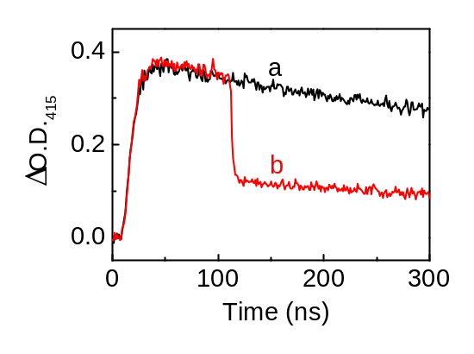

Fig. A Kinetic traces illustrating the time profiles of ΔO.D.₄₁₅ during the two-colour two-laser flash photolysis of Np (6.0 × 10⁻³ M) with BP (6.0 × 10⁻³ M) as the triplet sensitizer in Ar-saturated CCl₄ solution at room temperature. a: with 355-nm laser irradiation without 425-nm laser irradiation. b: with 355 and 425-nm two-colour two-laser irradiation.

B: The evidence for formation of Cl-benzene complex induced by Np(T_{n})

Two-colour two-laser excitation experiments were performed in the presence of various concentrations of benzene (0 ~ 2.0 M) in Ar-saturated CCl₄ solution at room temperature. In the absence of benzene, the bleaching at 490 nm was observed and found to be similar to that at 415 nm. No change of transient absorption of Np(T₁) at 415 nm was observed at various concentrations of benzene in the solutions. However, the bleaching at 490 nm decreased with increasing the concentration of benzene as shown in Fig. B. These results show that a Cl-benzene complex with absorption at 490 nm was generated from the reaction of benzene and Cl formed by dissociation of CCl₄(T₁) during 425-nm laser irradiation. Similar results were obtained when CCl₄ was replaced by CH₂Cl₂. It is well known that Cl reacts with various arenes to give Cl-arene complexes with an absorption peak at 500 nm.¹⁻³
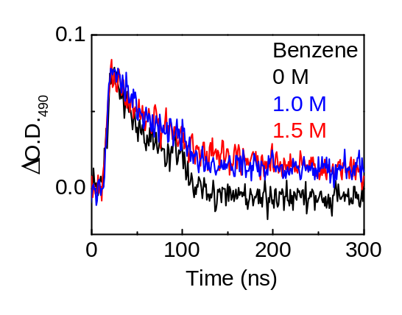

Fig. B Kinetic traces illustrating the time profiles of ΔO.D.₄₉₀ in the two-colour two-laser flash photolysis of Np (6.0 × 10⁻³ M) with BP (6.0 × 10⁻³ M) as triplet sensitizer in the absence and presence of benzene: 1.0, 1.5 M, in Ar-saturated CCl₄ solution at room temperature.

C: The evidence for no electron transfer from Np(T_{n}) to Q

Np monomer and dimer radical cations with absorption peaks at 625 and 685 nm and 570 nm, respectively, were observed under 308-nm excimer laser irradiation of Np (6.0 × 10⁻³ M) with DCNB (0.1 M) mixture in Ar-saturated acetonitrile solution at room temperature.⁴ The spectra and time profiles were shown in Fig. C-1 and Fig. C-2, respectively. If DCNB could act as an electron acceptor for the quenching of Np(T_{n}), Np radical cation and DCNB radical anion would be observed, because 65% of Np(T₁) was excited to give Np(T_{n}). No absorption peak in the 500-700 nm wavelengths was observed during the two-colour two-laser flash photolysis at the high concentration of DCNB (0.7 M) as shown in Fig. C-3. Fig. C-4 shows no absorption at 570 and 685 nm in the 300 ns time scale. The experimental results show that no electron transfer from Np(T_{n}) to Q occurred.
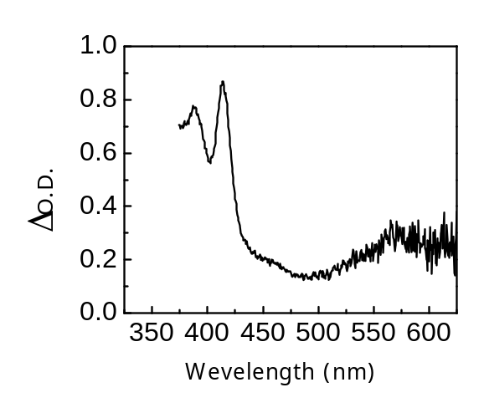

Fig. C-1 Transient absorption spectrum obtained at 100 ns after 308-nm excimer laser excitation during laser photolysis of Np (6.0 × 10⁻³ M) with DCNB (0.1 M) in Ar-saturated acetonitrile solution at room temperature.
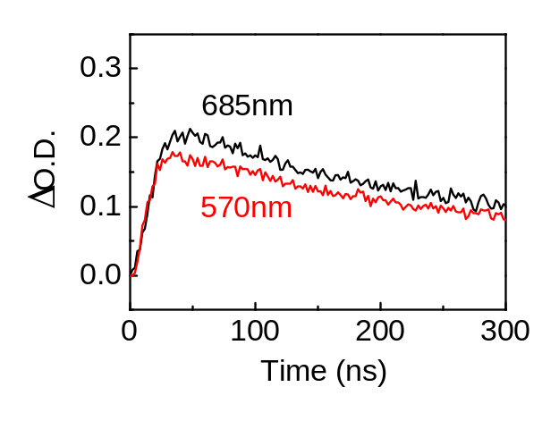

Fig. C-2 Kinetic traces illustrating the time profiles of ΔO.D.₅₇₀ and ΔO.D.₆₈₅ in the 308-nm excimer laser flash photolysis of Np (6.0 × 10⁻³ M) with DCNB (0.1 M) in Ar-saturated acetonitrile solution at room temperature.

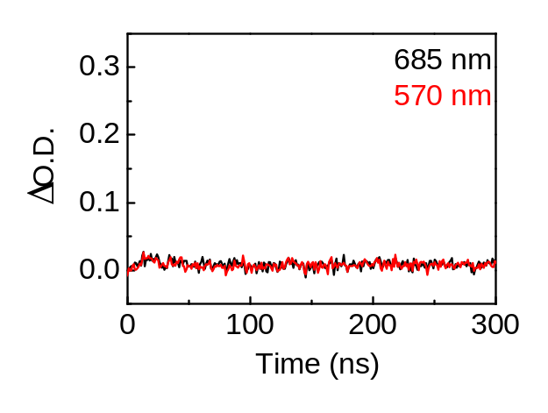

Fig. C-4 Kinetic traces illustrating the time profiles of ΔO.D.₅₇₀ and ΔO.D.₆₈₅ in the two-colour two-laser flash photolysis of Np (6.0 × 10⁻³ M) with BP (6.0 × 10⁻³ M) and DCNB (0.7 M) in Ar-saturated acetonitrile solution at room temperature.

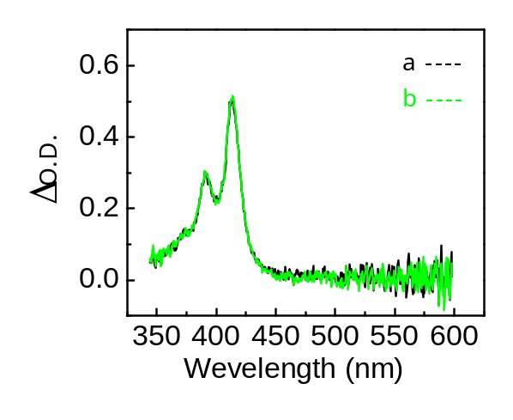

Fig. C-3 Transient absorption spectra obtained at 100 ns after 425-nm laser excitation during two-colour two-laser flash photolysis of Np (6.0 × 10⁻³ M) with BP (6.0 × 10⁻³ M) and DCNB (0.7 M) in Ar-saturated acetonitrile solution at room temperature. a: with 355-nm laser irradiation without 425-nm laser irradiation. b: with 355 and 425-nm two-colour two-laser irradiation.

Supplementary information references:

1, T. Gannon and W. G. McGimpsey, J. Org. Chem., 1993, 58, 5639.
2, N. Ichinose and T. Majima, Chem. Phys. Lett., 2000, 322, 15.
3, T. Sumiyoshi, M. Kawasaki, and M. Katayama, Bull. Chem. Soc. Jpn. 1993, 66, 2510.
4, A. Tsuchida, Y. Tsujii, S. Ito and M. Yamamoto, J. Phys. Chem., 1989, 93, 1244.

