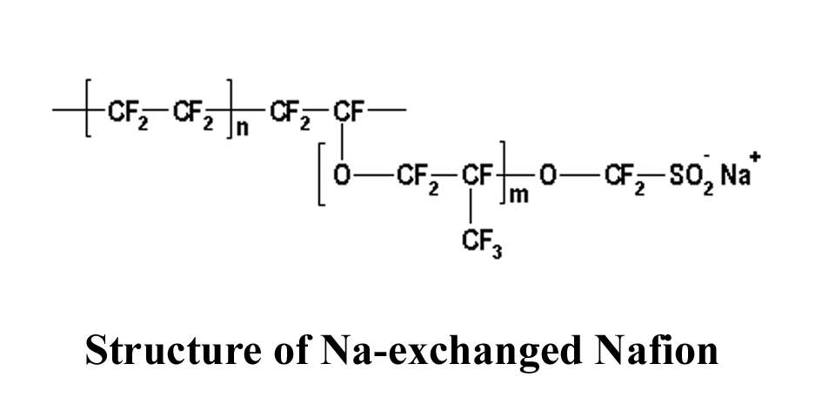
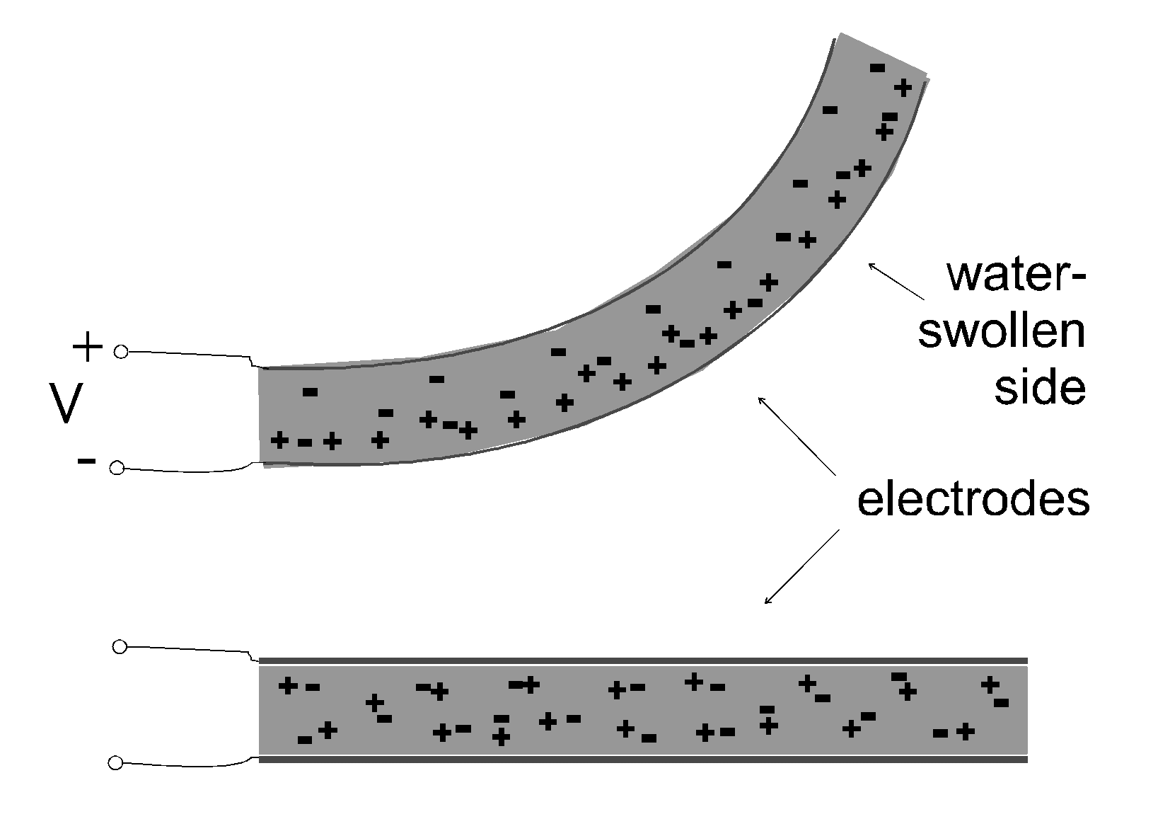

Schematic description of actuation mechanism of an Electro-Active Polymer actuator device

