ELECTRONIC SUPPLEMENTARY DATA

Synthesis and characterisation of (4)·3thf
Bu^{t}Li (0.59 ml, 1 mmol, 1.7M in pentane) was added to a slurry of 2-ethyl-N,N-diisopropyl-1-naphthamide 3 (0.30 g, 1 mmol) in thf:hex. (0.5 ml: 0.5 ml) at –78 ºC. The resultant dark green solution was allowed to warm to –30 ºC and stored at that temperature for 24 hrs. whereupon (4)·3thf deposited. Yield 27 mg (30 %; corrected for thf loss, see text; first batch yield), m. p. 162-164 °C. Found: C 75.50, H 8.73, N 5.21 %. Calcd. for C₂₃H₃₂NO₂Li (corrected for thf loss): C 76.43, H 8.92, N 3.88 %.

¹H NMR spectroscopy (400 MHz, –25 ºC, [²H₈]thf) δ 6.37-5.50 (m, 6H, Ar), 4.49 (sept., 1H, NCH), 3.62 (m, 4H, thf), 3.45 (sept., 1H, NCH), 2.84 (q, 1H, CHMe), 1.79 (m, 4H, thf), 1.57 (d, 3H, NMe), 1.50 (d, 3H, NMe), 1.49 (d, 3H, CHMe), 1.20 (d, 3H, NMe), 1.01 (d, 3H, NMe). ¹³C NMR spectroscopy (100 MHz, –25 ºC, [²H₈]thf) δ 178.3 (CO), 138.7-98.3 (Ar), 68.4 (CHMe), 67.3 (thf), 50.9, 45.0 (NCH), 25.5 (thf), 21.2-20.0 (NMe), 12.7 (CHMe).

¹H NMR spectroscopy (400 MHz, –25 ºC, [²H₈]PhMe) δ 7.26-6.54 (m, 6H, Ar), 4.50 (sept., 1H, NCH), 3.48 (m, 8H, thf), 3.21 (q, 1H, CHMe), 3.05 (sept., 1H, NCH), 2.06 (d, 3H, CHMe), 1.62 (d, 3H, NMe), 1.49 (s, br., 3H, NMe), 1.34 (m, 8H, thf), 0.84 (s, br., 6H, NMe). ¹³C NMR spectroscopy (100 MHz, –25 ºC, [²H₈]PhMe) δ 178.5 (CO), 134.4-99.0 (Ar), 67.8 (thf), 58.2 (CHMe), 52.3, 45.6 (NCH), 25.3 (thf), 21.8, (NMe), 13.8 (CHMe).

¹H NMR spectroscopy (400 MHz, –80 ºC, [²H₈]PhMe) δ 7.39-6.54 (m, 6H, Ar), 4.67 (sept., 0.6H, NCH), 4.43 (sept., 0.4H, NCH), 3.50 (m, 4H, thf), 2.37 (q, 0.6H, CHMe), 3.31 (q, 0.4H, CHMe), 2.94 (sept., 0.6H, NCH), 2.76 (sept., 0.4H, NCH), 2.21 (d, 1.2H, CHMe), 2.18 (d, 1.8H, CHMe), 1.62 (m, br, 4.8H, NMe), 1.35 (sh, br, 1.2H, NMe), 1.30 (m, 4H, thf), 0.97 (d, 1.8H, NMe), 0.87 (d, 1.8H, NMe), 0.74 (m, br, 2.4H, NMe). ¹³C NMR spectroscopy (100 MHz, –80 ºC, [²H₈]PhMe) δ 178.6, 177.9 (CO), 144.1-99.4 (Ar), 67.9 (thf), 60.6, 57.0 (CHMe), 53.0-45.4 (NCH), 25.5 (thf), 22.2 (NMe), 14.3, 14.1 (CHMe).

Crystal data for (4)·3thf: C₃₁H_{48.5}LiNO₄; M = 506.15, monoclinic, space group Pn, a = 9.9696(4), b = 18.6529(8), c = 16.5704(5) Å, β = 92.384(2)º, U = 3078.8(2) Å³, Z = 4, D_{c} = 1.092 g cm⁻³, Mo-K_{α} (λ = 0.71069 Å), μ = 0.070 mm⁻¹, T = 180(2) K. 17732 reflections (8977 unique, θ < 25.02º, R_{int} = 0.0482), data were collected. Refinement on F² values of all data gave wR2 = 0.2004, conventional R = 0.0713 on F values of all reflections with F² > 2σ(F²), 740 parameters. Residual electron density within ±0.40 e Å⁻³. CCDC-205221. The asymmetric unit contains two crystallographically independent molecules, of which one exhibits disorder of the naphthyl system over two positions. This has been modelled as two parts, with occupancies of 0.619(8) and 0.381(8).
Variable temperature NMR spectroscopy

Variable temperature ¹H NMR spectra for (4)·3thf in [²H₈]thf

27ºC
0ºC
–25ºC
–50ºC
–80ºC
Variable temperature ¹H NMR spectra for (4)·3thf in [²H₈]PhMe

27ºC
0ºC
–25ºC
–50ºC
–60ºC
–70ºC
–80ºC
Variable temperature ¹H NMR spectra for (4)·3thf in [²H₈]PhMe

–45ºC
–47ºC
–48ºC
–49ºC
–50ºC
–52ºC

Gaussian 98 calculations on 3 and its lithium derivatives

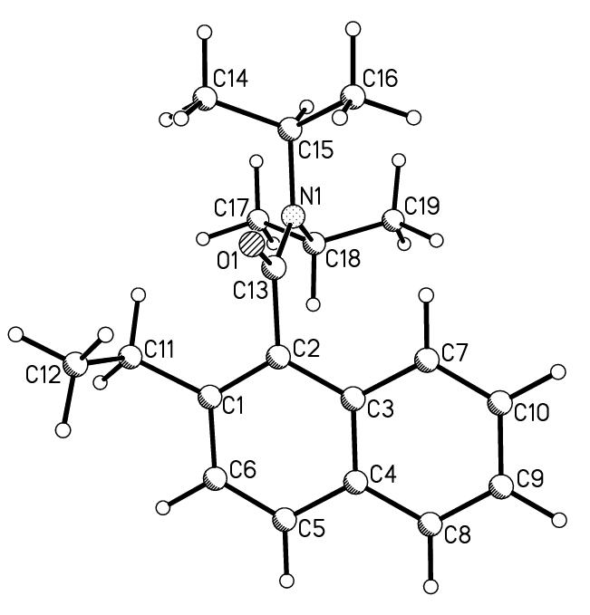
I

 | I
C1–C11 / Å | 1.514
C1–C2 / Å | 1.385
C2–C13 / Å | 1.519
C13–O1 / Å | 1.227

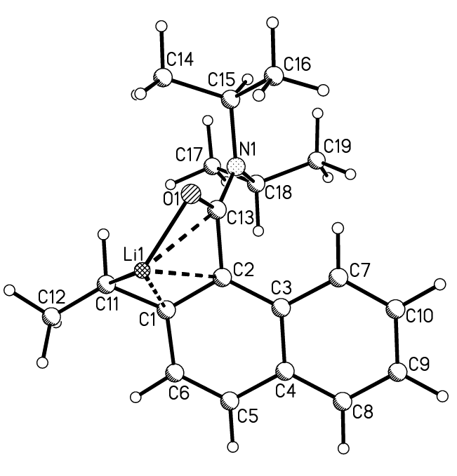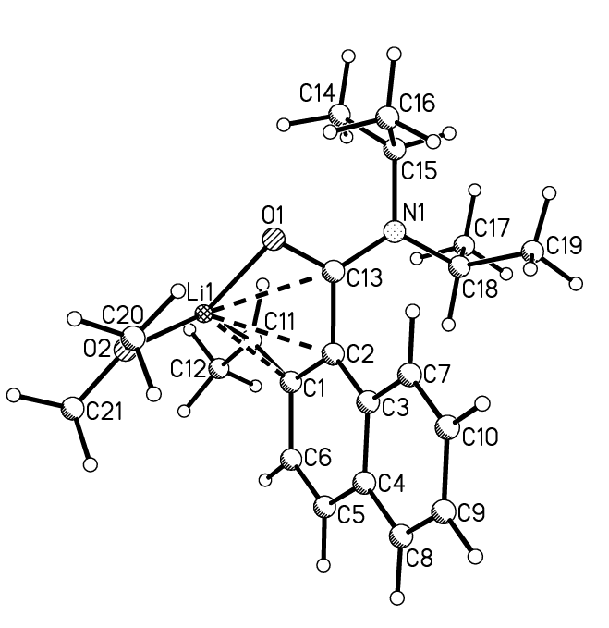

IIa IIIa

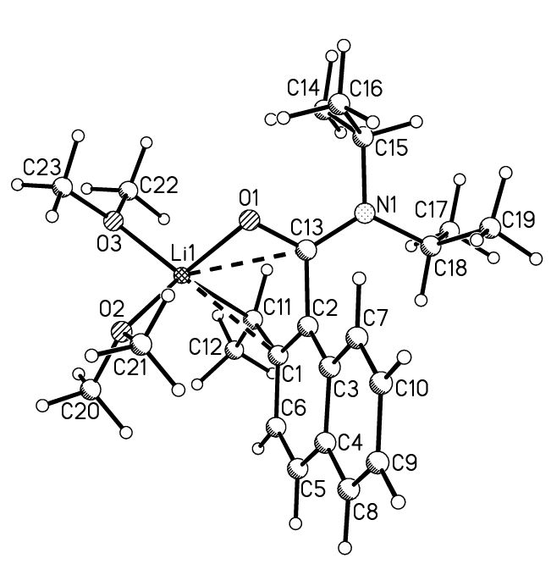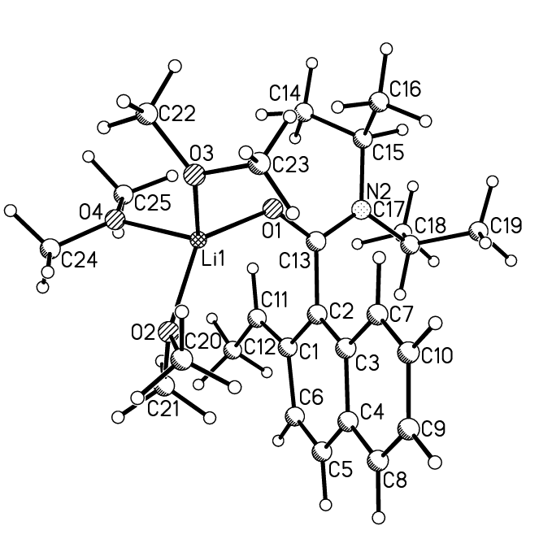
IVa Va

 | IIa | IIIIa | IVa | Va
Li1–C11 / Å | 2.123 | 2.195 | 2.276 | –
Li1–O1 / Å | 1.866 | 1.907 | 1.931 | 1.888
C1–C11 / Å | 1.416 | 1.408 | 1.405 | 1.380
C1–C2 / Å | 1.439 | 1.441 | 1.440 | 1.451
C2–C13 / Å | 1.503 | 1.500 | 1.495 | 1.492
C13–O1 / Å | 1.262 | 1.259 | 1.257 | 1.260
O1–Li1–C11 / º | 105.3 | 99.3 | 94.4 | –
Li1–O1–C13 / º | 98.2 | 100.3 | 110.6 | 129.5
C11 | –0.33 | –0.23 | –0.37 | –0.27
C1 | 0.00 | +0.04 | 0.00 | +0.03
C2 | –0.35 | –0.33 | –0.25 | –0.32
C13 | +0.50 | +0.52 | +0.47 | +0.47
O1 | –0.48 | –0.47 | –0.48 | –0.51
Li1 | +0.49 | +0.53 | +0.55 | +0.62
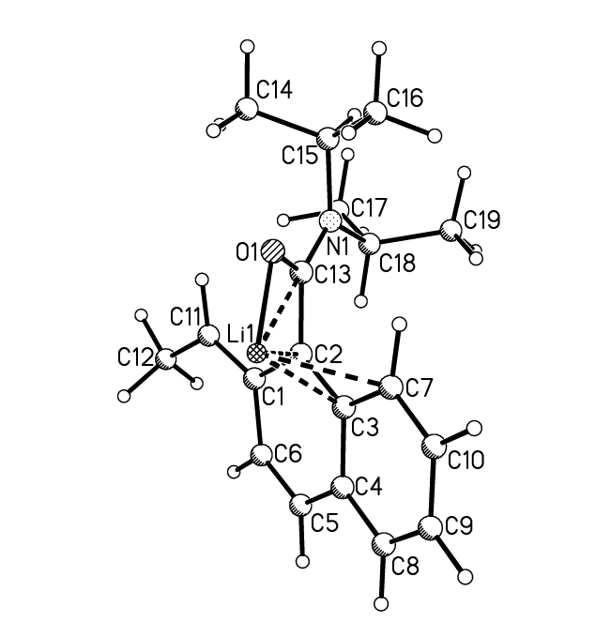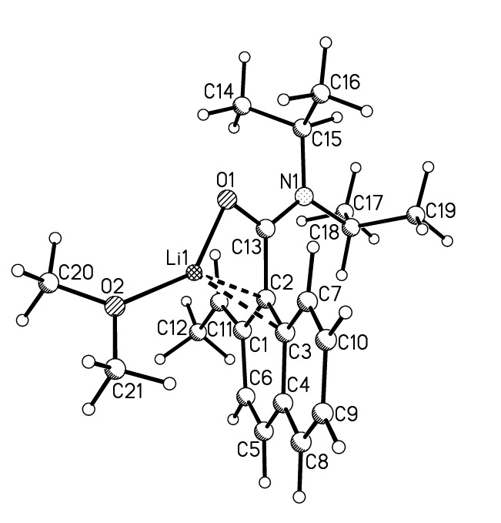

IIb IIIb

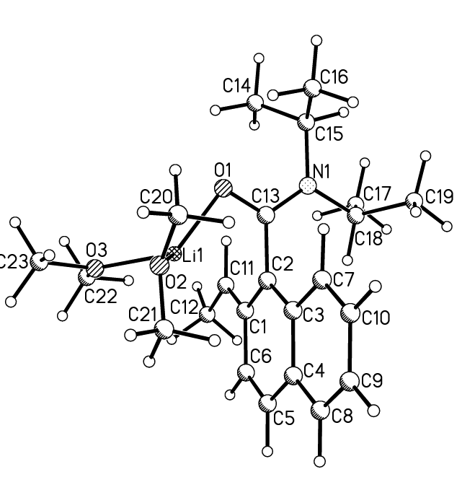
IVb Vb

 | IIb | IIIIb | IVb | Vb (= Va)
Li1–O1 / Å | 1.840 | 1.871 | 1.904 | 1.888
C1–C11 / Å | 1.368 | 1.370 | 1.379 | 1.380
C1–C2 / Å | 1.467 | 1.464 | 1.455 | 1.451
C2–C13 / Å | 1.495 | 1.495 | 1.500 | 1.492
C13–O1 / Å | 1.270 | 1.266 | 1.260 | 1.260
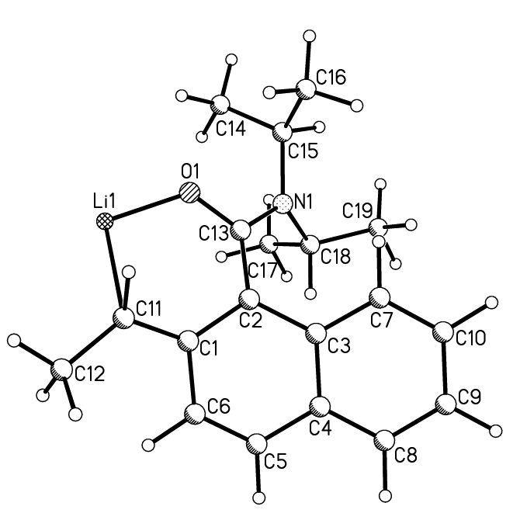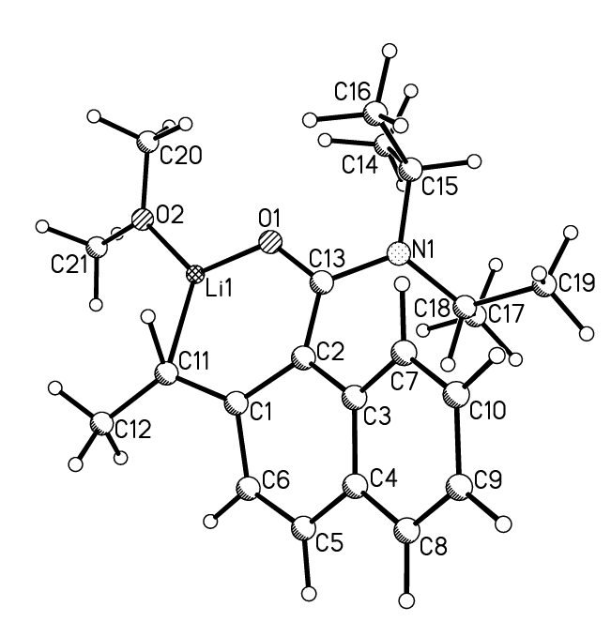

IIc IIIc

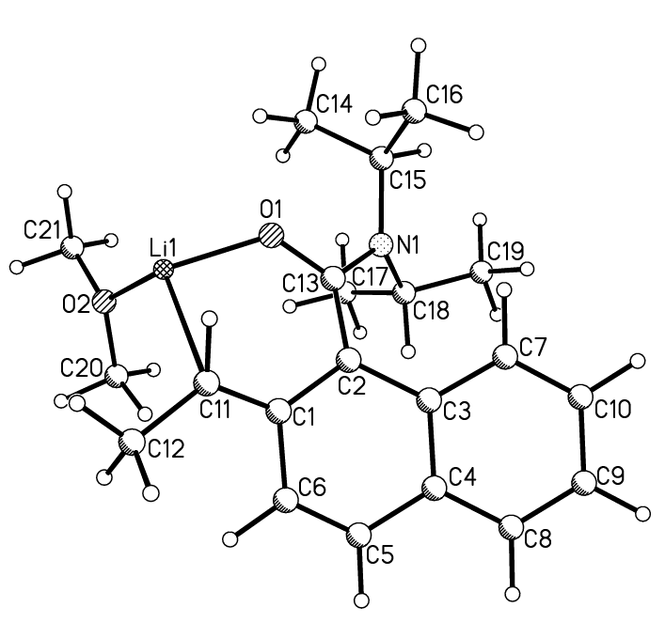
IVc Vc

 | IIc | IIIIc | IVc | Vc (= Va)
Li1–C11 / Å | 2.087 | 2.166 | 2.321 | –
Li1–O1 / Å | 1.739 | 1.772 | 1.826 | 1.888
C1–C11 / Å | 1.403 | 1.390 | 1.380 | 1.380
C1–C2 / Å | 1.462 | 1.467 | 1.474 | 1.451
C2–C13 / Å | 1.446 | 1.438 | 1.432 | 1.492
C13–O1 / Å | 1.277 | 1.276 | 1.276 | 1.260
O1–Li1–C11 / º | 98.3 | 94.0 | 86.3 | –
Li1–O1–C13 / º | 125.2 | 128.4 | 126.5 | 129.5
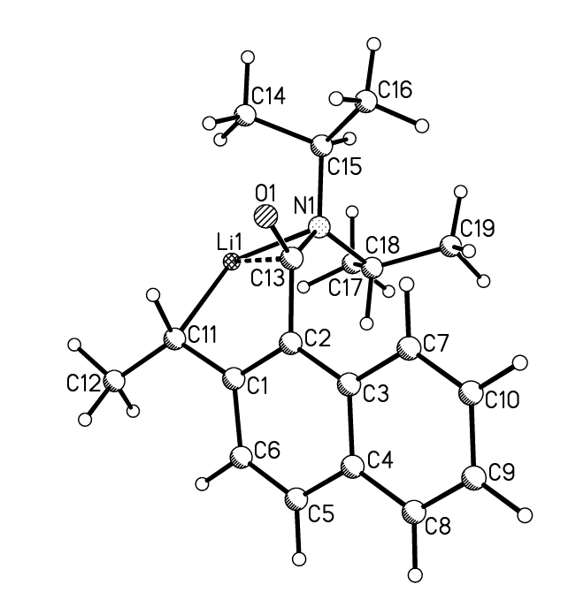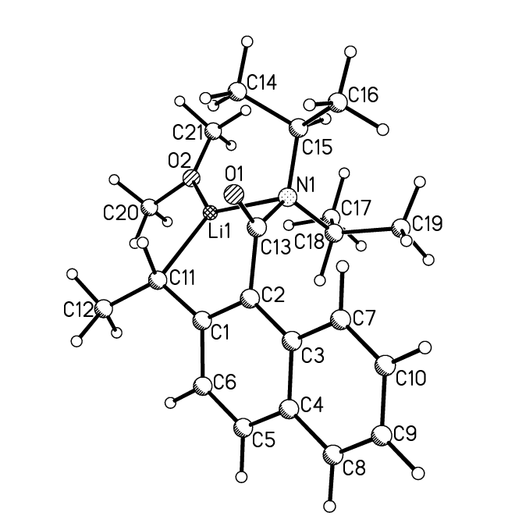

IId IIId

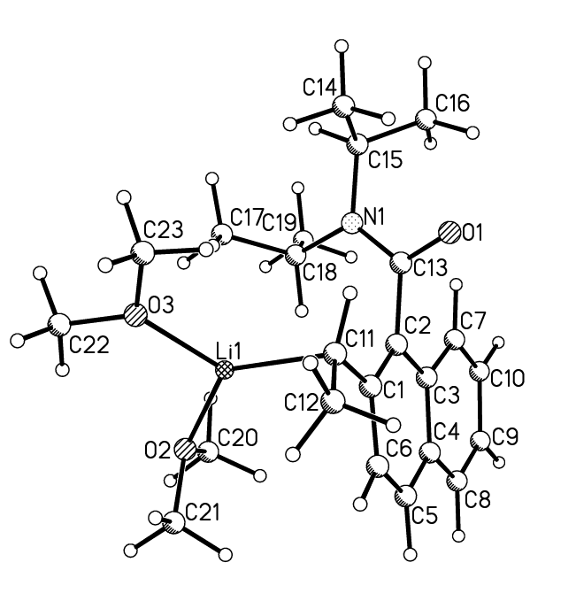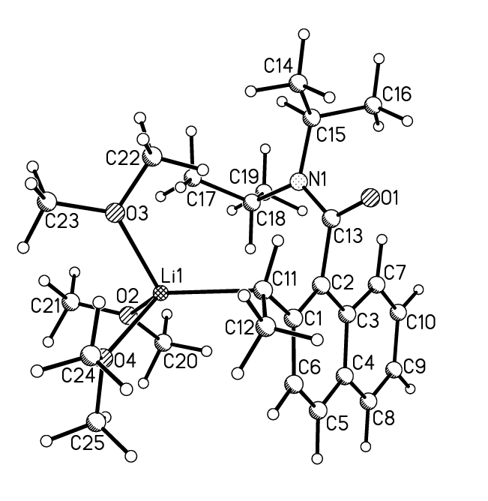
IVd Vd

 | IId | IIIId | IVd | Vd
Li1–C11 / Å | 2.025 | 2.085 | 2.098 | 2.199
Li1–N1 / Å | 2.071 | 2.233 | – | –
C1–C11 / Å | 1.450 | 1.443 | 1.435 | 1.440
C1–C2 / Å | 1.417 | 1.417 | 1.423 | 1.421
C2–C13 / Å | 1.500 | 1.500 | 1.514 | 1.515
C13–N1 / Å | 1.435 | 1.432 | 1.384 | 1.385
N1–Li1–C11 / º | 110.5 | 103.2 | – | –
Li1–N1–C13 / º | 92.4 | 93.5 | – | –
Table 1 Absolute and relative energies of 2-ethyl-N,N-diisopropyl-1-naphthamide (I) and its lithium derivatives (IIa-d)-(Va-d) calculated using Gaussian 98 with geometries refined using DFT procedure at the B3LYP level/6-311G** basis set.

——————————————————————————————————
Structure | DFT Energy (Har.) | DFT + ZP Energy  (Har.) | Relative Energy  (kcal mol^{–1})
——————————————————————————————————
I | –869.312712 | –868.921968 | –
IIa | –876.254499 | –875.874960 | 0.0
IIb | –875.242494 | –875.863256 | 7.3
IIc | –876.230919 | –875.851586 | 14.7
IId | –876.219260 | –875.840086 | 21.9
IIIa | –1031.356142 | –1030.897244 | 0.0
IIIb | –1031.347755 | –1030.888605 | 5.4
IIIc | –1031.333235 | –1030.874146 | 14.5
IIId | –1031.316455 | –1030.856897 | 25.3
IVa | –1186.445065 | –1185.906070 | 0.0
IVb | –1186.440644 | –1185.901749 | 2.7
IVc | –1186.425981 | –1185.886836 | 12.1
IVd | –1186.410019 | –1185.871314 | 21.8
Va | –1341.522344 | –1340.903418 | 0.0
Vb (= Va) | –1341.522344 | –1340.903418 | 0.0
Vc (= Va) | –1341.522344 | –1340.903418 | 0.0
Vd | –1341.492632 | –1340.873914 | 18.5
——————————————————————————————————

Table 2 ΔE (kcal mol^{–1}) for the conversions of I, IIa, IIIa and IVa into IIa, IIIa, IVa and Va, respectively.Error: Reference source not found-Error: Reference source not found

——————————————————————————————————
Process | ΔE (kcal mol^{–1})
——————————————————————————————————
I + MeLi → IIa + MeH | –29.1
IIa + Me₂O → IIIa | –18.0
IIIa + Me₂O → IVa | –9.7
IVa + Me₂O → Va | –2.4
——————————————————————————————————

References

Gaussian 98, Revision A.9, M. J. Frisch, G. W. Trucks, H. B. Schlegel, G. E. Scuseria, M. A. Robb, J. R. Cheeseman, V. G. Zakrzewski, J. A. Montgomery, Jr., R. E. Stratmann, J. C. Burant, S. Dapprich, J. M. Millam, A. D. Daniels, K. N. Kudin, M. C. Strain, O. Farkas, J. Tomasi, V. Barone, M. Cossi, R. Cammi, B. Mennucci, C. Pomelli, C. Adamo, S. Clifford, J. Ochterski, G. A. Petersson, P. Y. Ayala, Q. Cui, K. Morokuma, D. K. Malick, A. D. Rabuck, K. Raghavachari, J. B. Foresman, J. Cioslowski, J. V. Ortiz, A. G. Baboul, B. B. Stefanov, G. Liu, A. Liashenko, P. Piskorz, I. Komaromi, R. Gomperts, R. L. Martin, D. J. Fox, T. Keith, M. A. Al-Laham, C. Y. Peng, A. Nanayakkara, M. Challacombe, P. M. W. Gill, B. Johnson, W. Chen, M. W. Wong, J. L. Andres, C. Gonzalez, M. Head-Gordon, E. S. Replogle, and J. A. Pople, Gaussian, Inc., Pittsburgh PA, 1998.
A D. Becke, Phys. Rev. A, 1988, 38, 3098; A. D. Becke, J. Chem. Phys., 1993, 98, 5648.
W. J. Lehre, R. Ditchfield and J. A. Pople, J. Chem. Phys., 1972, 56, 2257; P. C. Harihanan and J. A. Pople, Theor. Chim. Acta, 1973, 28, 213, J. D. Dill and J. A. Pople, J. Chem. Phys., 1975, 62, 2921.

