Electronic Supplementary Information

Title A pseudorotaxane-based molecular machine controlled by light and thermal stimuli

Author Kyu-Sung Jeong∗, Kyoung-Jin Chang and Young-Jae An

Contents
1. Synthesis of thread 1 and macrocycle 6
2. ¹H – ¹H NOESY spectra of trans-1 and cis-1
3. Modeling structures of trans-1 and cis-1
4. UV-visible spectra change of thread 1 upon irradiation
5. ¹H NMR spectral changes of thread 1 induced by irradiation and heating

1. Synthesis of thread 1 and macrocycle 6
General Experimental Methods: All reagents were, unless otherwise noted, used as purchased. Chloroform was distilled under nitrogen from calcium hydride, toluene and tetrahydrofuran from Na/benzophenone, and triethylamine from KOH. Melting points were uncorrected. All NMR spectra were recorded on a DRX-500 spectrometer and chemical shifts were reported in ppm downfield relative to TMS (0 ppm) for ¹H NMR, and the residual solvent peak (CHCl₃: 77 ppm) for ¹³C NMR spectrum. Infrared spectra were obtained with a Nicolet impact 410 FT-IR spectrometer and FAB-MS spectra were obtained with a JEOL, JMS-AX505WA mass spectrometer.
2,7-Di-tert-butyl-9,9-dimethyl-4,5-dinitro-9H-xanthene (3): To a suspension of 2,7-bis(1,1-dimethyl)-9,9-dimethylxanthene 2¹ (2.70 g, 0.73 mol) in acetic acid (300 mL) was added dropwise fuming nitric acid (30 mL) in acetic acid (30 mL) for 1 h at room temperature, the solution was stirred for 42 h at room temperature. Precipitates were filtered, washed with water (3 × 5 mL) and dried in vacuo. White solid (1.70 g, 49%); mp 296-298 ºC; R_{f}: 0.15 (CH₂Cl₂:n-Hex=1:1); ¹H NMR (500 MHz, CDCl₃): δ (ppm) 7.78 (d, J = 4.4 Hz, 2H), 7.65 (d, J = 4.4 Hz, 2H), 1.67 (s, 6H), 1.36 (s, 18H); ¹³C NMR (126 MHz, CDCl₃): δ (ppm) 147.7, 141.1, 139.3, 132.4, 127.5, 121.4, 35.8, 35.5, 32.6, 31.8; IR (KBr) 1600, 1265 cm⁻¹; Anal. Calcd for C₂₃H₂₈N₂O₅: C, 66.97; H, 6.84; N, 6.79; Found: C, 66.92; H, 6.87, N, 6.76.
2,7-Di-tert-9,9-dimethyl-9H-xanthene-4,5-diamine (4): Compound 3 (0.90 g, 2.4 mmol) was dissolved in THF(50 mL) and a catalytic amount of Raney Ni was added. The solution was stirred under H₂ balloon for 1 h. The catalyst was filtered off through celite and the solvent was evaporated to yield 4 as a white solid (0.71 g, 93%); mp 210-211 ℃; R_{f}: 0.46 (EtOAc:CH₂Cl₂=1:5); ¹H NMR (500 MHz, CDCl₃): δ (ppm) 6.84 (s, 2H), 6.69 (s, 2H), 3.80 (s, 4H; NH₂), 1.61(s, 6H), 1.30 (s, 18H); ¹³C NMR (126 MHz, CDCl₃): δ (ppm) 135.6, 133.5, 127.5, 113.1, 111.8, 110.4, 35.8, 32.5, 32.0, 31.0; IR(KBr) 3400 cm⁻¹; Anal. Calcd for C₂₃H₃₂N₂O: C, 78.36; H, 9.15; N, 7.95. Found: C, 78.35; H, 9.13, N, 7.94.

(1) J. S. Nowick, P. Ballester, F. Ebmeyer and J. Rebek, Jr., J. Am. Chem. Soc., 1990, 112, 8902.
2,7-Di-tert-9,9-dimethyl-5-phenylazo-9H-xanthen-4-ylamine (5): A solution of compound 4 (0.16
g, 0.45 mmol), nitrosobenzene (0.48 mg, 0.45 mmol, 1 equiv) and two drops of acetic acid in CHCl₃ (6 mL) was stirred at room temperature under argon.² After stirring 12 h, the solution was diluted with CHCl₃ washed with saturated NaHCO₃ solution and brine, and dried over anhydrous MgSO₄. After concentration, the residue was purified by column chromatography (CH₂Cl₂:n-Hex=1:1) to give 5 as a redish solid (0.12 g, 61%); R_{f}: 0.47 (CH₂Cl₂:n-Hex=1:1); mp 180-182 ℃; ¹H NMR (500 MHz, CDCl₃): δ (ppm) 7.97 (d, J= 6.7 Hz, 2H), 7.62-7.46 (m, 5H), 6.85 (d, J= 2.1 Hz, 1H), 6.73 (d, J= 2.1 Hz, 1H), 4.04 (s, 2H; NH₂), 1.69 (s, 6H), 1.34 (s, 9H), 1.32 (s, 9H); ¹³C NMR (126 MHz, CDCl₃): δ 146.7, 145.8, 140.6, 137.1, 133.0, 130.7, 129.2, 128.8, 127.0, 126.5, 123.4, 122.7, 116.6, 112.8, 112.1, 111.5, 35.1, 32.3, 32.2, 32.1; IR(KBr) 3410, 1480 cm⁻¹; Anal. Calcd for C₂₉H₃₅N₃O: C, 78.87; H, 7.99; N, 9.52. Found: C, 78.87; H, 7.98; N, 9.51.
N-(2,7-Di-tert-butyl-9,9-dimethyl-5-phenylazo-9H-xanthen-4-yl)-N’,N’-diethyl-terephthalamide
(1): To a solution of terephthaloyl chloride (0.11 g, 0.56 mmol) in CHCl₃ (35 mL) was added dropwise compound 5 (0.25 g, 0.56 mmol, 1 equiv) and triethylamine (0.20 mL, 1.1 mmol, 2 equiv) in CHCl₃ (20 mL) for 2 h at 0 ºC (ice-water bath) under argon. After stirring for 2.5 h at room temperature, diethylamine (0.3 mL, 3.36 mmol, 6 equiv) was added at 0 ºC and the mixture was stirred for 4 h at room temperature. The organic solution was washed with saturated NaHCO₃ solution and brine, and dried over anhydrous MgSO₄. After concentration, the residue was purified by column chromatography (EtOAc) to give 1 as a redish solid (90 mg, 26%); R_{f}: 0.63 (EtOAc); mp 238-240 ℃; ¹H NMR (500 MHz, CDCl₃): δ (ppm) 8.98 (s, 1H; NH), 8.63 (s, 1H), 7.87 (d, J = 7.8 Hz, 2H), 7.79 (s, 2H), 7.62
7.62 (s, 1H), 7.55 (s, 1H), 7.50-7.41 (m, 3H), 7.24 (s, 1H), 7.09 (d, J = 7.8 Hz, 2H), 3.58 (m, 2H), 3.16 (m, 2H), 1.74 (s, 6H), 1.59 (s, 6H), 1.38(s, 9H); ¹³C NMR (126 MHz, CDCl₃): δ (ppm) 164.5, 152.5,

(2) (a) W. Shuangxi and C. A. Rigiberto, Org. Lett., 2001, 3, 3831; (b) M. H. Davey, V. Y. Lee, R. D. Miller and T. J. Marks, J. Org. Chem., 1999, 64, 4976.
147.1, 146.3, 141.4, 140.4, 137.1, 135.3, 131.6, 130.1, 128.8, 127.6, 126.5, 125.2, 123.3, 122.7, 122.0, 117.6, 116.3, 114.9, 112.9, 40.8, 34.9, 31.9, 31.7, 31.5, 13.2; IR(KBr) 3287, 1688, 1480 cm⁻¹; Anal. Calcd for C₄₁H₄₈N₄O₃: C, 76.37; H, 7.50; N, 8.69. Found: C, 76.36; H, 7.48; N, 8.68.

4-Nitro-pyridine-2,6-dicarbonyl bis(diamine) 9: 1,1-Bis-(4-amino-3,5- dimethylphenyl)cyclohexane 8 ³ (3.89 g, 12.0 mmol, 3 equiv) was dissolved in CH₂Cl₂ (20 mL) and 0.5 mL of N,N-diisopropylethylamine (2 mL, 12.0 mmol, 3 equiv) was added. The solution of 4-nitro-pyridine-2,6-dicarbonyl dichloride 7 ⁴ ( 1.00 g, 4.0 mmol) in CH₂Cl₂ (17 mL) was added dropwise for 3 h at 0 ºC (ice-water bath) under argon and the solution was stirred for 11 h at room temperature. The solution was washed with saturated NaHCO₃ solution and brine, and dried over anhydrous MgSO₄.
After concentration, the residue was purified by column chromatography (EtOAc:CHCl₃=1:6) to give 9 as a brown solid (1.04 g, 32%); R_{f}: 0.2 (EtOAc:CHCl₃=1:6); mp >300℃; ¹H NMR (500 MHz, CDCl₃): δ (ppm) 9.17 (s, 2H), 8.86 (s, 2H; NH), 6.80 (s, 4H), 3.46 (s, 4H; NH₂), 2.20 (s, 22H), 2.15 (s, 12H), 1.54 (s, 16H); ¹³C NMR (126 MHz, CDCl₃): δ (ppm) 165.2, 159.4, 152.4, 149.0, 145.6,
(3) (a) C. A. Hunter, J. Am. Chem. Soc., 1992, 114, 5303-5311. (b) F. J. Carver, C.A. Hunter, R. J. Shannon, J. Chem. Soc., Chem. Commun., 1994, 1277.
(4) J. S. Bradshaw, G. E.Mass, J. D. Lamb, R. M. Izatt, J. J. Christensen, J. Am. Chem. Soc. 1980, 102, 467.
140.1, 137.1,134.3, 129.7, 127.2, 127.0, 126.9, 124.7, 121.4, 120.0, 44.9, 37.2, 23.0, 19.0, 18.1; IR(KBr) 3410, 3287, 1600, 1693 cm⁻¹; Anal. Calcd for C₅₁H₆₀N₆O₄: C, 74.60; H, 7.37; N, 10.24. Found: C, 74.58; H, 7.36; N, 10.20.
Tetralactom macrocycle 6: Compound 9 (0.99 g, 1.2 mmol) was dissolved in CH₂Cl₂ (10 mL) and 4-nitro-pyridine-2,6-dicarbonyl dichloride 7 (0.30 g, 1.2 mmol, 1 equiv) was separately dissolved in CH₂Cl₂ (10 mL). These two solutions were dropwise added to CH₂Cl₂ (20 mL) and N,N-diisopropylethylamine (0.6 mL, 3.6 mmol, 3 equiv) for 3 h at room temperature under argon. The solution was stirred for additional 15 h at room temperature. The organic solution was washed with saturated NaHCO₃ solution and brine, and dried over anhydrous MgSO₄. After concentration, the residue was purified by column chromatography (EtOAc:CH₂Cl₂=1:20) to give 6 as a yellow solid (0.27 g, 23%); R_{f}: 0.3 (EtOAc:CH₂Cl₂=1:20); mp >300 ℃; ¹H NMR(500 MHz, CDCl₃): δ (ppm) 9.18 (s, 4H), 8.82 (s, 4H; NH), 6.99 (s, 8H), 2.29 (m, 9H), 2.15 (s, 15H), 1.64 (m, 10H); ¹³C NMR (126 MHz, CDCl₃): δ (ppm) 159.0, 152.0, 159.0, 149.0, 134.6, 127.6, 126.3, 119.2, 45.0, 37.2, 223.0, 19.4, 18.5; IR(KBr) 3414, 1704, 1600 cm⁻¹; Anal. Calcd for C₅₈H₆₀N₈O₈: C, 69.86; H, 6.06; N, 11.24. Found: C, 69.84; H, 6.05; N, 11.22.

2. ¹H – ¹H NOESY spectra of trans-1 and cis-1
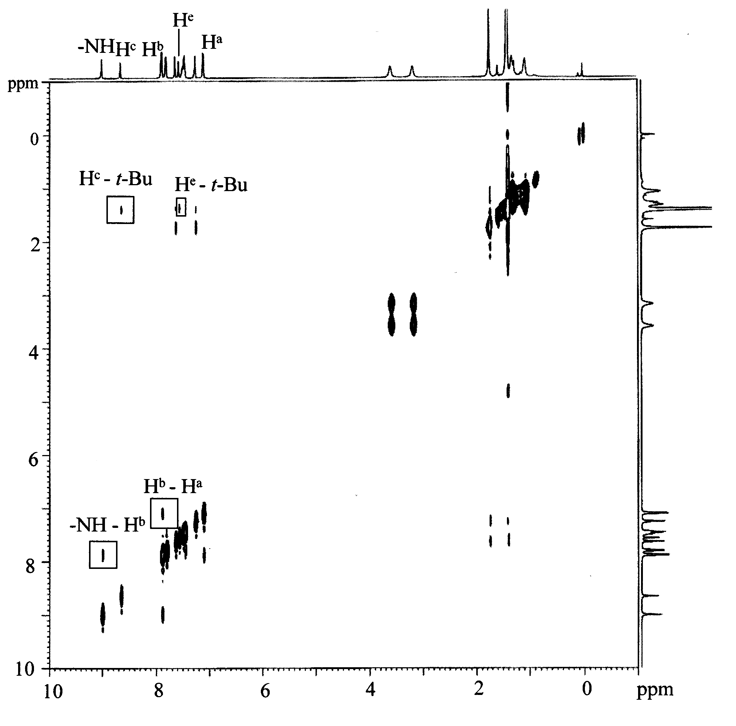
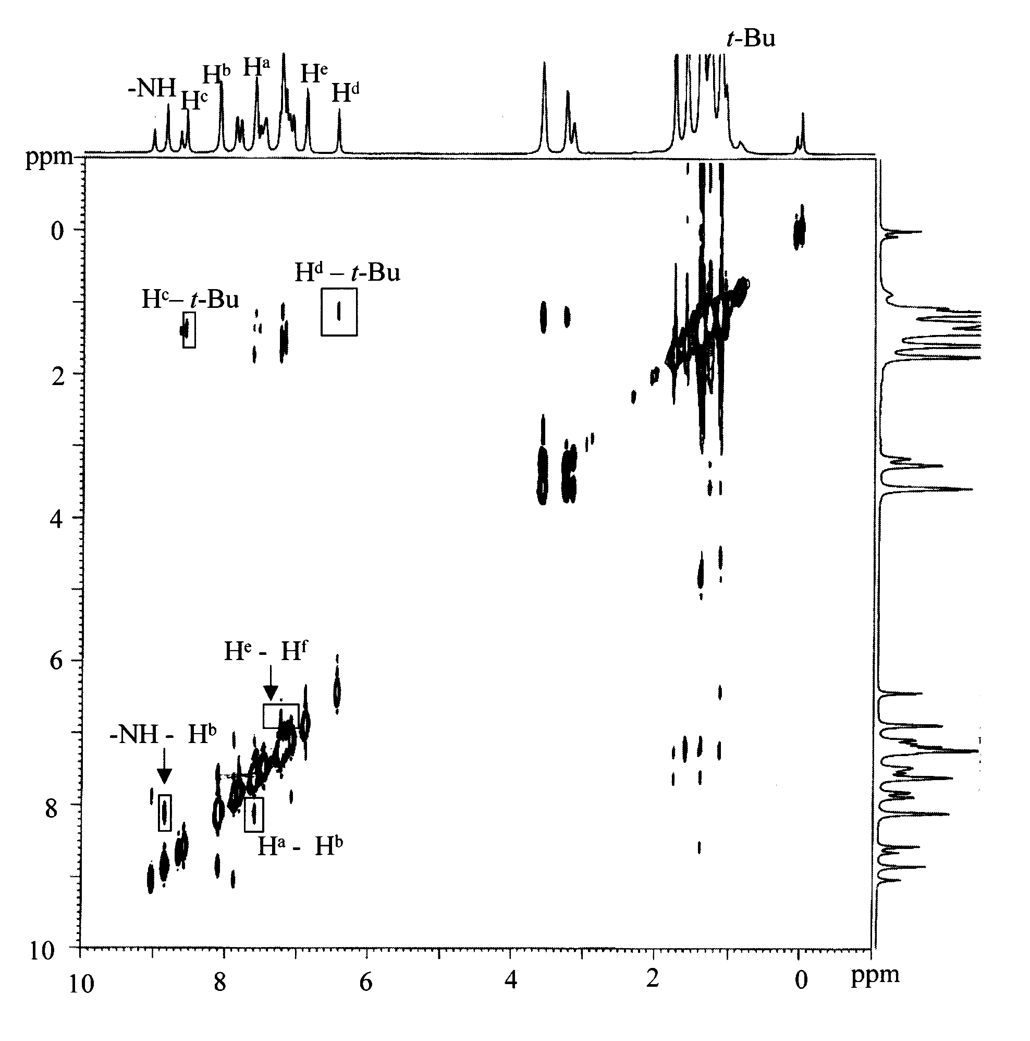
Fig. S1 ¹H-¹H NOESYspectrum of trans–1(top) and cis-1(bottom) in CDCl₃ at 5 ºC (500 MHz, mixing time = 0.6 s, relaxation delay = 2 s).
ppm
3. Modeling structure of trans-1 and cis-1
The energy-minimized structure of trans-1 and cis-1 were obtained from MacroModel ⁵ 7.1 program on a Silicon Graphics Indigo² IMPACT workstation. The structures was generated with MM2* force field via 1000 separated search steps in Monte Carlo conformational search.
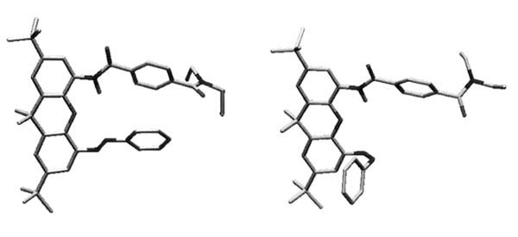
Fig. S2 Energy-minimized structures of trans-1(left) and cis-1(right).
4. UV-visible spectra change of thread 1 upon irradiation
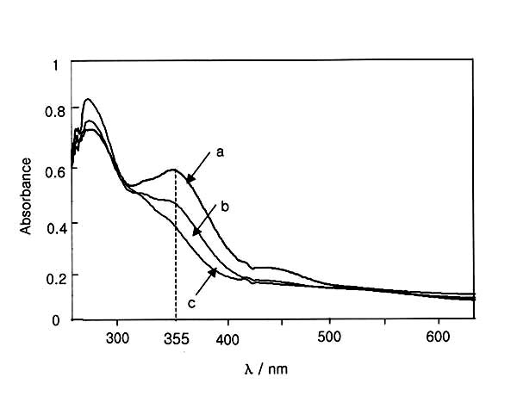
Fig. S3 UV-visible absorption spectra of a CHCl₃ solution of the thread 1 (2.0ⅹ10⁻⁵ M) that initially contains in approximately 94:6 ration of trans-1 and cis-1 isomer: (a) no irradiation, (b) 1.5 h irradiation and (c) 3 h irradiation with the long-wave (365 nm) UV light produced by a commercial UV lamp for the TLC detection.
(5) F. Mohamedi, N. G. T. Richards, W. C. H. Liskamp, M. Lipton, C. Caufield, G. Chang, T. Hendrickson, W. C. Still, J. Comp. Chem., 1990, 11, 440.
5. ¹H NMR Spectral changes of thread 1 induced by irradiation and heating
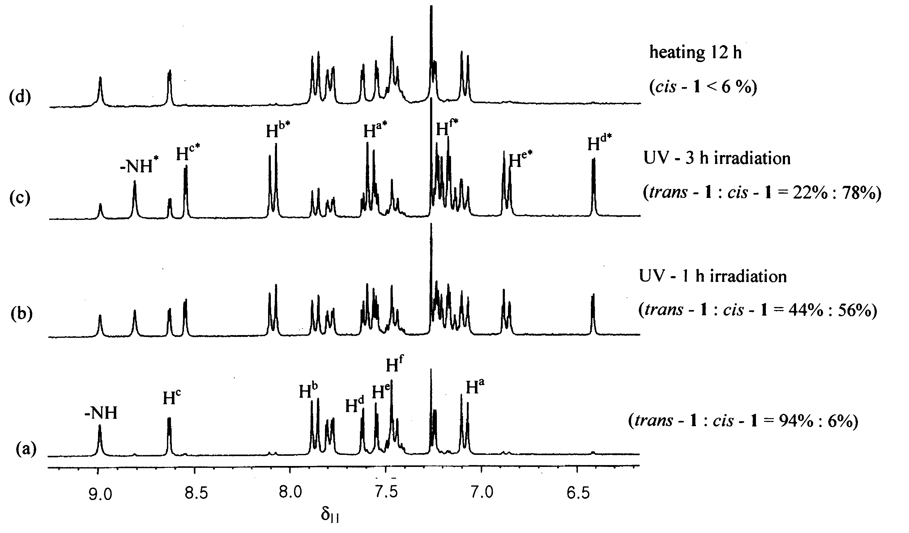
Fig. S4 Partial ¹H NMR spectra (500 MHz, CDCl₃, 5 ºC) of thread 1; (a) trans - 1/ cis - 1 = 94% : 6%; (b) after irradiation for 1 h (trans - 1/ cis - 1 = 44% : 56%); (c) after irradiation for 3 h irradiation (trans - 1 / cis - 1 = 22% : 78%); (d) after heating (50~55℃) for 12 h (cis - 1 < 6%). The irradiation experiments were performed with the long-wave (365 nm) UV light produced by a commercial UV lamp for the TLC detection.

