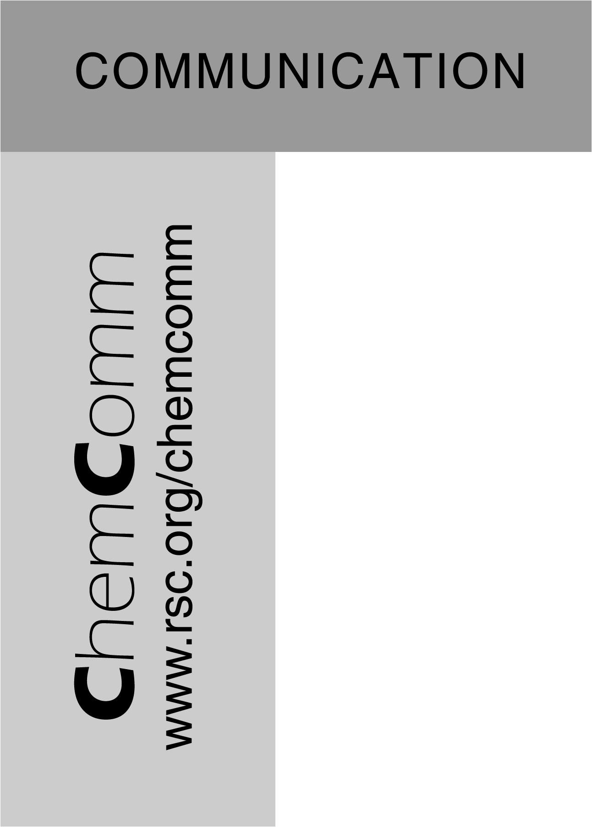
Supplementary material (ESI) for Chemical Communications
Layer by layer self-assembled multilayers of redox polyelectrolytes and gold nanoparticles
Nancy Ferreyra,ª Liliane Coche-Guérente,ª Julien Fatisson,ª Manuel Lopez Teijelo^{b} and Pierre Labbé*ª
ª Laboratoire d’Electrochimie Organique et de Photochimie Rédox, UMR CNRS 5630, Institut de Chimie Moléculaire de Grenoble, FR CNRS 2607, Université Joseph Fourier, BP 53, 38041 Grenoble cédex 09, France. Fax: +33 4 76514 67; Tel: +33 4 76514718; E-mail: Pierre.Labbe@ujf-grenoble.fr
^{b} INFIQC, Departamento de Fisicoquímica, Facultad de Ciencias Químicas, Universidad Nacional de Córdoba, Pabellón Argentina, Ciudad Universitaria, 5000 Córdoba, Argentina. Fax: +54 351 334188; Tel: +54 351 4334169; E-mail: mlopez@mail.fcq.unc.edu.ar
This submission was created using the RSC ChemComm Template (DO NOT DELETE THIS TEXT)
(LINE INCLUDED FOR SPACING ONLY - DO NOT DELETE THIS TEXT)

S-1 shows the chemical structure of the viologen- functionnalized poly(4-vinylpyridinium) PV whose synthesis and characterization have been reported in a previous work [N. F. Ferreyra, L. Coche-Guerente, P. Labbe, E. Calvo and V. Solis, Langmuir, 2003, 19, 3864].
NP gold colloids were obtained from Sigma and were synthesized following the tannic acid/citrate method [J.W. Slot and H.J. Geuze, Eur. J. Cell Biol., 1985, 38, 87]. According to the certificate of analysis the mean particle diameters of the NP₆ and NP₁₁ colloids used in this study were respectively 6.4±0.6 nm and 11.0±0.7 nm. These characteristics have been confirmed by transmission electron microscopy and SAXS. The particle concentration provided by Sigma, respectively 1.8×10¹³ and 3.72×10¹² particles/mL for NP₆ and NP₁₁ colloids, have been used to estimate the NP surface coverage in PV-NP bilayer from UV-visible absorption experiments. In a first approximation, it was assumed for these calculations that the surface plasmon resonance absorption band of NP immobilized in a PV-NP assembly keep the same characteristics as those measured in the native Sigma colloidal dispersion, that is an absorbance at 520 nm of 0.96 and 0.75 (l=1 cm) respectively for the native NP₆ and NP₁₁ Sigma colloids. The growing of multilayered PV-NP assemblies onto quartz slides was evidenced from the stepwise increase of the NP₆ or NP₁₁ surface plasmon resonance absorption band intensity (Fig. 1B of the paper). The observed linear increase in absorbance, respectively 0.0074 and 0.0316 for each layer of NP₆ and NP₁₁ on average, allows to determine a surface coverage of 1.3×10¹¹ and 1.6×10¹¹ nanoparticles/cm² respectively for each layer of NP₆ or NP₁₁ in PV-NP assemblies.
S-2 shows the Δ−ψ trajectories obtained at two wavelengths (546.1 and 632.8 nm) for PV-NP₆ assemblies ended either by PV or NP₆. These trajectories were fitted on the basis of a single layer of isotropic optical properties. The mean thickness determined from the fits is presented as a function of layer number in Fig. 2 of the paper.
S-3 shows the evolution of the NP₆ surface plasmon resonance absorbance (λ_{max}=515 nm) during its assembly onto a quartz slide previously modified by a PV monolayer as a function of the contact time of the NP₆ colloid with the quartz surface. The NP₆ surface coverage increases with time until a plateau is reached after 90 min. The experiments and results presented in the communication were mainly realized with a NP adsorption contact time of 15 min. Other experiments were realized with a NP adsorption time of 60 min.
S-4 compares the surface coverage evolution of electroactive viologen moieties in an Au/MPS/(PV-NP₆)_{n} assembly as a function of layer number for NP adsorption contact time of 15 and 60 min. It can be seen that a higher NP₆ surface coverage gives a lower surface coverage of electroactive viologen.

n ∼ 571
x ∼ 163

MW ∼ 135 kD

λ_{max} = 460 nm
ξ₄₆₀ = 313 000 L mol⁻¹ cm⁻¹

S-1: Structure of polyviologen PV.

S-2: Ellipsometric parameters obtained at (A) 546.1 and (B) 632.8 nm for the PV (○) and NP₆ () adsorption during the assembling of a (PV-NP₆)_{n} multiplayer onto an Au/MPS surface. Fit corresponding to PV (---) and NP (⎯) adsorption.

S-3: Evolution of the NP₆ surface plasmon resonance absorbance (λ_{max}=515 nm) during the assembling of NP₆ onto a quartz slide previously modified by a PV monolayer as a function of the contact time of the NP₆ colloid with the quartz surface.

S-4: Evolution of the surface coverage of electroactive viologen in an Au/MPS/(PV-NP₆)_{n} assembly as a function of layer number for a NP₆ adsorption step contact time of (a) 15 and (b) 60 min.

