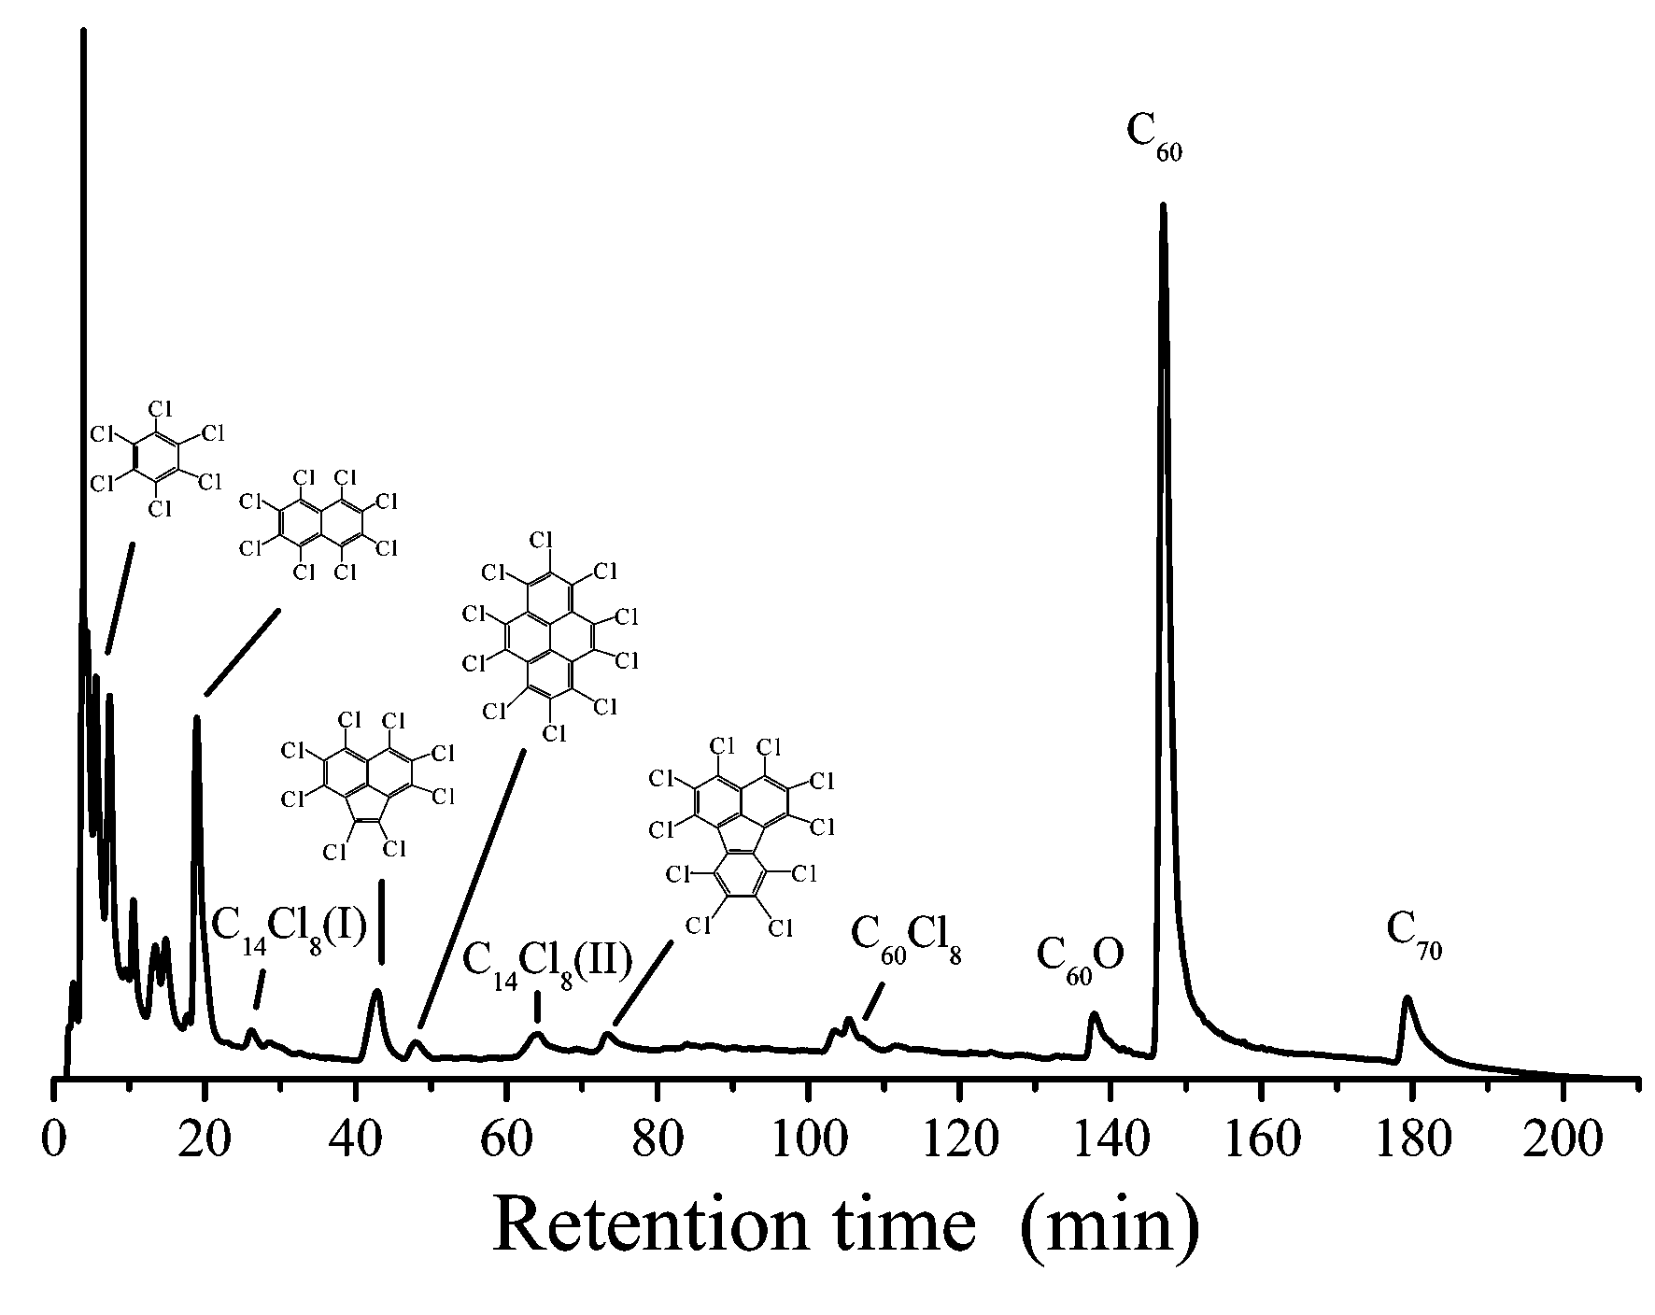

Typical HPLC-UV chromatogram (recorded at 330 nm) of the products from the graphite arc-discharge in the presence of CCl₄ (10 torr) and He (300 torr). The sample was separated on a Hypersil ® ODS2 column (Thermo Quest, 250×4.6 mm), and eluted by methanol/ethanol/cyclohexane in a gradient mode: linear increase of cyclohexane from 0 to 5% in first 50 min and from 5% to 35% in next 120 min and then holding for 30 min (the volume of methanol-ethanol, premixed in volume rate of 11:2, was varied against that of cyclohexane). The LC injection volume for the toluene-soluble soot extract was 5 μL.
Table 2 Four repeats of Exp. 4 and Exp. 5

Exp. Serial | Exp. conditions |  | Consumed graphite reactant  (g) | Collected soot  (g) | Chromatographic peak areas  (mA.U.×min) |  | Fullerenes weights in 2.7g Soot  (mg) |  | Fullerenes yields  (%)
Exp. Serial | CCl₄  (torr) | He  (torr) | Consumed graphite reactant  (g) | Collected soot  (g) | C₆₀ | C₇₀ | C₆₀ | C₇₀ | C₆₀ | C₇₀
14 | 0 | 300 | 3.09 | 3.05 | 414 | 103 | 65.5 | 8.3 | 2.38 | 0.30
15 | 0 | 300 | 2.90 | 2.70 | 522 | 129 | 82.2 | 9.1 | 2.84 | 0.31
16 | 0 | 300 | 3.00 | 2.80 | 505 | 132 | 79.6 | 10.6 | 2.76 | 0.37
17 | 0 | 300 | 2.75 | 2.72 | 372 | 115 | 58.6 | 9.3 | 2.14 | 0.34
18 | 10 | 300 | 2.27 | 3.48 | 1690 | 250 | 266.2 | 20.2 | 15.10 | 1.15
19 | 10 | 300 | 1.69 | 3.10 | 1167 | 192 | 183.9 | 15.5 | 12.50 | 1.05
20 | 10 | 300 | 2.17 | 3.20 | 1584 | 251 | 249.5 | 20.3 | 13.60 | 1.10
21 | 10 | 300 | 1.64 | 3.00 | 1180 | 256 | 185.9 | 20.7 | 12.58 | 1.40

