SUPPORTING INFORMATION
Hydrogen-bonded cubanes in the crystal structure of 2,6-di(Pr^{i})aniline hydrochloride and their inorganic analogues [M²⁺(2,6-di(Pr^{i})C₆H₅N²⁻)]₄ (M = Sn, Pb)

Andrew D. Bond and Emma L. Doyle

S1. Synthesis and spectroscopic characterisation of 1

HCl (1.37 ml, 4.0 mol dm⁻³ in 1,4-dioxane) was added to a solution of diisopropylaniline (0.97 g, 5.5 mmol) in pentane (20 ml) at –78°C. The solution was mixed at –78°C for one hour and the solvent removed. The crude residue of 1 was recrystallised from thf (20 ml) as white needles. IR (Nujol, NaCl), ν = 3583.5 cm⁻¹ (N–H str.). ¹H NMR (400.132 MHz, [D₈]toluene, 25°C), δ = 4.92 (br. s., 5H), 3.58 (4H, CH₂O, thf), 1.51 (4H, CH₂CH₂, thf), 1.49 (s., 90H, ^{t}Bu). Elemental analysis, calcd.(%): C 65.6, H 10.1, N 6.4, Cl 16.1; found: C 67.3, H 9.4, N 6.3, Cl 15.8. m.p. = 206°C. Owing to the relatively low solubility of 1 in aromatic solvents, investigations of the composition of the solution species were limited to lower concentrations. Cryoscopic molecular mass measurements in benzene reveal that there is significant dissociation of the cubane structure of 1 within the range of concentrations investigated, with the association state (n) for [2,6-di(Pr^{i})-C₆H₃NH₃Cl]_{n} being 1.13 ± 0.09 (M = 241 ± 20) at a concentration of 0.010 mol dm⁻³, and 1.29 ± 0.07 (M = 276 ± 15) at a concentration of 0.020 mol dm⁻³.

S2. Details of the cubane geometries for 2 and 3

The following data are derived from: H. Chen, R. A. Bartlett, H. V. Rasika Dias, M. M. Olmstead and P. P. Power, Inorg. Chem. 1991, 30, 3390. For ease of reference, atom labeling is retained from the CSD entries. Standard uncertainties are estimated from values averaged over the two crystallographically-distinct cubanes that are given in the original report.

S2(a). Sn–N distances in [Sn(2,6-di(Pr^{i})aniline]₄ (2) [CSD refcode: VOFTAL]

Cubane 1 |  |  |  |  |  | Cubane 2
 |  |  | Sn–N (Å) |  |  |  |  |  | Sn–N (Å)
B | Sn1 | N1 | 2.193* | (s) |  | B | Sn5 | N5 | 2.179* | (s)
 | Sn2 | N1 | 2.251 | (l) |  |  | Sn6 | N5 | 2.249 | (l)
 | Sn3 | N1 | 2.272 | (l) |  |  | Sn7 | N5 | 2.272 | (l)
A | Sn4 | N2 | 2.205 | (s) |  | A | Sn6 | N6 | 2.228 | (s)
 | Sn1 | N2 | 2.212 | (s) |  |  | Sn8 | N6 | 2.229 | (s)
 | Sn2 | N2 | 2.256* | (l) |  |  | Sn5 | N6 | 2.289* | (l)
B | Sn3 | N3 | 2.190* | (s) |  | A | Sn8 | N7 | 2.173 | (s)
 | Sn4 | N3 | 2.248 | (l) |  |  | Sn5 | N7 | 2.219 | (s)
 | Sn1 | N3 | 2.274 | (l) |  |  | Sn7 | N7 | 2.255* | (l)
A | Sn2 | N4 | 2.199 | (s) |  | A | Sn7 | N8 | 2.195 | (s)
 | Sn3 | N4 | 2.218 | (s) |  |  | Sn6 | N8 | 2.231 | (s)
 | Sn4 | N4 | 2.261* | (l) |  |  | Sn8 | N8 | 2.316* | (l)
Standard uncertainties ca. 0.009 Å on all measurements. Distances marked (*) are the cube edges that lie parallel to the aromatic ring planes in the A orientation, and perpendicular to the ring planes in the B orientation.
SUPPORTING INFORMATION
Hydrogen-bonded cubanes in the crystal structure of 2,6-di(Pr^{i})aniline hydrochloride and their inorganic analogues [M²⁺(2,6-di(Pr^{i})C₆H₅N²⁻)]₄ (M = Sn, Pb)

Andrew D. Bond and Emma L. Doyle

S2(b). Newman-type projections along the C–N bonds in (2)

Cubane 1  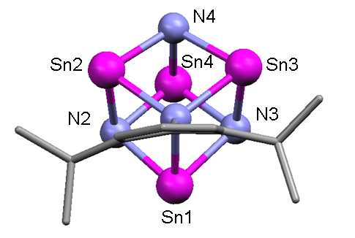 | 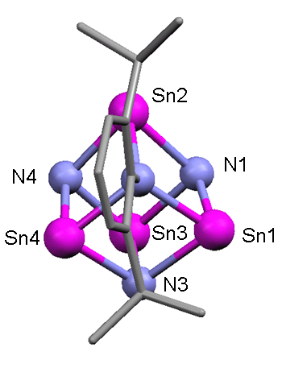 | 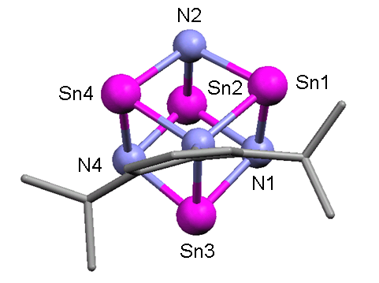 | 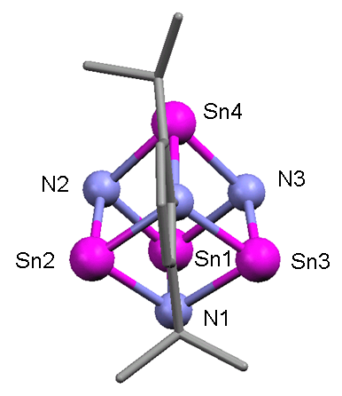
N1 (B) | N2 (A) | N3 (B) | N4 (A)

Cubane 2
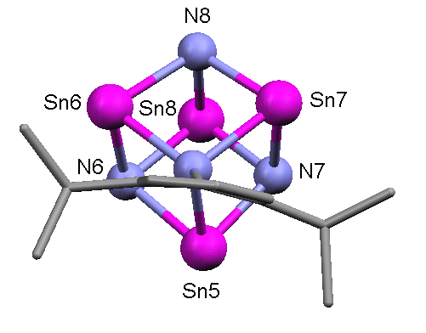 | 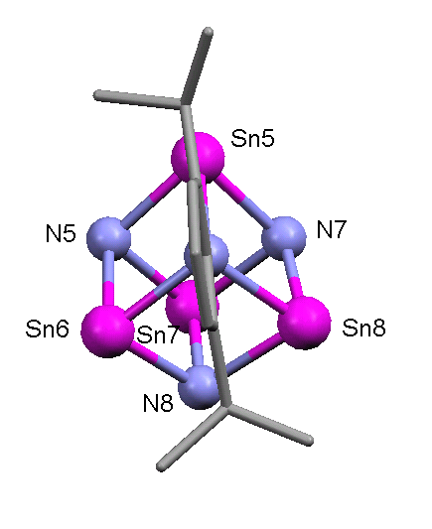 | 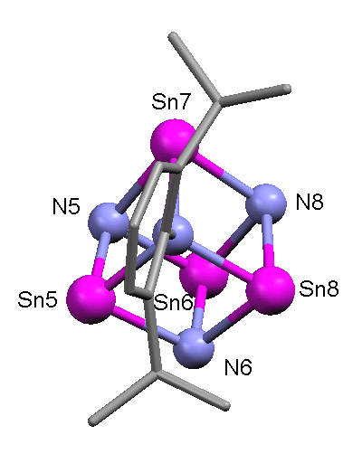 | 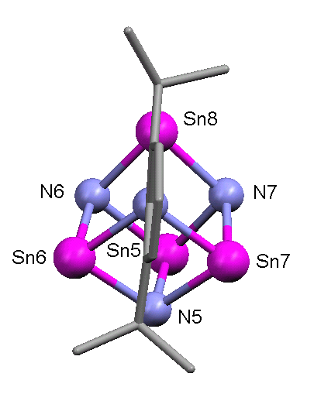
N5 (B) | N6 (A) | N7 (A) | N8 (A)

S2(c). Pb–N distances in [Pb(2,6-di(Pr^{i})aniline]₄ (3) [CSD refcode: VOFTEP]

Cubane 1 |  |  |  |  |  | Cubane 2
 |  |  | Pb–N (Å) |  |  |  |  |  | Pb–N (Å)
B | Pb1 | N1 | 2.29* | (s) |  | B | Pb5 | N5 | 2.31* | (s)
 | Pb2 | N1 | 2.33 | (l) |  |  | Pb6 | N5 | 2.38 | (l)
 | Pb3 | N1 | 2.39 | (l) |  |  | Pb7 | N5 | 2.39 | (l)
A | Pb4 | N2 | 2.31 | (s) |  | A | Pb6 | N6 | 2.33 | (s)
 | Pb1 | N2 | 2.33 | (s) |  |  | Pb8 | N6 | 2.32 | (s)
 | Pb2 | N2 | 2.33* | (l) |  |  | Pb5 | N6 | 2.42* | (l)
B | Pb3 | N3 | 2.25* | (s) |  | A | Pb8 | N7 | 2.28 | (s)
 | Pb4 | N3 | 2.32 | (l) |  |  | Pb5 | N7 | 2.32 | (s)
 | Pb1 | N3 | 2.39 | (l) |  |  | Pb7 | N7 | 2.42* | (l)
A | Pb2 | N4 | 2.25 | (s) |  | A | Pb7 | N8 | 2.30 | (s)
 | Pb3 | N4 | 2.32 | (s) |  |  | Pb6 | N8 | 2.27 | (s)
 | Pb4 | N4 | 2.35* | (l) |  |  | Pb8 | N8 | 2.45* | (l)
Standard uncertainties ca. 0.02 Å on all measurements.

Relatively low precision of the structure obscures the variation in Pb–N distances to some extent, particularly in Cubane 1 (note N2). For each A orientation, however, the shortest contact always lies along the cube edge that is aligned with the aromatic ring of the organic moiety (marked *). In each B orientation, the longest contact always lies perpendicular to the ring plane of the organic moiety (marked *). The trend is much more apparent in Cubane 2.
SUPPORTING INFORMATION
Hydrogen-bonded cubanes in the crystal structure of 2,6-di(Pr^{i})aniline hydrochloride and their inorganic analogues [M²⁺(2,6-di(Pr^{i})C₆H₅N²⁻)]₄ (M = Sn, Pb)

Andrew D. Bond and Emma L. Doyle

S2(d). Newman-type projections along the C–N bonds in (3)

Cubane 1
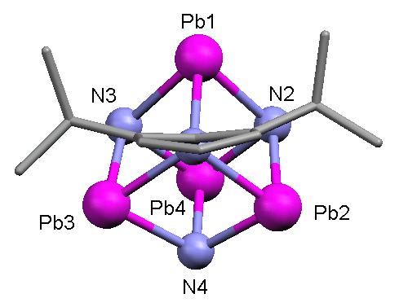 | 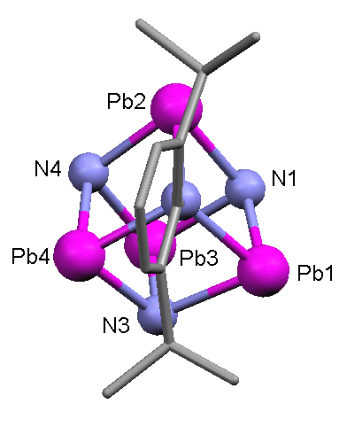 | 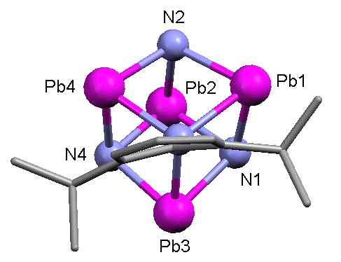 | 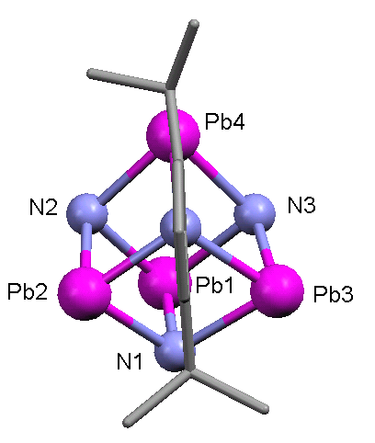
N1(B) | N2(A) | N3(B) | N4(A)

Cubane 2
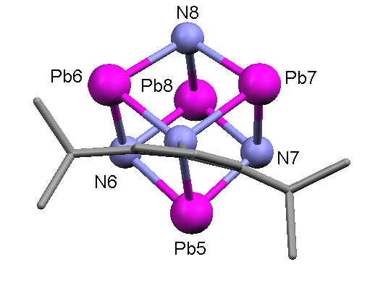 | 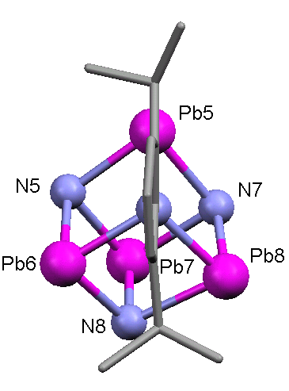 | 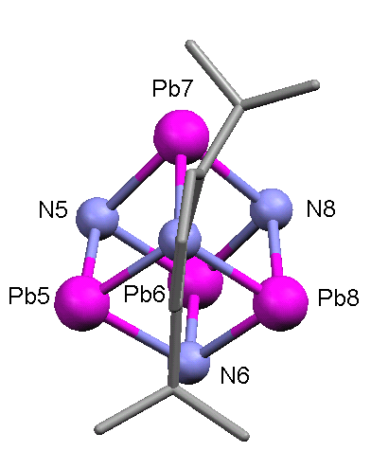 | 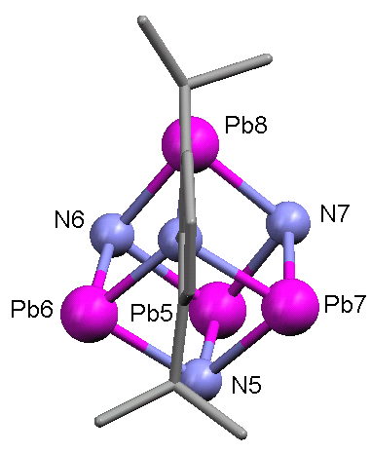
N5(B) | N6(A) | N7(A) | N8(A)

