Electronic Supplementary Information

Yuanzhe Piao and Hasuck Kim*

School of Chemistry, Center for Molecular Catalysis, Seoul National University, Seoul 151-747, Korea. Fax: 82-2-889-1568; Tel: 82-2-880-6666; E-mail: hasuckim@.snu.ac.kr

In order to prepare additional samples with different diameter, chemical treatment of porous alumina membrane was performed in 5 wt% H₃PO₄ at 35 °C for 10 min. The diameter of the pores was approximately 50 nm. The diameter of the AgI nanowires prepared with this porous alumina template was approximately 50 nm, equal to the pore diameter of the alumina membrane.
Figure shows the FE-SEM images of the ordered porous alumina membrane from the top (a), from the side (b) after chemical treatment performed in 5 wt% H₃PO₄ at 35 °C for 10 min to widen the pores, and Figure (c) shows the AgI nanowires prepared by this method.

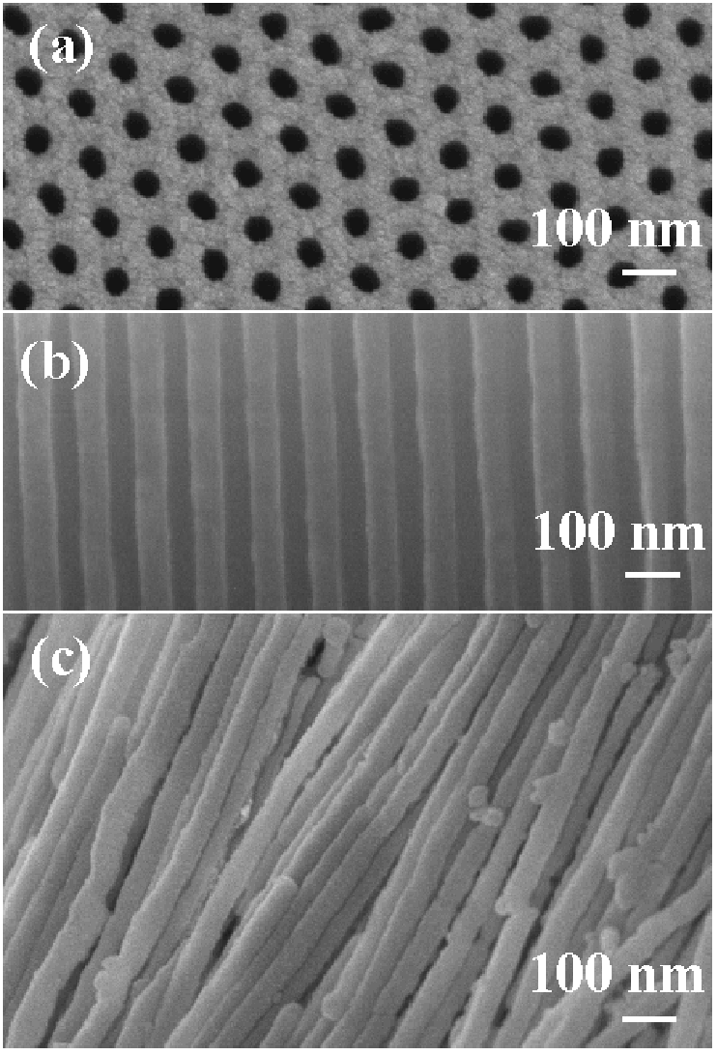

FE-SEM images of the ordered porous alumina membrane from the top (a), from the side (b) after chemical treatment performed in 5 wt% H₃PO₄ at 35 °C for 10 min, and (c) shows the AgI nanowires prepared by this method.

