Supporting Information for

Protein-DNA Interaction: Impedance Study of MutS Binding to a DNA Mismatch

Chen-Zhong Li, Yi-Tao Long, Jeremy S. Lee* and Heinz-Bernhard Kraatz*

Email: kraatz@skyway.usask.ca; leejs@sask.usask.ca

Pretreatment of gold electrodes
Gold disk electrodes (Bioanalytical Systems, 1.6 mm diameter, ca. 0.02 cm² geometrical area, roughness coefficients between 1.2 and 1.4 as determined by Cu UPD) were used for the electrochemical measurements. Before modification, the bulk gold electrodes were lightly polished with 0.05 μm alumina (Buhler), and then sonicated for 10 minutes in ethanol. Afterwards the electrodes were immersed in boiling 2 M KOH (in 30 % ethanol) for 30 minutes, followed by sonication consecutively in concentrated hot HNO₃ (30 min) and freshly distilled and degassed ethanol (10 min) and then rinsed with Milli-Q water. The electrochemical pretreatments were performed in a BAS cell by cycling from a potential of -0.1 to +1.25 V versus Ag/AgCl in 0.1 M H₂SO₄ solution until a stable gold oxidation peak at 1.1 V versus Ag/AgCl was obtained. The pretreated gold electrodes were then rinsed with water and ethanol and immediately used for the preparation of DNA monolayers.
Gold films for AFM analysis were prepared by evaporation of high purity gold in a ultrahigh vacuum onto freshly cleaved mica, up to a topical thickness of ca. 1000 Ǻ. Before each experiment the gold film was annealed (hydrogen flame length ca. 2 -4 cm) by sweeping the substrate back and forth for about 30-60 s, keeping the small flame spot on the film a dim orange color.¹ After annealing, the surfaces were immediately used for modification and/or AFM measurements.

Protocol for MutS protein purification and concentration
MutS (2 mg/ml) from the thermophilic bacterium thermus aquaticus, was purchased from InterScience. Cyclic voltammograms with the crude protein solution showed that dithiothreitol (DTT) present in the commercial buffer disrupts and eventually destroys the DNA SAM on the gold surface. Thus, it was decided to remove all by dialyzing the protein solution against binding buffer (20% glycerol solution containing 20 mM Tris-ClO₄, 100 mM NaClO4, 0.01 mM EDTA, pH 7.0) in a 0.5 ml cassette (3.5 K cut-off, from Pierce). 400 μl MutS protein solution was transferred into the dialysis cassette. Excess air was removed from the cassette, which was placed on a foam float and suspend in 1L binding buffer in the cold room (4°C) overnight while stirring. 250 μl of the dialyzed purified MutS protein solution was removed from the dialysis cassette and concentrated 10 fold (NanosepTM micro-concentrator, 10 K cut off; Pall Filtron) into the exchange buffer (15 % glycerol solution containing 20 mM Tris-ClO₄, 200 mM NaClO₄, 5 mM MgCl₂, 0.01 mM EDTA, pH 7.0). The MutS concentration was determined by UV spectroscopy using the theoretical extinction coefficient (76,874 M⁻¹cm⁻¹ at 280 mm for the protein dimer).²

Surface Characterization
A Pico SPM from Molecular Imaging with an AFMM 1271 scanner was used to capture the structural AFM images of DNA SAMs and DNA-MutS interactions. In-situ AFM experiments for DNA and DNA-protein covered substrates were carried out in 0.2 M Tris buffer (ph 7.5) with a Picocell in tapping mode at room temperature.
(a)  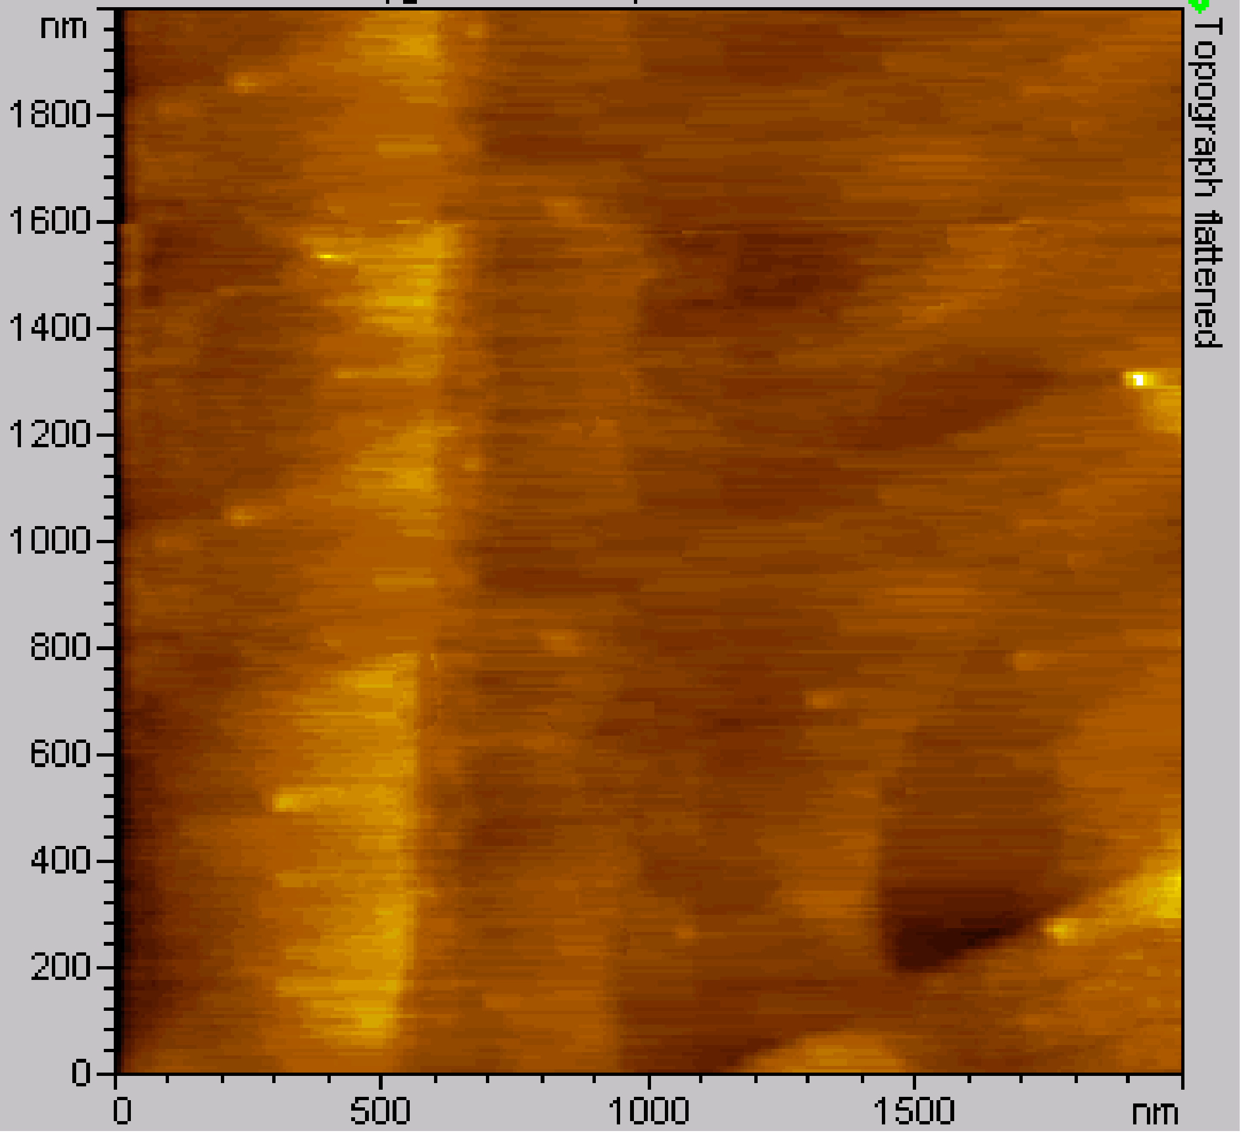 | (b)  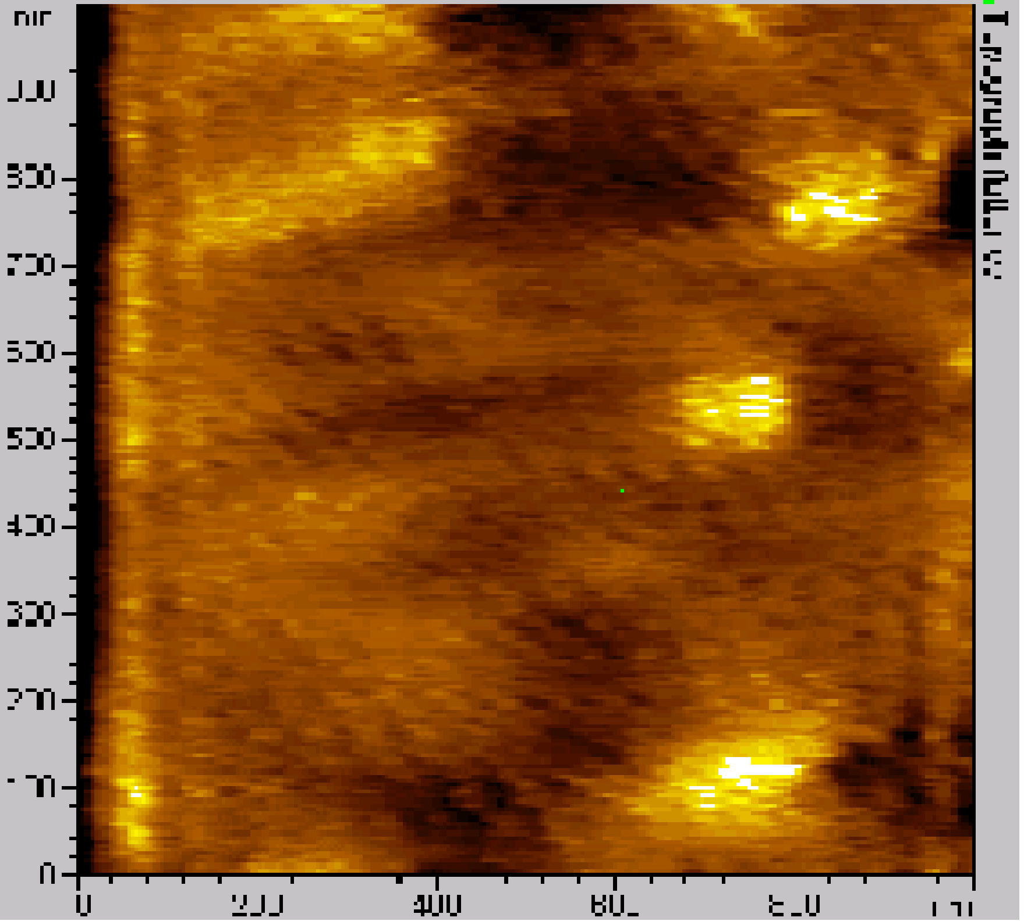
Figure S1. (a) Representative AFM image of the Au surface (after annealing in H₂ flame for 40 s) in the contact mode showing atomically flat gold terraces. Scan size 2000 x 2000 nm. (b) AFM image of the thiolated ds-DNA (20-mer) SAMs closely packed Au surface in tapping mode. Scan size 1000 x 1000 nm.

Oxide-sharpened Si₃N₄ tapping-mode cantilevers with a normal bending force constant from 2.5 to 8.5 N/m and resonance frequencies between 120 to 190 kHz were employed to reduce any damage to biological samples caused by physical contact with the tip.³ Topographic and phase images were obtained simultaneously using a resonance frequency of approximately 149.53 kHz for the probe oscillation. Topographical images of the plain gold substrates after flame annealing were obtained in the connect mode using a cantilever with the resonance frequencies in the range from 65 to 150 Hz (Figure S1a). The scan speed was in the range from 1.46 - 1.85 lines/s. In Figure S1b shows a typical AFM image of a ds-DNA modified gold surface before dilution treatment by butanethiol.
The thickness the SAMs was measured using a LSE Stokes Ellipsometer equipped with a 632.8 nm He-Ne laser at an incident angle of 70°. To obatin accurate optical constants of a bare gold surface, the flame annealed gold film was used right away to ellipsometric baseline measurement. The value reported is the average of ten separate data points. A refractive index N_{f} of 1.55 was used for DNA and DNA-protein layers.

Electrochemical Measurements and Data Analysis
Cyclic voltammetry experiments were performed using a potentiostat/galvanostat (EG/G model 283) linked to a PC via GPIB running Power Suite. A conventional three-electrode cell was used for all electrochemical measurements (SAM-modified gold working electrode, Ag/AgCl reference electrode (BAS) connected to the cell via a Luggin capillary, and Pt wire auxiliary electrode). All potentials are reported with the respect to the Ag/AgCl reference electrode.

ACIS was measured using an EG&G M1025 FRA interfaced to an EG&G potentiostat model 283. The data acquisition and control was handled by a computer interfaced to the FRA and potentiostat via an IEEE−488 General Purpose Interface Bus (GPIB) and run with software for EIS (M398). The experiments were run at an applied bias potential of the E⁰` of the [Fe(CN)₆]^{3-/4-} redox couple, with 5 mV (rms) sinusoidal excitation amplitude. The data was measured and collected for 31 harmonic frequencies from 0.1 Hz to 100 kHz at 5 steps per decade.

The equivalent circuit (R_{s}(Q_{y}[R_{ct}(R_{diff}Q_{x})]) used to rationalize the experimental data is shown in Figure S2. It comprises a solution resistor R_{s}, a charge transfer resistance R_{ct}, surface capacitance Q_{y} and a combination of two parallel diffusion-like elements R_{diff} and Q_{x}, which give information about the diffusion through the SAM.⁴
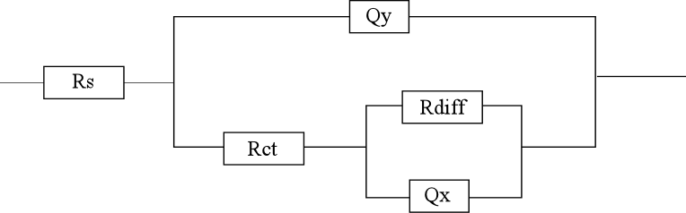
Figure S2. Equivalent circuit used to analyze the experimental impedance spectrum.

Table 1. Summary of the fitting parameters (equivalent circuit see Figure S2) (normalized to the electrode geometric area). The simulated curves are shown as solid line in all Nyquist plot figures.

MutS data analysis surface area 0.024 cm²
 | Rs (Ω) | Rct (Ω)x10² | Rdiff (Ω)x10² | Qy (F) |  | Qx (F)
 |  |  |  | Yo (10⁻⁵) | n | Yo x(10⁻³) | n
DNA | 5.09 ± 1.33 | 1.34 ± 0.21 | 6.00 ± 3.52 | 2.67 ± 0.09 | 0.95 ± 0.1 | 15.7 ± 0.2 | 0.40 ± 0.2
DNA MutS | 4.03 ± 0.72 | 1.6 ± 0.1 | 10.78 ± 0.33 | 2.76 ± 0.12 | 0.94 ± 0.2 | 17.7 ± 0.5 | 0.48 ± 0.1
Mismatch DNA | 5.09 ± 1.2 | 1.34 ± 0.07 | 6.54 ± 2.93 | 2.67 ± 0.45 | 0.95 ± 0.2 | 15.7 ± 0.2 | 0.40 ± 0.06
Mismatch DNA Muts | 3.98 ± 0.79 | 1.69 ± 0.17 | 11.88 ± 0.31 | 2.91 ± 0.33 | 0.94 ± 0.1 | 20.2 ± 0.8 | 0.47 ± 0.02
Diluted DNA | 3.90 ± 0.41 | 4.34 ± 0.08 | 13.32 ± 0.05 | 1.78 ± 0.08 | 0.94 ± 0.03 | 1.03 ± 0.14 | 0.48 ± 0.01
Diluted mismatch DNA | 3.96 ± 0.52 | 4.27 ± 0.22 | 13.52 ± 0.07 | 1.63 ± 0.25 | 0.94 ± 0.1 | 1.13 ± 0.42 | 0.45 ± 0.01
Diluted DNA MutS | 3.74 ± 0.55 | 4.96 ± 0.18 | 13.56 ± 0.17 | 1.83 ± 0.04 | 0.9 ± 0.2 | 1.03 ± 0.25 | 0.48 ± 0.01
Diluted Mismatch  DNA MutS | 3.55 ± 0.72 | 6.83 ± 0.61 | 17.82 ± 0.13 | 2.08 ± 0.15 | 0.94 ± 0.1 | 0.65 ± 0.16 | 0.53 ± 0.04

References
1. Electroanalytical Chemistry, H.O. Finklea, Marcel Dekker Inc., New York, 1996.
2. M. J. Schofield, S. Nayak, T.H. Scott, C. Du and P. Hsieh, J. Biol. Chem. 2001, 276, 28291-28299.
3. Electrochemical Nanotechnology: In-Situ Local Probe Techniques at Electrochemical Interfaces. eds. W.J. Lorenz and W. Plieth, Wiley-VCH, New York, 1998.
4. M. Dijksma, B.A. Boukamp, B. Kamp and W.P.V. Bennekom, Langmuir 2002, 18, 3105-3112.

