Mesoporous Silica with Ia3d Cubic Structure and Good Thermal Stability

Jiebin Pang, J. Eric Hampsey, Qingyuan Hu, Zhiwang Wu, Vijay T. John, and Yunfeng Lu*

Figure 1. XRD (a, c) and nitrogen sorption isotherms (b, d) of the as-synthesized powders after calcinations in air at 900 ºC for 4 h (a, b) and the as-synthesized powders after calcinations in air at 500 ºC for 6 h and then at 900 ºC for 4 h in nitrogen or air (c, d). For comparison, the results of the powders calcined in nitrogen at 900 ºC for 4 h or calcined in air at 500 ºC for 6 h are also included.

Figure 2. XRD pattern of the sample prepared with the molar ratio of DM/CTAB is 1/2, showing a hexagonal mesostructure.

Figure 3. EDS spectrum of the powders carbonized in nitrogen at 900 ºC for 4 h. (Note: The samples were prepared by directly dispersing the fine powders onto a Cu grid coated with a porous C film. For the EDS analysis, the electron beam was focused on the sample to decrease the disturbance from the C film coated on Cu grid. EDS is mainly used for qualitative analysis rather than quantitative analysis, therefore the quantitative values are just for reference.)

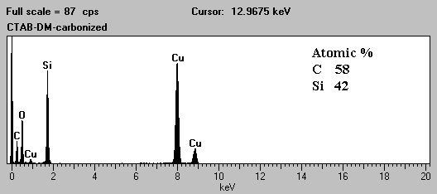

Figure 4. TGA curve of the powders carbonized in nitrogen at 900 ºC for 4 h. (Note: TGA of the samples was performed on a Thermal Analysis Hi-Res TGA 2950 instrument with a heating rate of 5 ºC/min, a heating range from 30 to 700 ºC, and an oxygen flow rate of 80 cm³/min.)

Scheme 1. Proposed formation mechanism of the the Ia3d cubic mesostructure in nitrogen at high temperatures such as 900 ºC.

