supplementary information

S1

Cyclopentyl PNA (cpPNA) as Conformationally Consrained Chiral PNA analogue: Synthesis and DNA/RNA Hybridization Studies
T. Govindaraju, Vaijayanti A. Kumar* and Krishna N. Ganesh*
Division of Organic Chemistry (Synthesis), National Chemical Laboratory, Pune 411 008, India.
Tele Fax: 91 20 589 3153; E-mail: kng@ems.ncl.res.in

Table of contents
(S2-S5): Experimental procedures.
(S5-S16): ¹H and ¹³C NMR spectra of compounds 3, 5, 7, 8, 9 and 9a.
(S17-S21): Mass spectra of compounds 3, 5, 7, 8, 9 and 9a.
(S22-S36): HPLC profiles of PNA 10, PNA 11, PNA 12, PNA 13, PNA 17.
(S27-S31): Mass spectra (MALDI-TOF) of PNA 10, PNA 11, PNA 12, PNA 13, PNA 17.
(S32-S34): Melting curves of PNA 10, PNA 11, PNA 12, PNA 13, PNA 14, PNA 15, PNA 16 with d(CGCA₈CGC), d[CGCA₅CA₄CGC], and poly rA and their corresponding derivatives.
(S35) Melting curves of PNA 17 and PNA 18 with d(CGCA₈CGC) and corresponding derivative curves.
(S36): CD-curves and CD- Job’s plot for PNA 12:DNA19.
(S37-S38): Ortep diagrams of (1S,2R)-9 and (1R,2S)-9.
(S39): Crystal structure data of 9a,b.
(S40) UV-Job’s plot for PNA 12:DNA19.
General Experimental Procedure: Melting points of samples were determined in open capillary tubes and are uncorrected. IR spectra were recorded on an infrared Fourier Transform spectrophotometer using KBr pellets. Column chromatographic separations were performed using silica gel 60-120 mesh, solvent systems 10-25% EtOAc/Pet ether and pure DCM to 3% MeOH/DCM. ¹H and ¹³C were obtained using Bruker AC-200 (200 MHz) and 500 MHz NMR spectrometers. The chemical shifts are reported in delta (δ) values. Mass spectra were obtained either by FAB or LCMS techniques. Oligomers were characterized by RP HPLC, C18 column and MALDI-TOF mass spectrometry. The enzyme Amano-PS was obtained as a gift from Amano Pharmaceuticals, Japan.

S2

Enzymatic Resolution of Racemic 2-azido cyclopentyl butanoate (1R/S,2R/S) with Pseudomonas cepacia: To a solution of enzyme Pseudomonas cepacia (500 mg) in Phosphate buffer (150 ml, pH = 7.2) was added racemic 2-azido cyclopentyl butyrates (1R/S,2R/S) (10 g). The mixture was stirred vigorously for 1.5 h, which accomplished 40% conversion for alcohol (-) (1R,2R)-2. The enzyme was separated by filtration and the filtrate was extracted into DCM. The solvent was evaporated and the column chromatographic separation of the residue afford chiraly pure alcohol (1R.2R)-2 and optically enriched butyrate (1S,2S). The optically enriched butyrate (1S,2S) was subjected to second enzyme hydrolysis as described above to yield optically pure butyrate (1S,2S) after column separation. From butyrate (1S,2S), alcohol (1S,2S)-2 was obtained by methanolysis with catalytic amount of NaOMe in MeOH in 40% overall yield.
The enantiomeric purity was confirmed by comparing with known values for the optical rotations of alcohols (1R,2R)-2 and (1S,2S)-2 from the literature [for alcohol (1R,2R)- 2; [∝]₂₀^{D} = - 84.0° (lit⁸.- 78.0°, c. 1.5, CH₂Cl₂); alcohol (1S,2S)-2; [∝]₂₀^{D} = + 84.1° (lit.⁸ + 84.1.°, c. 1.6, CH₂Cl₂)].

(1R,2R)–2-(N-t-butyloxycarbonylamino)-cyclopentanol [(1R,2R)- 3]: To a solution of (1R,2R)-2-azido cyclopentanol (3.5 g, 27.55 mmol) in dry ethyl acetate (10 ml) placed in a hydrogenation flask was added di-t-butyl dicarbonate (7.21g, 33.06 mmol) and Adams catalyst (2 mol%). The mixture was hydrogenated in Parr apparatus (rt, 35-40 psi . 3.5 h). The catalyst was filtered, solvent in filtrate was evaporated under reduced pressure and the residue was purified by column chromatography ( EtOAc/Petroleum ether) to afford a white solid of the alcohol (1R,2R) 3. Yield (4.6g, 83 %); m.p.87.0°; [α]_{D}²⁰ +21.0° (c 1.0, CH₂Cl₂); ¹H-NMR (CHCl₃-d, 200 MHz); δ_{H} 1.00- 1.45 (10H, m, 4-CH, t-Boc), 1.45-1.8 (3H, m, 4-CH, 3-CH₂), 1.8-2.15 (2H, m, 5-CH₂), 3.4-3.7(1H, m, 2-CH), 3.8-4.0 (1H, m, 1-CH), 4.1-4.4 (1H, bd, -OH), 4.6-5.0 (1H, bd, carbamate NH); ¹³C-NMR (CHCl₃-d, 200 MHz): δ_{C} 20.2, 27.9, 29.5, 31.57, 59.5, 78.21, 78.98, 156.55; Anal Calcd (%) for C₁₀H₁₉NO₃: C, 59.7; H, 9.45; N, 6.96; Found C, 59.63; H, 9.81; N, 6.86; LCMS: 202.05 [M+H].

(1R,2R)-2-(N-t-butyloxycarbonylamino)-cyclopentan-1-methyl sulfonate [(1R,2R)-4]: To a stirred solution of alcohol (1R,2R)-3 (4.3 g, 21.39 mmol) and triethyl amine (6.49 g, 64.17 mmol) in dry CH₂Cl₂ (40 ml) at 0°C under nitrogen was added methanesulfonyl chloride (3.92 g, 34.22 mmol) over a period of 15 min. The mixture was stirred for another 20 mins at room temperature and the solvent was evaporated under reduced pressure. The residue was extracted with CH₂Cl₂, washed successively with KHSO₄ solution, water, brine and stored over Na₂SO₄. The organic layer was concentrated to afford mesylate (1R,2R)-4. Yield (5.6 g, 93%), which without any purification. used for further reaction.

S3

(1S,2R)-2-(N-t-butyloxycarbonylamino)-1-azidocyclopentane [(1S,2R)-5]: A stirred mixture of the mesylate (1R,2R)-4 (5.0 g, 17.92 mmol) and NaN₃ (9.3 g, 0.143 mol)
in DMF (25 ml) under nitrogen was heated at 68-70°C for 5 h. After cooling, the solvent was evaporated under reduced pressure and the residue was extracted with EtOAc (25mlx2), stored over Na₂SO₄. The organic layer was removed under reduced pressure and crude product was purified by column chromatography (EtOAc/Pet ether) to afford a white solid of azide (1S,2R)-5. Yield (3.65g, 91.5%): m.p. 81.0°; IR, ν (cm⁻¹) (KBr); 3442.7, 3014.53, 2995.24, 2113.84, 1706.88 cm⁻¹: [α]_{D}²⁰ + 116° (c 1.0, CH₂Cl₂); ¹H-NMR (CHCl₃-d, 200 MHz); δ_{H} 1.0-1.45(11H, m, 4-CH₂, t-Boc), 1.65-2.0 (4H, m,5-CH₂, 3-CH₂), 3.7-4.1 (2H, m, 1-CH, 2-CH), 4.6-5.0 (1H, bd, carbamate NH): ¹³C-NMR (CHCl₃-d, 200 MHz): δ_{C} 19.8, 28.2, 28.7, 29.01, 54.7, 64.1, 79.4, 155.3: Anal Calcd (%) for C₁₀H₁₈N₄O₂: C, 53.09; H, 7.96; N, 24.77; Found C, 52.55; H, 7.9; N, 24.8;MS (FAB+) 227 (35%) [M+1], 171 (100%) [M+1- N₃], 127 (15%) [M+1- tBoc].

(1S,2R)-2-(N-t-butyloxycarbonylamino)-1-aminocyclopentane [(1S,2R)-6]: To a solution of the azide (1S,2R)-5 (3.0 g, 13.27 mmol) in Methanol (5 ml) taken in hydrogenation flask was added Adam’s catalyst (2 mol%). The reaction mixture was hydrogenated in a Parr apparatus for 3.5 h at rt and H₂ of pressure 35-40 psi. The catalyst was filtered off and then solvent was removed under reduced pressure to yield a residue of the amine (1S,2R)-6 as a colorless oil. Yield (2.6 g, 98.0%); This compound was used for the further reaction without any purification.

N-[(2R)-tBoc-aminocyclopent-(1S)-yl]-glycine ethyl ester [(1S,2R)]-7: To a stirred mixture of amine (1S,2R)-6 (2.5 g, 12.5 mmol), and freshly prepare KF-celite (4.35 g, 37.5 mmol) in dry acetonitrile (150 ml), ethyl bromoacetate (1.87 g, 11.25 mmol) was added dropwise for 30 min. at rt under nitrogen atmosphere and then heated to 65°C. After 3.0 h the celite was filtered off and the solvent in the filtrate was evaporated under reduced pressure which on column chromatographic purification (EtOAc) afforded the ethyl ester (1S,2R)-7 as colorless oil. Yield (2.81 g, 78.5%): [α]_{D}²⁰ – 32.69° (c 0.52, CH₂Cl₂); ¹H-NMR (CHCl₃-d, 200 MHz); δ_{H} 0.62-2.1 (18H, m, 4-CH2, 3-CH2, 5-CH2, t-Boc, ester-CH₃), 2.7-3.1 (1H, bd, 2-CH), 3.1-3.4 (2H, s, -CH2-C=0), 3.5-3.9 (1H, bd, 1-CH), 3.9-4.2 (2H, q, ester-CH₂), 4.9-5.6 (2H, bd, NH and carbamate-NH); ¹³C-NMR (CHCl₃-d, 200 MHz): δ_{C} 13.5, 19.9, 27.85, 29.3, 30.27, 48.6, 52.5, 59.5, 60.1, 78.4, 155.5, 171.2; Anal Calcd (%) for C₁₄H₂₆N₂O₄: C, 58.74; H, 9.09; N, 9.79; Found C, 58.85; H, 8.66; N, 9.50;LCMS; 287.05 [M+H], 187 [M+H-tBoc].

S4
N-[(2R)-tBoc-aminocyclopentan-(1S)-yl]-N-(chloroacetyl)-glycine ethyl ester [(1S,2R)-8]: To a stirred solution of the amine (1R,2S)-7 (2.5 g, 8.7 mmol) in 10% Na₂CO₃ (65 ml) and 1,4-dioxan (65 ml) cooled to 0°C, was added chloroacetyl chloride (4.93 g, 43.7 mmol) in two additions. After 30 min the dioxan was removed under reduced pressure and the residue was extracted into EtOAc (2 x 50 ml), dried over Na₂SO₄. The solvent was evaporated under reduced pressure and the residue was purified by column chromatography (MeOH/CH₂Cl₂) affording chloro compound (1S,2R)-8 as white solid. Yield (2.4 g, 76%); m.p. 131.0°C. [α]_{D}²⁰ +55.0° (c 1.0, CH₂Cl₂); ¹H-NMR (CHCl₃-d, 500 MHz); δ_{H} 1.0-2.4 (18H, m, 3CH₂ cycl, tBoc, ester CH₃), 3.5-4.5 (8H, m, 1-CH, 2-CH, N-CH₂, -COCH₂Cl, -COOCH₂), 5.5-6.0 (1H, bd, carbamate NH); ¹³C-NMR (CHCl₃-d, 500 MHz): δ_{C} 13.75, 20.8, 27.8, 28.0, 30.55, 41.1, 46.0, 53.3, 58.8, 61.0, 78.2, 155.5, 167.6, 169.5; Anal Calcd (%) for C₁₆H₂₇N₂O₅Cl: C, 52.89; H, 7.43; N, 7.71; Cl, 9.77; Found C, 52.61; H, 7.91; N, 7.58; Cl, 9.72: MS LCMS; 363.05 [M+H], 263.05 [M+1-tBoc].

N-[(2R)-t-Boc-Aminocyclopent-(1S)-yl]-N-(thymin-1-acetyl)-glycine ethyl ester [(1S,2R)-9]: A mixture of chloro-compound (1S,2R)-8 (2.0 g, 5.52 mmol), thymine (0.70 g, 5.52 mmol) and anhydrous K₂CO₃ (0.91 g, 6.62 mmol) in dry DMF (10 ml) under nitrogen was heated with stirring at 65°C for 4.0 h. After cooling, the solvent was removed under reduced pressure to leave a residue, which was extracted into DCM (2x 25 ml) and dried over Na₂SO₄. The solvent evaporated and the crude compound was purified by column chromatography (MeOH/DCM) to afford a White solid of thymine monomer ethyl ester (1S,2R)-9. Yield (1.8g, 72.2%): m.p. 211.0-215.0°C. [α]_{D}²⁰ - ° (c 1.5, CH₂Cl₂); ¹H-NMR (CHCl₃-d, 500 MHz); δ_{H} 1.11-1.2 (3H. t, ester CH3), 1.26-1.4 (10H, tBoc, 4-CH), 1.4-1.53 (1H, m, 4-CH), 1.6-1.7 (1H,m, 5-CH), 1.7-1.78 (1H, m, 3-CH),1.81(3H, s, thymine CH₃), 2.02-2.15 (2H, 5-CH), 3.6-4.5 (7H, m, 2-CH, N-CH₂, -COCH₂, -COOCH₂), 5.0-5.2 (1H, d, 1-CH), 5.4-5.6 (1H, bd, carbamate NH), 7.04 (1H, s, thymine –CH=C-), 9.4-9.6 (1H, bd, thymine NH); ¹³C-NMR (CHCl₃-d, 500 MHz): δ_{C} 12.0, 13.8, 21.3, 28.1, 28.3, 31.1, 46.0, 47.83, 52.4, 58.8, 61.2, 79.8, 110.0, 141.2, 151.1, 155.7, 164.35, 167.3, 169.3: Anal Calcd (%) for C₂₁H₃₂N₄O₇: C, 55.75; H, 7.07; N, 12.38; Found C, 55.63; H, 7.45; N, 12.08;MS (FAB⁺); 453 [M+1] (42%), 353 (100%) [M+1-tBoc].

N-[(2R)-t-Boc-Aminocyclopent-(1S)-yl]-N-(thymin-1-acetyl)-glycine [(1S,2R)-9a]: To the monomer ester (1S,2R)-9 (1.0 g, 2.283 mmol) suspended in THF (10 ml), a solution of 0.5 M LiOH (10ml, 5.1 mmol) was added and mixture was stirred for 30 mins. The mixture was washed with EtOAc (2 X 10 ml). The aqueous layer was acidified to pH 3 and extracted with EtOAc (4 X 20 ml). The EtOAc layer was dried over sodium sulfate and evaporated under reduced pressure to afford monomer (1S,2R)-9a as a white solid. Yield: 0.92 g (97.8 %); m.p.139.0-141.0°C; [α]_{D}²⁰ -17.0 ° (c 1.0, CH₂Cl₂); ¹H-NMR (CHCl₃-d, 200 MHz); δ_{H} 1.0-2.4 (18H, m, t-Boc, thymine-CH₃,cypent 3CH₂), 3.5-4.8 (5H, m, 2-CH, N-CH₂, -COCH₂), 5.13 and 5.31(1H, bd, carbamate NH), 5.95 (1H, s, 1-CH), 7.1-7.18 (1H, thymine –CH=C-), 9.9-10.2 (2H, bd, thymine NH and -COOH); ¹³C-NMR (DMSO-d₆, 200 MHz): δ_{C} 12.0, 21.87, 28.6, 28.31, 30.0, 38.4, 45.8, 48.12, 50.5, 59.03, 78.5, 108.44, 141.9, 151.4, 156.0, 164.6, 167.9, 171.2’: Anal Calcd (%) for C₁₉H₂₈N₄O₇: C, 53.77; H, 6.60; N, 13.20; Found C, 53.57; H, 6.91; N,13.11; MS (FAB⁺); 453 [M+1] (42%), 353 (100%) [M+1-tBoc].MS (FAB⁺); 439 [M+1] (6 %), 339 (100%), [M+1-tBoc].

S5

S6

S6

S7

S8

S9

S10

S11

S12

S13

S14

S15

S16

S17

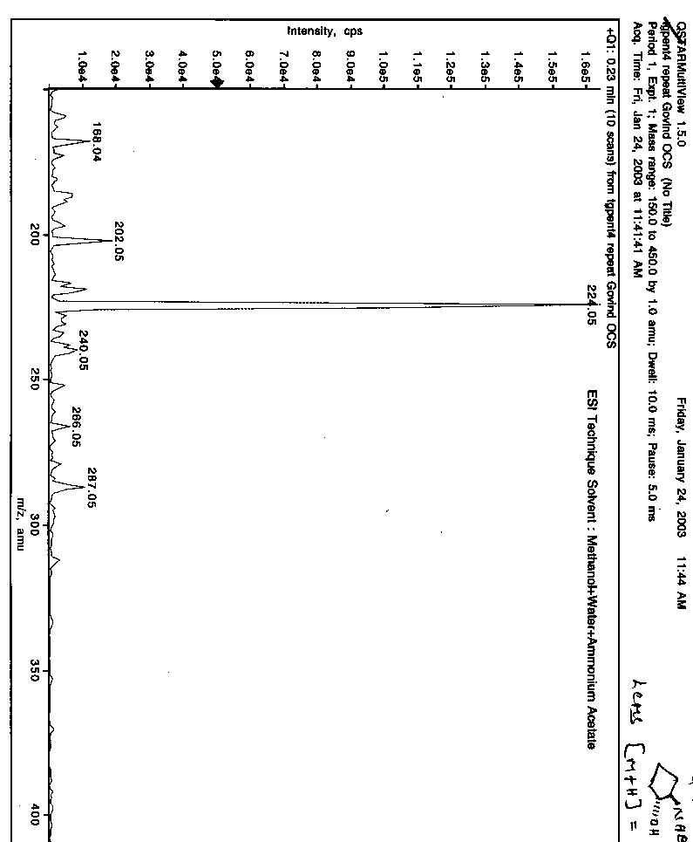
Mass spectrum of compound (1R,2R) 3

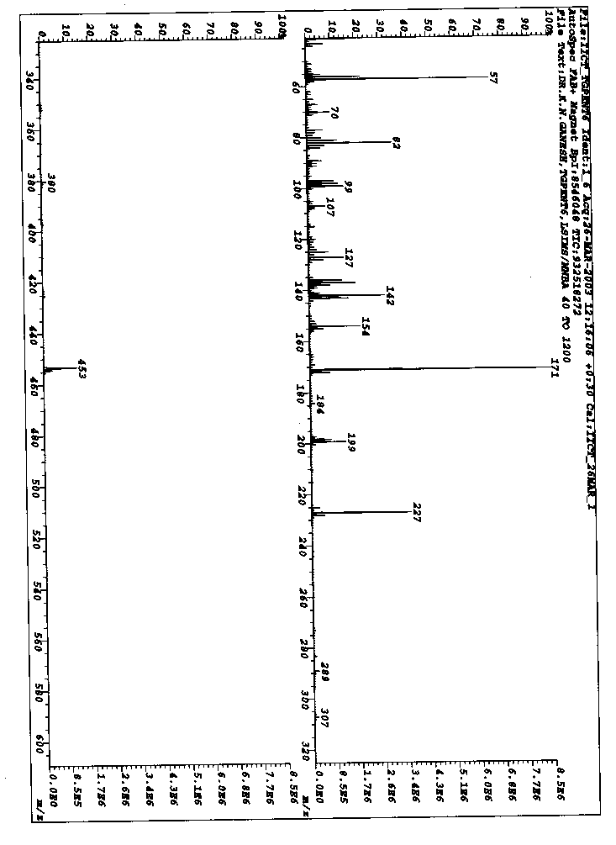
Mass spectrum of compound (1S,2R) 5

S18

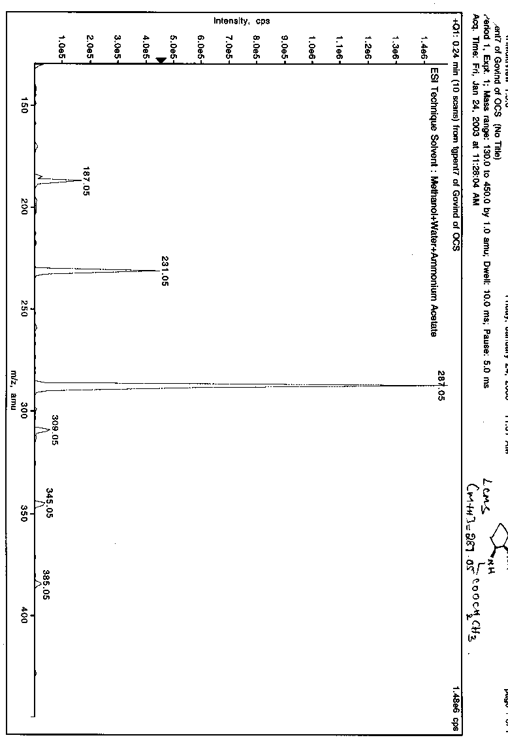
Mass spectrum of compound (1S,2R) 7

S19

S20
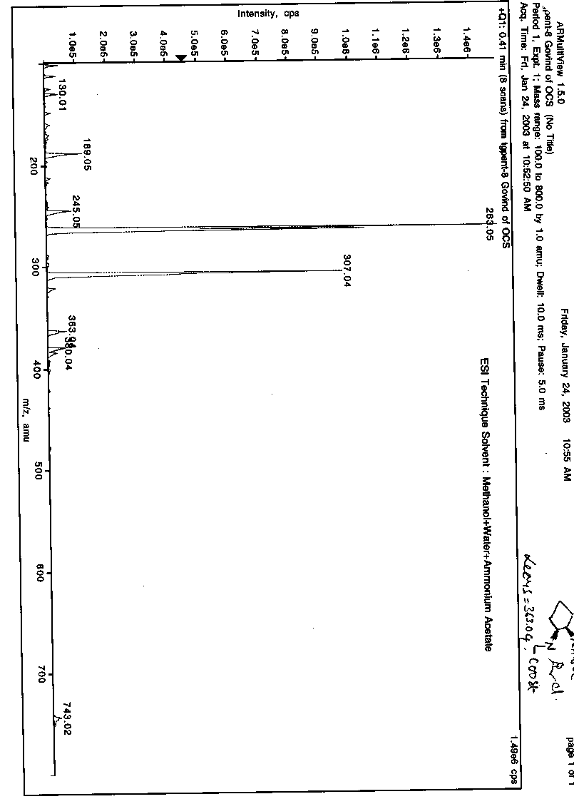
Mass spectrum of compound (1S,2R) 8

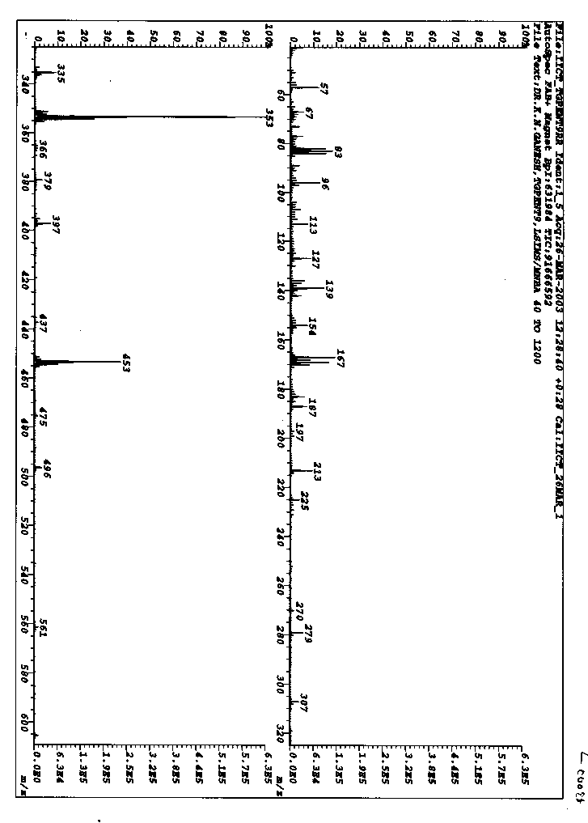
Mass spectrum of compound (1S,2R) 9
[M+H⁺]= 453

S21

S22

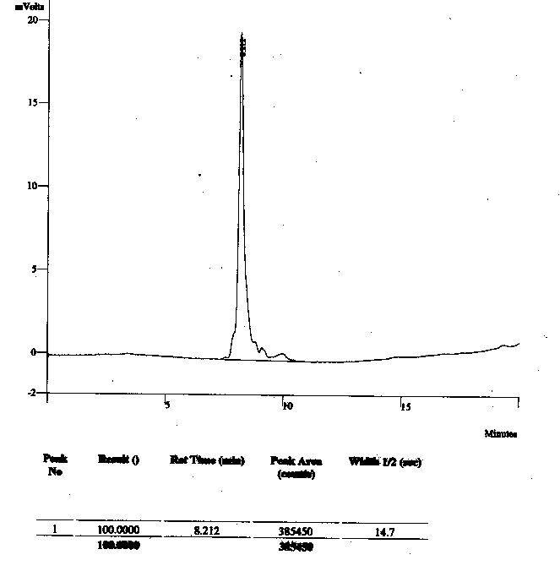
HPLC profile for PNA 10

S23

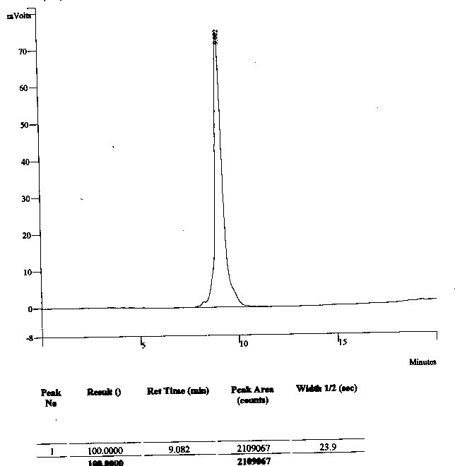
HPLC profile for PNA 11

S243

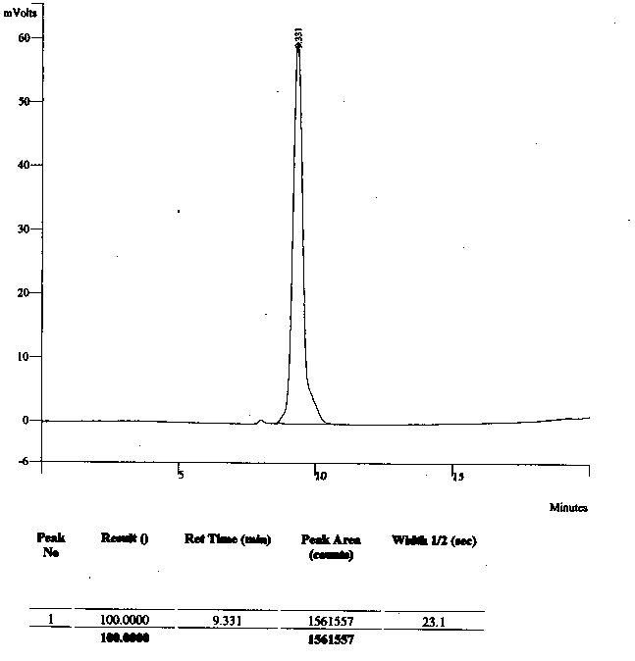
HPLC profile for PNA 12

S25

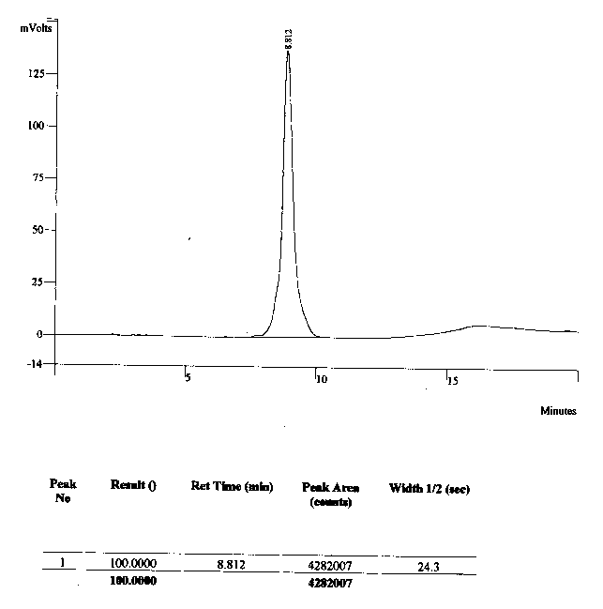
HPLC profile for PNA 13

S26

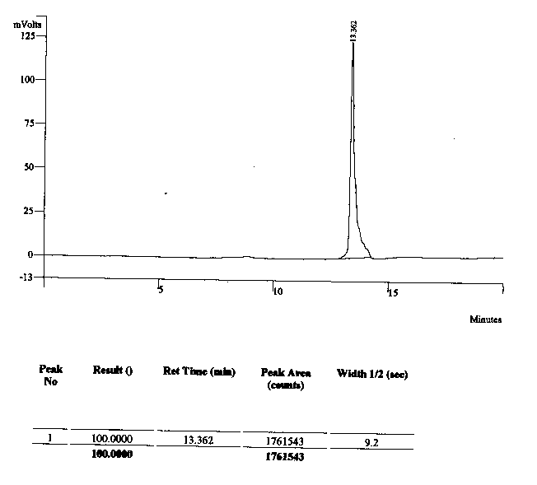
HPLC profile PNA 17

S27
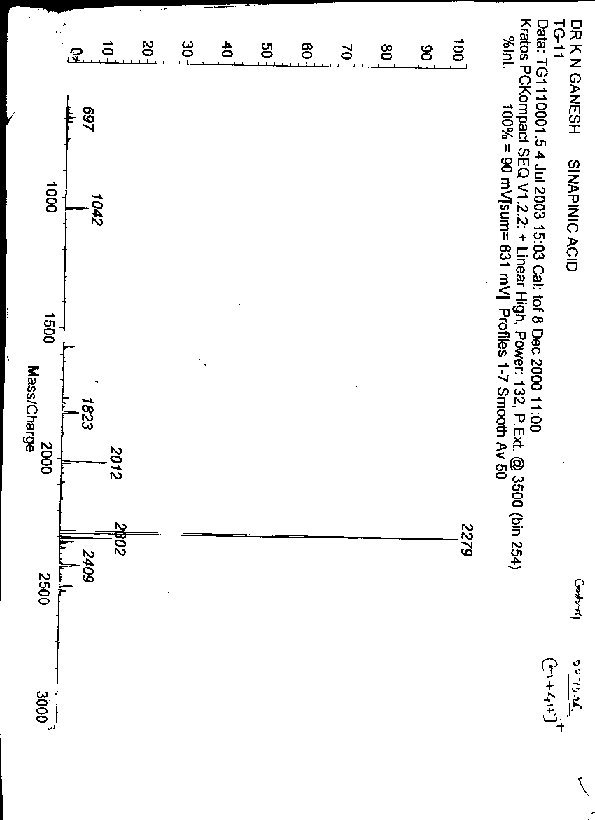
MALDI-TOF spectrum of PNA 10
[M+2H⁺]=2279.0

S28

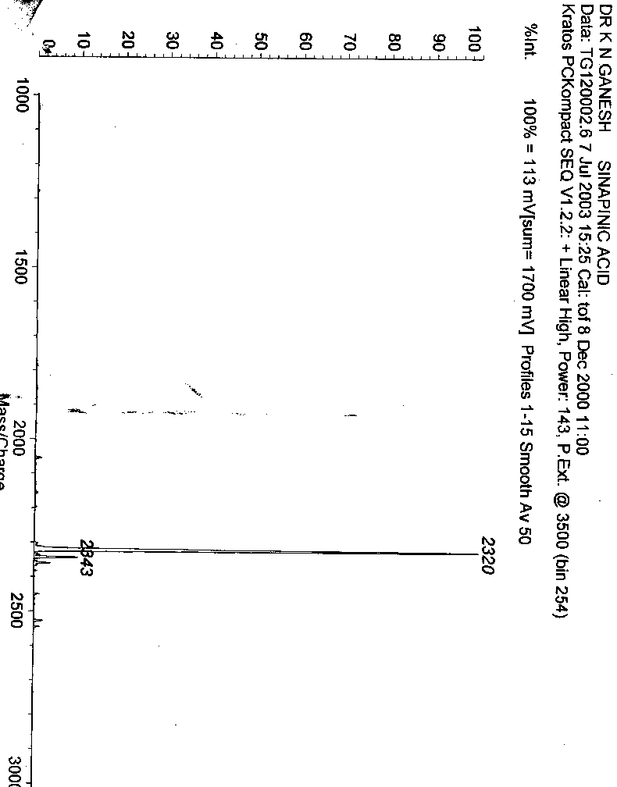
MALDI-TOF spectrum of PNA 11
[M+H⁺]=2320.0

S29

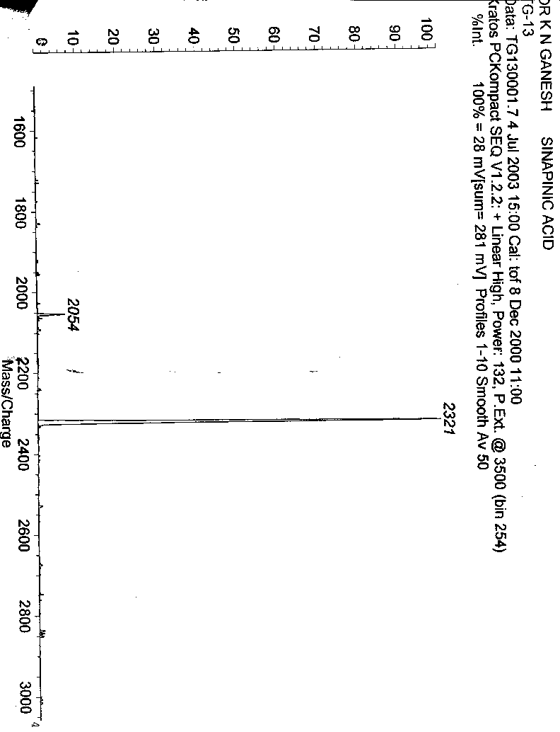
MALDI-TOF spectrum of PNA 12
[M+2H⁺]=2321.0

S30

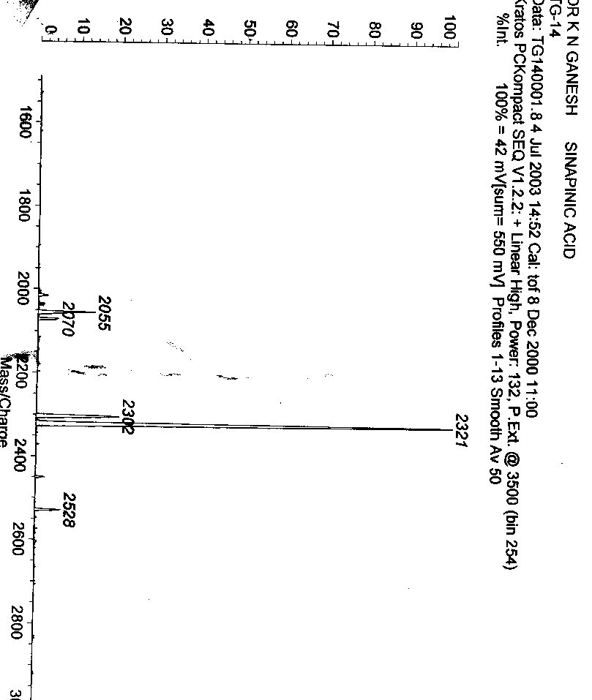
MALDI-TOF spectrum of PNA 13
[M+2H⁺]=2321.0

S31

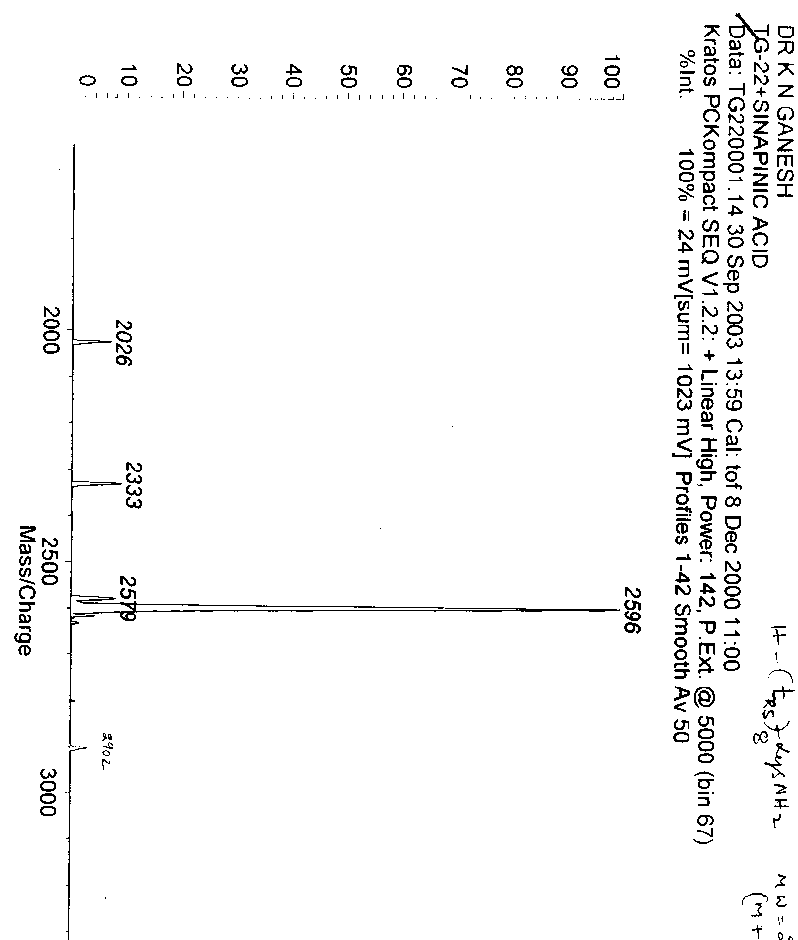
MALDI-TOF spectrum of PNA 17
[M+H⁺]=2596.0

S32

A: Melting profiles of PNA 10, PNA 11 , PNA 13, PNA 14, PNA 16 with DNA 19 and B: Corresponding derivative curves.
A: Melting profiles of PNA 10, PNA 12, PNA 15 with DNA 19. and B: Corresponding derivative curves.

S33

A: Melting profiles of PNA 10, PNA 11 , PNA 13, PNA 14, PNA 16 with DNA 20 (mismatch). and B: Corresponding derivative curves.
A: Melting profiles of PNA 10, PNA 12, PNA 15 with DNA 20 (mismatch). and B: Corresponding derivative curves.

S34

A: Melting profiles of PNA 10, PNA 11 , PNA 13, PNA 16 with poly rA . and B: Corresponding derivative curves
A: Melting profiles of PNA 10, PNA 12, PNA 15 with poly rA. and B: Corresponding derivative curves.

S35

A: Melting profiles of PNA 17, PNA 18 with DNA 19 and B: Corresponding derivative curves.

UV-Tm measurements: The complementary DNA 0ligomers were synthesised on an Applied Biosystems DNA Synthesizer. The poly rA was obtained from Sigma-Aldrich. The concentration was calculated on the basis of absorbance from the molar extinction coefficients of the corresponding nucleobases. The complexes were prepared in 10 mM sodium phosphate buffer, pH 7.0 containing NaCl (100 mM) and EDTA (0.1 mM) and were annealed by keeping the samples at 90°C for 5 minutes followed by slow cooling to room temperature. Absorbance versus temperature profiles were obtained by monitoring at 260 nm with Perkin-Elmer Lambda 35 spectrophotometer scanning from 5 to 90°C at a ramp rate of 0.2°C per minute. The data were processed using Microcal Origin 5.0 and Tm values derived from the derivative curves.

S36

CD-curves for PNA 12 and the complementary DNA 19 d(CGCA₈CGC) mixtures in the molar ratios of 0:100, 10:90, 20:80, 30:70, 40:60, 50:50, 60:40, 70:30, 80:20, 90:10, 100:0 (Buffer, 10 mM Sodium phosphate pH 7.0, 100 mM NaCl, 0.1 mM EDTA)

CD-Job’s plot for PNA 12 and the complementary DNA 19 d(CGCA₈CGC) mixtures in the molar ratios of 0:100, 10:90, 20:80, 30:70, 40:60, 50:50, 60:40, 70:30, 80:20, 90:10, 100:0 at 254 nm (Buffer, 10 mM Sodium phosphate pH 7.0, 100 mM NaCl, 0.1 mM EDTA)

S37

Ortep¹ Diagram of (1S,2R)-9

S38
Ortep¹ diagram of (1R,2S)-9

1. Johnson, C. K, ORTEP II, report ORNL-5138, Oak Ridge National Laboratory, Tennesse, U.S.A, 1976. (Incorporated in SHEX TL package from Bruker-axs.
S39
Crystal data

X-Ray quality single crystals of both (1S,2R)-9 and (1R,2S)-9 could be obtained from chloroform and petroleum ether. X-ray intensity data were collected on a Bruker SMART APEX CCD diffractometer at room temperature.

Crystal data: (1S,2R)-9. C₂₁H₃₂N₄O₇, M = 452.51, Crystal system: Rectangular, Crystal dimensions 0.63 x 0.60 x 0.24 mm, a = 10.6505(7), b = 10.6505(7), c = 43.402(4) Å, space group P 4₃2₁2, V=4923.3(6) Å³, Z = 8, D_{c} = 1.221 g cm^{–3},µ (Mo-K_{α}) = 0.092 mm⁻¹, T = 293(2) K, F(000) = 1936, Max. and min. transmission 0.9786 and 0.9438, 34716 reflections collected, 4339 unique [I>2σ (I)], S= 1.370, R value 0.0733, wR2 = 0.1537 (all data R = 0.0746, wR2 = 0.1543).

Crystal data (1R,2S)-9. C₂₁H₃₂N₄O₇, M = 452.51, Crystal system: Tetragonal, Crystal dimensions 0.66 x 0.33 x 0.11 mm, space group P 4₁2₁2, a = 10.6483(4), b = 10.6483(4), c = 43.318(3) Å, V= 4911.7(4) Å³, Z = 8, D_{c} = 1.224 g cm^{–3},µ (Mo-K_{α}) = 0.092 mm^{–1}, T = 293(2) K, F(000) = 1936, Max. and min. transmission 0.9903 and 0.9416, 24647 reflections collected, 4333 unique [I>2σ (I)], S= 1.123, R value 0.0537, wR2 = 0.1164 (all data R = 0.0693, wR2 = 0.1224).

All the data were corrected for Lorentzian, polarisation and absorption effects using Bruker’s SAINT and SADABS programs. SHELX-97 (G. M. Sheldrick, SHELX-97 program for crystal structure solution and refinement, University of Gottingen, Germany, 1997) was used for structure solution and full matrix least squares refinement on F². Hydrogen atoms were included in the refinement as per the riding model. The absolute structure was derived from a knowledge of the configuration of the starting materials for synthesis.

(11) Johnson, C.K, ORTEP II, report ORNL-5138, Oak Ridge National Laboratory, Tenesse, USA (1976). (Incorporated in SHELX TL package from Bruker-axs).

S 40

UV Job’s Plot for PNA 12: DNA 19 showing 2:1 binding

UV-Job’s plot for PNA 12 and the complementary DNA 19 d(CGCA₈CGC) mixtures in the molar ratios of 0:100, 10:90, 20:80, 30:70, 40:60, 50:50, 60:40, 70:30, 80:20, 90:10, 100:0 (Buffer, 10 mM Sodium phosphate pH 7.0, 100 mM NaCl, 0.1 mM EDTA)

