Electronic Supplementary Information
Desymmetrization of meso-Dienyne by Asymmetric Pauson-Khand type Reaction Catalysts

Nakcheol Jeong*, Dong Hoon Kim, Jun Hun Choi

Department of Chemistry and Division of Molecular Engineering and Chemistry,
Korea University, Seoul, 136-701, Korea.

General considerations; Reactions were carried out in oven-dried glassware sealed with rubber septa under an atmosphere pressure of carbon monoxide or argon from a balloon. Anhydrous liquids and solutions were transferred by an oven dried syringe or stainless steel cannula. Reactions were run using Teflon-coated magnetic stir bars. Elevated temperatures were maintained in thermostat-controlled oil baths. Organic solutions were concentrated using a Büchi rotary evaporator with a desktop vacuum pump. Thin layer chromatography plates were visualized by ultraviolet light and treatment with acidic p-anisaldehyde stain followed by gentle heating. Chromatographic purification of products was accomplished by flash chromatography, by using Merck silica gel 60 (230-400mesh).
Unless otherwise noted, all material were obtained from commercial suppliers and used without further purification. [Rh(CO)₂Cl]₂ and [Ir(COD)Cl]₂ were purchased from Strem Chemicals. AgOTf and [Rh(COD)Cl]₂ were purchased from Aldrich Chemical Co.
Tetrahydrofuran (THF) was freshly distilled from sodium benzophenone ketyl prior to use. Toluene was distilled from calcium hydride and stored over MS 4A.
¹H NMR spectra were recorded on Varian Gemini 300MHz. Chemical shifts are reported in ppm from TMS with the solvent resonance as internal standard (CHCl₃, δ7.26ppm). ¹³C NMR spectra were recorded on Varian Gemini 75MHz spectrometer with complete proton decoupling. Chemical shifts are reported in ppm from TMS with the solvent as the internal reference (CDCl₃, δ77.7ppm). High-Performance Liquid Chromatography (HPLC) was conducted using a Waters model 600 pumping system with a Waters model 2487 ultraviolet detector at 254nm. Infrared (IR) spectra were recorded on a Bomem 102 FT-IR spectrometer. Optical rotations were measured at the 589nm sodium D-Line from RUDOLPH AUTOPOL automatic polarimeter. Low- and high-resolution mass spectra were obtained on a JEOL JMS-AX505WA mass spectroscopy.

Determination of Enantiomeric Purity; The enantiomeric excesses (%ee) were determined by chiral HPLC analysis. CHIRALPAK AS-H 25cm x 0.46cm column (Daicel Chemical Ind. Ltd.) was used for 2a (entries 5, 6, 7, 8), 3b (entries 13, 14, 15), 2d (entries 19, 20, 21), 2e (entries 22, 23, 24) and 3d (entry 20). CHIRALPAK AS 25cm x 0.46cm column (Daicel Chemical Ind. Ltd.) was used for 2a (entries 1, 2, 3, 4, 9, 10, 11, 12). CHIRALCEL OD-H 25cm x 0.46cm column (Daicel Chemical Ind. Ltd.) was used for 2b (entries 13, 14, 15), 3a (entries 1-12), 2c (entries 13, 14, 15), 3c (entries 13, 14, 15) and 3e (entry 23).

Preparation of the substrates;
4-methyl-N-2-propynyl-benzenesulfonamide
Prop-2-ynylamine (2.5mL, 36.3mmol) was dissolved in Pyridine (20mL) was stirred for 0.5h. Methanesulfonyl chloride (10.4g, 54.5mmol) was added one portion at 0℃ and the solution was stirred to room temperature over 2h, the reaction was quenched with 1N aqueous HCl and the mixture was extracted with ethyl acetate (3x150mL). The combined organic layer was dried over MgSO₄ and concentrated in vacuo. The crude solid was recrystallized with n-hexane/ethyl acetate (90/10, v/v) afforded the product (7.4g, 97%) as a white needle-like solid.
mp: 76℃; ¹H-NMR (CDCl₃, 300MHz) δ 7.78(d, J=6Hz, 2H), 7.32(d, J=9Hz, 2H), 4.72(m, 1H), 3.83(m, J=6Hz, 2H), 2.44(s, 3H), 2.12(t, J=3Hz, 1H); ¹³C-NMR (CDCl₃, 75MHz) δ 148.81, 136.44, 129.66, 127.36, 72.95, 32.81, 21.53; IR (KBr, cm⁻¹) 3535, 3278, 1595, 1319, 1161; HRMS (EI⁺) Exact mass calcd for C₁₀H₁₁NO₂S: 209.0511, found: 209.0514

4-methyl-N-2-propynyl-N-(1-vinyl-allyl)-benzenesulfonamide (1c)
To solution of and 4-methyl-N-2-propynyl-benzenesulfonamide (4.0g, 19.1mmol), penta-1,4-dien-3-ol (2.79mL, 28.6mmol) and triphenylphosphine (7.5g, 28.6mmol) in THF (200mL) at 0℃ was slowly added DEAD (4.4mL, 28.6mmol), and the resulting orange solution was stirred at room temperature for 1 hour. The reaction mi9xture was diluted with ethyl acetate. The organic layer was separated and dried over MgSO₄ and concentrated in vacuo. The resulting solid was suspended in hexanes, and filtered. The filtrate was concentrated in vacuo. Flash chromatography (silica gel with n-hexane/ethyl acetate (30/1, v/v)) afforded a colorless oil as a mixture of 1c and 1c’ (4.9g, 90%). And then, a mixture was dissolved in toluene (120mL) and the solution was heated at 160℃ for 15 hours. After cooling the reaction mixture to rt, the solvent was removed in vacuo. The resulting residue was subjected to column chromatography on silica gel with n-hexane/ethyl acetate (30/1, v/v) as an eluent to give the product 1c (1.62g, 31% overall yield of 2 step) as a white solid.
mp: 63℃; ¹H-NMR (CDCl₃, 300MHz) δ 7.79(d, J=6Hz, 2H), 7.27(d, J=6Hz, 2H), 5.88(ddd, J=6, 10.6, 17.1, 2H), 5.19(m, 4H), 4.98(m, 1H), 4.05(d, J=2.1Hz, 2H), 2.42(s, 3H), 2.13(s, 1H); ¹³C-NMR (CDCl₃, 75MHz) δ 143.30, 137.42, 134.27, 129.23, 127.68, 118.92, 79.63, 72.63, 61.97, 33.44, 21.48; IR (KBr, cm⁻¹) 3270, 3093, 2941, 2119, 1923, 1639, 1558, 1395, 1152; HRMS (EI⁺) Exact mass calcd for C₁₅H₁₇NO₂S: 275.0980, found: 275.0992

N-But-2-ynyl-4-methyl-N-(1-vinyl-allyl)-benzenesulfonamide (1a)
To a THF (20mL) solution of 1c (500.0mg, 1.82mmol) was slowly added a solution of n-BuLi (1.4ml, 2.2mmol) inhexane at -78℃ under argon to obtain a lavender-cooled solution. After 0.5 hour, DMPU (2mL) was added at the same temperature and the solution was stirred for additional 0.5 hour, whereupon the color of the solution became dull red. Iodomethane (567μL, 9.1mmol) was added dropwise to obtain a pale yellow solution. After allowing the solution to warm to room temperature over 1 hour, the reaction was quenched with H₂O, and the mixture was extracted with ethyl acetate (3x20mL). The combined organic layer was dried over MgSO₄ and concentrated in vacuo. The crude oily residue was purified by silica gel flash chromatography with n-hexane/ethyl acetate (30/1, v/v) as an eluent to afford the product 1a (330mg, 63%) as a white solid
mp: 57℃; ¹H-NMR (CDCl₃, 300MHz) δ 7.79(d, J=9Hz, 2H), 7.27(d, J=9Hz, 2H), 5.88(ddd, J=6, 10.6, 17.1Hz, 2H), 5.20(m, 4H), 4.98(m, 1H), 3.99(d, J=3Hz, 2H), 2.42(s, 3H), 1.64(t, J=3Hz, 3H); ¹³C-NMR (CDCl₃, 75MHz) δ 142.99, 137.83, 134.70, 129.04, 127.79, 118.54, 80.54, 74.78, 62.06, 34.06, 21.49, 3.38; IR (KBr, cm⁻¹) 3087, 2927, 2225, 1600, 1423, 1345, 1156; HRMS (EI⁺) Exact mass calcd for C₁₆H₁₉NO₂S: 289.1137, found: 289.1129

N-But-2-ynyl-4-phenyl-N-(1-vinyl-allyl)-benzenesulfonamide (1b)
To a stirred mixture of 1c (200mg, 0.73mmol), CuI(4.2mg, 0.03mM), and Pd(PPh₃)₄ (8.4mg, 0.01mmol) in THF(7ml) was added triethylamine(7mL) and iodobenzene(123μL, 1.1mmol) in succession. The mixture was stirred at room temperature for 0.5 hour. The solvent was evaporated, and the residue was treated with n-hexane. The mixture was filtered through Celite pad and the filtrated was concentrated in vacuo. The crude oily residue was purified by flash chromatography of silics gel with n-hexane/ethyl acetate (30/1, v/v) as an eluent to afford the product 1b (245mg, 95%) as pale yellow oil.
¹H-NMR (CDCl₃, 300MHz) δ 7.82(d, J=8.1Hz, 2H), 7.13-7.28(m, 2H, 5H), 5.94(ddd, J=6, 9, 16.6Hz, 2H), 5.23(d, J=9.9Hz, 2H), 5.21(d, J=7.8Hz, 2H), 5.07(m, 1H), 4.28(s, 2H), 2.31(s, 3H); ¹³C-NMR (CDCl₃, 75MHz) δ 142.9, 137.4, 134.3, 131.0, 128.9, 128.0, 127.8, 127.5, 122.3, 118.5, 84.9, 84.4, 61.9, 34.2, 21.3; IR (KBr, cm⁻¹) 3105, 2921, 2251, 1642, 1606, 1489, 1347, 1157; HRMS (EI⁺) Exact mass calcd for C₂₁H₂₁NO₂S: 351.1293, found: 351.1274

3-But-2-ynyloxy-penta-1, 4-diene (1d)
NaH(433mg, 18.1mmol) and Penta-1, 4-dien-3-ol (1.8ml, 18.1mmol) were placed in THF. 1-Bromo-but-2-yne (2.0g, 15.0mmol) was added to the solution at 0℃. And the reaction mixture was allowed to stir for 18 hours at room temperature. The reaction mixture was quenched with saturated aqueous NH₄Cl (50mL) and extracted with ethyl acetate (3x50mL). The combined organic layers were washed with saturated brine and dried over MgSO_{4.} The filtrate was concentrated in vacuo. Then the crude oily product was placed in benzene (100mL) and heated at 120℃ for 24 hours. The reaction mixture was cooled to rt, and the solvent was removed in vacu., The resulting residue was subjected to column chromatography on silica gel with n-hexane/ethyl acetate (10/1, v/v) as the eluent to give the product 1d (1.3g, 64% overall yield of 2 step) as colorless oil.
¹H-NMR (CDCl₃, 300MHz) δ 5.79(ddd, J=6, 9, 16.6Hz, 2H), 5.25(m, 4H), 4.40(m, 1H), 4.10(s, 2H), 1.86(s, 3H); ¹³C-NMR (CDCl₃, 75MHz) δ 137.12, 117.19, 82.02, 80.17, 75.24, 55.58, 3.51; IR (KBr, cm⁻¹) 3078, 2922, 2224, 1638, 1358, 1061

[3-(1-Vinyl-allyloxy)-prop-1-ynyl]-benzene (1e)
Trimethyl phosphite (128μL, 0.40mM) was added directly to a red suspension of Wilkinson’s catalyst (251mg, 0.10mmol) in anhydrous THF (10mL). The reaction mixture was warmed to 30℃, under an atmosphere of argon and allowed to form new catalyst over ca. 15 minutes resulting in a light yellow homogeneous solution. In a separate flask, a solution of lithium hexamethyldisilylazide (5.20ml, 5.16mmol, 1.0M solution in THF) was added dropwise to a suspension of copper(I) iodide (1.0g, 5.43mmol) and 3-phenyl-prop-2-yn-1-ol (682mg, 5.16mmol) in anhydrous THF (10mL) under argon. The reaction mixture was allowed to form over 2 minutes until a light yellow homogeneous solution was obtained. The mixture was cooled to 0ºC. To this solution was added a former solution of new catalyst via cannula at that temperature. A solution of allylic carbonate (400mg, 2.714mmol) was then added into the reaction mixture via a syringe. The reaction mixture was allowed to slowly warm to room temperature over 18 hours resulting in a tan heterogeneous solution. The reaction mixture was filtered through silica gel and washed with ethyl ether, and the filtrate concentrated in vacuo to afford a crude oil. Purification by silica gel flash chromatography with n-hexane/ethyl acetate(70/1, v/v) as an eluent afforded the product 1e (268mg, 50%) as colorless oil.
¹H-NMR (CDCl₃, 300MHz) δ 7.46(m, 2H), 7.31(m, 2H), 5.83(ddd, J=6, 9, 16.6Hz, 2H), 5.28(m, 4H), 4.52(m, 1H), 4.38(s, 2H); ¹³C-NMR (CDCl₃, 75MHz) δ 137.03, 131.82, 12.8.95, 128.34, 122.89, 117.56, 86.06, 85.36, 80.49, 55.87; IR (KBr, cm⁻¹) 3075, 2924, 2237, 1732, 1065 ; HRMS (EI⁺) Exact mass calcd for C₁₄H₁₄O: 198.1045, found: 198.1030

General Procedure for the Enantioselective Pauson-Khand Type Reaction by [Rh(CO)₂Cl]₂
[Rh(CO)₂Cl] (1.2mg, 0.03mmol), (R)-tolBANAP (6.1mg, 0.09mmol) in THF (1mL) were placed in flask under atmosphere of argon. The mixture is stirred at room temperature for 10 minutes. Complete consumption of the ligand was confirmed by tlc analysis. Then a solution of AgOTf (3.1mg, 0.12mmol) in THF (1mL) added to the mixture and the resultant mixture was stirred at this temperature for additional 30 minutes. Then the reaction mixture was evacuated and charged with 1 atm carbon monoxide followed by the addition of a solution of the dienyenes 1 (0.1mmol) in THF (1mL). The reaction mixture was heated at 90℃ for 0.5 hour. After completion of the reaction, the reaction mixture was cooled to room temperature and the carbon monoxide was released in the hood. The reaction mixture then was concentrated in vacuo, and the crude residue was filtered through a plug of silica gel with the aid of ethyl acetate and the filtrate was again concentrated in vacuo to give oily residue. The crude mixture was purified by column chromatography on silica gel eluting with n-hexane/ethyl acetate (5/1, v/v) to give the product as a white solid. The Ee was determined by HPLC analysis using a previously specified chiral column.

General Procedure for the Enantioselective Pauson-Khand Type Reaction with Cinnamaldehyde under Solvent-Free Conditions by [Rh(COD)Cl]₂
[Rh(COD)Cl]₂ (3.7mg, 0.05mM), (R)-tolBINAP (10.2mg, 0.10mmol), dienyene (30mg, 0.15mmol) and cinnamaldehyde (378μL, 3mmol) were placed in a flask under atmosphere pressure on argon. The reaction mixture was stirred at 120℃ for 4 hours. After the completion of the reaction, the crude mixture was purified by column chromatography (silica gel) with n-hexane/ethyl acetate (5/1, v/v) as an eluent to give the corresponding product. The Ee was determined by HPLC analysis using a previously specified chiral column.

General Procedure for the Enantioselective Pauson-Khand Type Reaction by [Ir(COD)Cl]₂
(R)-tolBINAP (23.1mg, 0.30mmol) and [Ir(COD)Cl]₂ (10.5mg, 0.15mmol) were placed in toluene (1mL) and the mixture was warmed to 40℃ under atmospheric pressure of carbon monoxide, a light yellow solution was obtained in 15 min. To this mixture was added a solution of dienyene (0.1mmol) in toluene (2mL) and theresultant reaction mixture was refluxed at 130℃ for 24 hours. After cooling the reaction mixture to room temperature, carbon monoxide was released in the hood. The resulting mixture was passed through a small pad of silica gel using a mixed eluent of n-hexane and ethyl acetate (3/1, v/v). The organic layer was concentrated in vacuo. Purification of the crude residue by column chromatography on silica gel eluting with n-hexane/ethyl acetate (5/1, v/v) afforded the corresponding products. The Ee was determined by HPLC analysis using a previously specified chiral column.
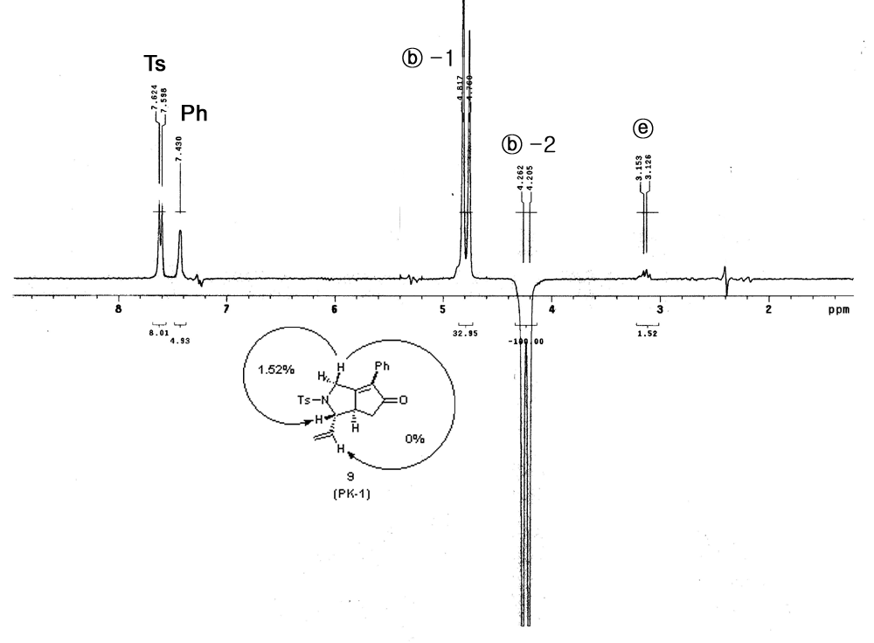
NOE spectra of 2b

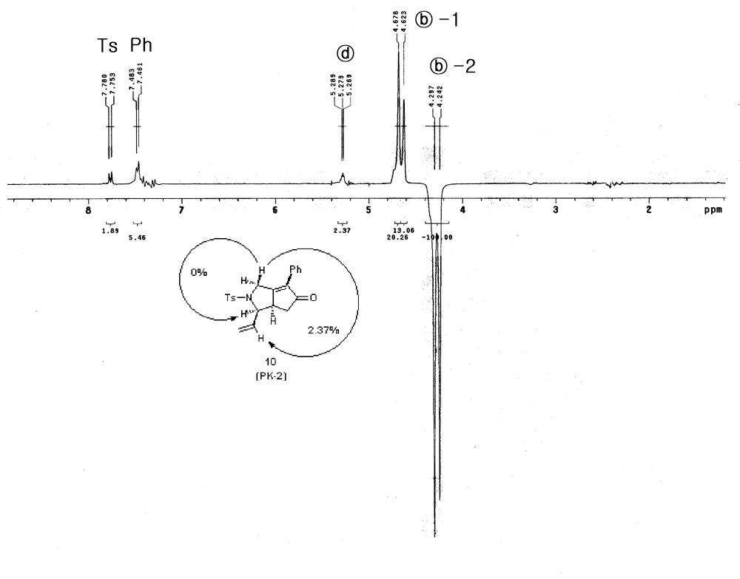
NOE spectra of 3b

6-Methyl-2-(toluene-4-sulfonyl)-3-vinyl-2,3,3a,4-tetrahydro-1H- cyclopenta[c]pyrrol-5-one. (entries 1-12)
a. PK-1 product (2a)
White solid; mp: 113-115℃; ¹H-NMR (CDCl₃, 300MHz) δ 7.68(d, J=9Hz, 2H), 7.34(d, J=9Hz, 2H), 6.02(m, 1H), 5.23(m, 2H), 4.40(d, J=16.2Hz, 1H), 4.13(d, J=16.2Hz, 1H), 3.08(m, 1H, 1H), 2.56(dd, J=6.0, 18.0Hz, 1H), 2.44(s, 3H), 2.00(dd, J=18.0, 2.7Hz, 1H), 1.65(s, 3H); ¹³C-NMR (CDCl₃, 75MHz) δ 206.96, 168.29, 144.08, 134.03, 133.53, 129.80, 127.69, 117.16, 69.05, 48.82, 48.71, 38.23, 21.57, 8.57; IR (KBr, cm⁻¹) 2916, 1710, 1677, 1348, 1160; HRMS (EI⁺) Exact mass calcd for C₁₇H₁₉NO₃S: 317.1086, found: 317.1077; HPLC (DAICELL CHIRALPAK AS, n-HEX/IPA=2/1, flow 1.0ml/min, detection at 254nm) t_{R}=19.130min(major) and 53.975min(minor) ; [α]_{D}²³=+122.02° (C=0.28, CHCl_{3,} 96%ee), [α]_{D}²⁶=+120°(C=0.3, CHCl_{3,} 93%ee), [α]_{D}²³=+113.6°(C=0.45, CHCl_{3,} 92%ee), [α]_{D}²³=+92.9° (C=0.5, CHCl_{3,} 85%ee)
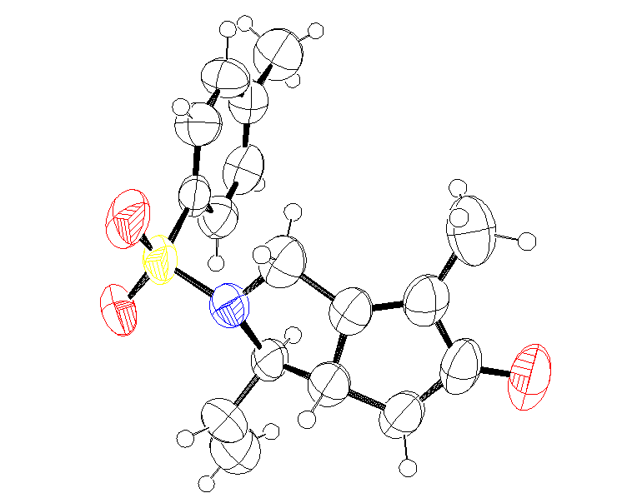
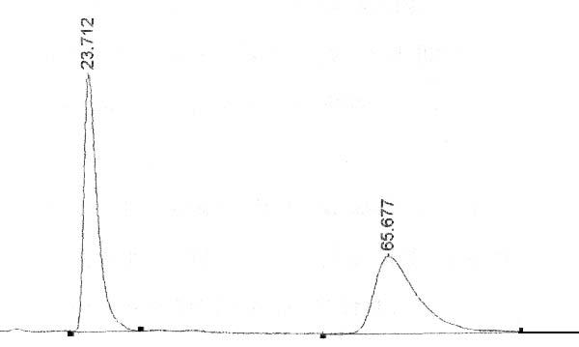 Racemic Product
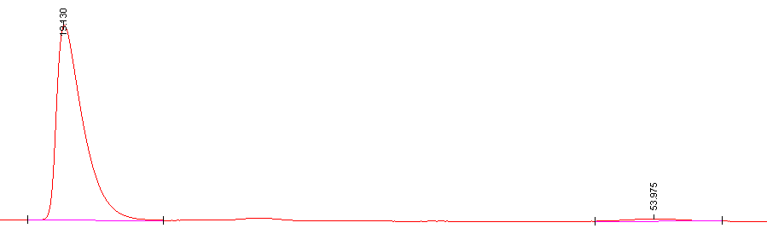 96%ee
Compound 2a that was crystallized from IPA/n-Hexane to afford single crystal and HPLC Charts of 2a (entry 11, CHIRALPAK AS, n-Hex/IPA = 2/1)
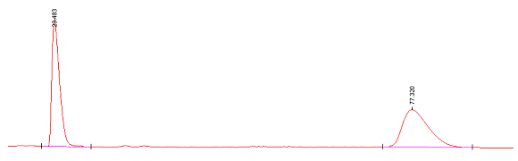 Racemic Product
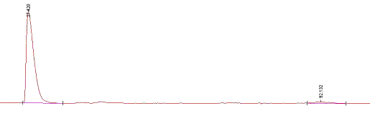 93% ee (entry 9)
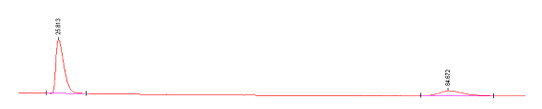 58% ee (entry 5)
HPLC Charts of 2a (entry 5, CHIRALPAK AS-H, n-Hex/IPA=2/1,
flow rate=1.0ml/min (t_{R} =25.813min (major) and 84.672min (minor))

b. PK-2 product (3a)
White solid; ¹H-NMR (CDCl₃, 300MHz) δ 7.76(d, J=8.1Hz, 2H), 7.32(d, J=8.1Hz, 2H), 5.31(m, 3H), 4.67(m, 1H), 4.28(m, 2H), 2.48-2.39(m, 1H, 3H), 2.12(dd, J=18.0, 2.7Hz, 1H), 1.72(s, 3H); ¹³C-NMR (CDCl₃, 75MHz) δ 208.01, 170.0, 143.8, 135.8, 134.7, 131.6 129.8, 127.4, 119.9, 63.1, 46.0, 45.5, 36.6, 21.5, 8.7; IR (KBr, cm⁻¹) 2919, 1717, 1683, 1341, 1160; HPLC (DAICELL CHIRALPAK OD-H, n-HEX/IPA=9/1, flow 0.7ml/min detection at 254nm) t_{R}=31.273min(major) and 35.570min(minor); [α]_{D}²³=+51.6° (C=1.19, CHCl_{3,} 73% ee), [α]_{D}¹⁷=+59.47° (C=0.95, CHCl_{3,} 80% ee), [α]_{D}¹⁶=+57.4° (C=0.7, CHCl_{3,} 77% ee), [α]_{D}²³=+42.8° (C=0.5, CHCl_{3,} 53% ee)
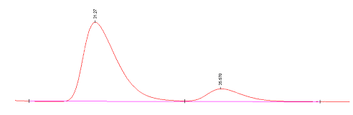
HPLC Charts of 3a (entry 5, CHIRALCELL OD-H, n-Hex/IPA = 9/1), 71% ee.
6-Phenyl-2-(toluene-4-sulfonyl)-3-vinyl-2,3,3a,4-tetrahydro-1H-cyclopenta[c]pyrrol-5-one. (entries 13, 14, 15)
a. PK-1 product (2b)
White solid; mp: 146-148℃; ¹H-NMR (CDCl₃, 300MHz) δ 7.61(d, J=8.5Hz, 2H), 7.42-7.39(m, 5H), 7.25(d, J=8.5Hz, 2H), 6.08(ddd, J=18.0, 10.0, 8.0Hz, 1H), 5.30(d, J=10.5Hz, 1H), 5.26(d, J=17.0Hz, 1H), 4.77(d, J=17.1Hz, 1H), 4.23(d, J=17.1Hz, 1H), 3.19(m, 1H), 3.13(m, 1H), 2.71(dd, J=18.0, 6.5Hz, 1H), 2.39(s, 3H), 2.22(dd, J=18.0, 3.5Hz, 1H); ¹³C-NMR (CDCl₃, 75MHz) δ 205.08, 169.50, 144.25, 137.05, 136.15, 133.55, 130.08, 130.03, 129.19, 128.89, 128.46, 127.87, 117.71, 68.69, 50.58, 49.17, 40.02, 21.76; IR (KBr, cm⁻¹) 1703, 1642, 1347, 1167, 929; HRMS (EI⁺) Exact mass calcd for C₂₂H₂₁NO₃S: 379.1242, found: 379.1260; HPLC (DAICELL CHIRALPAK OD-H, n-HEX/IPA=2/1, flow 1.0ml/min, detection at 254nm) t_{R}=11.516min(major) and 18.107min(minor); [α]_{D}²⁶=-55.8° (C=0.45, CHCl_{3,} 90 % ee)
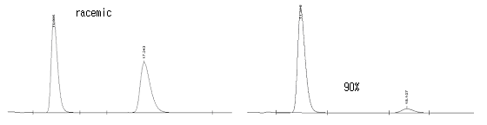
HPLC Charts of 2b (CHIRALCELL OD-H, n-Hex/IPA = 2/1)

b. PK-2 product (3b)
White solid; ¹H-NMR (CDCl₃, 300MHz) δ 7.77(d, J=8.2Hz, 2H) 7.42(m, 5H) 7.30(m, 2H) 5.28(m, 3H) 4.70(m, 1H) 4.65(d, J=15Hz, 1H) 4.30(d, J=16.8Hz, 1H) 3.25(ddd, J=3.8, 2.3, 2.1Hz, 1 H) 2.63(dd, J=18.3, 6.7Hz, 1H) 2.41(s, 3H) 2.34(dd, J=18.4, 3.6Hz, 1H); ¹³C-NMR (CDCl₃, 75MHz) δ 205.81, 171.11, 143.81, 136.68, 135.90, 131.43, 129.78, 128.90, 128.65, 127.35, 120.23, 62.53, 47.39, 45.64, 37.94, 21.49; IR (KBr, cm⁻¹) 1706, 1624, 1341, 1160, 927; HPLC (DAICELL CHIRALCELL OD-H, n-HEX/IPA=3/1, flow 0.7ml/min, detection at 254nm) t_{R}=45.112min(minor) and 66.628min(major)
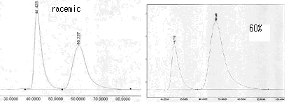
HPLC Charts of 3b (entry 13, CHIRALPAK OD-H, n-Hex/IPA =3/1)
2-(Toluene-4-sulfonyl)-3-vinyl-2,3,3a,4-tetrahydro-1H-cyclopenta[c]pyrrol-5-one (entries 16, 17, 18)
a. PK-1 product (2c)
White solid; mp: 123-125℃; ¹H-NMR (CDCl₃, 300MHz) δ 7.67(d, J=8.2Hz, 2H), 7.35(m, 2H), 6.04(m, 1H), 5.93(s, 1H), 5.27(m, 2H), 4.50(d, J=15Hz, 1H), 4.15(d, J=15Hz, 1H), 3.14(m, 2H), 2.44(s, 3H), 2.47(m, 1H), 2.03(m, 1H); ¹³C-NMR (CDCl₃, 75MHz) δ 207.07, 176.27, 144.45, 135.94, 131.53, 130.13, 126.29, 117.56, 59.09, 51.20, 48.01, 39.05, 21.80; IR (KBr, cm⁻¹) 2925, 1715, 1642, 1348, 1160; HRMS (FAB); [M+H]⁺ Exact mass calcd for C₁₆H₁₇NO₃S : 304.1007, found : 304.1006; HPLC (DAICELL CHIRALPAK OD-H, n-HEX/IPA=2/1, flow 1.0ml/min, detection at 254nm) t_{R}=13.983min(major) and 16.040min(minor)

b. PK-2 product (3c)
White solid; ¹H-NMR (CDCl₃, 300MHz) δ 7.75(d, J=8.2Hz, 2H), 7.31(m, 2H), 6.06(s, 1H), 5.23(m, 3H), 4.70(m, 1H), 4.85(d, J=18Hz, 1H), 4.20(d, J=18Hz, 1H), 3.12(m, 1H), 2.43(s, 3H), 2.55-2.38(m, 1H), 2.13(dd, J=2.9Hz, 18.0Hz, 1H); ¹³C-NMR (CDCl₃, 75MHz) δ 208.15, 178.26, 137.13, 133.40, 133.40, 130.06, 127.60, 127.00, 120.38, 63.18, 49.80, 47.06, 37.43, 21.80; IR (KBr, cm⁻¹) 2925, 1715, 1642, 1348, 1160; HPLC (DAICELL CHIRALPAK OD-H, n-HEX/IPA=2/1, flow 1.0ml/min, detection at 254nm) t_{R}=17.772min(major) and 22.177min(minor)
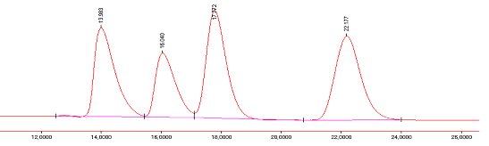
Racemic product
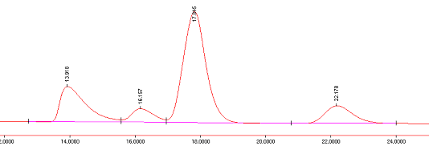
[Rh(CO)₂Cl]₂/(R)-tolBINAP
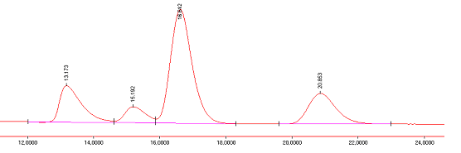
[Rh(COD)Cl]₂/(R)-tolBINAP
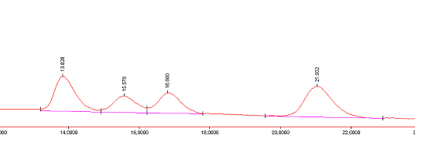
[Ir(COD)Cl]₂/(R)-(p-MeO)BINAP
Figure 14. HPLC Charts of 2d (entry 20, CHIRALPAK AS-H, n-Hex/IPA =9/1)

6-Methyl-3-vinyl-3a,4-dihydro-1H,3H-cyclopenta[c]furan-5-one. (entries 19, 20, 21)
a. PK-1 product (2d)
Colorless oil; ¹H NMR (CDCl_{3,} 300 MHz) δ 5.97(ddd, J=17.2, 10.3, 6.9Hz, 1H), 5.32(m, 2H), 4.69(d, J=15.4Hz, 1H), 4.57(d, J=15.4Hz, 1H), 3.77(dd, J=10.2, 6.9Hz, 1H), 2.92(dd, J=6.0, 4.4Hz, 1H), 2.64(dd, J=17.9, 6.3Hz, 1H), 2.13(dd, J=18.3, 3.4Hz, 1H), 1.77(s, 3H); ¹³C-NMR (CDCl₃, 75MHz) δ 209.20, 176.43, 136.29, 133.21, 118.67, 84.71, 65.48, 48.80, 38.12, 9.04; IR (KBr, cm⁻¹) 2923, 2855, 1731, 1666, 1115; HRMS (FAB); [M+H]⁺ Exact mass calcd for C₁₀H₁₃O₂ : 165.0916, found : 165.0926; HPLC (DAICEL CHIRALPAK AS-H, n-HEX/IPA=9/1, flow 0.8ml/min, detection at 254nm) t_{R}=12.937min(minor) and 15.375min(major); [α]_{D}²³=+71.8° (C=0.1, CHCl_{3,} 87% ee)
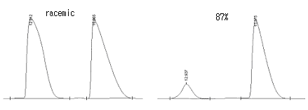
. HPLC Charts of 2d (entry 20, CHIRALPAK AS-H, n-Hex/IPA =9/1)
b. PK-2 product (3d)
Colorless oil; ¹H NMR (CDCl_{3,} 300 MHz) δ 5.52(m, 1H), 5.22(m, 2H), 4.74(m, 1H), 4.60(s, 2H), 3.40(m, 1H), 2.57(dd, J=18.1, 6.6Hz, 1H), 2.17(dd, J=18.3, 3.4Hz, 1H), 1.77(s, 3H); ¹³C-NMR (CDCl₃, 75MHz) δ 209.63, 174.72, 133.25, 133.15, 118.86, 79.80, 64.23, 46.31, 37.31, 9.13; IR (KBr, cm⁻¹) 2984, 1725, 1381, 1115; HPLC (DAICEL CHIRALPAK AS-H, n-HEX/IPA=5/1, flow 0.5ml/min, detection at 254nm) t_{R}=19.343min(minor) and 20.792min(major)
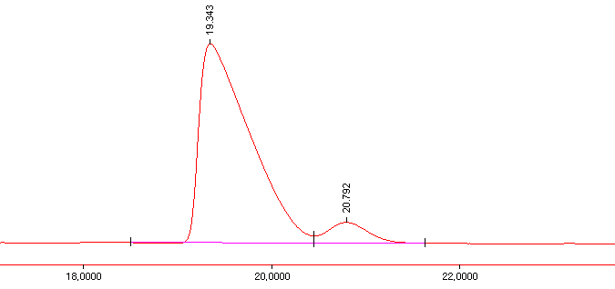
84%ee
HPLC Charts of 3d (entry 22, CHIRALPAK AS-H, n-Hex/IPA = 5:1)

6-Phenyl-3-vinyl-3a,4-dihydro-1H,3H-cyclopenta[c]furan-5-one. (entries 22, 23, 24)
a. PK-1 product (2e)
White solid; ¹H NMR (CDCl_{3,} 300 MHz) δ 7.53(m, 2H) 7.42(m, 3H) 6.03(ddd, J=17.2, 10.3, 7.1Hz, 1H) 5.34(m, 2H) 5.06(d, J=16.2Hz, 1H) 4.68(d, J=16.2Hz, 1H) 3.84(dd, J=10.3, 7.0Hz, 1H) 3.08(m, J=10.2, 6.5, 1.8, 1.8Hz, 1H) 2.80(dd, J=17.9, 6.6Hz, 1H) 2.36(dd, J=17.9, 3.3Hz, 1H); ¹³C-NMR (CDCl₃, 75MHz) δ 205.59, 177.35, 136.10, 135.33, 130.68, 128.94, 128.90, 128.30, 118.99, 84.31, 67.02, 48.85, 39.76; IR (KBr, cm⁻¹) 3070, 2916, 1702, 1652, 1114; HRMS (EI⁺) Exact mass calcd for C₁₅H₁₄O₂: 226.0989, found : 226.0994; HPLC (DAICEL CHIRALPAK AS-H, n-HEX/IPA=9/1, flow 0.8ml/min, detection at 254nm) t_{R}=8.868min(minor) and 12.467min(major)
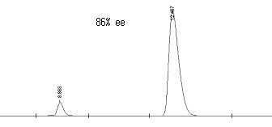
HPLC Charts of 2e (entry 22, CHIRALPAK AS-H, n-Hex/IPA = 9:1)

b. PK-2 product (3e)
Colorless oil; ¹H NMR (CDCl_{3,} 300 MHz) δ 7.54(m, 2H) 7.42(m, 3H) 5.55(ddd, J=17.2, 10.2, 7.0Hz, 1H) 5.24(m, 2H) 5.00(m, 1H) 4.76(m, 2H) 3.57(s, 1H) 2.78(dd, J=18.0, 6.7Hz, 1H) 2.40(dd, J=18.0, 3.7Hz, 1H); IR (KBr, cm⁻¹) 3070, 2916, 1702, 1652, 1114; HPLC (DAICEL CHIRALCELL OD-H, n-HEX/IPA=9/1, flow 0.8ml/min, detection at 254nm) t_{R}=14.605min(major) and 17.345min(minor)
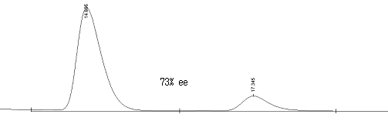
HPLC Charts of 3e (entry 23, CHIRALCELL OD-H, n-Hex/IPA = 9/1)

Determination of Absolute configuration of 6-Methyl-2-(toluene-4-sulfonyl)-3-vinyl-2,3,3a,4-tetrahydro-1H-cyclopenta[c]pyrrol-5-one (2a)
1-Ethyl-4 -methyl-2-(toluene-4-sulfonyl)-hexahydro-cyclopenta[c]pyrrol-5-one (5-a)
The enone 2a (entry 11) (40.0mg, 0.13mmol) was dissolved in ethanol (2mL) followed by addition of 10mol% Pd/C (1.4mg, 0.1nM). The resulting solution was stirred for 12 hours at ambient temperature under hydrogen (1atm). After removal of Pd/C by filteration through Celite, the filtrate was concentrated in vacuo and then purified by column chromatography (silica gel eluting with n-hexane/ethyl acetate (1/1, v/v)) to give the product 5-a (42.1mg, 99%) as a white solid.

[1-Ethyl-4-methyl-2-(toluene-4-sulfonyl)-hexahydro-cyclopenta[c]pyrrol-5-ylidene]-(2-methoxymethyl-pyrrolidin-1-yl)-amine (6-a)
The ketone 5-a (40.0mg, 0.12mmol), SAMP (48.3μL, 0.36mmol) and TsOH (a few crystals) were dissolved in benzene (2mL), and the mixture was stirred for 18 hours at 80℃. After filteration and evaporation of the solvent, the filtrate was concentrated and then the residue was purified by column chromatography (silica gel eluting with n-hexane/ethyl acetate (5/1, v/v)) to give the product 6-a (35mg) as a white solid. A single crystal of the 6a was grown by slow diffusion of hexanes into CH₂Cl₂. See below for X-ray crystallographic data.

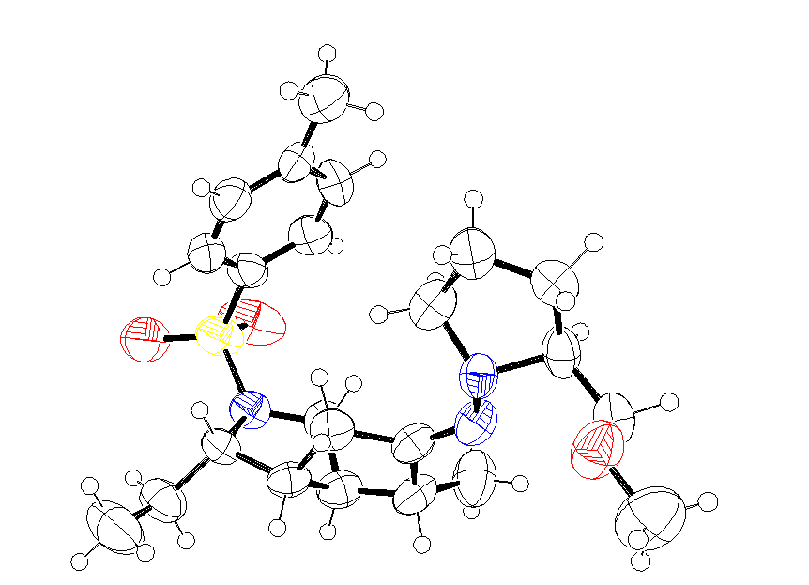

X-ray crystal structures of 6a (requisite CIF files have been submitted to the journal):

P. Andrew Evan, David K. Leahy, J. Am. Chem. Soc, 2002, 124, 7882-7883
N. Jeong, B. K. Sung, Y. K. Choi, J. Am. Chem. Soc. 2000, 122, 6771-6772
T. Shibata, N. Toshida, K. Takagi, J. Org. Chem. 2002, 67, 7446-7450
T. Sibada, K. Takagi, J. Am. Chem. Soc. 2000, 122, 9852-9853
S. E. Yoo, S. H. Lee, J. Org. Chem. 1994, 59, 6968-6972.
D. Enders, L. Wortmann, B. Ducker, G. Raabe, Helv. Chem. Acta, 1999, 82, 1195-1201

