Supplementary Material

Intermolecular stacking in the crystal structure of H₂(hp(HO)₄).

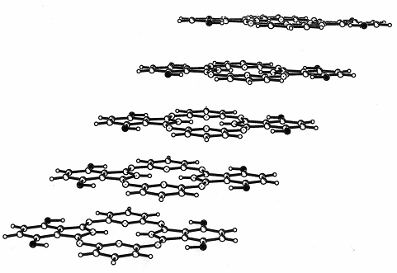

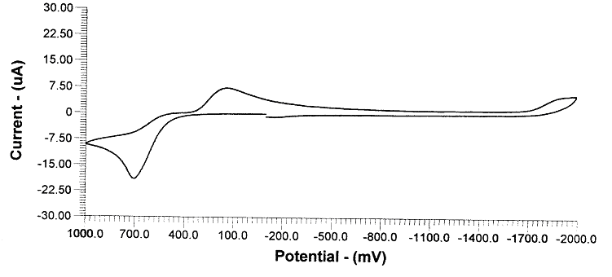

Cyclic voltammogram on Zn(py)(hp(OH)₄) in acetonitrile (C= 5 x 10⁻⁴ M), scan rate of 50 mV/s, TBAP as electrolyte, referenced to Ag/Ag⁺ in acetonitrile.

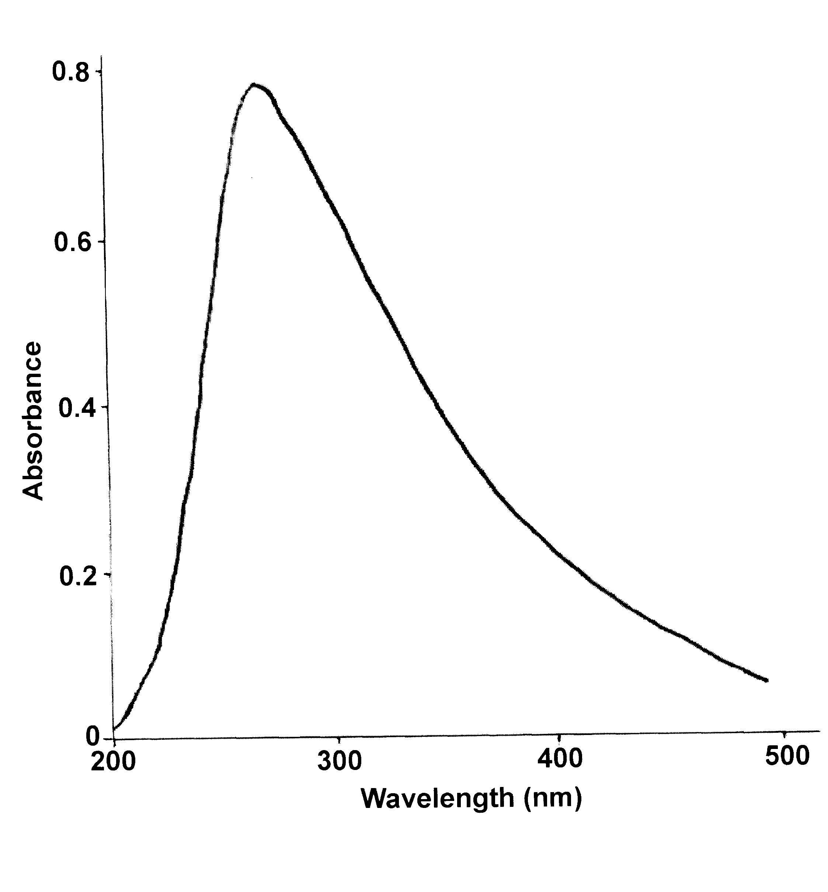
UV-vis absorption spectrum on Zn(hp(OH)₄)(py) in DMSO solution (C= 4 x 10⁻⁵ M). The spectrum was recorded on a computer-interfaced HP 8453A diode array spectrophotometer at room temperature in a quartz cell of 1 cm path length.

Emission spectra were recorded on a Hitachi F-2000 fluorescence spectrophotometer in degassed solutions under N₂.

