Supporting information
General experimental details: All manipulations were carried out in the glovebox. Calixarenes and Bi[N(SiMe₃)₂]₃ were made by the literature methods. p-tert-Butylcalix[4]arene was dried in the drying pistol at 110 °C under vacuum. p-tert-Butylcalix[8]arene was recrystallized from CHCl₃ without drying. Other chemicals were obtained from Aldrich. THF was freshly distilled from Na/benzophenone. The melting points of all compounds were taken in sealed and evacuated capillary tubes on a Mel-Temp apparatus (Laboratory Devices, Cambridge, MA) using a 400 ºC thermometer calibrated against a thermocouple. The melting points are uncorrected. ¹H NMR and ¹³C NMR spectra were recorded on a Varian XL-300 spectrometer at 300 and 75 MHz, respectively. Analytical samples were purified by recrystallization and dried in glovebox under vacuum. Microanalyses were performed by Microanalysis Laboratory, University of Illinois, Urbana-Champaign, Urbana, IL. IR and UV/Vis spectra were obtained with an Infinity GoldTM FTIR and Agilent 8453 spectrophotometers respectively. Filtrations used medium sintered glass filters.
Synthesis of compound 1.
A solution of SbCl₃ (0.092 g, 0.40 mmol) in 5 mL of THF was added to a solution of monosodium salt of Bu^{t}C4 (0.134 g, 0.199 mmol) in 8 mL of THF at room temperature in the glovebox. The reaction mixture was stirred for 20 min, and copious white precipitate was observed. The suspension was stirred for 12h at room temperature. Removal of insoluble white precipitate gave a colourless solution. The solution was pumped dry, and white powder (0.11 g, 69% yield) was obtained. Single crystals were obtained by slow evaporation of THF solution or recrystallization of 1 in THF at –35 °C for several weeks. ¹H NMR (300 MHz, THF-d₈) 7.21 (m, 4H, ArH), 7.12 (m, 4H, ArH), 4.45 (d, 2H, CH₂), 4.36 (d, 2H, CH₂), 3.74 (d, 2H, CH₂), 3.39 (d, 2H, CH₂), 1.35 (s, 18H, C(CH₃)₃), 1.26 (s, 18H, C(CH₃)₃). ¹³C NMR (75 MHz, THF-d₈), 153.8, 149.4, 146.4, 145.5, 138.0, 134.6, 133.5, 132.2, 126.9, 126.8, 126.3, 125.7 (aromatic carbons); 36.2, 35.9 (C(CH₃)₃); 35.0, 32.0 (CH₂); 32.3, 32.2 (CH₃). Anal. Calcd (Found): for 1 for C₄₄H₅₂Cl₂O₄Sb₂, C 55.09 (55.40), H 5.78 (5.78). IR (THF, cm⁻¹): 2970 (s), 2938 (vs), 2946 (vs), 2686 (s), 1476 (m), 1196 (m), 1088 (s), 1036 (s), 900 (s), 436 (vs). Uv/Vis (THF): λ_{max}/nm (ε/dm³mol⁻¹cm⁻¹) 251 (2.85×10⁵), 255 (2.84×10⁵), 257 (2.51×10⁵), 265 (2.23×10⁵). mp; dec ≥ 190 °C. Note that elemental analysis was performed on a dried sample, while X-ray structure was obtained from solvated crystals.
Synthesis of compound 2.
A solution of Bi[N(SiMe₃)₂]₃ (0.138 g, 0.197 mmol) in 5 mL of toluene was added to a suspension of Bu^{t}C8 (0.260 g, 0.200 mmol) in 10 mL of toluene. The reaction mixture was heated to 95 °C and stirred overnight to obtain a mixture of 2 and 3. The solvent was reduced to half volume, then 3 mL of THF and 3 mL of acetonitrile were added. The solution was kept for 2 days, and some block yellow crystals were obtained. Yellow solid was obtained after removal of solvents. The yellow solid was redissolved in 6 mL of toluene. Additional 3 mL of THF and 3 mL of acetonitrile were added to the toluene solution. The solution was kept for 2 days at room temperature, and more block yellow crystals were obtained. The same procedure was repeated 3 times to get more crystals. Overall 0.090 g of yellow crystals (84% yield based on Bu^{t}C8) were obtained. When acetonitrile was diffused into the solution of toluene-THF colorless block crystals (3) were obtained. Most of 3 was obtained from recrystallization of the mixture of 2 and 3 in toluene-CH₃CN-THF (1:1:1) solution at –35°C. Compound 3 was obtained in 56% yield (0.157g) and identified by X-ray diffraction. ¹H NMR for 2 (300 MHz, C₆D₆) 7.56 (d, 4H, ArH), 7.42 (d, 4H, ArH), 7.36 (d, 4H, ArH), 7.33(d, 4H, ArH), 5.60 (d, J = 11.4 Hz, 2H, CH₂), 5.26 (d, J = 12.8 Hz, 4H, CH₂), 4.22 (d, J = 12.3 Hz, 2H, CH₂), 3.79 (d, J = 11.9 Hz, 2H, CH₂), 3.36 (d, J = 12.8 Hz, 4H, CH₂), 2.73 (d, J = 12.3 Hz, 2H, CH₂), 1.34 (s, 72H, C(CH₃)₃), 1.30 (s, 72H, C(CH₃)₃). ¹³C NMR (75 MHz, C₆D₆), 152.6, 148.8, 145.2, 142.8, 136.7, 136.6, 128.5, 127.1, 126.8, 125.2, 124.1(aromatic carbons), 34.2, 34.0 (CH₂), 32.0, 31.8 (C(CH₃)₃), the quaternary carbons of t-butyl groups were not observed. Anal. Calcd (Found) for C₉₇H₁₁₅Bi₄NO₁₀, C 50.86 (50.98), H 5.06 (4.62). IR (KBr, cm⁻¹): 3421 (s), 2959 (vs), 1624 (m), 1462 (s), 1362 (s), 1294 (s), 1252 (s), 1119 (m), 907 (m), 840 (m). Uv/Vis (C₆H₆): λ_{max}/nm (ε/dm³mol⁻¹cm⁻¹) 277 (4.68×10⁶), 335 (2.14×10⁶). mp; dec. ≥ 120 °C. Elemental analysis was performed on a dried sample, while X-ray structure was obtained from solvated crystals.

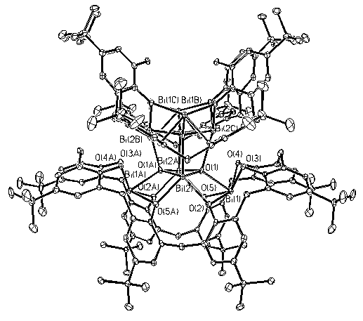
Fig. S1 An ORTEP view of 2·4(C₇H₈)4(OC₄H₁₀)6(CH₃CN) (30% probability). The H atoms and solvent molecules are omitted for clarity.

