Electronic Supplementary Information (ESI)

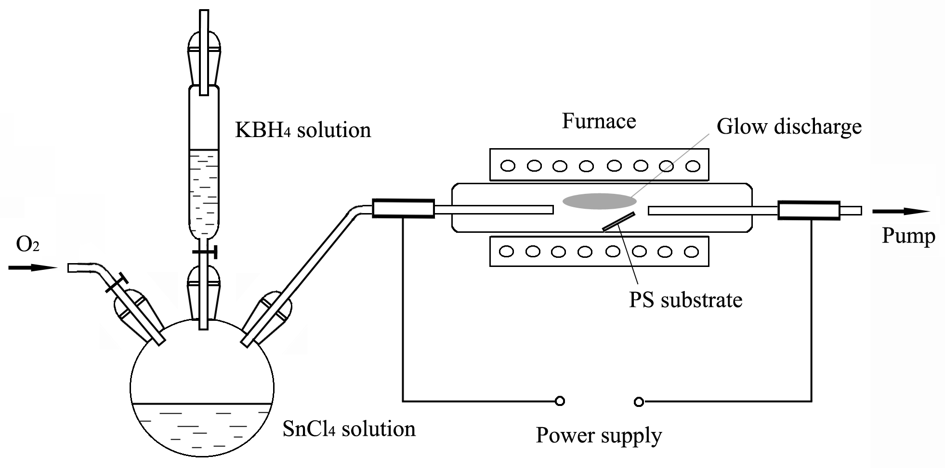
Figure S1 Diagram of the glow discharge setup.

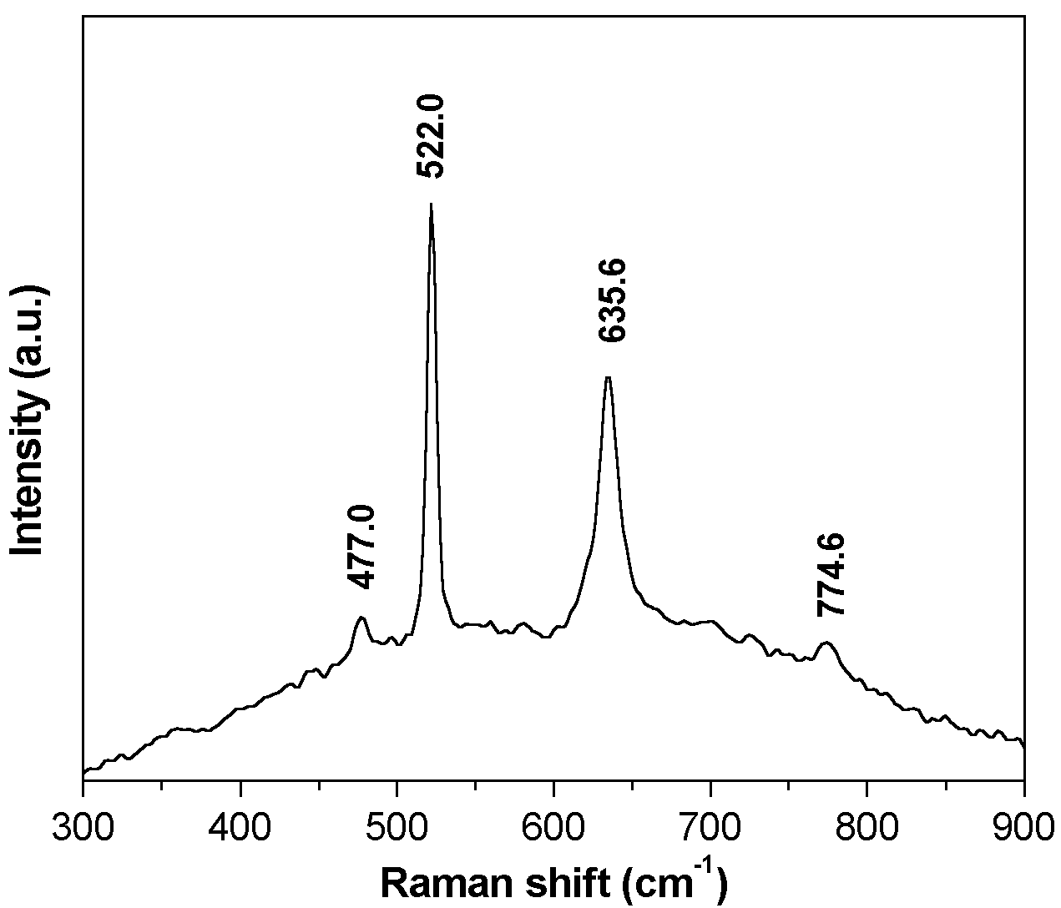
Figure S2 Raman spectrum of the products.

