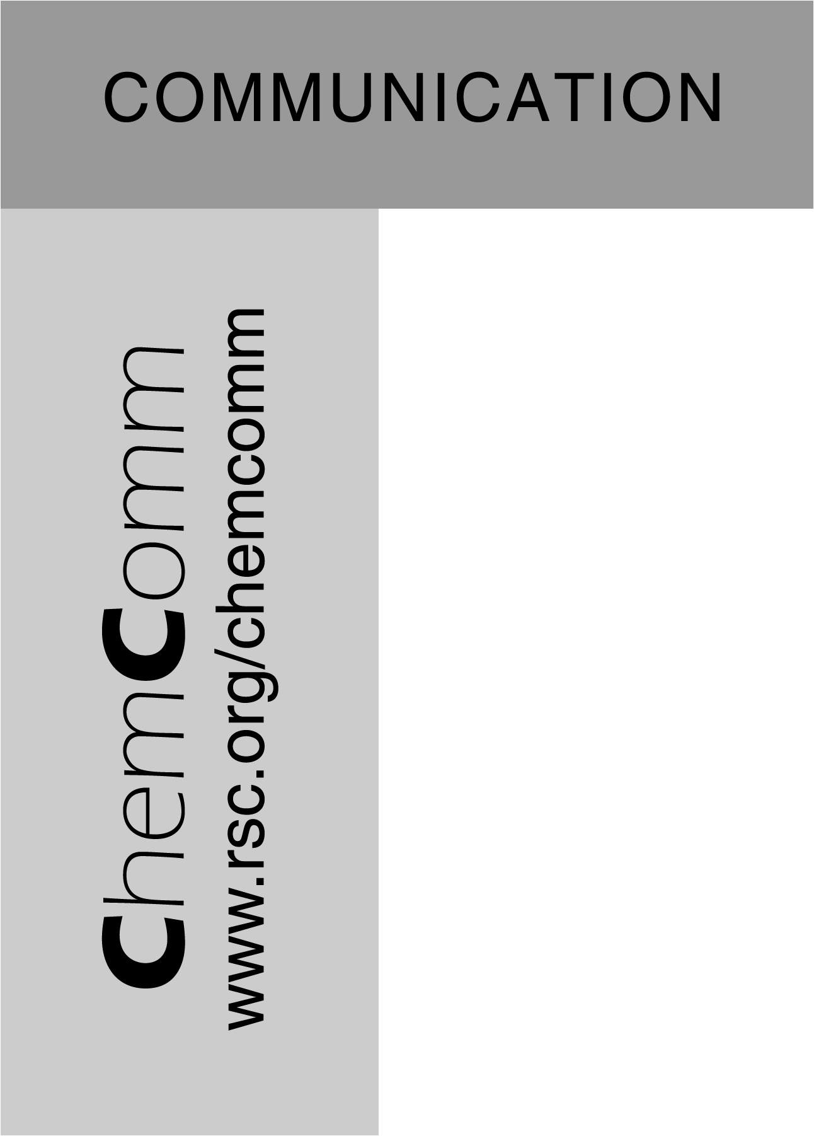
Supporting information
Rhodium catalysed tandem conjugate addition-protonation: an enantioselective synthesis of 2-substituted succinic esters
Rebecca J. Moss, Kelly J. Wadsworth, Christopher J. Chapman and Christopher G. Frost*
Department of Chemistry, University of Bath, Claverton Down, Bath, BA2 7AY, UK. Fax: 01225 386231; Tel: 01225 386142; E-mail: c.g.frost@bath.ac.uk

It is important to note that the use of potassium trifluoro(organo)borates was essential for achieving good enantioselectivity. A preliminary investigation into the tandem 1,4-addition/enantioselective protonation by the addition of phenylboronic acid to dimethyl itaconate (1) in the presence of Rh(acac)(C₂H₂)₂, (R)-BINAP and dioxane:water (10:1) as the solvent/proton source, afforded high yields of product 3b (70-90%) but low enantioselectivity (<5% ee). This is in sharp contrast to the corresponding enantioselective transformation of cyclohexenone (Scheme 1). ¹
Scheme 1. A comparison of boronic acids with potassium trifluoro(organo)borates

This disparity emphasizes the significance of the protonation step and the importance of the catalyst precursor, solvent and aryl nucleophile. In the presence of cationic rhodium complex prepared in situ from [Rh(COD)₂][PF₆] and (R)-BINAP in a toluene-water mix at 110ºC, the conjugate addition of potassium phenyltrifluoroborate to 2-cyclohexenone proceeded in 99% yield and 98% enantioselectivity. The reaction of potassium trifluoroborate salts has some characteristic properties that differ greatly from the reaction with boronic acids; firstly, the reaction is best catalysed by complexes formed from cationic rhodium salts, such as [Rh(COD)₂][OTf], [Rh(COD)₂][BF₄], [Rh(COD)₂][PF₆] and [Rh(COD)₂][ClO₄], with complexes formed from neutral species such as [Rh(acac)(C₂H₄)₂] failing to efficiently catalyse the reaction. Secondly, whilst the yield is generally unaffected by the solvent used the enantioselectivity is highly dependent on the solvent system, with aprotic and non-chelating solvents preferred with an excess of water.

General procedure for conjugate additions of boronic acids to dimethyl itaconate:
An oven dried Shlenk tube under argon is charged with [Rh(acac)(C₂H₄)₂] (3 mol%), ligand (3.3 mol%), dimethyl itaconate 1 (1 mmol), boronic acid (2 mmol), NaF (63 mg, 1.5 mmol) and dioxane (1.5 mL). The mixture was stirred at room temperature for 30 minutes and water (150 µL) added. The mixture was then stirred under an atmosphere of argon at 100˚C for 24 hours. After cooling to room temperature the solution was dissolved in ethyl acetate (3 mL) and water (5 mL) added. The aqueous layer was separated and extracted with ethyl acetate (3 × 5 mL), the combined organics were washed with brine (10 mL), dried (MgSO₄) and concentrated in vacuo. The residue was purified by silica gel column chromatography affording analytically pure product.

General procedure for conjugate additions of potassium trifluoro(organo)borate salts to dimethyl itaconate:
A Shlenk tube was purged with argon then charged with [Rh(cod)₂]PF_{z} (3 mol%), (R)- or (S)-BINAP (6.6 mol%) and potassium trifluoro(organo)borate salt (0.5 mmol). A degassed solvent/water mixture (20:1) was added at room temperature followed by dimethyl itaconate (0.25 mmol). The tube was immediately transferred to a preheated oil bath at 110ºC and the mixture stirred for 18 hours. After cooling to room temperature the mixture was extracted with diethyl ether (x3). The organic extracts were then combined, washed with brine (x3), dried with magnesium sulfate and concentrated in vacuo. The residue was purified by silica gel column chromatography affording analytically pure product. Enantioselectivity was determined by HPLC analysis on a Thermo Separation Products spectra series system using a chiral column (Chiracel OD-H, hexane:isopropanol 95:5).

3a was isolated as a colourless crystalline solid. M.p. (96-97ºC, lit. 96.7ºC)²; ¹H NMR (300MHz, CDCl₃): δ 2.37(1H, dd, J=5.1, 17.1Hz, CH₂), 2.69(1H, dd, J=9.3, 17.1Hz, CH₂), 3.06(1H, dd, J=9.3, 13.5Hz, CH₂), 3.25(1H, m, CH₂), 3.52(2H, dd, J=5.7, 13.5Hz, CH₂), 3.54(3H, s, CH₃), 3.61(3H, s, CH₃), 7.21(1H, d, J=8.1Hz, Ar), 7.32(1H, t, J=6.9Hz, Ar), 7.46(2H, m, Ar), 7.69(1H, d, J=8.4, Ar), 7.8(1H, d, J=9.3, Ar), 8.02(1H, d, J=8.7, Ar); ¹³C NMR (75.5 MHz, CDCl₃): δ 35.5, 35.6, 42.5, 52.1, 52.4, 123.9, 125.7, 126.1, 126.7, 127.8, 128.1, 129.3, 132.1, 134.3, 134.6, 175.3, 172.6; IR(nujol, cm⁻¹) ν 1159(s), 1377(s), 1462(s), 1719(m), 2724(m), 2862(br); MS (FAB⁺) m/z 286 (56%, M⁺+H); HRMS (FAB⁺) [found 286.1210 M⁺+H C₁₇H₁₈O₄ requires M 286.1205]; Anal. Calcd for C₁₇H₁₈O₄: C, 71.31; H, 6.34; Found: C, 71.30; H, 6.34%.
Chiral HPLC: Chiracel OD-H, hexane:isopropanol 95:5, 19.7 min. (R), 28.1 min. (S). ³

Chiral HPLC: Chiracel OD-H, hexane:isopropanol 95:5, 10.6 min. (R), 12.4 min. (S). ³
Chiral HPLC: Chiracel OD-H, hexane:isopropanol 95:5, 8.4 min. (R), 13.7 min. (S).

Chiral HPLC: Chiracel OD-H, hexane:isopropanol 95:5, 11.3 min. (R), 16.9 min. (S).
Chiral HPLC: Chiracel OD-H, hexane:isopropanol 95:5, 22.9 min. (R), 36.8 min. (S).

Chiral HPLC: Chiracel OD-H, hexane:isopropanol 95:5, 8.7 min. (R), 14.8 min. (S).

Chiral HPLC: Chiracel OD-H, hexane:isopropanol 95:5, 8.3 min. (R), 15.1 min. (S).

Chiral HPLC: Chiracel OD-H, hexane:isopropanol 95:5, 8.1 min. (R), 13.9 min. (S).

Chiral HPLC: Chiracel OD-H, hexane:isopropanol 95:5, 23.1 min. (R), 37.3 min. (S).

Notes and references

- T. Hayashi and K. Yamasaki, Chem. Rev., 2003, 103, 2829; M. Pucheault, S. Darses and J. –P. Gênet, Eur. J. Org. Chem., 2002, 3552.
- J. A. Dixon and D. D. Neiswender Jr., J. Org. Chem., 1960, 25, 499.
- M. P. Sibi and K. Patil, Angew. Chem. Int. Ed., 2004, 43, 1235.

