Supplementary data

Novel Pt/CeO₂/C catalysts for electrooxidation of alcohols in alkaline media
Changwei Xu and Pei Kang Shen*

State Key Laboratory of Optoelectronic Materials and Technologies, School of Physics and Engineering, Sun Yat-Sen University, Guangzhou 510275, P.R. China. Fax: 86-20-84113369; Tel: 86-20-84036736; E-mail: stdp32@zsu.edu.cn

Catalyst preparation and characterization

11.6 ml of 0.1 mol dm⁻³ Ce(NO₃)₃ aqueous solution mixed with 0.2 mg carbon black (Vulcan XC-72R, Cabot Corp., USA). K₂CO₃(1 mol dm⁻³ aqueous solution) was added into the mixture to form Ce₂(CO₃)₃ precipitates. The precipitate was washed and dried in oven at 100ºC. The mixture was put into a microwave oven and then be alternatively heated 20 seconds and paused 60 seconds for six times. Theoretically, 0.4 mg CeO₂/C could be obtained. Pt-CeO₂/C catalysts were prepared by the reduction of H₂PtCl₆ solution on CeO₂/C powder. The ratios of Pt and CeO₂ were calculated by the molar ratios of the precursors added assuming without lose during the preparation processes. Finally, the electrodes were made by dispersing the Pt/C or Pt-CeO₂/C powders in 2-propanol with Nafion solution under ultrasonic stirring, then, the catalyst ink was deposited on the surface of a graphite rod with the geometric area of 0.50cm² and dried at 80ºC for 30 minutes. The Pt loadings on the Pt/C and Pt-CeO₂/C electrodes were normally controlled at 0.3 mg cm⁻². The unit of mg cm⁻² used in the article is the geometric area of the electrode without accounts the surface area of the ceria. We normally use mg cm⁻² to express the loadings of the components in the catalyst since the CeO₂ is changeable.
The structure of the ceria was characterized by XRD and showed that ceria is a cubic crystallite. The XRD pattern of Pt-CeO₂/C combined the crystalline features of Pt and CeO₂, indicating the coexistence of both them.

Fig. S1 XRD patterns of CeO₂/C, Pt/C and Pt-CeO₂ /C.

The Pt-CeO₂ /C samples were characterized by TEM. One of the typical TEM patterns is shown Fig. S2. The sample, in fact, is not uniformly dispersed. The optimization of the preparation method is in progress to further improve the performance of the catalysts.

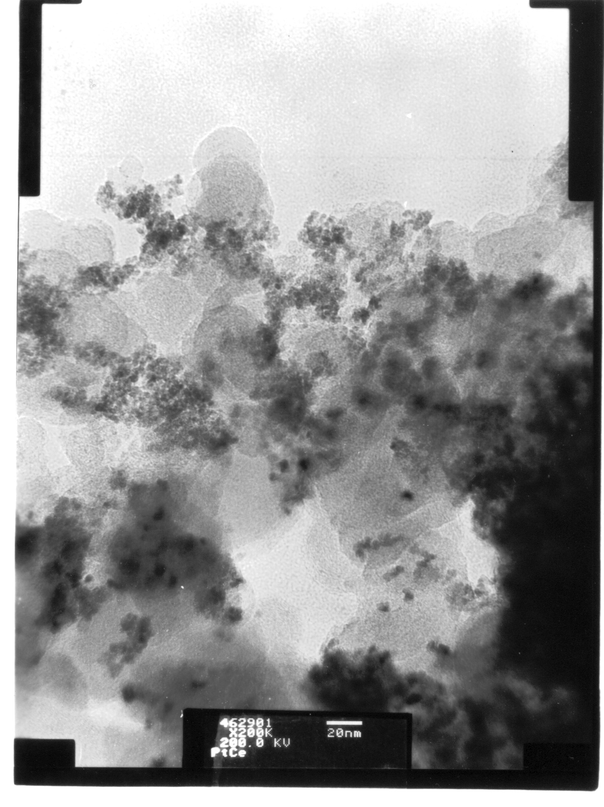

Fig. S2 TEM micrograph of Pt-CeO₂ /C powder. (The bar in the photo is 20 nm).

