Ring-opening Reactions of Methylenecyclopropanes with
Diphenyl Diselenide upon Heating; Formation of 3-Phenylselenyl-2,5-dihydrofuran Derivatives

Le-Ping Liuª and Min Shi^{b}*
ªDepartment Chemistry, East China Normal University,
3663 Zhongshanbei Lu, Shanghai 200062, China
^{b}State Key Laboratory of Organometallic Chemistry,
Shanghai Institute of Organic Chemistry, Chinese Academy of Sciences,
354 Fenglin Lu, Shanghai 200032, China.
Mshi@pub.sioc.ac.cn.

Typical reaction procedure S2
Spectroscopic data and ¹H NMR charts of compounds S3-S11

Experimental Procedures
General Methods. Melting points are uncorrected. ¹H and ¹³C NMR spectra were recorded at 300 and 75 MHz respectively. Mass spectra were recorded by EI, MALDI and ESI methods, and HRMS was measured on a Finnigan MA⁺ mass spectrometer. Organic solvents used were dried by standard methods when necessary. Commercially available reagents were used without further purification. All reactions were monitored by TLC with Huanghai GF254 silica gel coated plates. Flash column chromatography was carried out using 300-400 mesh silica gel or 200-300 mesh Al₂O₃ at increased pressure. MCPs 1 were prepared according to the literature.¹
Ref. 1. (a) K. Utimoto, M. Tamura, K. Sisido, Tetrahedron 1973, 29, 1169. (b) H. J. Reich, M. L.Cohen, P. S. Clark, Org. Synth. Vol. 59, 1979, 141.

Typical reaction procedure for the reaction of MCPs 1 with diphenyl diselenide: MCP 1a (62 mg, 0.3 mmol) and diphenyl diselenide (93 mg, 0.3 mmol) was heated at 150 ºC without solvent for 3 hours under a N₂ atmosphere, then the reaction mixture was cooled to room temperature. The mixture was subjected to a flash column chromatography to give the desired product 2a (132 mg, 85%) as a white solid.

Typical reaction procedure for the oxidative cyclization of compound 2 with hydrogen peroxide: To a solution of compound 2a (104 mg, 0.2 mmol) in 5 mL of CH₂Cl₂ was added excess H₂O₂ (30% aqueous solution) (110 μL, 1.0 mmol). experiment A): The reaction mixture was stirred for 5 h at room temperature (monitored by TLC) and then added 5 mL of NaHSO₃ (1% aqueous solution) and stirred for another 0.5 h. The organic layer was washed with brine and dried over anhydrous Na₂SO₄. The solvent was removed under reduced pressure and the residue was subjected to a flash column chromatography to give the product 3a (38 mg, 50%) as a colorless oil. experiment B): The reaction mixture was stirred for 30 min at room temperature (monitored by TLC) and then added 5 mL of K₂CO₃ (5% aqueous solution) and stirred for another 60 min (monitored by TLC). The organic layer was washed with brine and dried over anhydrous Na₂SO₄. The solvent was removed under reduced pressure and the residue was subjected to a flash column chromatography to give the product 4a (32 mg, 72%) as a colorless oil.

Typical reaction procedure for the transformation of 4a to 3a: To a solution of compound 4a (44 mg, 0.2 mmol) in 1.0 mL of CH₂Cl₂ was added PhSeSePh (31 mg, 0.1 mmol) and the reaction mixture was added SO₂Cl₂ (15 mg, 0.11 mmol, dissolved in 0.5 mL CH₂Cl₂) dropwise. The mixture was stirred for 2 min at room temperature (monitored by TLC). The solvent was removed under reduced pressure and the residue was subjected to a flash column chromatography to give the product 3a (54 mg, 71%) as a colorless oil.

Compound 2a: a white solid, m.p. 78-80 ºC; IR (KBr) ν 3055, 2969, 1600, 1578, 1476, 1195, 1000, 736, 700, 669 cm⁻¹; ¹H NMR (CDCl₃, 300 MHz, TMS) δ 2.71 (2H, t, J = 7.5 Hz, CH₂), 3.03 (2H, t, J = 7.5 Hz, CH₂), 7.06-7.11 (5H, m, Ar), 7.15-7.30 (13H, m, Ar), 7.44-7.46 (2H, m, Ar); ¹³C NMR (CDCl₃, 75 MHz, TMS) δ 26.7, 35.2, 126.2, 127.1, 127.36, 127.39, 128.0, 128.3, 128.4, 128.9, 129.0, 129.07, 129.12, 130.2, 131.5, 132.8, 133.6, 141.4, 143.2, 147.0; MS (EI) m/e 520 (M⁺, 6.30), 363 (25.62), 205 (26.75), 180 (97.96), 165 (62.38), 105 (91.68), 91 (68.12), 84 (100); Anal. Calcd. for C₂₈H₂₄Se₂ requires C, 64.87; H, 4.63%. Found: C, 64.81; H, 4.35%.
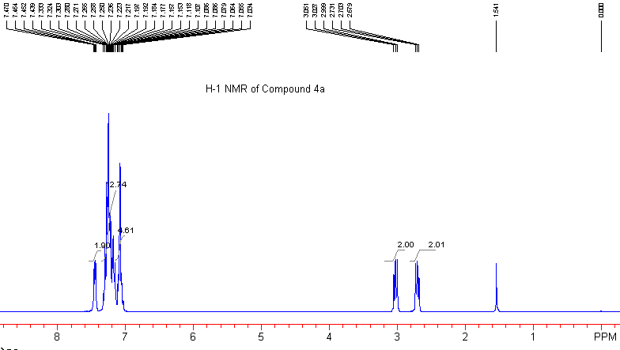

Compound 2b: a white solid, m.p. 80-82 ºC; IR (KBr) ν 3070, 2920, 1578, 1476, 1265, 1180, 999, 817, 735, 691, 669 cm⁻¹; ¹H NMR (CDCl₃, 300 MHz, TMS) δ 2.21 (3H, s, CH₃), 2.23 (3H, s, CH₃), 2.63 (2H, t, J = 7.5 Hz, CH₂), 2.93 (2H, t, J = 7.5 Hz, CH₂), 6.93-7.02 (13H, m, Ar), 7.11-7.14 (3H, m, Ar), 7.34-7.37 (2H, m, Ar); ¹³C NMR (CDCl₃, 75 MHz, TMS) δ 21.16, 21.24, 26.7, 35.2, 126.0, 127.2, 128.6, 128.7, 128.90, 128.93, 128.95, 129.02, 130.2, 130.4, 131.5, 131.8, 133.4, 136.6, 137.0, 138.6, 140.5, 147.1; MS (EI) m/e 548 (M⁺, 0.11), 365 (31.08), 260 (60.55), 219 (27.36), 199 (64.83), 184 (33.58), 156 (43.70), 128 (94.28), 91 (100); Anal. Calcd. for C₃₀H₂₈Se₂ requires C, 65.94; H, 5.16%. Found: C, 66.07; H, 5.16%.

Compound 2c: a white solid, m.p. 108-110 ºC; IR (KBr) ν 3044, 1604, 1508, 1245, 1173, 1033, 833, 736, 691 cm⁻¹; ¹H NMR (CDCl₃, 300 MHz, TMS) δ 2.72 (2H, t, J = 7.5 Hz, CH₂), 3.02 (2H, t, J = 7.5 Hz, CH₂), 3.77 (3H, s, OCH₃), 3.79 (3H, s, OCH₃), 6.77-6.83 (4H, m, Ar), 7.04-7.12 (9H, m, Ar), 7.22-7.24 (3H, m, Ar), 7.43-7.46 (2H, m, Ar); ¹³C NMR (CDCl₃, 75 MHz, TMS) δ 26.9, 35.4, 55.12, 55.15, 113.2, 113.6, 126.1, 127.2, 128.8, 129.1, 130.2, 130.4, 130.51, 130.53, 131.4, 131.5, 133.3, 134.1, 136.0, 146.5, 158.5, 158.8; MS (EI) m/e 580 (M⁺, 26.69), 423 (46.04), 346 (11.41), 266 (63.98), 252 (100), 235 (37.24), 223 (15.53); Anal. Calcd. for C₃₀H₂₈O₂Se₂ requires C, 62.29; H, 4.88%. Found: C, 62.44; H, 4.98%.

Compound 2d: a white solid, m.p. 114-116 ºC; IR (KBr) ν 3056, 1578, 1489, 1437, 1090, 1014, 836, 735, 691 cm⁻¹; ¹H NMR (CDCl₃, 300 MHz, TMS) δ 2.66 (2H, t, J = 7.5 Hz, CH₂), 2.98 (2H, t, J = 7.5 Hz, CH₂), 7.01-7.11 (8H, m, Ar), 7.19-7.28 (8H, m, Ar), 7.42-7.45 (2H, m, Ar); ¹³C NMR (CDCl₃, 75 MHz, TMS) δ 26.7, 35.1, 126.5, 127.7, 128.3, 128.6, 128.9, 129.24, 129.6, 129.7, 130.4, 130.5, 131.9, 133.2, 133.5, 133.9, 134.6, 139.4, 141.1, 143.9; MS (EI) m/e 588 (M⁺, 21.23), 532 (8.88), 431 (91.47), 377 (12.53), 354 (17.15), 239 (63.11), 203 (79.73), 157 (78.84), 91 (100); Anal. Calcd. for C₂₈H₂₂Cl₂Se₂ requires C, 57.26; H, 3.75%. Found: C, 57.55; H, 3.86%.

Compound 2e: a white solid, m.p. 70-72 ºC; IR (KBr) ν 3069, 1599, 1505, 1437, 1223, 1115, 835, 736, 691 cm⁻¹; ¹H NMR (CDCl₃, 300 MHz, TMS) δ 2.67 (2H, t, J = 7.5 Hz, CH₂), 3.00 (2H, t, J = 7.5 Hz, CH₂), 6.90-7.01 (4H, m, Ar), 7.05-7.16 (9H, m, Ar), 7.24-7.27 (3H, m, Ar), 7.42-7.45 (2H, m, Ar); ¹³C NMR (CDCl₃, 75 MHz, TMS) δ 26.8, 35.1, 115.0 (d, J_{C-F} = 21.3 Hz), 115.3 (d, J_{C-F} = 20.8 Hz ), 126.4, 127.6, 128.9, 129.2, 129.78, 129.81, 130.7 (d, J_{C-F} = 7.7 Hz), 130.9 (d, J_{C-F} = 8.2 Hz), 131.8, 133.7, 133.8, 137.1 (d, J_{C-F} = 4.0 Hz), 138.0 (d, J_{C-F} = 3.4 Hz), 144.4, 161.8 (d, J_{C-F} = 246.2 Hz), 162.0 (d, J_{C-F} = 245.4 Hz); MS (EI) m/e 556 (M⁺, 32.56), 399 (100), 322 (20.20), 242 (48.42), 227 (64.68), 201 (25.52), 157 (57.11), 109 (53.27); Anal. Calcd. for C₂₈H₂₂F₂Se₂ requires C, 60.66; H, 4.00%. Found: C, 60.51; H, 4.01%.

Compound 2f: a white solid, m.p. 68-70 ºC; IR (KBr) ν 3056, 2923, 1578, 1476, 1180, 1066, 999, 734, 691, 669 cm⁻¹; ¹H NMR (CDCl₃, 300 MHz, TMS) δ 1.60-1.72 (2H, m, CH₂), 2.08-2.24 (4H, m, 2CH₂), 2.80-2.91 (4H, m, 2CH₂), 3.18 (2H, t, J = 7.5 Hz, CH₂), 3.46-3.51 (1H, m, CH), 7.27-7.55 (15H, m, Ar); ¹³C NMR (CDCl₃, 75 MHz, TMS) δ 26.6, 30.8, 35.2, 35.4, 35.7, 35.8, 44.3, 122.7, 126.1, 126.2, 126.5, 126.7, 128.3, 128.9, 129.0, 130.3, 131.1, 131.7, 132.0, 146.2, 147.2; MS (EI) m/e 512 (M⁺, 5.28), 355 (15.62), 197 (11.79), 169 (12.86), 155 (21.01), 117 (25.71), 91 (100), 77(42.42); Anal. Calcd. for C₂₇H₂₈Se₂ requires C, 63.53; H, 5.53%. Found: C, 63.56; H, 5.54%.

Compound 2g: a colorless oil; IR (KBr) ν 3070, 2955, 1578, 1476, 1377, 1188, 1072, 733, 690, 669 cm⁻¹; ¹H NMR (CDCl₃, 300 MHz, TMS) δ 0.86-0.92 (6H, m, 2CH₃), 1.25-1.39 (8H, m, 4CH₂), 2.10 (2H, t, J = 7.5 Hz, CH₂), 2.39 (2H, t, J = 7.5 Hz, CH₂), 2.63 (2H, t, J = 7.5 Hz, CH₂), 2.63 (2H, t, J = 7.5 Hz, CH₂), 7.18-7.31 (8H, m, Ar), 7.39-7.42 (2H, m, Ar); ¹³C NMR (CDCl₃, 75 MHz, TMS) δ 14.0, 14.1, 22.8, 22.9, 27.0, 31.3, 31.5, 32.2, 35.3, 36.8, 125.4, 126.2, 126.5, 128.9, 129.0, 130.3, 131.1, 131.6, 132.2, 149.6; MS (EI) m/e 480 (M⁺, 11.68), 323 (39.72), 199 (48.92), 157 (82.44), 130 (53.47), 109 (60.71), 91 (82.06), 77 (100); HRMS (MALDI) Calcd. for C₂₄H₃₃Se₂⁺¹ (M⁺+1) requires 481.0878, Found: 481.0907.

Compound 2h (Z/E = 1:1): a colorless oil. IR (KBr) ν 3055, 1605, 1509, 1476, 1437, 1177, 822, 735, 691 cm⁻¹; mixtures of Z/E-isomers: ¹H NMR (CDCl₃, 300 MHz, TMS) δ 2.61 (2H, t, J = 7.5 Hz, CH₂), 2.77 (2H, t, J = 7.5 Hz, CH₂), 3.04 (4H, t, J = 7.5 Hz, 2CH₂), 3.72 (3H, s, OCH₃), 3.73 (3H, s, OCH₃), 6.67-7.01 (10H, m, Ar), 7.10-7.20 (10H, m, Ar), 7.29-7.45 (10H, m, Ar); MS (EI) m/e 474 (M⁺, 1.50), 316 (41.84), 236 (39.89), 186 (47.06), 161 (100), 147 (53.65), 128 (32.76), 115 (86.81); HRMS (MALDI) Calcd. for C₂₃H₂₃OSe₂⁺¹ (M⁺+1) requires 475.0081, Found: 475.0074.

Compound 2i (Z/E = 1:1): a colorless oil. IR (KBr) ν 3069, 2935, 1608, 1500, 1300, 1209, 1034, 834, 736, 691 cm⁻¹; mixtures of Z/E-isomers: ¹H NMR (CDCl₃, 300 MHz, TMS) δ 2.62 (2H, t, J = 7.5 Hz, CH₂), 2.69 (2H, t, J = 7.5 Hz, CH₂), 2.99-3.05 (4H, m, 2CH₂), 3.67 (3H, s, OCH₃), 3.70 (3H, s, OCH₃), 3.71 (3H, s, OCH₃), 3.72 (3H, s, OCH₃), 6.21-6.40 (6H, m, Ar), 6.89-7.46 (22H, m, Ar); MS (EI) m/e 504 (M⁺, 20.93), 424 (6.44), 347 (28.99), 266 (7.76), 189 (76.11), 175 (100), 161 (60.85), 151 (29.40); HRMS (MALDI) Calcd. for C₂₄H₂₅O₂Se₂⁺¹ (M⁺+1) requires 505.0183, Found: 505.0180.

Compound Z-2j: a colorless oil. IR (KBr) ν 3055, 2935, 1578, 1476, 1437, 1335, 1239, 1007, 864, 737, 692 cm⁻¹; ¹H NMR (CDCl₃, 300 MHz, TMS) δ 2.62 (2H, t, J = 7.5 Hz, CH₂), 3.00 (2H, t, J = 7.5 Hz, CH₂), 3.77 (6H, s, OCH₃), 3.79 (3H, s, OCH₃), 6.61 (2H, s, Ar), 6.77 (1H, s, =CH), 7.12-7.19 (6H, m, Ar), 7.28-7.32 (2H, m, Ar), 7.37-7.40 (2H, m, Ar); ¹³C NMR (CDCl₃, 75 MHz, TMS) δ 27.1, 40.5, 56.0, 60.8, 106.1, 126.7, 127.7, 128.6, 129.0, 129.2, 130.0, 132.3, 132.4, 132.6, 133.2, 133.8, 137.3, 152.7; MS (EI) m/e 534 (M⁺, 8.89), 378 (59.68), 221 (90.58), 207 (55.87), 190 (100), 176 (76.03), 159 (36.48), 115 (38.87), 91 (90.38); HRMS (MALDI) Calcd. for C₂₅H₂₇O₃Se₂⁺¹ (M⁺+1) requires 535.0280, Found: 535.0285.
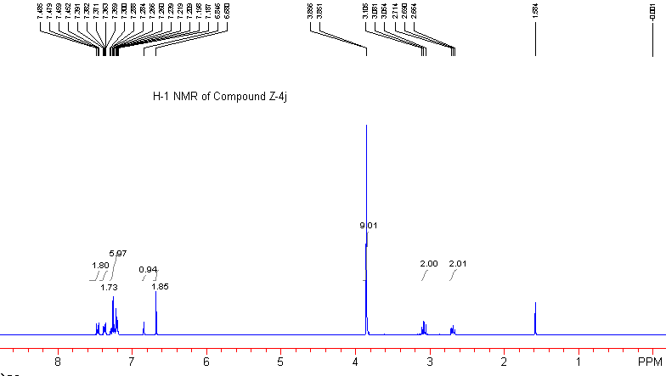

Figure 1. The NOESY Spectrum of Z-2j Isomer.
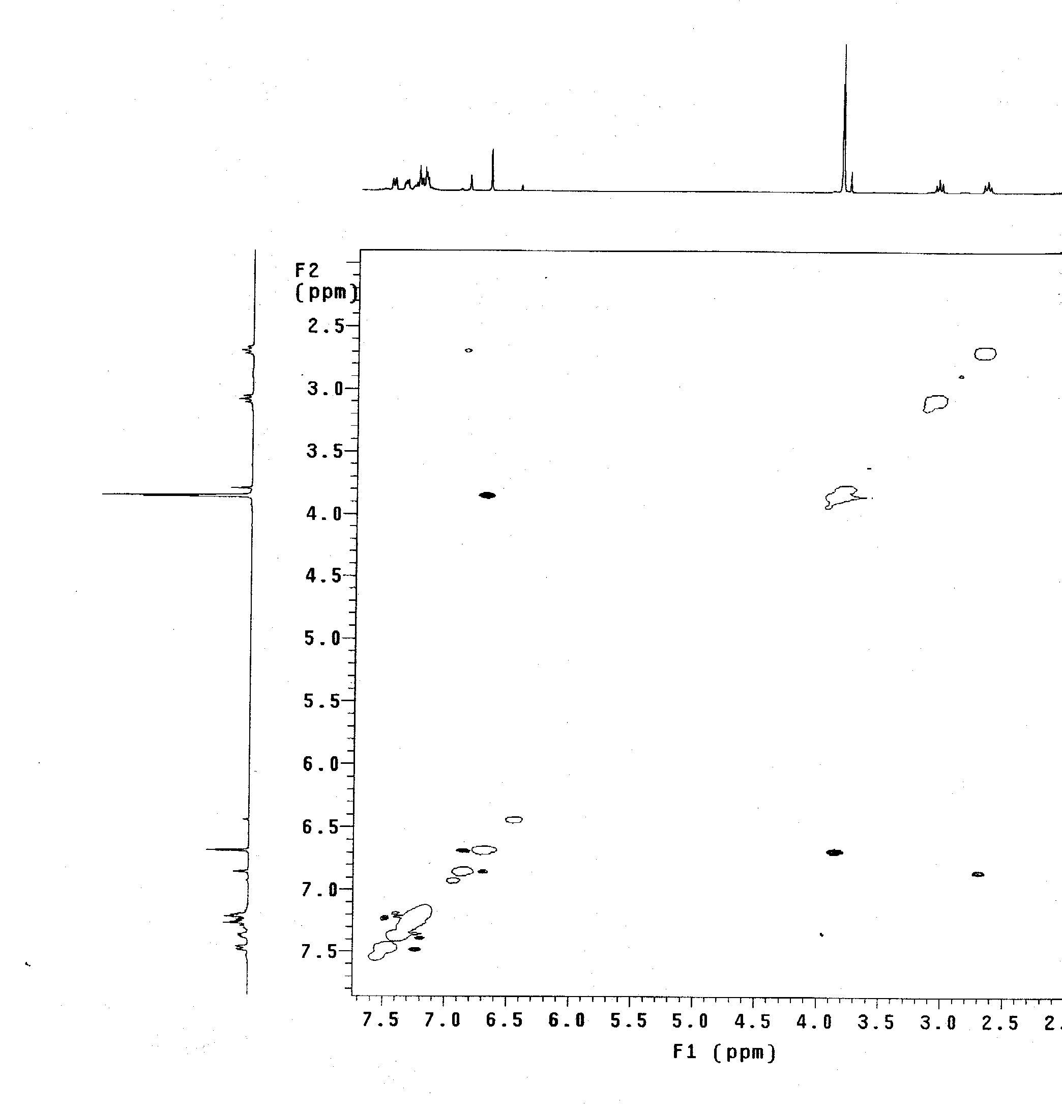
Compound E-2j: a colorless oil. IR (KBr) ν 3055, 2935, 1578, 1476, 1437, 1331, 1239, 1008, 824, 737, 692 cm⁻¹; ¹H NMR (CDCl₃, 300 MHz, TMS) δ 2.80 (2H, t, J = 7.5 Hz, CH₂), 3.08 (2H, t, J = 7.5 Hz, CH₂), 3.72 (6H, s, OCH₃), 3.78 (3H, s, OCH₃), 6.36 (2H, s, Ar), 6.85 (1H, s, =CH), 7.08-7.25 (8H, m, Ar), 7.45-7.48 (2H, m, Ar); ¹³C NMR (CDCl₃, 75 MHz, TMS) δ 26.2, 33.9, 56.1, 60.9, 105.3, 126.8, 127.7, 129.0, 129.2, 129.3, 129.6, 132.2, 132.4, 133.3, 133.7, 135.3, 135.5, 153.0; MS (EI) m/e 534 (M⁺, 23.47), 378 (60.37), 296 (36.01), 281 (31.05), 221 (77.94), 189 (82.97), 175 (53.38), 115 (37.88), 91 (100); HRMS (MALDI) Calcd. for C₂₅H₂₇O₃Se₂⁺¹ (M⁺+1) requires 535.0276, Found: 535.0285.
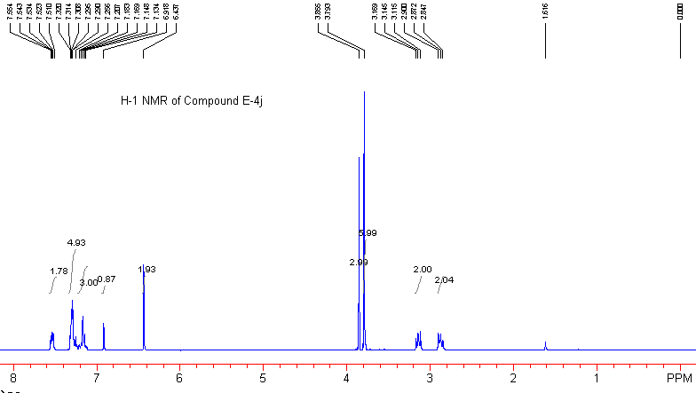

Compound Z-2k: a colorless oil. IR (KBr) ν 3055, 2927, 1578, 1476, 1437, 1397, 1072, 1010, 864, 736, 691 cm⁻¹; ¹H NMR (CDCl₃, 300 MHz, TMS) δ 2.61 (2H, t, J = 7.5 Hz, CH₂), 3.00 (2H, t, J = 7.5 Hz, CH₂), 6.75 (1H, s, =CH), 7.12-7.39 (14H, m, Ar); MS (EI) m/e 524 (M⁺, 6.63), 522 (M⁺, 9.77), 365 (29.34), 286 (8.92), 215 (13.97), 157 (22.47), 128 (100), 115 (23.78), 91 (30.74); HRMS (MALDI) Calcd. for C₂₂H₂₀BrSe₂⁺¹ (M⁺+1) requires 522.9084, Found: 522.9073.

Compound E-2k: a colorless oil. IR (KBr) ν 3055, 2930, 1578, 1476, 1437, 1301, 1266, 1010, 869, 736, 691 cm⁻¹; ¹H NMR (CDCl₃, 300 MHz, TMS) δ 2.79 (2H, t, J = 7.5 Hz, CH₂), 3.07 (2H, t, J = 7.5 Hz, CH₂), 6.81 (1H, s, =CH), 6.94-6.96 (2H, m, Ar), 7.18-7.36 (10H, m, Ar), 7.52-7.55 (2H, m, Ar); ¹³C NMR (CDCl₃, 75 MHz, TMS) δ 26.2, 33.9, 121.0, 127.0, 127.9, 129.0, 129.1, 129.3, 129.4, 129.4, 131.5, 132.9, 133.7, 133.9, 135.6, 136.8; MS (EI) m/e 524 (M⁺, 3.26), 522 (M⁺, 4.68), 365 (16.72), 281 (10.84), 217 (8.70), 199 (51.13), 184 (26.91), 156 (33.98), 128 (100), 115 (34.63); HRMS (MALDI) Calcd. for C₂₂H₂₀BrSe₂⁺¹ (M⁺+1) requires 522.9109, Found: 522.9073.

Compound 2l (Z/E = 1:1): a colorless oil. IR (KBr) ν 3059, 2929, 1601, 1577, 1509, 1251, 1174, 836, 736, 691 cm⁻¹; mixtures of Z/E-isomers: ¹H NMR (CDCl₃, 300 MHz, TMS) δ 1.35-1.45 (6H, m, 2CH₃), 2.06 (3H, s, CH₃), 2.27 (3H, s, CH₃), 2.58 (2H, t, J = 7.5 Hz, CH₂), 2.74 (2H, t, J = 7.5 Hz, CH₂), 2.95 (2H, t, J = 7.5 Hz, CH₂), 3.10 (2H, t, J = 7.5 Hz, CH₂), 3.88-4.07 (4H, m, 2CH₂), 6.82-6.94 (6H, m, Ar), 7.04-7.10 (6H, m, Ar), 7.19-7.42 (16H, m, Ar); MS (EI) m/e 502 (20.69), 345 (75.87), 214 (44.60), 188 (64.20), 145 (86.85), 115 (69.14), 91 (100); HRMS (MALDI) Calcd. for C₂₅H₂₇OSe₂⁺¹ (M⁺+1) requires 503.0374, Found: 503.0387.

Compound 2m (Z/E = 1:1): a colorless oil. IR (KBr) ν 3054, 2930, 1605, 1577, 1507, 1245, 1173, 833, 735, 691 cm⁻¹; mixtures of Z/E-isomers: ¹H NMR (CDCl₃, 300 MHz, TMS) δ 2.76-2.85 (4H, m, 2CH₂), 3.07-3.14 (4H, m, 2CH₂), 3.82 (3H, s, OCH₃), 3.84 (3H, s, OCH₃), 6.85-6.91 (4H, m, Ar), 7.10-7.37 (30H, m, Ar), 7.51-7.55 (4H, m, Ar); MS (EI) m/e 550 (23.72), 393 (72.59), 316 (18.94), 236 (72.05), 222 (100), 205 (42.06), 178 ( 49.17), 157 (49.18), 91 (75.83); HRMS (MALDI) Calcd. for C₂₉H₂₆OSe₂⁺¹ (M⁺) requires 550.0310, Found: 550.0309.

Compound 2n (Z/E = 1:1): a colorless oil. IR (KBr) ν 3054, 2929, 1577, 1476, 1437, 1267, 1146, 736, 691 cm⁻¹; mixtures of Z/E-isomers: ¹H NMR (CDCl₃, 300 MHz, TMS) δ 2.56-2.65 (2H, m, CH₂), 2.76-2.90 (2H, m, CH₂), 3.06-3.15 (4H, m, 2CH₂), 7.13-7.42 (30H, m, Ar), 7.54-7.58 (8H, m, Ar); MS (EI) m/e 556 (M⁺, 12.38), 554 (M⁺, 24.86), 519 (25.03), 397 (49.72), 320 (14.28), 203 (100), 185 (50.16), 157 (93.81), 91 (90.42); HRMS (MALDI) Calcd. for C₂₈H₂₃ClSe₂Na⁺¹ (M⁺+23) requires 576.9724, Found: 576.9711.

Compound 3a: a colorless oil. IR (KBr) ν 3058, 2840, 1578, 1476, 1439, 1226, 1058, 876, 757, 699 cm⁻¹; ¹H NMR (CDCl₃, 300 MHz, TMS) δ 4.72 (2H, d, J = 1.5 Hz, CH₂), 5.71 (1H, t, J = 1.5 Hz, =CH), 7.24-7.37 (9H, m, Ar), 7.44-7.49 (6H, m, Ar); ¹³C NMR (CDCl₃, 75 MHz, TMS) δ 74.3, 96.1, 127.55, 127.64, 127.9, 128.3, 129.4, 130.0, 132.4, 134.7, 137.5, 142.9; MS (EI) m/e 378 (M⁺, 19.64), 301 (17.66), 221 (9.38), 192 (38.39), 165 (15.60), 144 (34.52), 115 (100), 105 (27.41), 91 (19.59); HRMS (MALDI) Calcd. for C₂₂H₁₉OSe⁺¹ (M⁺+1) requires 379.0589, Found: 379.0596.
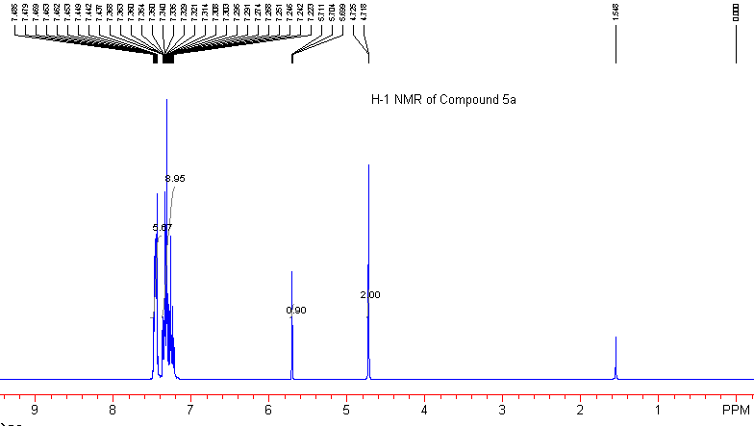

Compound 3b: a colorless oil. IR (KBr) ν 3054, 2839, 1578, 1476, 1438, 1228, 1059, 879, 740, 691 cm⁻¹; ¹H NMR (CDCl₃, 300 MHz, TMS) δ 2.35 (6H, s, CH₃), 4.70 (2H, d, J = 1.5 Hz, CH₂), 5.66 (1H, t, J = 1.5 Hz, =CH), 7.13-7.16 (4H, m, Ar), 7.25-7.35 (7H, m, Ar), 7.47-7.51 (2H, m, Ar); ¹³C NMR (CDCl₃, 75 MHz, TMS) δ 21.1, 74.2, 95.8, 126.9, 127.5, 128.2, 128.6, 128.8, 129.3, 134.7, 137.1, 137.2, 140.0; MS (EI) m/e 406 (M⁺, 2.25), 315 (3.38), 249 (2.49), 210 (29.97), 195 (19.01), 178 (9.16), 165 (8.38), 119 (100), 91 (49.39); HRMS (MALDI) Calcd. for C₂₄H₂₃OSe⁺¹ (M⁺+1) requires 407.0903, Found: 407.0909.

Compound 3c: a colorless oil. IR (KBr) ν 3057, 2835, 1579, 1509, 1439, 1250, 1174, 878, 740, 691 cm⁻¹; ¹H NMR (CDCl₃, 300 MHz, TMS) δ 3.81 (6H, s, 2OCH₃), 4.70 (2H, d, J = 1.5 Hz, CH₂), 5.68 (1H, t, J = 1.5 Hz, =CH), 6.84-6.89 (4H, m, Ar), 7.26-7.30 (3H, m, Ar), 7.34-7.38 (4H, m, Ar), 7.47-7.50 (2H, m, Ar); ¹³C NMR (CDCl₃, 75 MHz, TMS) δ 55.2, 74.0, 95.5, 113.2, 127.0, 128.2, 128.8, 128.9, 129.3, 134.6, 135.2, 137.2, 158.9; MS (EI) m/e 438 (M⁺, 4.83), 331 (13.95), 281 (13.61), 226 (18.62), 195 (9.66), 165 (15.08), 135 (35.03), 115 (100), 84 (39.82); HRMS (MALDI) Calcd. for C₂₄H₂₃O₃Se⁺¹ (M⁺+1) requires 439.0799, Found: 439.0807.

Compound 3d: a colorless oil. IR (KBr) ν 3058, 2843, 1577, 1487, 1438, 1221, 1058, 881, 740, 690 cm⁻¹; ¹H NMR (CDCl₃, 300 MHz, TMS) δ 4.71 (2H, d, J = 1.5 Hz, CH₂), 5.78 (1H, t, J = 1.5 Hz, =CH), 7.26-7.37 (11H, m, Ar), 7.43-7.46 (2H, m, Ar); ¹³C NMR (CDCl₃, 75 MHz, TMS) δ 74.3, 95.2, 128.16, 128.22, 128.4, 128.7, 129.0, 129.5, 133.8, 134.6, 135.8, 141.0; MS (EI) m/e 448 (M⁺, 1.75), 446 (M⁺, 3.45), 335 (4.48), 250 (17.49), 215 (7.00), 189 (13.10), 178 (13.95), 157 (11.64), 139 (100), 115 (69.45); HRMS (MALDI) Calcd. for C₂₂H₁₇Cl₂OSe⁺¹ (M⁺+1) requires 446.9815, Found: 446.9816.

Compound 3e: a colorless oil; IR (KBr) ν 3072, 2843, 1578, 1507, 1476, 1229, 1058, 831, 740, 691 cm⁻¹; ¹H NMR (CDCl₃, 300 MHz, TMS) δ 4.71 (2H, t, J = 1.5 Hz, CH₂), 5.76 (1H, t, J = 1.5 Hz, =CH), 6.98-7.04 (4H, m, Ar), 7.25-7.29 (3H, m, Ar), 7.37-7.47 (6H, m, Ar); ¹³C NMR (CDCl₃, 75 MHz, TMS) δ 74.2, 95.2, 114.8 (d, J_{C-F} = 21.2 Hz), 128.3, 128.4, 129.39 (d, J_{C-F} = 7.8 Hz ), 129.44, 134.5, 136.3 (2C), 138.5 (d, J_{C-F} = 3.4 Hz), 162.3 (d, J_{C-F} = 245.6 Hz); MS (EI) m/e 414 (M⁺, 2.02), 319 (6.81), 228 (24.72), 201 (16.51), 162 (19.16), 123 (89.70), 115 (100), 95 (64.13); HRMS (MALDI) Calcd. for C₂₂H₁₇F₂OSe⁺¹ (M⁺+1) requires 415.0394, Found: 415.0407.

Compound 3m: a colorless oil. IR (KBr) ν 3057, 2835, 1607, 1578, 1510, 1439, 1250, 1175, 877, 741, 700 cm⁻¹; ¹H NMR (CDCl₃, 300 MHz, TMS) δ 3.84 (3H, s, OCH₃), 4.75 (2H, d, J = 1.8 Hz, CH₂), 5.74 (1H, t, J = 1.8 Hz, =CH), 6.89-6.92 (2H, m, Ar), 7.27-7.41 (8H, m, Ar), 7.50-7.53 (4H, m, Ar); ¹³C NMR (CDCl₃, 75 MHz, TMS) δ 55.2, 74.2, 95.8, 113.3, 127.37, 127.40, 127.6, 127.9, 128.2, 128.9, 129.0, 129.3, 134.6, 135.1, 137.0, 143.1, 159.0; MS (EI) m/e 408 (M⁺, 10.90), 331 (37.2), 251 (21.21), 222 (21.32), 196 (22.42), 178 (26.30), 165 (10.70), 135 (52.30), 115 (100), 105 (24.31); HRMS (MALDI) Calcd. for C₂₃H₂₁O₂Se⁺¹ (M⁺+1) requires 409.0716, Found: 409.0701.

Compound 3n: a colorless oil. IR (KBr) ν 3059, 2843, 1603, 1578, 1437, 1219, 1064, 877, 758, 698 cm⁻¹; ¹H NMR (CDCl₃, 300 MHz, TMS) δ 4.66 (1H, dd, J₁, J₂ = 1.8, 12.9 Hz, CH₂), 4.84 (1H, dd, J₁, J₂ = 1.8, 12.9 Hz, CH₂), 5.72 (1H, t, J = 1.8 Hz, =CH), 7.27-7.42 (10H, m, Ar), 7.51-7.55 (3H, m, Ar), 7.71-7.74 (1H, m, Ar); MS (EI) m/e 414 (M⁺, 5.74), 412 (M⁺, 13.08), 377 (19.37), 335 (5.66), 255 (8.76), 225 (9.91), 189 (43.28), 165 (16.18), 115 (100), 84 (40.07); HRMS (MALDI) Calcd. for C₂₂H₁₇OClSeNa⁺¹ (M⁺+23) requires 435.0050, Found: 435.0025.

Compound 4a: a colorless oil; IR (KBr) ν 3360, 3055, 2928, 1950, 1597, 1491, 1442, 1265, 1074, 736, 698 cm⁻¹; ¹H NMR (CDCl₃, 300 MHz, TMS) δ 4.29 (2H, d, J = 5.7 Hz, OCH₂), 5.89 (1H, t, J = 5.7 Hz, =CH), 7.24-7.37 (10H, m, Ar); ¹³C NMR (CDCl₃, 75 MHz, TMS) δ 60.6, 95.1, 112.5, 127.5, 128.4, 128.5, 136.3, 204.3; MS (EI) m/e 222 (M⁺, 40.11), 203 (16.80), 189 (100), 178 (14.80), 165 (46.86), 131 (16.77), 115 (36.52), 105 (53.04); HRMS (EI) Calcd. for C₁₆H₁₄O (M⁺) requires 222.1045, Found: 222.1013.
