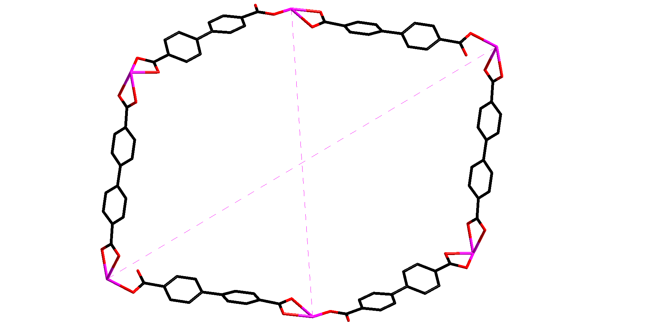
23.7 Å

33.2 Å
Fig. S1 The 12-membered grid in complex 1.

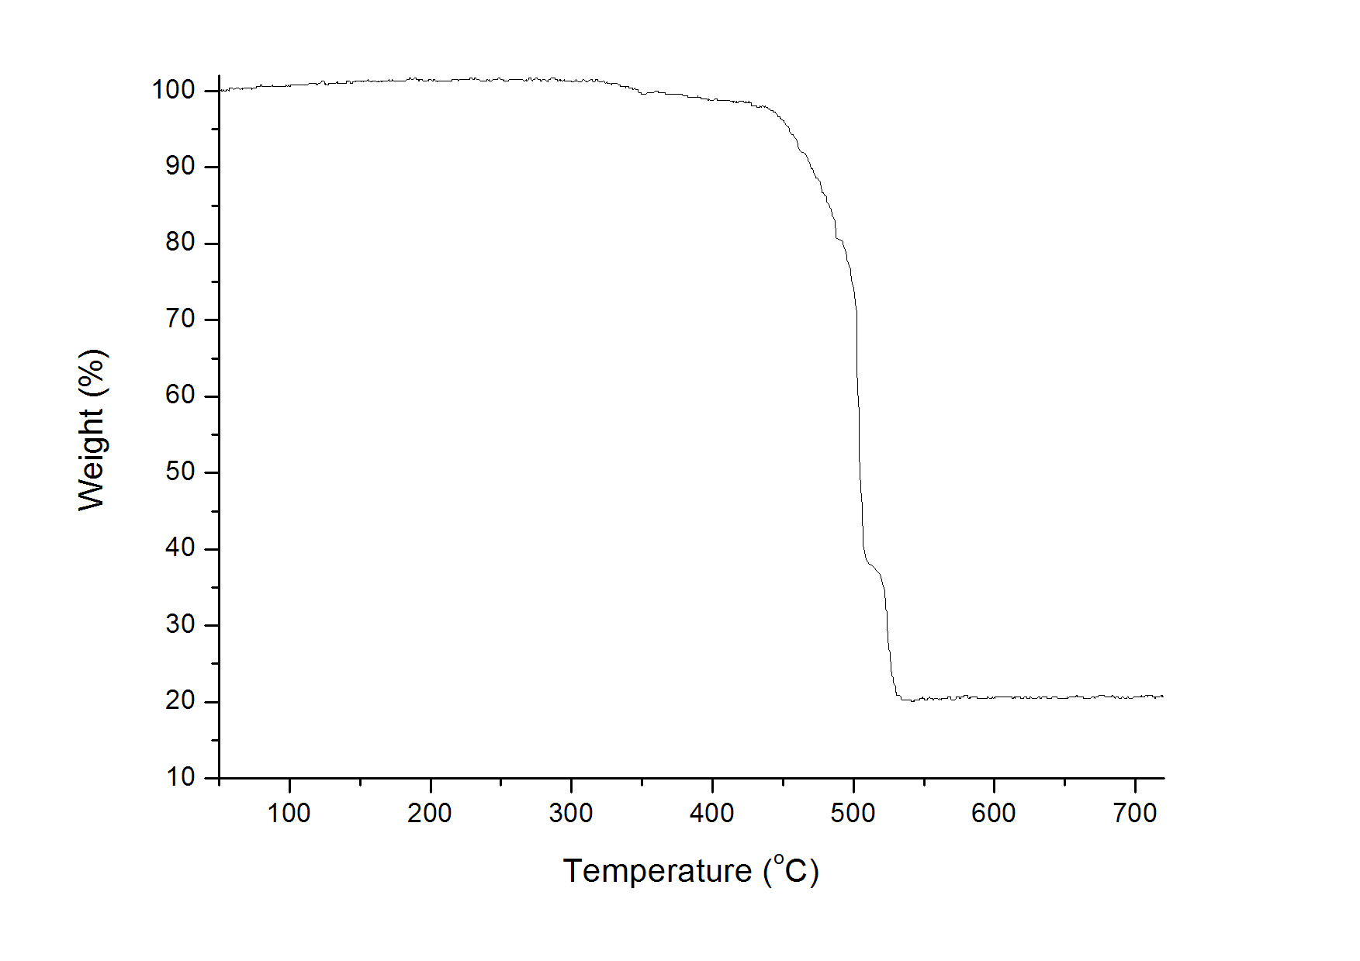 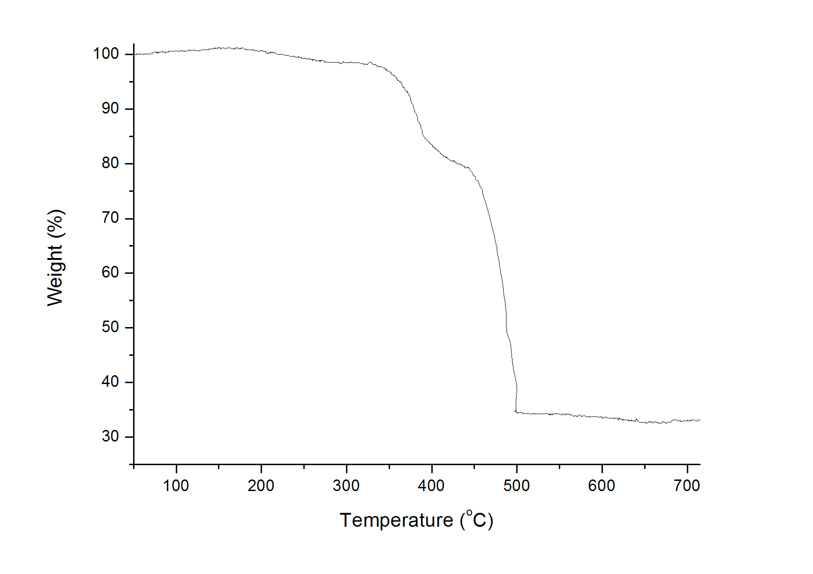
(a) (b)
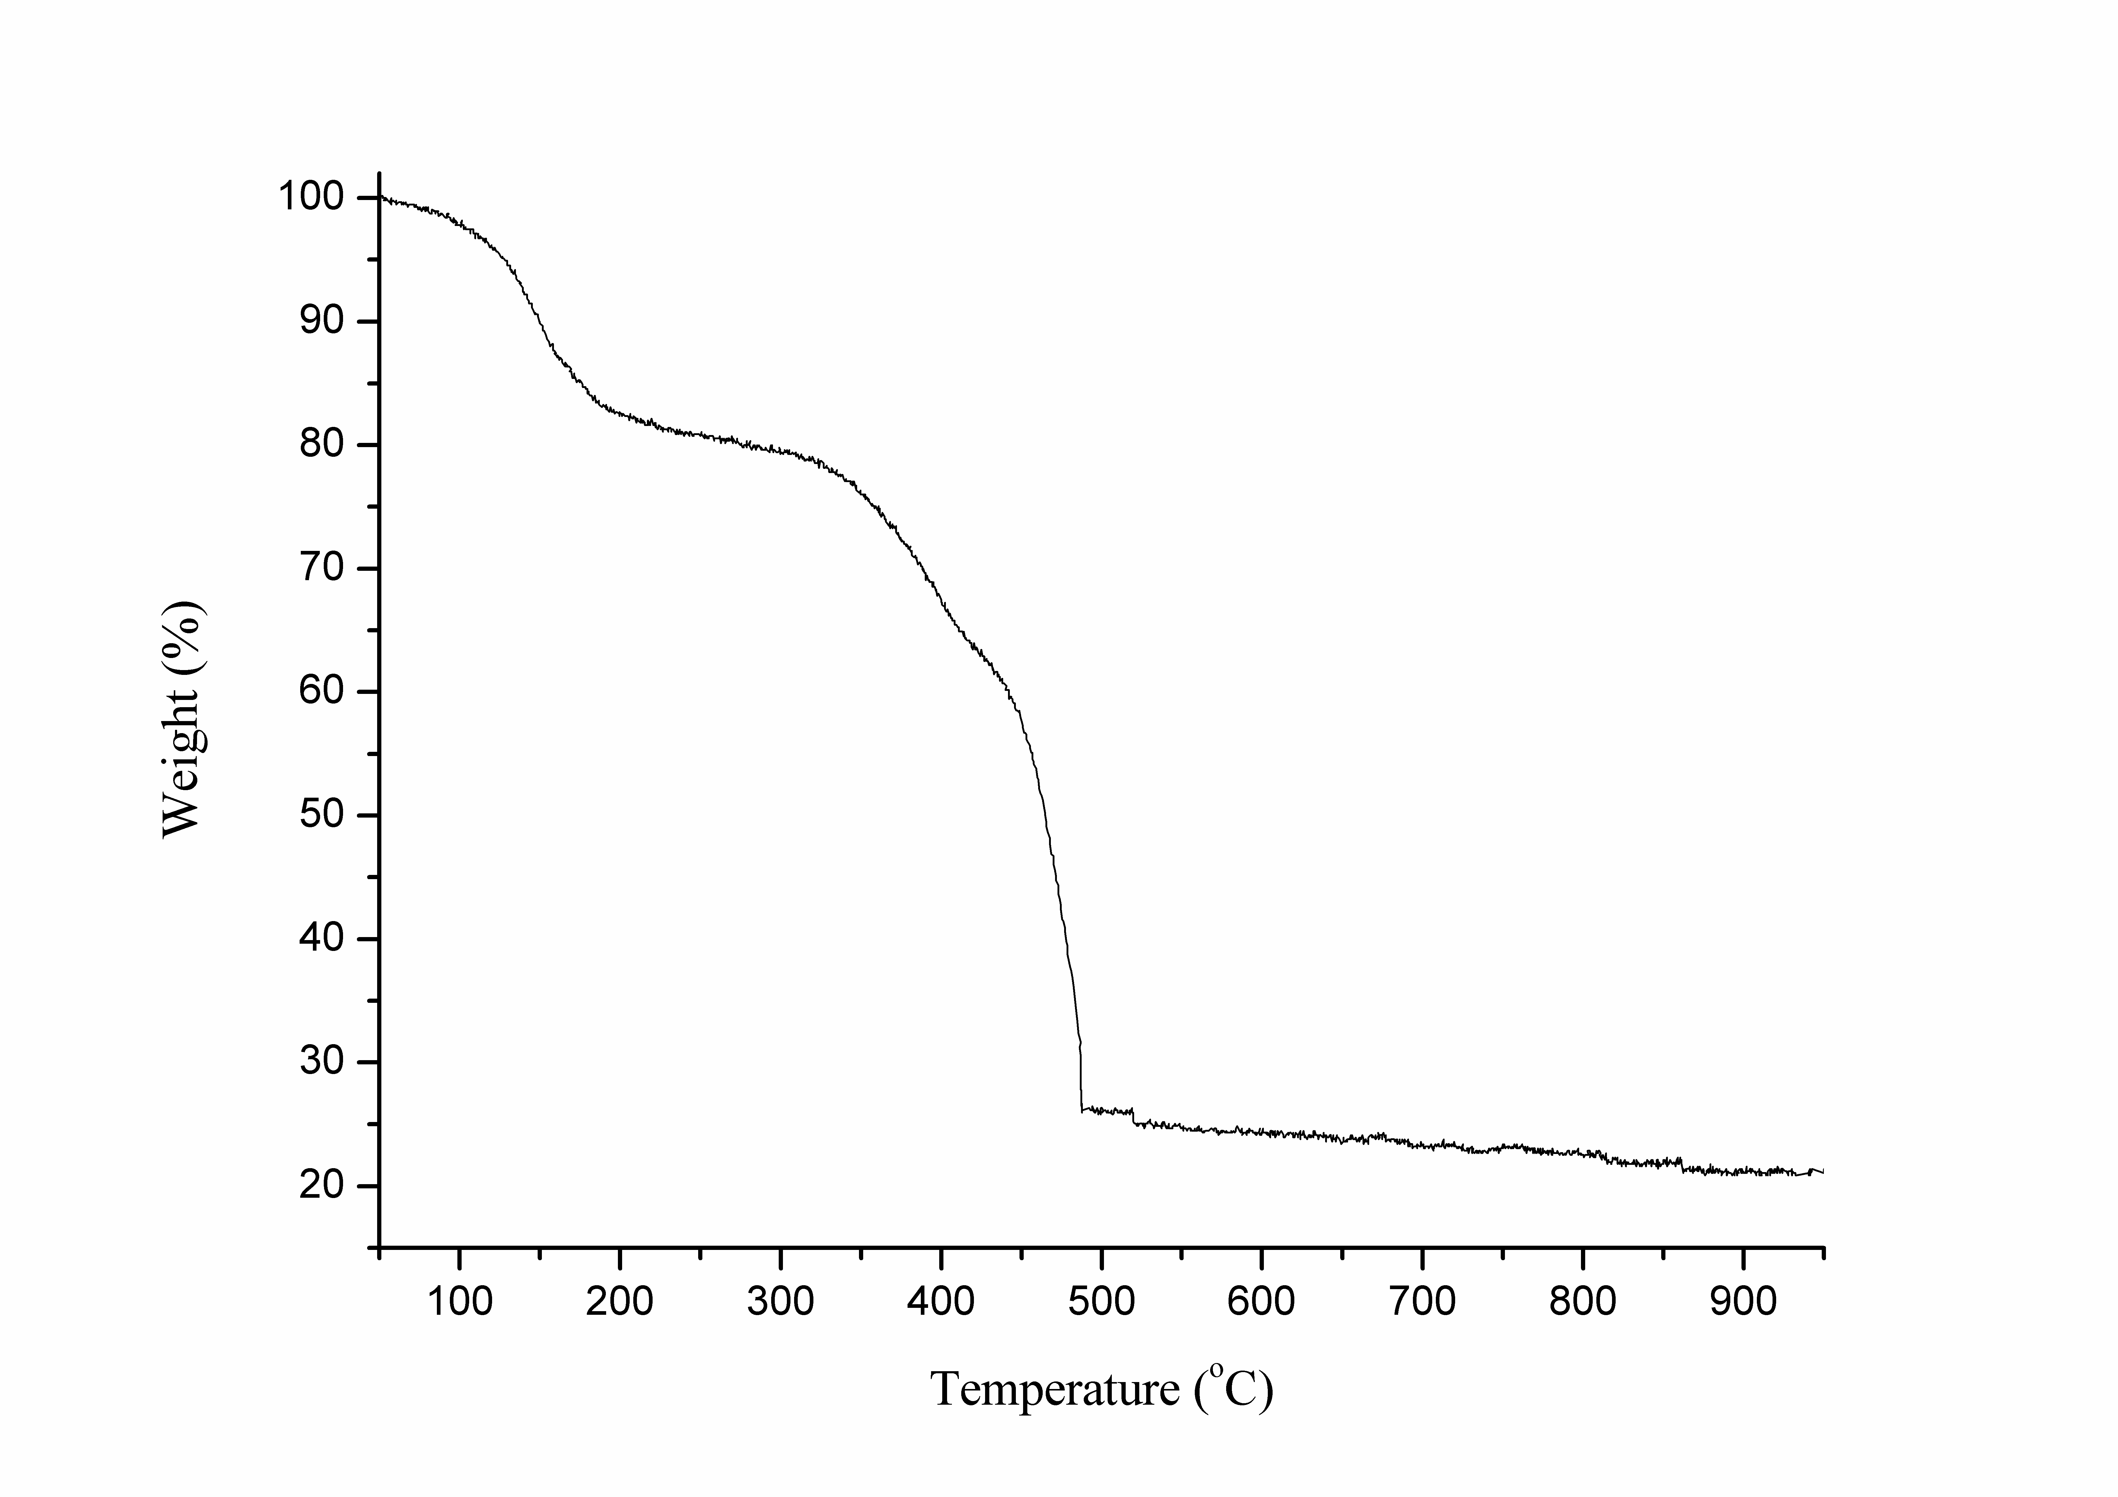
(C)
Fig. S2 TG curve of complexes 1 (a), 2 (b), and 3(c).

Table S1
Selected bond lengths [Å] and angles [°] for complex 1.
In(1)−O(6)#1  In(1)−O(2)  In(1)−O(4)  In(1)−O(1)  In(1)−O(3)  In(1)−N(1)  In(1)−N(2) | 2.142(3)  2.207(2)  2.208(2)  2.358(2)  2.383(2)  2.384(3)  2.332(3) | C(13)−O(1)  C(13)−O(2)  C(27)−O(3)  C(27)−O(4)  C(26)−O(5)  C(26)−O(6) | 1.250(4)  1.279(4)  1.253(4)  1.272(4)  1.250(5)  1.269(5)
O(6)#1−In(1)−O(2)  O(6)#1−In(1)−O(4)  O(2)−In(1)−O(4)  O(6)#1−In(1)−O(1)  O(2)−In(1)−O(1)  O(4)−In(1)−O(1)  O(6)#1−In(1)−O(3)  O(2)−In(1)−O(3)  O(4)−In(1)−O(3)  O(1)−In(1)−O(3)  O(6)#1−In(1)−N(2)  O(2)−In(1)−N(2) | 139.09(10)  127.63(10)  84.72(10)  82.91(10)  57.01(8)  121.24(9)  86.27(10)  95.26(9)  56.61(9)  82.24(8)  113.96(11)  94.95(10) | O(4)−In(1)−N(2)  O(1)−In(1)−N(2)  O(3)−In(1)−N(2)  O(6)#1−In(1)−N(1)  O(2)−In(1)−N(1)  O(4)−In(1)−N(1)  N(2)−In(1)−N(1)  O(1)−In(1)−N(1)  O(3)−In(1)−N(1)  O(1)−C(13)−O(2)  O(5)−C(26)−O(6)  O(3)−C(27)−O(4) | 78.23(10)  140.04(9)  132.32(9)  82.44(10)  81.21(10)  143.65(10)  69.86(10)  77.47(9)  157.81(9)  119.3(3)  121.1(4)  119.6(3)
Symmetry transformations used to generate equivalent atoms:
#1 x + 1, −y + 1/2, z−1/2 #2 x−1,−y + 1/2, z + 1/2 #3 −x,−y,−z

Table S2
Selected bond lengths [Å] and angles [°] for complex 2.
In(1)−O(3)  In(1)−O(3)#1  In(1)−O(4)  In(1)−O(1)#2  In(1)−O(1) | 2.069(4)  2.104(4)  2.183(5)  2.260(5)  2.260(5) | In(1)−O(2)  In(1)−O(2)#2  In(1)#3−O(3)  C(1)−O(1)  C(1)−O(2) | 2.361(4)  2.361(4)  2.104(4)  1.251(6)  1.269(6)
O(3)−In(1)−O(3)#1  O(3)−In(1)−O(4)  O(3)#1−In(1)−O(4)  O(3)−In(1)−O(1)#2  O(3)#1−In(1)−O(1)#2  O(4)−In(1)−O(1)#2  O(3)−In(1)−O(1)  O(3)#1−In(1)−O(1)  O(4)−In(1)−O(1)  O(1)#2−In(1)−O(1)  O(3)−In(1)−O(2) | 100.91(9)  171.4(2)  87.7(2)  91.52(10)  85.54(10)  89.13(11)  91.52(10)  85.54(10)  89.13(11)  170.98(19)  88.90(14) | O(3)#1−In(1)−O(2)  O(4)−In(1)−O(2)  O(1)#2−In(1)−O(2)  O(1)−In(1)−O(2)  O(3)−In(1)−O(2)#2  O(3)#1−In(1)−O(2)#2  O(4)−In(1)−O(2)#2  O(1)#2−In(1)−O(2)#2  O(1)−In(1)−O(2)#2  O(2)−In(1)−O(2)#2  O(1)−C(1)−O(2) | 140.98(9)  84.34(17)  132.29(13)  56.27(13)  88.90(14)  140.98(9)  84.34(17)  56.27(13)  132.29(13)  76.05(17)  119.8(5)
Symmetry transformations used to generate equivalent atoms:
#1 x−1/2, y, −z + 1/2 #2 x, −y + 3/2, z #3 x + 1/2, y, −z + 1/2
#4 −x + 1,−y + 1,−z

Table S3
Selected bond lengths [Å] and angles [°] for complex 3.
In(1)−O(8)#1  In(1)−O(8)#2  In(1)−O(5)  In(1)−O(5)#3  In(1)−O(6)#3  In(1)−O(6)  In(1)−O(7)#1  In(1)−O(7)#2  In(1)#8−O(7)  In(1)#8−O(8)  In(2)−O(4)#4  In(2)−O(4)  In(2)−O(1)#5  In(2)−O(1)#6 | 2.234(3)  2.234(3)  2.238(3)  2.238(3)  2.320(3)  2.320(3)  2.321(3)  2.321(3)  2.321(3)  2.234(3)  2.190(3)  2.190(3)  2.240(3)  2.240(3) | In(2)−O(2)#6  In(2)−O(2)#5  In(2)−O(3)#4  In(2)−O(3)  In(2)#7−O(1)  In(2)#7−O(2)  C(13)−O(1)  C(13)−O(2)  C(14)−O(3)  C(14)−O(4)  C(27)−O(5)  C(27)−O(6)  C(28)−O(7)  C(28)−O(8) | 2.327(3)  2.327(3)  2.406(3)  2.406(3)  2.240(3)  2.327(3)  1.263(6) 1.229(5)  1.207(6)  1.286(5)  1.215(5)  1.200(6)  1.253(5)  1.220(4)
O(8)#1−In(1)−O(8)#2  O(8)#1−In(1)−O(5)  O(8)#2−In(1)−O(5)  O(8)#1−In(1)−O(5)#3  O(8)#2−In(1)−O(5)#3  O(5)−In(1)−O(5)#3  O(8)#1−In(1)−O(6)#3  O(8)#2−In(1)−O(6)#3  O(5)−In(1)−O(6)#3  O(5)#3−In(1)−O(6)#3  O(8)#1−In(1)−O(6)  O(8)#2−In(1)−O(6)  O(5)−In(1)−O(6)  O(5)#3−In(1)−O(6)  O(6)#3−In(1)−O(6)  O(8)#1−In(1)−O(7)#1  O(8)#2−In(1)−O(7)#1  O(5)−In(1)−O(7)#1  O(5)#3−In(1)−O(7)#1  O(6)#3−In(1)−O(7)#1  O(6)−In(1)−O(7)#1  O(8)#1−In(1)−O(7)#2  O(8)#2−In(1)−O(7)#2  O(5)−In(1)−O(7)#2  O(5)#3−In(1)−O(7)#2  O(6)#3−In(1)−O(7)#2  O(6)−In(1)−O(7)#2  O(7)#1−In(1)−O(7)#2  O(4)#4−In(2)−O(4)  O(4)#4−In(2)−O(1)#5 | 121.54(13)  82.45(11)  130.46(10)  130.46(10)  82.45(11)  115.99(16)  85.47(11)  135.32(11)  84.07(12)  54.36(12)  135.32(11)  85.47(11)  54.36(12)  84.07(12)  99.34(17)  56.62(10)  83.51(10)  138.17(11)  88.55(11)  84.42(11)  167.45(12)  83.51(10)  56.62(10)  88.55(11)  138.17(11)  167.45(12)  84.42(11)  94.46(15)  124.06(15)  85.66(11) | O(4)−In(2)−O(1)#5  O(4)#4−In(2)−O(1)#6  O(4)−In(2)−O(1)#6  O(1)#5−In(2)−O(1)#6  O(4)#4−In(2)−O(2)#6  O(4)−In(2)−O(2)#6  O(1)#5−In(2)−O(2)#6  O(1)#6−In(2)−O(2)#6  O(4)#4−In(2)−O(2)#5  O(4)−In(2)−O(2)#5  O(1)#5−In(2)−O(2)#5  O(1)#6−In(2)−O(2)#5  O(2)#6−In(2)−O(2)#5  O(4)#4−In(2)−O(3)#4  O(4)−In(2)−O(3)#4  O(1)#5−In(2)−O(3)#4  O(1)#6−In(2)−O(3)#4  O(2)#6−In(2)−O(3)#4  O(2)#5−In(2)−O(3)#4  O(4)#4−In(2)−O(3)  O(4)−In(2)−O(3)  O(1)#5−In(2)−O(3)  O(1)#6−In(2)−O(3)  O(2)#6−In(2)−O(3)  O(2)#5−In(2)−O(3)  O(3)#4−In(2)−O(3)  O(2)−C(13)−O(1)  O(3)−C(14)−O(4)  O(6)−C(27)−O(5)  O(8)−C(28)−O(7) | 137.97(11)  137.97(11)  85.66(11)  89.34(15)  81.47(10)  121.79(10)  88.59(10)  56.67(10)  121.79(10)  81.47(10)  56.67(10)  88.59(10)  132.39(13)  55.26(11)  82.96(10)  94.41(11)  166.63(12)  136.13(10)  82.81(10)  82.96(10)  55.26(11)  166.63(12)  94.41(11)  82.81(10)  136.13(10)  84.87(15)  121.0(4)  118.2(4)  119.3(4)  121.8(4)
Symmetry transformations used to generate equivalent atoms:
#1 −x+1/2,y−1/4,z+1/4 #2 x−1/4,y−1/4,−z #3 −x+1/4,y,−z+1/4
#4 −x−1/4,−y−1/4,z #5 −x,y−1/4,z−1/4 #6 x−1/4,−y,z−1/4
#7 x+1/4,−y,z+1/4 #8 x+1/4,y+1/4,−z #9 −x+1/2,−y,−z+1/2

