Electronic Supplementary Information

A nitro-decorated NbO-type metal-organic framework with highly selective CO₂ uptake and CH₄ storage capacity

Mingxing Zhang ª, Qian Wang ª, Zhiyong Lu ª, Huiyan Liuª, Wenglong Liu*^{b}and Junfeng Bai*ª

ª State Key Laboratory of Coordination Chemistry, School of Chemistry and Chemical Engineering, Nanjing University, Nanjing 210093, China.
E-mail: bjunfeng@nju.edu.cn. Tel: +86-25-83593384.

^{b} College of Chemistry and Chemical Engineering, Yangzhou University, Yangzhou 225002, China.
E-mail: liuwl@yzu.edu.cn.

Experimental Details
All reagents were obtained from commercial vendors and, unless otherwise noted, were used without further purification.
Synthesis of 2'-nitro-[1,1':4',1''-terphenyl]-3,3'',5,5''-tetracarboxylic acid (H₄NTPTB) 1,4-dibromo-2-nitrobenzene (0.28g, 1.0mmol), benzene-1,3-dicarboxyethylester-5-boronic acid (1.28 g, 2.4 mmol), and K₂CO₃ (4.20 g, 20.0 mmol) were added to degassed THF (30 mL). After stirring, Pd(PPh₃)₄ (0.1 g, 0.086 mmol) was added, then the mixture was heated to 70 °C for 3 days under N₂. The resultant was evaporated to dryness and taken up in CH₂Cl₂ which later had been dried over MgSO4. This CH₂Cl₂ solution was evaporated to dryness and the residue was washed briefly with ethanol (40 mL). The crude product was hydrolyzed by refluxing in 2 M aqueous NaOH followed by acidification with 37% HCl to afford H₄NTPTB. IR (KBr, cm^{–1}): 3546 (br,s), 3091 (br,s), 2522 (br,s), 1700 (s), 1635 (m), 1602 (s), 1532 (m), 1436 (m), 1414 (m), 1326 (m), 1275 (m), 1212 (m), 1101 (m). ¹H NMR (DMSO-d₆, δ ppm): 13.489 (broad peak, COOH), 8.54 (s, 4H, ArH), 8.49 (s, 1H, ArH), 8.226-8.242 (d, 2H, ArH), 8.153 (s, 2H, ArH), 7.783-7.797 (d, 2H, ArH). Anal. Calcd (Found) for H₄NTPTB, C₁₈H₉N₅O₁₀: C, 58.54 (58.02); H, 2.9 (3.2); N, 3.1 (3.01)%. MS (ESI) m/z (M – H⁺)⁻ : 449.0520
[Cu₂(NTPTB⁴⁻)(H₂O)₂]·6H₂O.2DMF, NJU-Bai 14. H₄NTPTB (10.0 mg) and Cu(NO₃)₂·3H₂O (24 mg, 0.1mmol) in 2 mL DMF /water (5:3:1) with 2 mL 2.7 M HNO₃ (in DMF) were stirred for a few minutes in air and the clear solution was transferred into a autoclave Teflon-line stainless vessel (20 mL). The vessel was sealed and heated to 65 °C for 2 days and then cooled to room temperature at a rate 5 ºC/hour. Blue block crystals of NJU-Bai 14 were filtered and washed with DMF. Yield 12.5 mg. Selected IR (cm⁻¹): 3374 (br, s), 2971 (vs), 2363 (s), 1652 (m), 1559 (vs), 1531 (m), 1447 (m), 1367 (w), 1084(m), 1044 (m), 872 (m), 842 (m), 774 (m). Anal. Calcd (Found), C₂₆H₃₉Cu₂N₃O₁₆: C, 39.75 (39.52); H, 5.01 (4.85); N, 5.41 (5.52)%.
Sample activation. The solvent-exchanged sample was prepared by immersing the as-synthesized samples in dry methanol for 3 days to remove the nonvolatile solvates, and the extract was decanted every 8 hours and fresh acetone was replaced. The completely activated sample was obtained by heating the solvent-exchanged sample at 100 °C under a dynamic high vacuum for 24 hours. During this time, the pale blue sample changed to a deep purple-blue color indicative of the presence of unsaturated metal Cu^{II} sites. The similar color change upon activation was observed for other frameworks that constructed from copper paddlewheel clusters^{[2]}.
X-ray Crystallography. Single-crystal X-ray diffraction data were measured on a Bruker Apex II CCD diffractometer at 150 K using graphite monochromated Mo/Kα radiation (λ = 0.71073 Å). Data reduction was made with the Bruker SAINT program. The structures were solved by direct methods and refined with full-matrix least squares technique using the SHELXTL package^{[3]}. Non-hydrogen atoms were refined with anisotropic displacement parameters during the final cycles. Organic hydrogen atoms were placed in calculated positions with isotropic displacement parameters set to 1.2 × U_{eq} of the attached atom. The hydrogen atoms of the ligated water molecules could not be located. The unit cell includes a large region of disordered solvent molecules, which could not be modelled as discrete atomic sites. We employed PLATON/SQUEEZE^{[4]} to calculate the diffraction contribution of the solvent molecules and, thereby, to produce a set of solvent-free diffraction intensities; structures were then refined again using the data generated.
In the structure, the middle benzene ring moiety in the ligand is disordered over several positions. CCDC 981572 contains the supplementary crystallographic data for NJU-Bai 14. The data can be obtained free of charge at www.ccdc.cam.ac.uk/conts/retrieving.html or from the Cambridge Crystallographic Data Centre, 12, Union Road, Cambridge CB2 1EZ, UK.
Low pressure gas sorption measurements. Low-pressure gases (N₂, CH₄ and CO₂) sorption isotherms (up to 1 bar) were performed on Micromeritics ASAP 2020 M+C surface area and pore size analyzer. Before gases sorption measurements, about 100 mg samples were activated by using the “outgas” function of the surface area analyzer. For all isotherms, warm and cold free space correction measurements were performed using ultra-high purity He gas (UHP grade 5.0, 99.999% purity). A part of the N₂ sorption isotherm at 77 K in the P/P₀ range 0. 001–0.03 was fitted to the BET equation to estimate the BET surface area and the Langmuir surface area calculation was performed using all data points. The pore size distribution (PSD) was obtained from the DFT model in the Micromeritics ASAP2020 software package (assuming cylinder pore geometry) based on the N₂ sorption isotherm.
High pressure gravimetric gas sorption measurements. High pressure CH₄ gas adsorption measurements were performed using Rubotherm ISOSORP-HyGpra+V adsorption analyzer. High pressure excess adsorption of CO₂ and N₂ were measured using an IGA-003 gravimetric adsorption instrument (Hiden-Isochema, UK) over a pressure range of 0-20 bar at 77 K (liquid nitrogen bath) or 273 K and 298 K after an activation procedure same to that in low-pressure volumetric gas adsorption measurement. Before measurements, about 100 mg acetone-exchanged samples were degassed at 100 °C for 24 h under a dynamic high vacuum to obtain about 45 mg fully desolvated samples. During the gases sorption measurements, the sample mass was monitored until equilibrium was reached (within 15 minutes) at each pressure.
Estimation of the isosteric heats of gas adsorption. A virial-type^{[5]} expression comprising the temperature-independent parameters a_{i} and b_{j} was employed to calculate the enthalpies of adsorption for CO₂ and CH₄ (at 273 and 298 K) on NJU-BAI 14. In each case, the data were fitted using the equation:
Here, P is the pressure expressed in Torr, N is the amount adsorbed in mmol/g, T is the temperature in K, a_{i} and b_{j} are virial coefficients, and m, n represent the number of coefficients required to adequately describe the isotherms (m and n were gradually increased until the contribution of extra added a and b coefficients was deemed to be statistically insignificant towards the overall fit, and the average value of the squared deviations from the experimental values was minimized). The values of the virial coefficients a₀ through a_{m} were then used to calculate the isosteric heat of adsorption using the following expression.
Q_{st} is the coverage-dependent isosteric heat of adsorption and R is the universal gas constant. The heat of CO₂ and CH₄ sorption for NJU-Bai 14 in the manuscript is determined by using the low pressure gas sorption data measured in the pressure range from 0-10 bar (273 and 298 K)
Other Physical Measurements. The IR spectra were obtained on a VECTOR TM 22 spectrometer with KBr pellets in the 4000∼400 cm⁻¹ region. ¹H NMR spectra were recorded on a Bruker DRX-500 spectrometer with tetramethylsilane as an internal reference. Thermal gravimetric analyses (TGA) were performed under N₂ atmosphere (100 ml/min) with a heating rate of 5 °C/min using a 2960 SDT thermogravimetric analyzer. Powder X-ray diffraction (PXRD) data were collected over the 2θ range 5 ~ 30º on a Bruker axs D8 Advance diffractometer using Cu Kα radiation (λ = 1.5418 Å) with a routine power of 1600 W (40 kV, 40 mA) in a scan speed of 0.2 s/deg at room temperature.

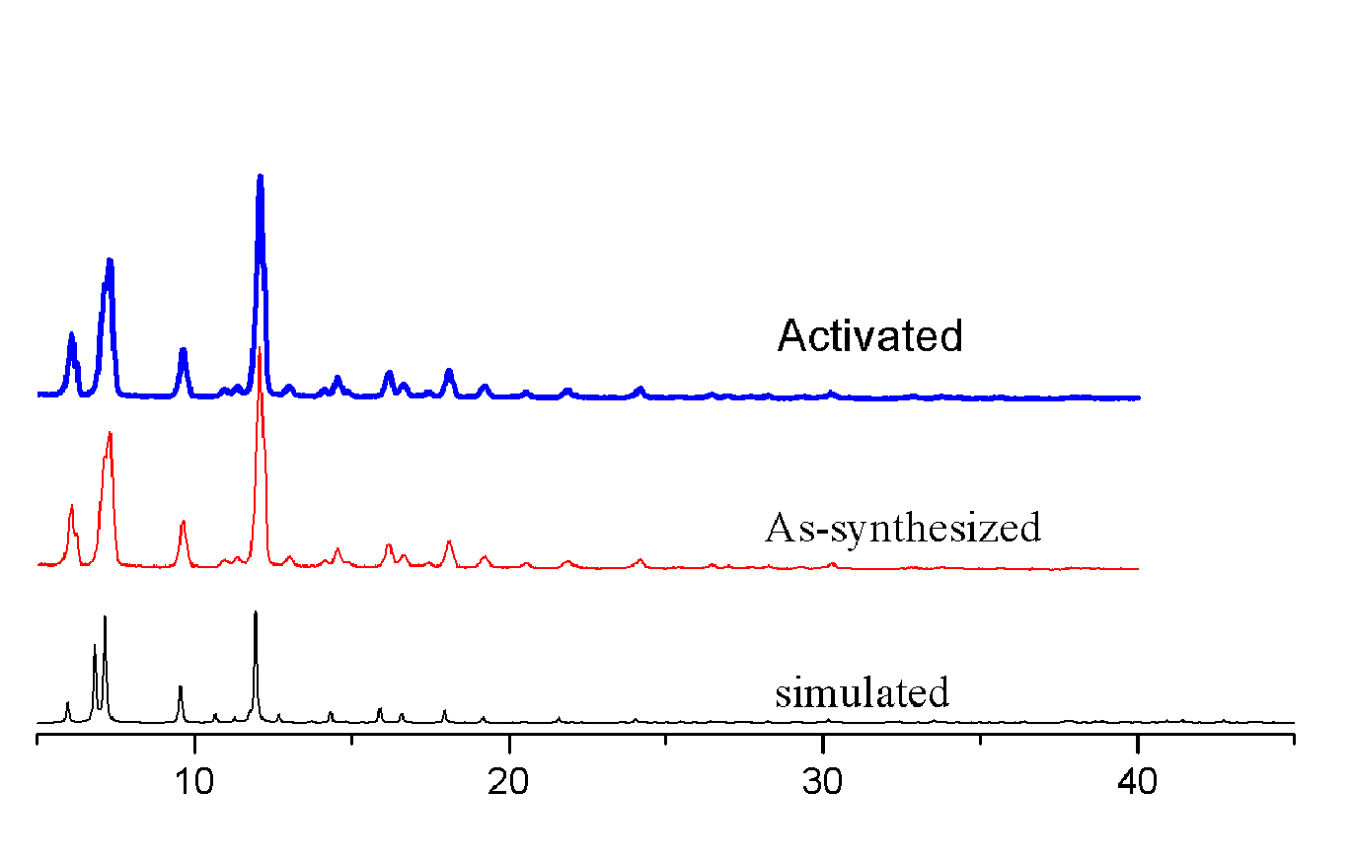
Figure S1. The PXRD patterns of NJU-Bai 14. A simulated PXRD pattern from the single-crystal structure; as-synthesized, and activated samples, respectively.

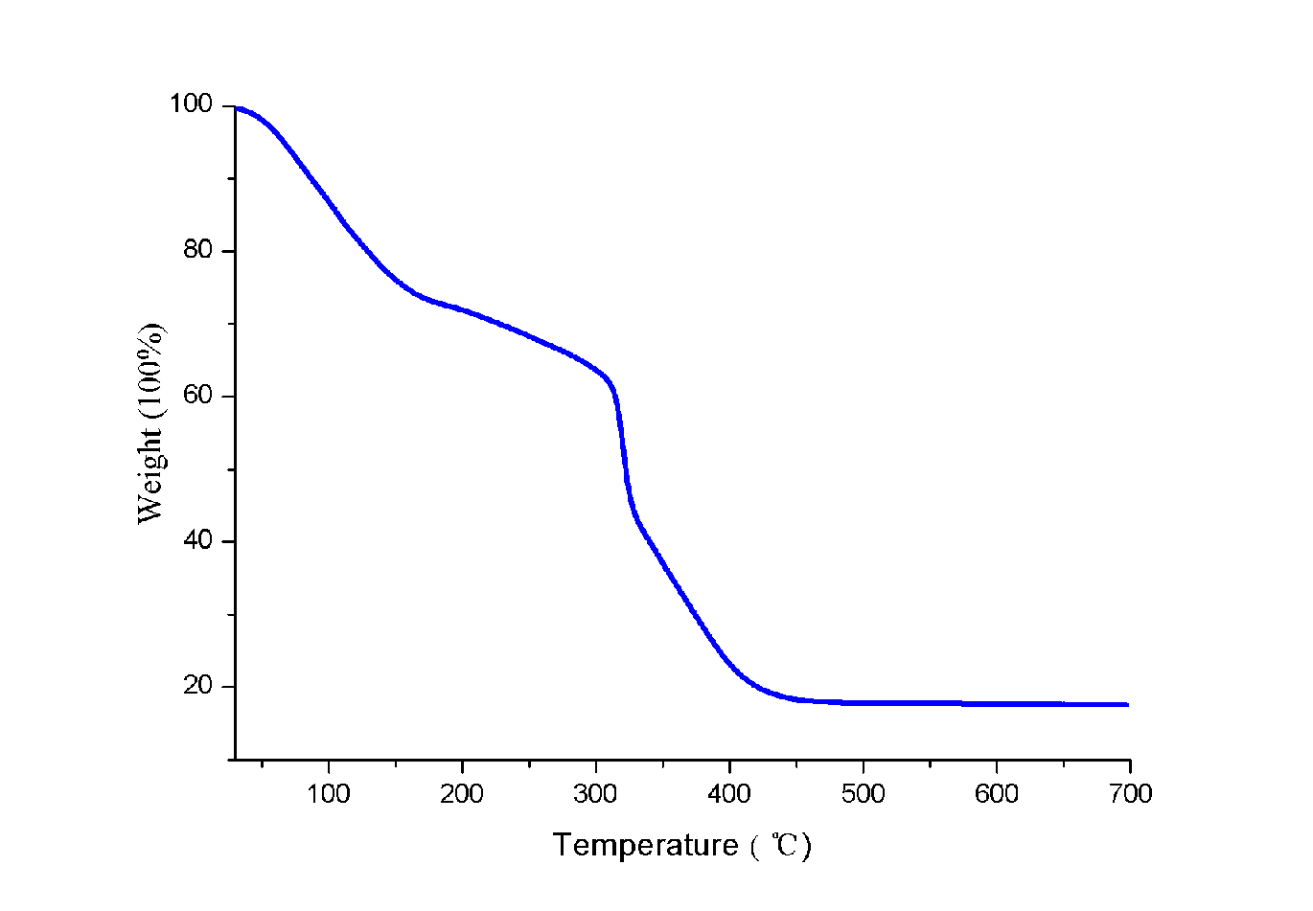
Figure S2. TGA-DSC data of as-synthesized NJU-Bai 14.
Figure S3. (a) The N₂ sorption isotherm at 77 K for NJU-Bai 14, filled and open symbols represent adsorption and desorption, respectively. (b) The BET plots for NJU-Bai 14 in the chosen range (P/P₀ = 0.001 – 0.03). This range was chosen according to two major criteria established in literatures^{[6]}: The pressure range selected should have values of Q(P₀-P) increasing with P/P₀. Inset: The y intercept of the linear region must be positive to yield a meaningful value of the c parameter, which should be greater than zero.

Figure S4 (a)The fitting initial slope for CO₂, CH₄ and N₂ isotherms for NJU-Bai 14 collected at 273 K (R = related coefficient). The calculated selectivity of CO₂/CH₄ and CO₂/N₂ is 8 and 28, respectively. (b)The fitting initial slope for CO₂, CH₄ and N₂ isotherms for NOTT-101 collected at 273 K (R = related coefficient). The calculated selectivity of CO₂/CH₄ and CO₂/N₂ is 7 and 21, respectively.

Figure S5. Details of virial equation (solid lines) fitting to the experimental CO₂ a) and CH₄ b) Adsorption data (symbols) for NJU-Bai 14 collected at 273 K (blue symbols) and 298 K (red symbols).

Figure S6. Isosteric heats of CO₂ and CH₄ adsorption for NJU-Bai 14 and NOTT-101

.

Figure S7. Gases sorption properties of NJU-Bai 14. High-pressure excess CH₄ isotherms.

Figure S8. Infrared spectra. Red line: as-synthesized NJU-Bai 14; Green line: activated NJU-Bai 14.
Note the absence of the vibration frequencies of the solvent DMF molecules in the activated sample. The presence of the stretching frequencies at 1616 cm⁻¹ in activated sample may result from the rapid re-adsorption of trace moisture during the IR measurements

Reference
[1]. S. M. Aharoni and S. F. Edwards, Macromolecules, 1989, 22, 3361.
[2]. Y. Yan, X. Lin, S. H. Yang, A. J. Blake, A. Dailly, N. R. Champness, P. Hubberstey, M. Schroder, Chem. Commun., 2009, 1025.
[3]. G. M. Sheldrick, Acta Crystallogr. Sect. A, 2008, 64, 112.
[4]. A. L. Spek, J. Appl. Crystallogr., 2003, 36, 7.
[5]. J. L. C. Rowsell and O. M. Yaghi, J. Am. Chem. Soc., 2006, 128, 1304.
[6]. a) K. S. Walton and R. Q. Snurr, J. Am. Chem. Soc., 2007, 129, 8552; b) J. Rouquerol, P. Llewellyn and F. Rouquerol, Stud. Surf. Sci. Catal., 2007, 160, 49.

