Supplementary data for Paper No B204763B
Entitled “Alternating Stacks of Neutral and Ion-Radical Hydrocarbons – A Feasible Path to Ferromagnetic Materials?”
Authors: A. Ivanova, M. Baumgarten, St. Karabunarliev, and N. Tyutyulkov

Fig. S1
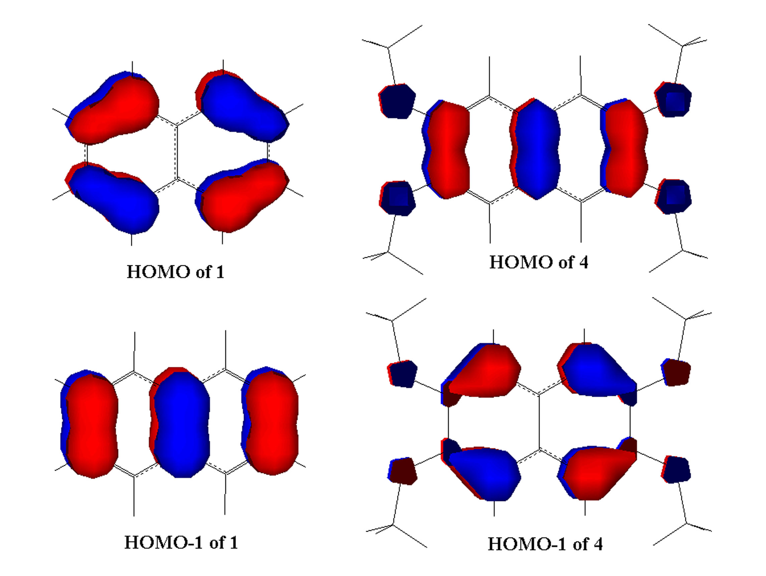

Figure S1: Illustration of the switching of HOMO and HOMO-1 upon –OCH₃-substitution
A
B
Figure S2: Calculated heats of formation of trimers 8 (A) and 11-13 (B).

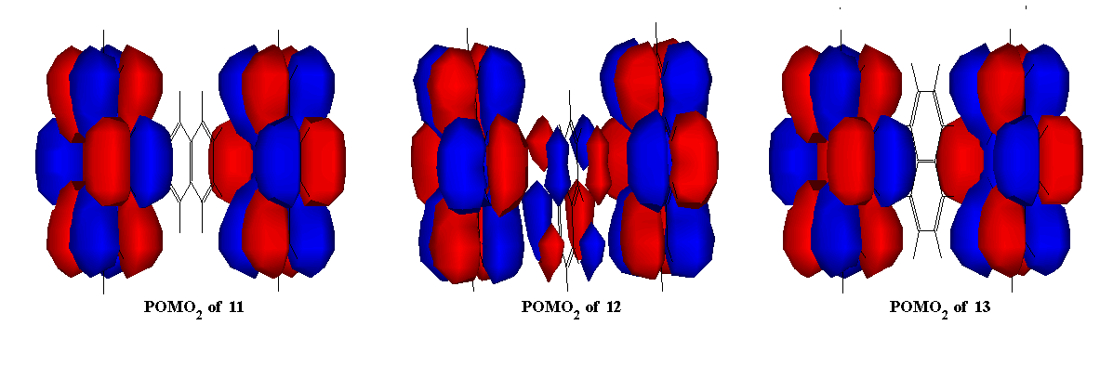

Figure S3: POMO₂ of 11, 12 and 13, illustrating the different degree of orbital mixing
Table S1: UB3LYP/6-311G calculated S² values for the triplet state of all trimers before and after annihilation of the spin contamination

Trimer | Conformation | S² before annihilation | S² after annihilation
7 | face-to-face | 2.0134 | 2.0002
7 | 90º-rotated | 2.0189 | 2.0002
8 | face-to-face | 2.0216 | 2.0003
8 | 90º-rotated | 2.0228 | 2.0003
9 | face-to-face | 2.0239 | 2.0004
9 | 90º-rotated | 2.0237 | 2.0004
10 | face-to-face | 2.0336 | 2.0007
10 | 90º-rotated | 2.0351 | 2.0007
11 | face-to-face | 2.0472 | 2.0014
12 | 60º-rotated | 2.0391 | 2.0010
13 | 90º-rotated | 2.0483 | 2.0015

AM1 optimised geometry of neutral naphthalene
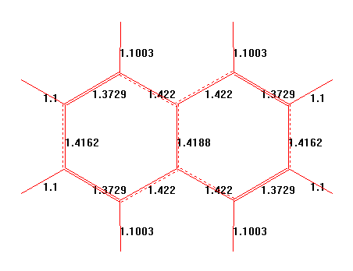
UB3LYP/6-311G optimised structures of radicals 1-5
